

Incidence rate of asymptomatic bacteriuria
and urinary tract infection

اسراء عارف بجواري 2151 By:
2rd year medical science
Supervisor:
د. انتصار الناجي
assisted by:
أ.ناجي الحمري
أ.اسماء الكوافي

Date of submission:

Abstract
Asymptomatic bacteriuria, defined as the presence of bacteria in the urine in the absence of urinary symptoms, is a common clinical finding that often warrants a decision about whether to initiate antimicrobial therapy. There are few indications to treat asymptomatic bacteriuria, and inappropriate treatment contributes to the development of antimicrobial resistance. In 2019, the Infectious Diseases Society of America revised its 2005 guidelines on asymptomatic bacteriuria, incorporating new evidence. The updated guidelines recommend screening and appropriate treatment for asymptomatic bacteriuria in pregnant women and in individuals undergoing endourological procedures associated with mucosal trauma. The guidelines recommend against screening and treatment in infants and children; healthy adults, including nonpregnant pre- and postmenopausal women; and patients with diabetes mellitus, long-term indwelling catheters, or spinal cord injuries.

Introduction
Asymptomatic bacteriuria, defined as the presence of bacteria in the urine in the absence of urinary symptoms, is a common clinical finding that often warrants a decision about whether to initiate antimicrobial therapy. There are few indications to treat asymptomatic bacteriuria, and inappropriate treatment contributes to the development of antimicrobial resistance. In 2019, the Infectious Diseases Society of America revised its 2005 guidelines on asymptomatic bacteriuria, incorporating new evidence. The updated guidelines recommend screening and appropriate treatment for asymptomatic bacteriuria in pregnant women and in individuals undergoing endourological procedures associated with mucosal trauma. ⁽¹⁾
The guidelines recommend against screening and treatment in infants and children; healthy adults, including nonpregnant pre- and postmenopausal women; and patients with diabetes mellitus, long-term indwelling catheters, or spinal cord injuries. ⁽¹⁻²⁾
The guidelines also recommend against screening and treatment in patients undergoing nonurological surgery, patients who have had a kidney transplant more than one month prior, recipients of other solid organ transplants, or those with impaired voiding following spinal cord injury. Although delirium in older adults can be caused by a urinary tract infection, the guidelines recommend that patients with delirium and no urinary or systemic symptoms be assessed for other causes of delirium, rather than initiating treatment for asymptomatic bacteriuria, because treatment has not been shown to have any beneficial effect on clinical outcomes. ⁽³⁾
Urinary tract infections (UTIs) are among the most common reasons antimicrobials are prescribed. Often, however, clinicians prescribe antimicrobials for asymptomatic bacteriuria, which is defined as the presence of bacteria in the urine in the absence of urinary symptoms. Treating asymptomatic bacteriuria is not beneficial for most patients and may be detrimental. For example, a retrospective study of more than 2,700 patients with asymptomatic bacteriuria at 46 hospitals showed that antimicrobial treatment did not improve outcomes and was associated with longer hospitalization. ⁽²⁻³⁾
Aim of study to show incident rate of asymptomatic bacterial infection among Libyan students

Methods and material

We take a sample of urine from 63 participant (33 females and 30 male) then we flame a calibrated wire loop, and we Mix the urine with insert the loop vertically into the urine to allow the urine to adhere to the loop. Then we spread the urine over the surface of the agar plate without flaming insert the loop vertically into the urine again to transfer of loopful to a second plate.
Then incubate for 24hr at 37 C in air Colonies are counted on each plate. The number of CFUs is multiplied by 1000 (if a 0.001 ml loop used) or by 100 (if a 0.01 ml loop was used) to determine the number of microorganisms per ml in the original specimen.
Data analysis by using SPSS Chi square test.

Result
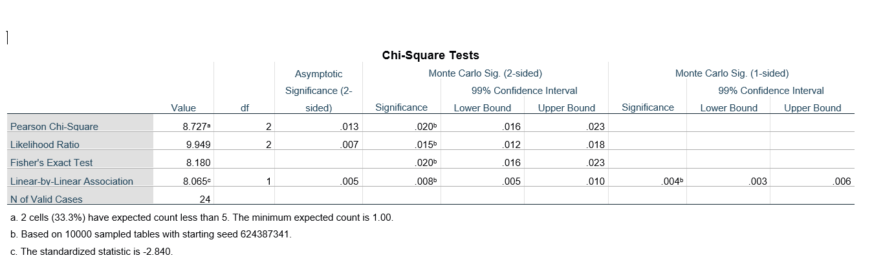

Discussion
As shown in this study found there’s significant bacteria overgrowth in urine of college student which means Asymptomatic bacteriuria is common, with varying prevalence by age, sex, sexual activity, and the presence of genitourinary abnormalities. Although asymptomatic bacteriuria is uncommon in children (less than 1% in boys and 1% to 2% in girls), it occurs in up to 5% of healthy premenopausal women, 2.8% to 8.6% of postmenopausal women, and 1.9% to 9.5% of pregnant women. ⁽¹⁾ Asymptomatic bacteriuria occurs in 100% of patients with long-term indwelling catheters.
In healthy women, the prevalence of bacteriuria increases with age, from about 1 percent in females five to 14 years of age to more than 20 percent in women at least 80 years of age living in the community. Escherichia coli is the most common organism isolated from patients with asymptomatic bacteriuria. ⁽²⁾
Asymptomatic bacteriuria is diagnosed when one bacterial species grows in the urine with at least 100,000 colony-forming units (CFUs) per mL, with or without pyuria, in a patient with no signs or symptoms of UTI. In asymptomatic patients with a newly inserted catheter or for specimens collected through in-and-out catheterization, a colony count of at least 100 CFUs per mL indicates asymptomatic bacteriuria ASB occurs in 0.8% of preschool girls and even fewer preschool boys. Children in this age group who are without genitourinary abnormalities do not require antibiotics to clear their bacteria because they do not appear to be at any risk for recurrent symptomatic infections, renal damage, or impaired renal growth. ⁽³⁾

The prevalence is very high in residents of long-term–care facilities, from 25% to 50% of women and 15% to 40% of men. Escherichia coli is the most frequent organism isolated, but a wide variety of other organisms may occur. Bacteriuria may be transient or persist for a prolonged period. Pregnant women with asymptomatic bacteriuria identified in early pregnancy and who are untreated have a risk of pyelonephritis later in pregnancy of 20% to 30%. Bacteremia is frequent in bacteriuric subjects following mucosal trauma with bleeding, with 5% to 10% of patients developing severe sepsis or septic shock. These two groups with clear evidence of negative outcomes should be screened for bacteriuria and appropriately treated. ⁽²⁻³⁾
Asymptomatic bacteriuria in other populations is benign and screening and treatment are not indicated. Antimicrobial treatment has no benefits but is associated with negative outcomes including reinfection with antimicrobial resistant organisms and a short-term increased frequency of symptomatic infection post-treatment Treatment of asymptomatic bacteriuria during pregnancy reduces these complications and improves perinatal morbidity and mortality. Without treatment, asymptomatic bacteriuria will persist in more than 80% of women and may progress to symptomatic urinary tract infection or acute pyelonephritis. ⁽⁴⁾
Screening for asymptomatic bacteriuria with a urine culture is recommended during the first prenatal visit and is repeated only in high-risk women, such as those with a history of recurrent urinary infections or urinary tract anomalies. If asymptomatic bacteriuria is found, prompt treatment is warranted, usually with a cephalosporin, for 3 days; a single dose of Fosfomycin can also be used. ⁽²⁻³⁾
Urinary tract infections (UTIs) are responsible for an estimated 7 million office visits, 1 million emergency room visits, and 100,000 hospitalizations each year, accounting for some 25% of all infections in geriatric patients.1 Health care providers often confuse asymptomatic bacteriuria, with UTI, and unnecessary antibiotic treatment of ASB in older adults is common. ⁽⁵⁾

Conclusion
Asymptomatic bacteriuria, defined as the presence of bacteria in the urine in the absence of urinary symptoms, is a common clinical finding that often warrants a decision about whether to initiate antimicrobial therapy. In healthy women, the prevalence of bacteriuria increases with age, and most common organism isolated from asymptomatic bacteriuria is Escherichia coli and the Screening for asymptomatic bacteriuria with a urine culture is recommended during the first prenatal visit of pregnancy and is repeated only in high-risk women and usually treated to prevent complication and improve prenatal mortality.

References

- Colgan R, Jaffe GA, Nicolle LE. Asymptomatic Bacteriuria. Am Fam Physician. 2020;102(2):99-104.

- Petty LA, Vaughn VM, Flanders SA, et al. Risk Factors and Outcomes Associated With Treatment of Asymptomatic Bacteriuria in Hospitalized Patients. JAMA Intern Med. 2019;179(11):1519-1527. doi:10.1001/jamainternmed.2019.2871

- Nicolle LE, Gupta K, Bradley SF, et al.; Clinical practice guideline for the management of asymptomatic bacteriuria: 2019 update by the Infectious Diseases Society of America. Clin Infect Dis. 2019;68(10):e83-e110.

- Nicolle LE. The paradigm shift to non-treatment of asymptomatic bacteriuria. Pathogens. 2016;5(2):e38.

- Owens DK, Davidson KW, Krist AH, et al.; Screening for asymptomatic bacteriuria in adults: U.S. Preventive Services Task Force recommendation statement. JAMA. 2019;322(12):1188-1194.

