


Abstract
LIBYAN INTERNATIONAL MEDICAL UNIVERSITY
FACULTY OF APPLIED MEDICAL SCIENCES
The difference in urine output after using furosemide in gender
Student name: Amira Mohammed alshaari
Roll number: 2627
supervisor: Dr. Hwuida Khattab Elhassi
Assistant by: Mr. Ahmed Gaibani
Date: June 2ed 2022
This current research aims to explore the difference between adult males and females in urine output after Lasix consumption. Furosemide is a diuretic that is used to treat edema (excess fluid in the body) caused by heart failure, liver disease, and renal illness. The sodium-potassium-s chloride (Na+/K+/2Cl-) cotransport of the ascending limb of the loop of Henle can be inhibited by this loop diuretic (NKCC2), which may affect the urine output which is normal ranging between 800-2500 mL per a day. There is only one study about whether there is a difference between urine output rates for both genders. In this study, 12 volunteers were given 40 mg of furosemide intravenously and their urine output was constantly monitored for 6 hours, and the results were recorded. By results, display that there is no significant difference consequent to P-value which was 0.142, and fail to reject the null hypothesis, accomplished by using the T-test, which was conducted using the Statistical Package for Social Sciences (SPSS).

- Introduction
Normal urine output per day is 800-2500 mL.¹ In normal conditions, ADH decreases the urine output by facultative reabsorption of water in the distal convoluted tubule and the collecting duct. The urine that is formed is concentrated with sodium and other ions. Loss of sodium decreases the osmolarity of plasma, making it hypotonic.² diuretics, sometimes known as water tablets is an agent that increases urine volume, by assisting the kidneys to excrete excess salt and water through the urine. Diuretics work by removing excess fluid and lowering blood pressure. When the body has too much fluid accumulating due to heart failure or other medical issues, diuretics can help. Diuretic type's include Thiazide diuretics, Loop diuretics, such as furosemide, and Potassium-sparing diuretics. In this report, we will discuss the impact of furosemide on gender's urine output.³
In an animal experiment conducted by Anabel Brandoni et al, Throughout the experiment, adult male and female Wistar rats aged 110–130 days were tested, and experiments were conducted in the absence and presence of a furosemide dose required to achieve identical furosemide excretion rates in both sexes. furosemide was administrated besides the dose of inulin at a priming dose(10mg/kg). In the absence of furosemide, male and female rats excreted sodium, potassium, and water in fractional amounts. Female rats had considerably higher natriuretic, kaliuretic, and diuretic responses to furosemide when expressed in fractional terms. Female rats also had higher diuretic, natriuretic, and kaliuretic efficiency of furosemide than male rats. This could be explained by the lower abundance of the Na-K-2Cl cotransporter in female kidney homogenates compared to male kidney homogenates.⁴
In another study conducted by Luca Zazzeron et al,⁵ specifically 39 enrolled patients were admitted to a postoperative ICU after major surgery and received single low-dose intravenous administration of furosemide. Urinary output, pH, sodium [Na+], potassium [K+], chloride [Cl−], and ammonium [NH4+] concentrations were measured every 10 min for three to 8 h, Low-dose furosemide administration immediately modifies urinary electrolyte excretion rates, likely in relation to the ongoing proximal tubular activity and patients baseline clinical characteristics, both unveiled by its inhibitory action on Henle’s loop. Such effects, when cumulative, found the bases for the long-term acid-base alterations observed, Real-time urinary electrolyte monitoring may represent an interesting and useful tool for better tailoring patient diuretic and hemodynamic therapies.
Furthermore, in an experiment conducted by K L Franson et al,⁶ particularly 6 males, and 6 females, received oral and intravenous furosemide, Total urine output was collected to measure and determine sodium and potassium concentrations. The results showed that there is no statistically significant difference found between male and female subjects. However, when the natriuretic response was adjusted for mg/kg of the intravenous furosemide dose received, male subjects had a higher peak sodium excretion rate than the female subjects.
This study aims to find out the difference between adult males and females in urine output after Lasix consumption.
- Methodology
This study is a quantitative experimental design. On 14 April 2022, the study was conducted at an analytical lab at the Libyan International Medical University, with 12 volunteers, 6 males, and 6 females, who were in good health and had no previous or chronic diseases. Their ages were not taken, and the only biometric data collected was their weight and urine output.
The participants were divided into two groups based on gender, and each group received a single dose of 40 mg of furosemide intravenously during their lab stay, as well as a period of not less than 6 hours of urine monitoring after the administration. This was to determine and record the amount of urine flow per hour.
The urine output was compared between the two groups, males and females, using the T-test, which was conducted using the Statistical Package for Social Sciences version 26 (SPSS), and the difference was declared significant after 6 hours were finished and all of the volunteers' readings were collected for each hour separately, in addition to their weights. The researchers' hypothesis is Formulated as:
- Result
40 mg of furosemide was used in 12 participants with good health, their ages were not considered in this research, only their weight. Hourly urine output rates were calculated for 6 hours. urine output was calculated by the equation: the amount of urine divided by the weight by dividing the number of hours, and the values did not exceed 600ml. The urine output rates during the sixth hour were used to determine whether there was a difference for both sexes or not, and by SPSS software the mean was calculated for each subject, figured out that the mean of male volunteers was 468, while the mean of female volunteers was 367. The standard deviation of both subjects males and females was 114.024 and 104.932 respectively (Table 1).
The lowest result of urine output recorded for a female was 216ml at a constant rate of 36ml per hour, while the highest result of urine output recorded for a male was 604.8ml at a constant rate of 100.8ml per hour. there are no extreme values in both subjects as shown in figures 1 and 2.
Since gender is considered qualitative data and urine output are quantitative data, an independent sample test was used in SPSS software to compare means, and the result was P-value =0.142, the result of the T-test summarized in table 3.

Table 1. Urine output every hour for 6 hours for both groups, male (n = 6) and female (n = 6).

Table 2. The mean, median, and std. deviation for both groups, male (n= 6) and female (n= 6)

Group Statistics
 | Gender | N | Mean | Std. Deviation | Std. Error Mean
UO6hr | Female | 6 | 367.2000 | 104.93244 | 42.83849
UO6hr | Male | 6 | 468.0000 | 114.02400 | 46.55010

Table 3. The P-value (P = 0.142) was calculated in this study, which included 12 volunteers, to determine whether there was a difference in urine output between the genders.
Independent Samples Test
 |  | Levine's Test for Equality of Variances |  | t-test for Equality of Means
 |  | F | Sig. | t | df | Sig. (2-tailed) | Mean Difference | Std. Error Difference | 95% Confidence Interval of the Difference
 |  |  |  |  |  |  |  |  | Lower | Upper
UO6hr | Equal variances assumed | .208 | .658 | -1.593- | 10 | .142 | -100.80000- | 63.26174 | -241.75595- | 40.15595
 | Equal variances not assumed |  |  | -1.593- | 9.932 | .142 | -100.80000- | 63.26174 | -241.88737- | 40.28737

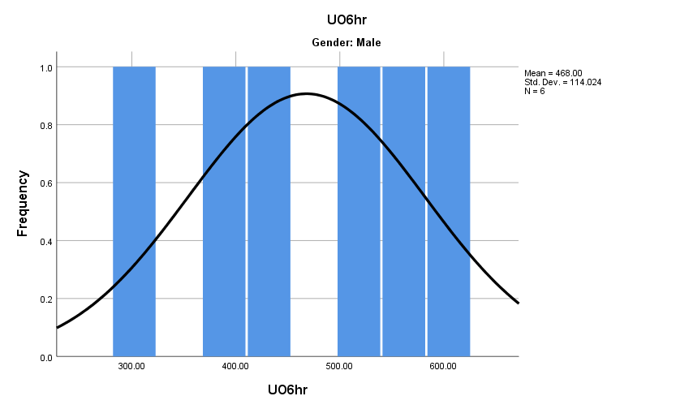
Fig. 2. The frequency of urine output at 6 hours for males shows normal distribution (no extreme values).
Fig. 1. The frequency of urine output at 6 hours for females, shows normal distribution (no extreme values).
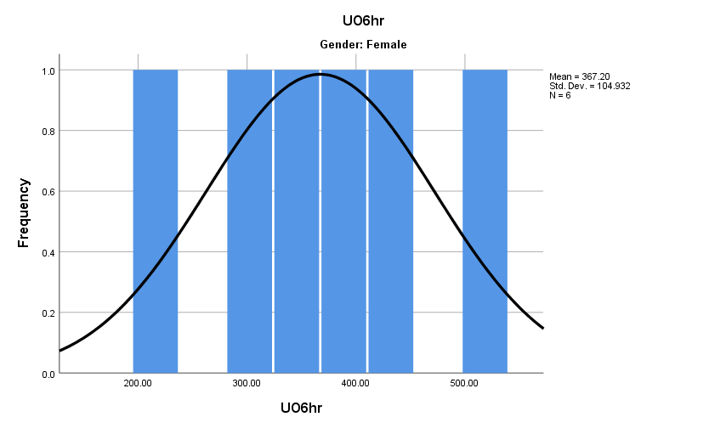

- Discussion
The study specifically investigating the furosemide effect on urine output in both genders. This static report found that there was no significant difference consequent to P-value which was 0.142, and according to this result fails to reject the null hypothesis Since P-value is greater than alpha = 0.05. Comparing the findings of this present research with other studies mentioned above, the researcher indicates that there is an agreement with some previous studies. Comparable to the animals' experiment which showed that there was a difference between male and female rats, the experience clarified that female rats had higher efficiency of furosemide than male rats, disparate from this current research result.⁴
This result coincides with an experiment conducted by K L Franson et al,⁶ in which their results exhibited that there was no difference between both genders when intravenous furosemide was administrated.
In a study conducted by the Department of Medicine, the University of Natal, and King Edward VIII Hospital, involving patients with acute and chronic kidney disease, all patients received a high dose of furosemide, and the results display that there are differences in the amount of urine output for both genders, However, this study differs in terms of the volunteers, as their health condition was diagnosed with acute and chronic kidney disease, realize that the pathological condition may affect the results.⁷ The study still needs many experiments and more volunteers to get more accurate results.

- Conclusion
This study was carried out to find if there is a difference between adult males and females in urine output after Lasix consumption, it is obvious that there is no difference in both genders. Based on the p-value (=0.142), it was statistically confirmed that there is no significant difference in urine output among males and females after volunteers received furosemide and recorded the results. As a result, the researcher suggests further research as well as adopting large and diverse implications to obtain a more accurate and clear finding.

References
- Khurana I. Medical Physiology For Undergraduate Students. London: Elsevier Health Sciences APAC; 2014.
- Sembulingam K, Sembulingam P, Sembulingam P. Essentials Of Medical Physiology. 6th ed.
- Diuretics: Types, Uses and Side Effects. Cleveland Clinic. https://my.clevelandclinic.org/health/treatments/21826-diuretics. Published 2022. Accessed May 19, 2022.
- Brandoni A, Villar S, Torres A. Gender-Related Differences in the Pharmacodynamics of Furosemide in Rats. Pharmacology. 2004;70(2):107-112. doi:10.1159/000074675.
- Zazzeron L, Ottolina D, Scotti E et al. Real-time urinary electrolyte monitoring after furosemide administration in surgical ICU patients with normal renal function. Ann Intensive Care. 2016;6(1). doi:10.1186/s13613-016-0168-y.
- Franson KL, Kuk JM, Lam NP, Lau AH. Gender effect on diuretic response to hydrochlorothiazide and furosemide. Int J Clin Pharmacol Ther. 1996;34(3):101-105.
- Seedat YK. High-dose furosemide (Lasix) in renal insufficiency. S Afr Med J. 1972;46(38):1371-1374.

