
Libyan International
Medical University

Gender-Related Differences in the Pharmacodynamics of Furosemide

By:Ali awad Alshagabi 3rd year medical science
Supervisor: Dr.basma and Dr.hwuida
assisted by: Dr.Ahmad aljebani

Date of submission:2022/6/20

Abstract
Furosemide is a loop diuretic that has been around for a long time. Furosemide has been approved by the Food and Drug Administration (FDA) to treat conditions characterized by volume overload and edema as a result of congestive heart failure exacerbation, liver failure, or renal failure, including the nephrotic syndrome. Historically, there has been a scarcity of information on female pharmacokinetics and the possibility of gender differences in the relationships between dose and efficacy or dose and adverse drug reactions. Only a few studies were able to clearly identify clinically significant gender effects in terms of pharmacodynamics. Because females make up roughly half of any species' population, it is appropriate to consider the effect of sex on drug pharmacokinetics and pharmacodynamics, of study to show gender difference in Pharmacodynamics of furosemide in human. there was no statistically significant difference between male and female subjects in terms of urine flow rate, sodium, and potassium excretion rates along the course of treatments, there was no statistically significant difference between male and female subjects in terms of urine flow rate, sodium, and potassium excretion rates along the course of treatments

Introduction
Furosemide is a loop diuretic that has been in use for decades. The Food and Drug Administration (FDA) has approved furosemide to treat conditions with volume overload and edema secondary to congestive heart failure exacerbation, liver failure, or renal failure, including the nephrotic syndrome. However, clinicians must be aware of updates related to the indications and administration of furosemide to ensure safe practices and minimize adverse effects. This activity reviews updates on the recommended use of furosemide, the mechanism of action, indications, contraindications, adverse effects, toxicity, and other key factors (e.g., off-label uses, dosing, pharmacokinetics, monitoring, relevant interactions) profile. It highlights the interprofessional team's role in caring for patients on furosemide therapy.
Furosemide inhibits tubular reabsorption of sodium and chloride in the proximal and distal tubules and the thick ascending loop of Henle by inhibiting the sodium-chloride cotransport system resulting in excessive excretion of water along with sodium, chloride, magnesium, and calcium. The onset of action of furosemide is usually within the first hour of oral furosemide intake, and it takes the first 1 to 2 hours to achieve a peak effect. The mean bioavailability of oral furosemide is 51% compared with the bioavailability of intravenously administered furosemide.^{1,2}
Aim
Aim of study to show gender difference in Pharmacodynamics of furosemide in human.
Methods and material
In six male and six female normal volunteers, the diuretic response to oral hydrochlorothiazide, oral and intravenous furosemide was measured. On four successive days, each participant received single doses of the various diuretics or no therapy after fasting overnight. Over the next 24 hours, total urine production was collected for volume measurement and salt and potassium concentration testing.^{1, 2}

Result & Discussion
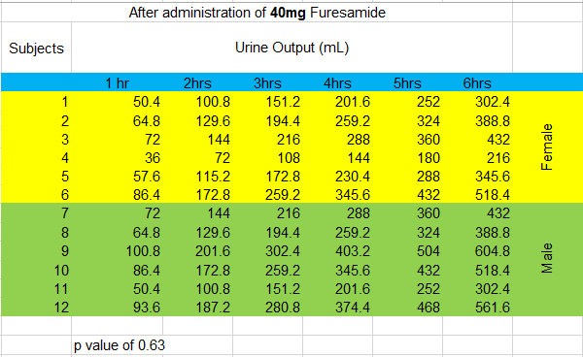
According with current study's findings, there was no statistically significant difference between male and female subjects in terms of urine flow rate, sodium, and potassium excretion rates along the course of treatments. ,The possibility of gender differences in the relationship between dose and efficacy of drugs has historically been limited. The aim of the present study was to evaluate the influence of sex on the pharmacodynamics of furosemide (FUR) in adult Wistar rats. Conventional renal clearance studies were performed in the absence and in the presence of a FUR dose necessary to produce identical urine excretion rates of FUR in both sexes. Fractional excretions of sodium, potassium, and water were similar in male and female rats in the absence of FUR. Natriuretic, kaliuretic, and diuretic responses to FUR, when expressed in fractional terms, were significantly increased in female rats. Diuretic, natriuretic, and kaliuretic efficiencies of FUR were also higher in female rats as compared with males. This might be explained by the lower abundance of the Na-K-2Cl cotransporter observed in homogenates from the medullae of female kidneys as compared with male ones.

Gender has been shown in other studies to cause differences in drug disposition and response to therapeutic agents. In 6 male and 6 female normal volunteers, we measured the diuretic response to oral hydrochlorothiazide, oral and intravenous furosemide. On four separate days after fasting overnight, each subject received single doses of the individual diuretics or no treatment. Over the next 24 hours, total urine output was collected for volume measurement and sodium and potassium concentration determination. There was no statistically significant difference between male and female subjects in terms of urine flow rate, sodium, and potassium excretion rates across treatments. When natriuretic response was adjusted for mg/kg of intravenous furosemide dose received, male subjects had a higher peak sodium excretion rate than female subjects. The findings of this study reveal a gender difference in the natriuretic response to diuretics. More research is needed to determine whether this gender difference is caused by differences in drug metabolism, disposition, or intrinsic diuretic responsiveness at the site of action.^{2,3}
Conclusion
More research is necessary to identify whether this gender disparity is due to differences in drug metabolism, disposition, or intrinsic diuretic responsiveness at the site of action.

References

- Philip Hampel, Kerstin Römermann, Martina Gramer, Wolfgang Löscher, The search for brain-permeant NKCC1 inhibitors for the treatment of seizures: Pharmacokinetic-pharmacodynamic modelling of NKCC1 inhibition by azosemide, torasemide, and bumetanide in mouse brain, Epilepsy & Behavior, 10.1016/j.yebeh.2020.107616, 114, (107616), (2021).

- Franson KL, Kuk JM, Lam NP, Lau AH. Gender effect on diuretic response to hydrochlorothiazide and furosemide. Int J Clin Pharmacol Ther. 1996 Mar;34(3):101-5. PMID: 8705087.

- Brandoni A, Villar SR, Torres AM. Gender-related differences in the pharmacodynamics of furosemide in rats. Pharmacology. 2004;70(2):107-112. doi:10.1159/000074675

