Student’s name: Younus Azhar Khan
Student’s No: 2424
Group: A2

Assignment to be submitted in Moodle by 19 March 2022
- Develop a network diagram for the project specified below. (50 %)
- Identify the Critical Activities and the total duration of the project. (35%)
- Justify which activity would you crash based on some rationale (15%)
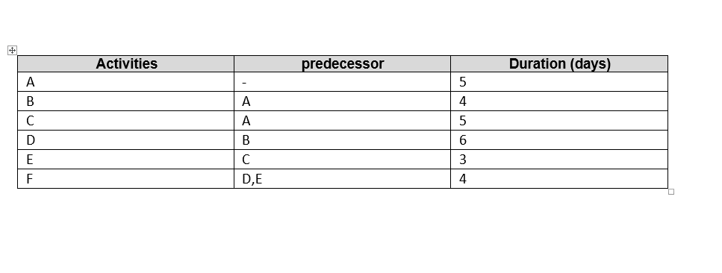
B
D

F
A
C
E

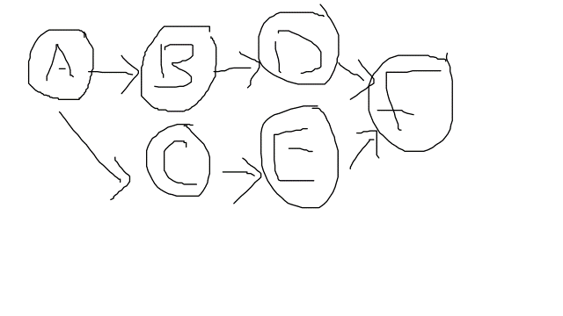
Identifying the critical path:
A-B-D-F = 5+4+6+4 = 19 day.
A-C-E-F = 5+5+3+4 = 17 day.
The first path is the most important.
Justify: Path 1 would take longer than Path 2 because it has more activities. Path 1 would be our critical path if time were an important factor; however, there are many factors that would cause this consideration to change, such as finance and the priority of sequences of activities that must be completed before the other.

