Urine output is higher in an adult male than an adult female after consumption of lasix

Student Name: Khadija Mohamed Bulifa

Student Number: 2570
Supervisor : DR. Basma
Assisted by : Eman Fergani
Abstract
Urinating is a way for the body to remove toxins and waste from the body. And the body is expected to release a certain amount of urine each day based on the amount of liquid that's taken. And if the body is releasing more or less urine than it should, this can be a sign that the patient is suffering from a medical condition that will require attention. And the difference between male and female urine is not significant. However, they differ slightly with the composition since the type of sex hormones are different among the gender. Therefore, hormonal products and metabolites of the hormones vary from male and female urine. Actually there are several benefits of urination or urine excretion but the most important thing is that the organisms control osmotic pressure or the balance between inorganic ions and water to maintain acid-base balance through this process. It also helps in promoting homeostasis, a process that helps maintain the stability that helps the organs or biological systems to survive.

INTRODUCTION
Urination is the release of urine from the bladder, urine from the kidneys is exceeded in spurts each seconds along the ureters to the bladder, in which it collects and later is exceeded to the outside of the urethra, called additionally micturition and voiding. The urinary process or urination is a complex process controlled by muscles of the bladder and sphincter mechanism and by modulatory centers in the central and peripheral nervous systems [1] , also the urine is a liquid produced by the kidneys to remove waste products from the blood stream, the human urine is yellowish in color and variable in chemical composition, which are ( water, Urea, Chloride, Sodium, Potassium, Creatinine, Inorganic sulfur ) and lesser amounts pf other ions and compounds are present, including hippuric acid, phosphorus, citric acid, glucuronic acid, ammonia, uric acid, and many others, also normal urine output or normal urination is 800-2000 mm each day if you take in around 2 liters of fluid throughout the day. However, normal values can vary in different laboratories, also decreased urine output or oliguria is a condition that causes the body to produce less than 400 millimeters of the urine a day. As one of the abnormal urine output, this is not to be confused with conditions where people fail to urinate at all or conditions like anuria when you produce 50 mm of urine or less. [2] Actually there are several benefits of urination or urine excretion but the most important thing is that the organisms control osmotic pressure or the balance between inorganic ions and water to maintain acid-base balance through this process. It also helps in promoting homeostasis, a process that helps maintain the stability that helps the organs or biological systems to survive. Also for whose are suffering from renal excretion and have difficulties with urination they use diuretics as a solution for their problem. Otherwise diuretics known as "water pills" are medications that increase the amount of salt and water excreted from the body. These medications increase the production of urine produced in the kidneys, which leads to increase urine flow, or diuresis. Mainly diuretics used to treat high blood pressure (hypertension) and fluid retention, or edema, that develops as a symptom of heart failure, kidney problems, and liver failure. Some diuretics can also treat swelling in the brain caused by a severe head injury or swelling in the eyes caused by eye conditions like glaucoma.[2] Also diuretics work by altering the balance of water, salt, and electrolytes in the body. More specifically, they have effects on the different processes in the kidneys that play a role in sodium and electrolyte reabsorption. There are several different types of diuretics. Each of them may work in different parts of the kidney. More specifically, there is the furosemide one of the diuretics and it's a loop diuretics that has a very particular mechanism of action in how it acts in the body [3]

Materials and Methods
A range of 6 males and 6 females participated in the study. They denied having any scientific situation problem, The medicine Furosemide 40mg changed into then provided orally to every of them. In this observe we used urine pattern box to degree the urine output even used a chi-rectangular statistic take a look at to investigate how a version compares to real determined information on this observe, and the statistical software program suite evolved version software program application changed into used for information management and statistical analysis.

Results and discussion
In this study we use furosemide as loop diuretics for comparing between males and females urine output and we found that females produce more urine output than male in normal but in our study we found that when we gave Lasix to them after 6 hours there is increase in females urination than in males but it is not significantly correct after urine output, because P-value it is not significantly correct for males and females because of the values are also not significantly true, and also the result it's not significant because of the small size. And for making sure about these studies, we did a study about rats and we gave them furosemide, after that. We found that urine output is more in males than females and that is mean the result it's not correct because it's supposed to be that males after given furosemide must be more than females in urine output. And we need to do more studies to see if there's a big difference between them or not because the data that we have it's not enough. And there's more than one study saying that urine output increased is found among people who take Lasix, especially for people who are female, 60+ old, and have been taking the drug for <1 month. And until now there's not a significant results and we need to do more studies.

Gender Mean Std. Deviation t-test p-value

42.83849 | 104.93244 | 367.2000 | 6 | Female
46.55010 | 114.02400 | 468.0000 | 6 | Male
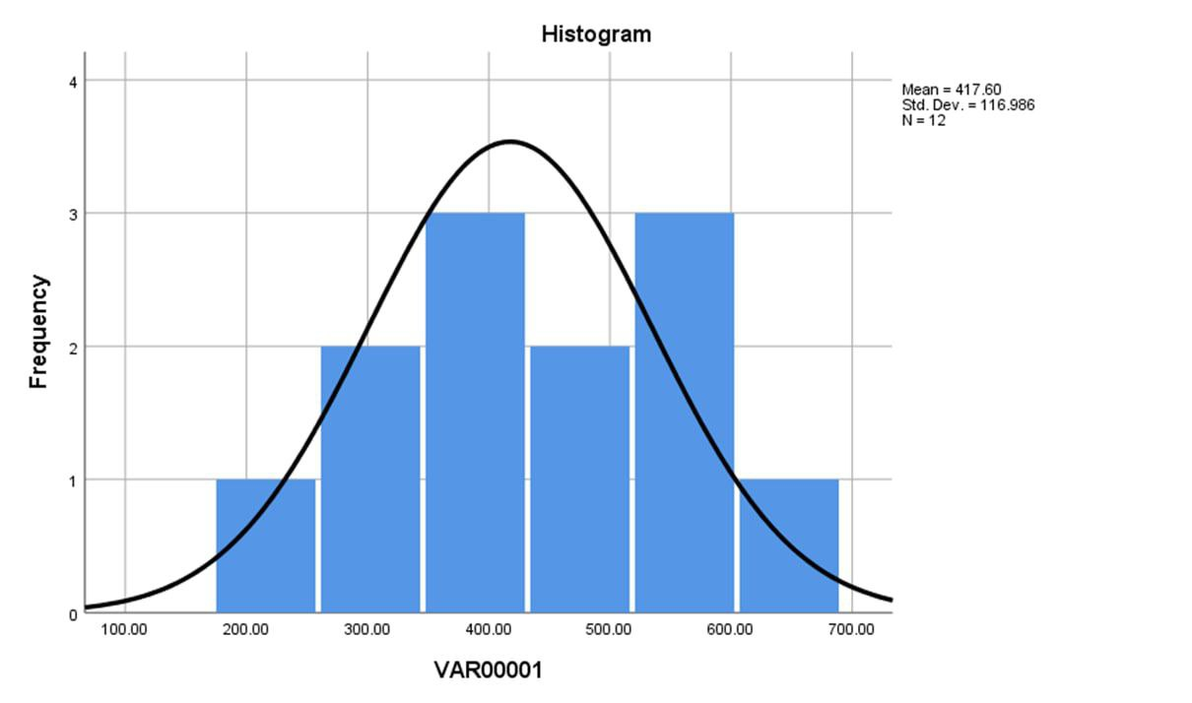

Conclusion

In brief that there are more studies about urine output but we are searching more and more to achieve for the real results, and for males and females urination it's considered normal to urinate around 2 liters of liquid every day, but this will vary based on your gender, age and other factors. And for excessive urination (polyuria) and (oliguria) if one of these conditions appear to continue for a long period of time, patient might has an underlying issue that is affecting overall health.

References

1. Urine Output: What's Normal and What's Not?. MD-Health.com. https://www.md-health.com/Normal-Urine-Output.html. Published 2022.
2. Diuretics: Types, Uses, Risks, and More. Healthline. https://www.healthline.com/health/diuretics. Published 2022.
3. Difference Between Male and Female Urine | Compare the Difference Between Similar Terms. Compare the Difference Between Similar Terms. https://www.differencebetween.com/difference-between-male-and-vs-female-urine/. Published 2022.

