

Libyian International Medical University
Faculty of Applied Medical Science

Incidence rate of Asymptomatic Bacteriuria among LIMU students

Presented by
Osaid aniba
2464
2nd year student
Date : 18/6/2022

Abstract:
Asymptomatic urinary infection, is bacteria present in urine in the absence of clinical signs or symptoms of urinary infection in the host.
Escherichia coli and gram-negative bacilli are the most common organisms isolated from patients with asymptomatic bacteriuria. This study aims to detect the incidence of asymptomatic bacteriuria between male and females of Libyan International Medical University students. The findings of this report study were obtained from medical students. Patient’s samples were examined by urine culture and grams staining at the microbiology lab. Therefore, the P-value of asymptomatic bacteriuria between male and females was less than 0.05. The incidences of asymptomatic bacteriuria in the females are significantly higher than males.

Introduction:
Asymptomatic bacteriuria, also known as bacteriuria or asymptomatic urinary infection, it’s the presence of bacteria in the usually sterile urine in the bladder or kidneys, together with the absence of clinical signs or symptoms related to urinary tract infections. It’s mostly found in healthy women, and in both men and women with abnormalities of the genitourinary tract. Individuals with underlying genitourinary abnormalities, including indwelling devices, may also have a high frequency of asymptomatic bacteriuria, irrespective of age or gender.¹
Asymptomatic bacteriuria is identifiable when voided urine specimens have at least 10⁵ cfu/ml of a uropathogen isolated in the absence of signs or symptoms of urinary infection.²
Escherichia coli are the most common isolated organism, but a wide variety of other organisms may occur. Bacteriuria can be temporary or persistent, lasting from around days to years and involving the same or different species. Bacteriuria may resolve spontaneously or as a result of antimicrobial therapy administered for any indication. Recurrent bacteriuria is frequent. Bacteriuria has been correlated with harmful outcomes in a few well-characterized populations, for whom screening and treatment of bacteriuria prevents adverse outcomes.³
Bacteriuria that is asymptomatic is typically harmless. Only pregnant women and patients who have undergone invasive urologic procedures with mucosal injuries are considered to have bacteriuria-related morbidity.⁴
This study aims to detect the incidence of asymptomatic bacteriuria between male and females of Libyan International Medical University students.

Materials and methods:
The findings of this report study were obtained from Medical students. The total number of participants who were both genders, male and female, amounted to 24 of which 12 were females and 12 were males. Participants were asked about their health status and took permission from them. Following the collection of the samples, each specimen was examined to determine its color, curd, and foaming. Then, to identify bacteria or other microorganisms in a urine sample, urine culture is used. First, the specimen is thoroughly mixed, then a drop from the specimen is looped into a sheep agar plate and allowed to dry, then several lines are drawn in a zigzag shaped pattern within the agar, and lastly it is left in the incubator for 24 hours. The last step is to count the colonies; each colony is multiplied by 1000 (10^{X4}), and if there are more than 50000 (10^{X5}) colonies, then significant growth is confirmed.
The gram stain is then used on the sample by lightly dipping the colony of bacteria in order to avoid spreading of too many germs. Allowing it to dry before passing it into the flame three times, with one second in between each pass. Then after the addition of a few drops of crystal violet stain, wait and the let the slide dry for 1 minute, and then dip it three times in water. After that we add several drops of iodine, after it comes the washing with alcohol, and lastly the addition of safranin, after repeating the processes, that were used previously with crystal violet. Allow it to dry before inspecting the sample under a microscope.

Results:

1: Effect of Gender differences on prevalence and of asymptomatic bacteriuria
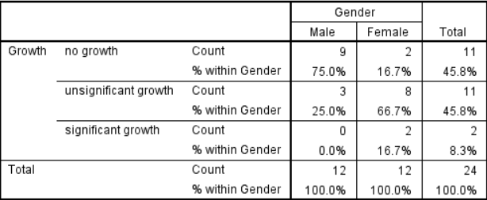
Table 2: bacterial growth and gender correlation
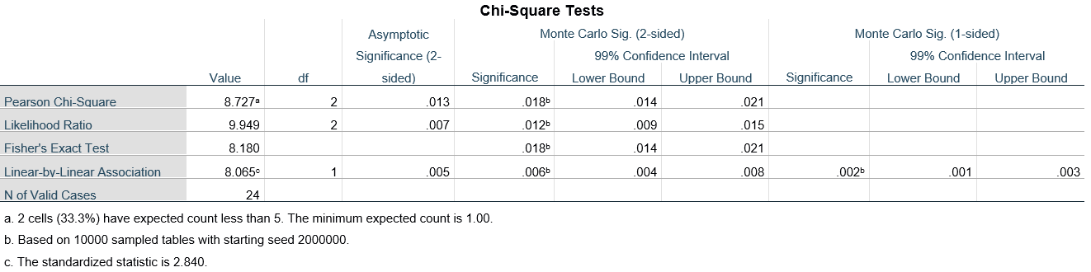
Table 3: Chi - Square Test (Asymp. Sig. (2 - sided) represents the p - value)

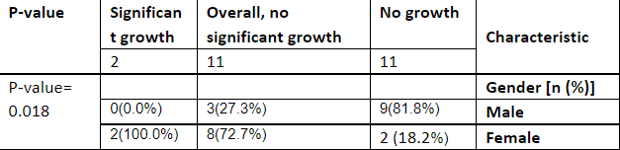
Table 4: summary table


Chart 1: difference in growth between males and females

There is a relationship between gender and asymptomatic bacteriuria, as indicated in Table 1. A Chi-Square test was conducted to assess if the association was significant. The hypothesis was that there is a relationship between the two variables, whereas the null hypothesis is that there is not. However, because the requirement of less than 20% of cells having an anticipated value of less than five was not satisfied, a fisher test was utilized instead.
We reject the null hypothesis in Table 3 since the p-value was less than 0.05, indicating that there is a relationship between gender and the prevalence of bacteriuria.

Discussion: Asymptomatic bacteriuria is common, with varying prevalence by age, sex, sexual activity, and the presence of genitourinary abnormalities. In healthy women, the prevalence of
bacteriuria inclines with age, from about 1 percent in females from 5 to 14 years of age to more than 20 percent in women at least 80 years of age living in the community.⁵
The incidence of asymptomatic bacteriuria between males and females has a P-value which is significant because it is less than (0.05). As a result, females have a significantly higher incidence of asymptomatic bacteriuria than males.
The null hypothesis is rejected since the P-value is less than (0.05).
This is due to a number of reasons, including the anatomical configuration of the female urinary system. The urethra, which is responsible for transporting urine out of the body, is smaller in females. The urethra is where germs enter the urinary tract, and a shorter urethra makes it easier for bacteria to enter since it has to travel a less distance. The closeness of the urethra to the rectum, which contains Escherichia coli, the most common cause of asymptomatic bacteriuria and urinary tract infections, is another reason for urinary tract infections. Because of the anatomical structure of their reproductive system, females are more prone to urinary tract infections and asymptomatic bacteriuria.⁶

Conclusion:
Finally, the findings of this study have emphasized the need of detecting asymptomatic bacteriuria as part of the medical screening for students at the university. Usually, the students wouldn’t go to a clinic, even though, they may be having an asymptomatic illness. Further investigations identifying bacteriuria prevalence, infecting organisms, and risk factors are needed. E. coli is the most common causative agent because it is from the colon's normal flora. More research should be done to see if there's a correlation between bacteriuria and age, or if it has anything to do with immune-related disorders. The incidence of asymptomatic bacteriuria in females is significantly higher than in males.

References:
1. Nicolle LE. Asymptomatic bacteriuria. Curr Opin Infect Dis. 2014;27(1):90-96. doi:10.1097/QCO.0000000000000019
2. Rowe TA, Juthani-Mehta M. Diagnosis and management of urinary tract infection in older adults. Infect Dis Clin North Am. 2014;28(1):75-89. doi:10.1016/j.idc.2013.10.004
3. Nicolle L. Asymptomatic Bacteriuria and Bacterial Interference. 2022.
4. Nicolle L. Asymptomatic bacteriuria. Curr Opin Infect Dis. 2014;27(1):90-96. doi:10.1097/qco.0000000000000019
5. SKOLNIK N, O'DRISCOLL K. Asymptomatic Bacteriuria in Adults. Fam Pract News. 2006;36(16):28. doi:10.1016/s0300-7073(06)73676-3
6. Geerlings SE. Clinical Presentations and Epidemiology of Urinary Tract Infections. Microbiol Spectr. 2016;4(5): 10.1128/microbiolspec.UTI-0002-2012. doi:10.1128

