(2021/2022)
LIMU/YEAR2
BLOCK: PTS

Lap Report
Use of urinary gram stain for detection of urinary tract infection in women

Student name: Belquees elgaddafy
Student number: 2875
Supervisor name : eman elfirjani

ABSTRACT:

A side centrifuge gram stain was used to screen for bacteriuria in women.
For standard culture for slide centrifuges gram staining, 4161 urine specimens were presented in urine preservative tubes. After carefully mixing each urine sample, 0.2 ml was pipette-filled into a slide centrifuge chamber and spun for 5 minutes at 2,000 pm.

The slides were heat-fixed, gram stained, and analyzed by laboratory technicians who scanned 12 different oil-immersion zones in a preset pattern.

The presence of the same organism in six or more areas was classified as a positive urine screen (E.coli isolated in 75 percent of the females studied). A 0.001ml loop was used to culture urine samples, and the growth of the cultures was compared to slide centrifuge screening.

The screen showed a sensitivity of 98 percent, specificity of 90 percent, a negative predictive value of 99 percent, and a positive predictive value of 65 percent when a colony count of 100,000 or more CFU/ml was employed as a reference. The screen demonstrated an 88 percent sensitivity rate, a 95 percent specificity rate, and a negative predictive value when a lower colony count of 10,000 or more CFU/ml was employed as a reference.

Introduction:
Urinary tract infection (UTI) is one of the most prevalent bacterial infections in women, with enteric bacteria (E.coli) being the most commonly isolated pathogen.
Because of its beneficial effect on female genitourinary health, rapid identification of bacteriuria is desirable.
Are reliable urine screening methods can provide physicians with useful, timely information and, in some cases, can eliminate the need for culture for urine specimens that reveal negative results.
To detect the presence of bacteriuria, the gram stain was utilized.
A study published in 1956 by (Kass) found that gram stain smears of uncensored urine were positive in 80 percent of specimens with bacteria counts of 100.000 or more CFU/ml.
We created the slides centrifuge to aid in the concentration of bacteria for gram staining of bodily fluids.
We tested its utility as a fast urine screening approach in an adult female population using specimens.
The quantitative culture was used to compare the results

Materials and methods :
Initially, 1684 urine specimens were collected, specimens were well mixed and 0.2 ml at each specimen was placed into a centrifuge chamber, capped, and centrifuged at 2000 for 5 minutes in a slide centrifuge.
The slides were heat-fixed and gram stained using :

- solutions of crystal violet, gram’s iodine, 95% ethanol and/or isopropanol-acetone mixture ( 3:1 ), and safranin.
- clean glass slides.
- Inoculating loop.
- Bunsen burner.
- Microscope.
- Immersion oil.
- Difco.
- Slide warmer
- Staining rack.
- Bacto gram stain regents from disco for the three-step gram stain.

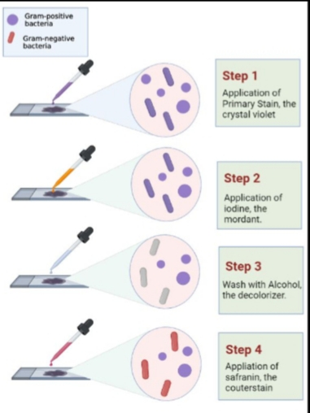
\

12 successive fields on each slide were scanned fast by oil-immersion microscopy, starting in the center of the slide centrifuge spot and following the pattern depicted in the figure.

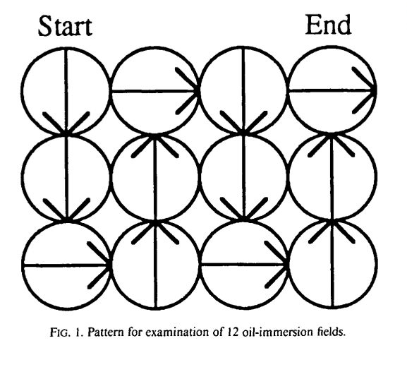
The number of fields in which organisms were seen was recorded and results were obtained.

Result:

The distribution of the combination of gram staining and culture results for the 1684 specimens is summarized in a table.
The sensitivity of the slide centrifuge screen in detecting 100,000 or more CFU/ml on culture was 98% and the specificity was 89%, the negative predictive value was 99%, and the positive predictive value was 66% for the 1684 specimens examined, using NBS and few as negative results and moderate and many as positive results.
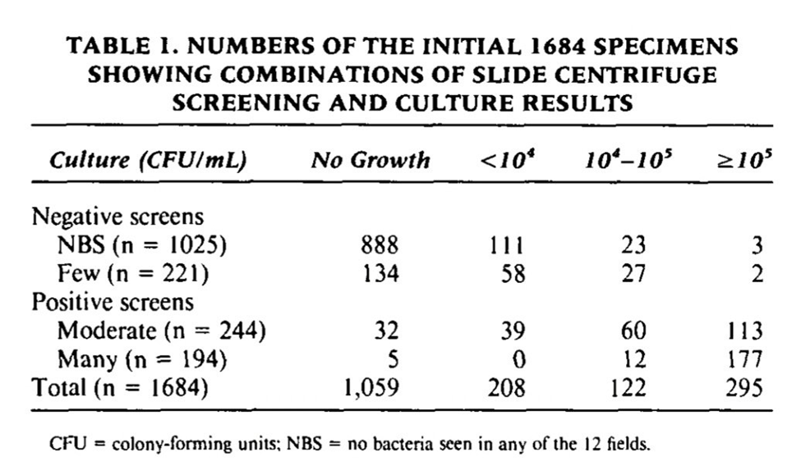
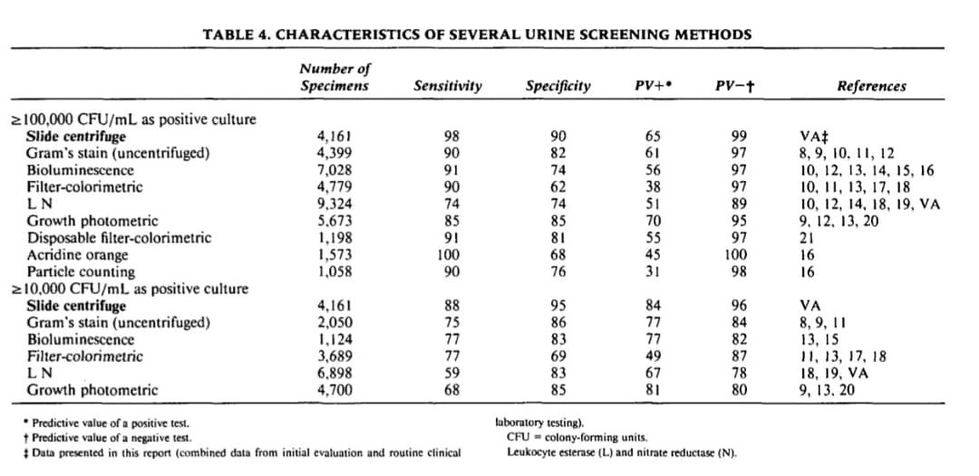

The most common organism isolated was enteric bacteria (E.coli) isolated in 75% of the samples under study.
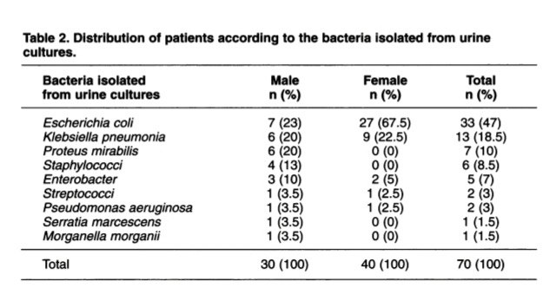

Discussion:

Recent studies demonstrate that oil-immersion microscopy of Gram-stained routinely centrifuged urine is reliable in detecting bacteriuria at 100,000 or more CFU/ml.
Our data from the slide centrifuge was compared to data from other screening methods that had recently been modified and published data.
The slide centrifuge screen was found to be a highly sensitive 98% screening method, with a high specificity rate of 90% in detecting 100,000 or more CFU/ml.

Because of the science of early diagnosis of UTI in females, colony counts as low as '100 CFU/ml may be scientific in specific populations (a young woman with acute dysuria and frequent urine or with short-catheter-associatediated infection)

Conclusion :

Finally, the slide centrifugation urine screen is a highly sensitive approach for detecting bacteriuria defects.
This test can be used on conserved urine to improve anaerobe, fastidious organisms

$اكتب المعادلة هنا.$, and yeast defection.
The test has a therapeutically useful turnaround time and gives the doctor gram stain features that can assist guide early antibiotic therapy.
Most notably, it has great sensitivity, a high predictive value for negative outcomes, and a low occurrence of false-negative results.

Results and Statistical analysis:
The purpose of this study was to examine the presence of
bacteria in urine samples from 24 middle-aged LIMU
understudies. There were twelve young ladies and twelve
young men. In 54.2 percent of LIMU students,
asymptomatic bacteriuria was discovered.
There were 7 (29.2%) understudy whose urine tests
developed less than 10,000 CFU/mL, 6 (25%) cases with
10,000 CFU/mL and more, and 11 (45.8%) with no
development. As a result, asymptomatic bacteriuria was
found to be prevalent in 18% of LIMU understudies.
(75%) followed in table 1:

Case Processing Summary
 | Cases
 | Valid |  | Missing |  | Total
 | N | Percent | N | Percent | N | Percent
Gender * UTICATS | 24 | 100.0% | 0 | 0.0% | 24 | 100.0%

Gender * UTICATS Crosstabulation
 |  |  | UTICATS |  |  | Total
 |  |  | No growth | No significant growth | Significant growth | Total
Gender | Male | Count | 9 | 3 | 0 | 12
Gender | Male | Expected Count | 5.5 | 5.5 | 1.0 | 12.0
Gender | Male | % within Gender | 75.0% | 25.0% | 0.0% | 100.0%
Gender | Male | % within UTICATS | 81.8% | 27.3% | 0.0% | 50.0%
Gender | Female | Count | 2 | 8 | 2 | 12
Gender | Female | Expected Count | 5.5 | 5.5 | 1.0 | 12.0
Gender | Female | % within Gender | 16.7% | 66.7% | 16.7% | 100.0%
Gender | Female | % within UTICATS | 18.2% | 72.7% | 100.0% | 50.0%
Total |  | Count | 11 | 11 | 2 | 24
 |  | Expected Count | 11.0 | 11.0 | 2.0 | 24.0
 |  | % within Gender | 45.8% | 45.8% | 8.3% | 100.0%
 |  | % within UTICATS | 100.0% | 100.0% | 100.0% | 100.0%

Chi-Square Tests
 |  | Value | df | Asymptotic Significance (2-sided) | Monte Carlo Sig. (2-sided) |  |  | Monte Carlo Sig. (1-sided)
 |  |  |  |  | Significance | 99% Confidence Interval |  | Significance | 99% Confidence Interval
 |  |  |  |  |  | Lower Bound | Upper Bound | Significance | Lower Bound | Upper Bound
 | Pearson Chi-Square | 8.727ª | 2 | .013 | .018^{b} | .014 | .021
 | Likelihood Ratio | 9.949 | 2 | .007 | .012^{b} | .009 | .015
 | Fisher's Exact Test | 8.180 |  |  | .018^{b} | .014 | .021
 | Linear-by-Linear Association | 8.065^{c} | 1 | .005 | .006^{b} | .004 | .008 | .002^{b} | .001 | .003
 | N of Valid Cases | 24
 | a. 2 cells (33.3%) have an expected count of less than 5. The minimum expected count is 1.00.
 | b. Based on 10000 sampled tables with starting seed 2000000.
 | c. The standardized statistic is 2.840.

Reference:
1-Levinson, Warren. Review of medical microbiology and immunology. 14rd ed. The .McGraw-Hill Companies, 2016
2-Olson ML, Shanholtzer CJ, Willard KE, Peterson LR. The slide centrifuge gram stain as a urine screening method. Am J Clin Pathol. 1991;96(4):454-458. doi:10.1093/ajcp/96.4.454
3-Czajkowski K, Broś-Konopielko M, Teliga-Czajkowska J. Urinary tract infection in women. Prz Menopauzalny. 2021;20(1):40-47. doi:10.5114/pm.2021.105382
4-Rippin KP, Stinson WC, Eisenstadt J, Washington JA. Clinical evaluation of the slide centrifuge (cytospin) gram's stained smear for the detection of bacteriuria and comparison with the FiltraCheck-UTI and UTIscreen. Am J Clin Pathol. 1995;103(3):316-319. doi:10.1093/ajcp/103.3.316
5-Ciancaglini E, Fazii P, Sforza GR. The use of a differential fluorescent staining method to detect bacteriuria. Clin Lab. 2004;50(11-12):685-688
6-Winquist AG, Orrico MA, Peterson LR. Evaluation of the cytocentrifuge Gram stain as a screening test for bacteriuria in specimens from specific patient populations. Am J Clin Pathol. 1997;108(5):515-524. doi:10.1093/ajcp/108.5.515

