Genders impact on prevalence and microbial diversity.

Student name: ali jibrail
Student number: 2463
Supervisors: Dr.Khadija Mansour

Libyan International Medical University
Third Year applied Medical science
2021 - 2022

ABSTRACT:

The presence of bacteria in correctly collected urine of a patient who has no signs or symptoms of a urinary infection is known as asymptomatic bacteriuria (ABUS). The goal of this study was to find out how common asymptomatic bacteriuria is among LIMU students. In this investigation, urine samples were taken from 24 males and females. The samples were cultivated on CLED agar and the presence of bacteria was determined to be negative. The organisms were E. coli, which is the most prevalent cause of bacteriuria in people who have no symptoms, and the P-value was statistically significant.

INTRODCATION:

Every day, the average person urinates between 800 and 2,000 milliliters. It entails Both male and females have a urinary system that includes two kidneys and a ureter (upper urinary tract), one bladder, and a urethra (lower urinary tract) that are responsible for urine generation and excretion.¹
A urinary tract infection (UTI) is an infection that can affect any component of the urinary system, causing Pyelonephritis (kidney inflammation), Cystitis (urinary bladder inflammation), and Urethritis ( inflammation of urethra )${ .}^{2}$
A lower urinary tract infection might spread to the upper urinary tract.
Patients may be symptomatic or asymptomatic, and the infection may be complicated or not.
Escherichia coli is the most common causal bacteria of UTI, and it enters the urethra by fecal contamination.
Every year, millions of people in the United States get bacterial urinary tract infections (UTIs).³
Escherichia coli dominates the nonpathogenic facultative flora of the human colon. Some E. coli strains, on the other hand, have developed the ability to cause disease in even the most resistant human hosts, including gastrointestinal, urinary, and central nervous system infections.⁴
When E. coli is introduced into the urethra, it adheres to epithelial cells in the urethra and begins to grow, resulting in infection. ⁵
The urine analysis test can help us identify this and other infections, as well as the level of many minerals in the body, the normal range of some substances (proteins, vitamins, etc.) and other disorders (prostate cancer).⁶ , and kidney injury for example $^{7}$. Literature review showed Another cause for the high occurrence, according to research, could be that the people who were researched were from the low/middle socioeconomic group. The prevalence of bacteria in a pregnant population has been shown to be influenced by socioeconomic status.. ⁹
According to studies, bacteriuira is more common in women and is frequently asymptomatic with recurrence..¹⁰ According to one study, the prevalence of asymptomatic bacteriuria in women with diabetes is 2 to 3 times higher than in women without diabetes .⁸
The purpose of this study is to see whether male and female bacteria grow differently

MATERIALS:
A total number of participants 24 students within the age range of 17 to 26 years were sampled for asymptomatic bacteriuria. Twelve male and twelve females. before sample collection, questionnaires were given to the students. The first part contained the Bio data of the students asking for any history of UTI. Having followed that, midstream urine had to be collected in the supplied sterile specimen bottles. The samples were viewed under a magnification. The samples were cultured using CLED agar and biochemically identified.

PHYSICAL EXAMINNTION
The presence of apparent cloudiness or an odd odor in a urine sample from an individual could suggest a problem, such as an infection. When blood is present in the urine, it might turn red or brown.

CHEMICAL EXAMINATIONS

A little plastic stick with biochemical strips is inserted into the urine to detect any changes. When compared to the specified limits for a urine dipstick test, the chemical strips vary in color.

MICROSCOPIC EXMINATION

The material was examined under a microscope. If the majority of the following are present: white blood cells, red blood cells, bacteria, or yeasts, use the Stein burner and freeze for a few seconds. A cutlery media was produced, and small volumes of urine were placed in it for one day in the incubator, after which one little amount of sample was deposited on a slid using a magnifying glass.

DISCUSION AND RESULT:
Urine samples from 24 LIMU students 12 from each gender, aged 20 to 22 years old were tested for the presence of microorganisms and the prevalence of significant bacteriuria in the population, using a completely quantitative research method. Out of 24 pupils 13 had significant bacterial growth, 10 of which were females, shown on Table 1.

(Table 1)

The p value indicates that there is a substantial link between gender differences and asymptomatic bacterial infection in the urine. Shown in the Table 2
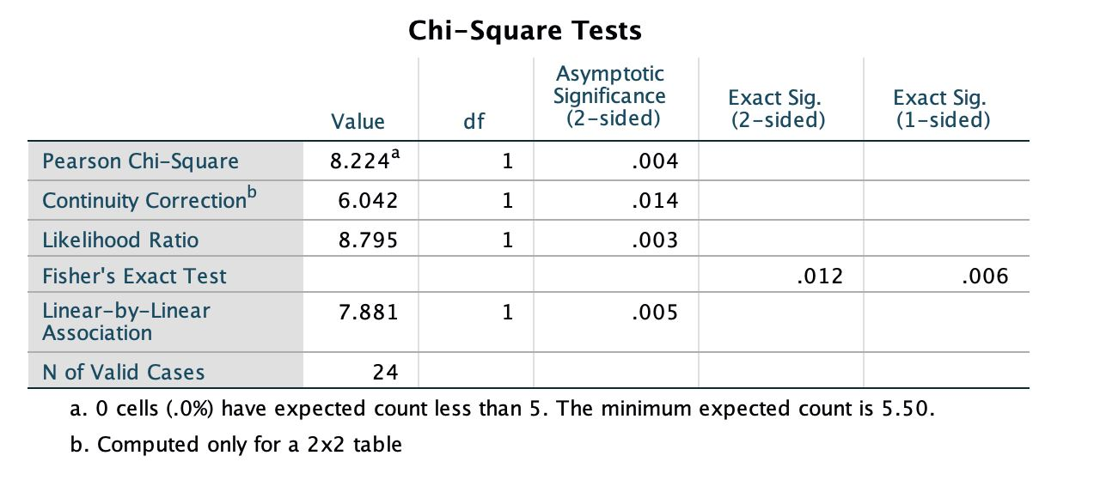
Table 2

Asymptomatic bacteriuria is frequent and a leading cause of urinary tract infections. This is because, under ideal circumstances, asymptomatic bacteriuria develops to symptomatic (clinical) UTI. Bacteria that colonize the urinary system can go to the bladder and cause cystitis, which is often accompanied with UTI symptoms like pain, frequency, and urgency. Bacteria from the urinary system can travel from the ureter to the kidneys, causing pyelonephritis, which can result in irreparable kidney damage, renal difficulties, and death. The prevalence of asymptomatic bacteriuria varies with age, gender, sexual activity, and the presence of genitourinary disorders. In healthy women, the prevalence of bacteriuria rises with age. Girls are affected more than women in the community.
This condition's exact pathogenesis has yet to be discovered. In this study, Escherichia coli was the most frequently isolated bacterial organism.
The second most common bacteria was Staphylococcus aureus. The identification of S. aureus as a uropathogen is not unique to our study. The most common bacterium found in patients with subclinical tuberculosis is The presence of white blood cells in urine, as well as the likelihood of pyuria, should not be taken as a guarantee of infection, as it may be missing in some cases. Yeast sp. was the most frequent bacterium in bacteriuria, unlike previous investigations in which E. coli was the most common. With current employment rates of occurrence. Furthermore, the pus cells collected from Candida sp. samples were discovered to be Candida sp. Asymptomatic bacteriuria treatment, on the other hand, has been proven to be effective. Antibiotics are used to treat asymptomatic bacteriuria.
Patients who are having urologic operations that are likely to induce mucosal bleeding, such as prostate surgery, as well as those who are in the first three months after a kidney transplant, should be treated. There is evidence that treating asymptomatic bacteriuria reduces the risk of a symptomatic urinary tract infection in these patients, and that early treatment has significant clinical advantages. Providing vital information on the best antibiotics to use to treat infections caused by these organisms. The most effective antibiotics for Gram negative and Gram positive pathogens were identified to be ciprofloxacin, gentamycin, and streptomycin.

Conclusion

The findings of this study have highlighted the need of include asymptomatic bacteriuria examination as part of a student's medical checkup. Bacteriuria without symptoms ASBU is particularly common in certain patient groups, and its prevalence rises with age. E. coli is the most prevalent etiological agent, and it is most common among female LIMU students. In addition, this study gives light on the most effective drugs for treating infections caused by these species.

References:

1 – Mcminn And Abrahams Clinical Atlas Of Human Anatomy Pdf 7th Edition - INFOLEARNERS
2- Shaikh, N., 2010. Acute urinary tract infection in infants and young children. Canadian Medical Association Journal, 182(8), pp.800-8013- robbins basic pathology
4- James P. Nataro, James B. Kaper. Diarrheagenic Escherichia coli. (1998)
5-ROPERT , W ,PhD.MICROBIOLOGY WITH DISEASES BY BODY SYSTEM
6- Fradet Y, Saad F, Aprikian A, Dessureault J, Elhilali M, Trudel C, Mâsse B, Piché L, Chypre C. uPM3, a new molecular urine test for the detection of prostate cancer. Urology. 2004 Aug
7-Vaidya VS, Ford GM, Waikar SS, Wang Y, Clement MB, Ramirez V, Glaab WE, Troth SP, Sistare FD, Prozialeck WC, Edwards JR. A rapid urine test for early detection of kidney injury. Kidney international. 2009 Jul
8- Zhanel G, Nicolle L, Harding G. Prevalence of Asymptomatic Bacteriuria and Associated Host Factors in Women with Diabetes Mellitus. Clinical Infectious Diseases. 1995;21(2):316-322. doi:10.1093/clinids/21.2.316.
9- Ho, P., Que, T., Chiu, S., Yung, R., Ng, T., Tsang, D., Seto, W. and Lau, Y., 2004. Fluoroquinolone and Other Antimicrobial Resistance in Invasive Pneumococci, Hong Kong, 1995–2001. Emerging Infectious Diseases, 10(7), pp.1250-1257.
10-Modarres, S. and Oskoii, N., 1997. Bacterial etiologic agents of urinary tract infection in children in the Islamic Republic of Iran. Eastern Mediterranean Health Journal, 3(2), pp.290-295.

