
Libyan International
Medical University

Report 1

By: 3rd year medical science
Name: …hassan nori………
Student name: …2166……..

Date of submission:

Abstract:
Pharmacodynamics is the study of a drug's molecular, biochemical, and physiological effects or actions. As our knowledge of medical medication toxicity and pharmacology advances, it is becoming more and more clear that men and women respond to pharmacological therapy differently. Women respond to occupational exposures differently than men do. This is due to of physiological changes in pharmacokinetic and pharmacodynamic, as well as changes in body size, surface area, total body water, extracellular water, and intracellular water.
Aim: this study established to investigat if there is gender difference on diuretics pharmodynamics

Introduction:
The study of a drug's molecular, biochemical, and physiological effects or activities is known as pharmacodynamics. Its root terms are "pharmakon," which means "drug," and "dynamikos," which means "power." All drugs work by interacting with biological targets or structures at the molecular level to alter the target molecule's functionality in relation to upcoming intermolecular interactions. These interactions include chemical interactions, receptor binding, and post-receptor consequences. Good example of these interactions include medications attaching to an enzyme's active site, medications interfering with cell surface signaling proteins to obstruct subsequent signaling, and medications acting via binding molecules like tumor necrosis factor. ⁽¹⁾ Gender is represented in terms of masculinity and femininity, whereas sex is the characteristic or feature that determines whether an organism is classed as female or male based on its reproductive organs and activities. It is heavily influenced by culture and refers to how individuals see themselves and how they expect others to act. Men and women respond to pharmacological therapy differently, as is becoming increasingly obvious as our understanding of medical drug toxicity and pharmacology grows. The way that females react to occupational exposures varies from how males do. This is the outcome of physiological variations in PK/PD as well as variations in body weight, length, surface area, total body water, extracellular and intracellular water. ⁽²⁾ A potent loop diuretic, furosemide is used to treat hypertension as well as oedematous conditions related to cardiac, renal, and hepatic failure. Apparently inconsistent systemic availability through the oral route and unexpected reactions to a given dosage usually make therapy more difficult. Furosemide is hypothesized to work at the luminal surface of the ascending limb of the loop of Henle by preventing the active reabsorption of chloride, although the precise role is still unknown. ⁽³⁾

Methods and material:
12 individuals Six males and six females were picked for the study. Each subject received a single dosage of furosemide on four different days following an overnight fast. The next day, sodium and potassium concentrations as well as the total volume of urine were measured.

Results:
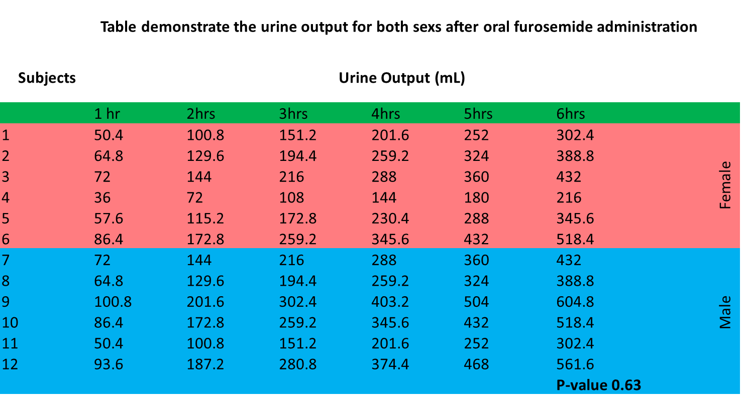
P-value greater than 0.05 therefore no statistically significant difference between male and female participants pharmacodynamics. Overall, the findings indicate that males produce urine at a somewhat greater pace than females.

Discussion:
The body's fluid and electrolyte balance influences how furosemide works when a specific dosage is administered. It has been shown that both acute and delayed tolerance occurs in both animals and humans, and it is thought that homeostatic processes that affect fluid and electrolyte balances are to blame. The non-specific organic acid pump is used to actively secrete furosemide to the site of action. When plasma furosemide concentrations, urinary excretion rates, and renal clearance were compared to the observed diuresis and saluresis, it was discovered that there were either no or weak correlations between those variables and plasma drug concentrations, but there were strong correlations between urine measurements. The drug concentration in urine, as opposed to plasma, determines the response. ⁽³⁾ Without these mechanisms, medications would constantly circulate through our systems, bind to numerous receptors, and interfere with critical physiological processes. Two processes, metabolism and elimination, are either individually or together responsible for drug inactivation. Drugs are typically removed from the body by the lungs, the liver, or the kidneys. Therefore, narcotics can be expelled from the body through feces and urine, but they can also do so through perspiration, tears, breast milk, expired air, and other means. Elimination depends on renal function. Through glomerular filtration, passive diffusion, and active secretion, chemicals can be eliminated into the urine. The rate at which a medication is eliminated by the kidneys will rise with increases in renal blood flow and glomerular filtration. Renal blood flow, glomerular filtration, tubular secretion, and tubular reabsorption are all greater in males than non-pregnant women when adjusted by body surface area. The primary organ for excreting drug metabolites or parent drug molecules is the kidney. All three of the main renal processes—glomerular filtration, tubular secretion, and tubular reabsorption—show documented sex differences. Men often have higher renal clearance than women. Women tend to be more susceptible to cortisol suppression and may also be more sensitive to the effects on basophils and helper T cells. There appear to be substantial sex variations in the pharmacodynamics of cortisol. This is intriguing since it suggests that men and women should get the same dosage and treatment regimen due to the balance in sex differences in both pharmacokinetics and pharmacodynamics.

Conclusion:
Our study shows no statistically significant gender difference on diuretics pharmodynamics. Specific medication pharmacokinetics and pharmacodynamics may vary between men and women. Understanding these sex-based variations in medication response is crucial because they might have an impact on drug safety and efficacy. Before treating women, doctors must set precise therapeutic goals for the medications of choice in order to reduce therapeutic adverse effects. It must be resolved if the efficacy of the therapy should be judged by clinical signs and symptoms or by the findings of laboratory tests. Additionally, it must be determined whether medication toxicity should be checked using clinical or laboratory methods, and for how long. One should also be familiar with and comprehend the clinical pharmacology principles as they relate to the medicine of choice.

References:

- Marino M, Jamal Z, Zito PM. Pharmacodynamics. [Updated 2022 Jan 11]. In: StatPearls [Internet]. Treasure Island (FL): StatPearls Publishing; 2022 Jan-. Available from: https://www.ncbi.nlm.nih.gov/books/NBK507791/
- Soldin OP, Mattison DR. Sex differences in pharmacokinetics and pharmacodynamics. Clin Pharmacokinet. 2009;48(3):143-157. doi:10.2165/00003088-200948030-00001
- Ponto LL, Schoenwald RD. Furosemide (frusemide). A pharmacokinetic/pharmacodynamic review (Part I). Clin Pharmacokinet. 1990;18(5):381-408. doi:10.2165/00003088-199018050-00004

