


The effect of gender on the action of Furosemide

Faculty of Applied medical sciences – LIMU
Somida Mohamed – 2429
Supervised by : Dr.Hwida khatab

12/06/2022

Abstract
Urinary incontinence is a mechanism of urine excretion from the bladder, controlling urination of the central nervous system located in the spinal cord, brain stem and cerebral cortex, first we take a sample of 12 individual 6 male and 6 female to perform. Urine dilution test, which included giving 1 liter of water and 40 mg of furosemide, the results of this study showed that furosemide was preferred by men over women, as shown by the average calculation of men and women. The exact cause of these differences is unknown, further studies should review the number of donors and the information associated with them, i.e. general health status, body weight and height. their own, to eliminate the dosage for each man and each woman separately and limit its side effects.

Introduction:
Urine is the body’s natural way of eliminating liquid waste. It is excreted via the urinary system which is composed of the kidneys, ureter, bladder, and urethra. Although the male and female urinary systems have similar parts, there are differences between the two :^{1,2}
Male Urinary System | Female Urinary System
Connected to the reproductive system | Not connected to the reproductive system
 | Transports urine
Urethra is 10 to 15 centimeters | Urethra is 3 to 4 centimeters
Passes the prostrate, internal and external sphincters, urogenital diaphragm, Cowper’s gland, and the entire length of the penis | Passes the neck of the bladder, internal and external sphincters, and urogenital diaphragm
Rarely has urinal infections | Urinal infections are common

Urinate: Urinating, also known as Urination, is the mechanism of urine excretion from the bladder, which controls the urination of the central nervous system located in the spinal cord, brain stem and cerebral cortex.³
Urine stored in the bladder Urine is waste and extra water that your kidneys filter from your blood. Urea is the name for waste products, your blood carries it to your kidneys and urine travels from your kidneys to your bladder through two small tubes called ureters. Urine is retained in the bladder until urination. It is round when full and shrinks when empty. If your urinary system is healthy, your bladder can comfortably hold up to 16 ounces of urine in 2-5 hours.³ Diuretics: come in many forms, but they all work by reducing the amount of fluid that is reabsorbed by the renal tubules, which then return the fluid to the bloodstream.⁴
Loop diuretics (furosemide / FUR / Lasix) block the sodium-potassium-chloride co-transporter in the thickened ascending loop of Henle in the kidney, causing diuresis. As a result, sodium, chloride, and potassium reabsorption is reduced or inhibited, leading to increased loss of sodium, chloride, and potassium from the nephron.
As a result, water is drawn into the nephron, increasing urine volume. Loop diuretics also inhibit calcium and magnesium reabsorption. Edema associated with heart failure, liver disorder, or kidney disease, they can also be used to treat high blood pressure. The FUR water pill prevents your body from absorbing too much salt. This allows salt to pass through the urine, instead of water . FUR is used to treat fluid retention (edema) in patients with congestive heart failure, liver disease, or kidney disease such as nephrotic syndrome. FUS is also used to treat high blood pressure (hypertension).⁴
Hypothesis: In this study, we will see if men and women respond differently to FUS

.Material :
A urine sample will be taken from 12 males and 6 females, and a test will be conducted with 1 liter of water and 40 grams of furosemide. There is a Every hour, urine samples are taken. You need to drain at least 750 liters of urine. There is a It was used for statistical analysis. It was not statistically significant
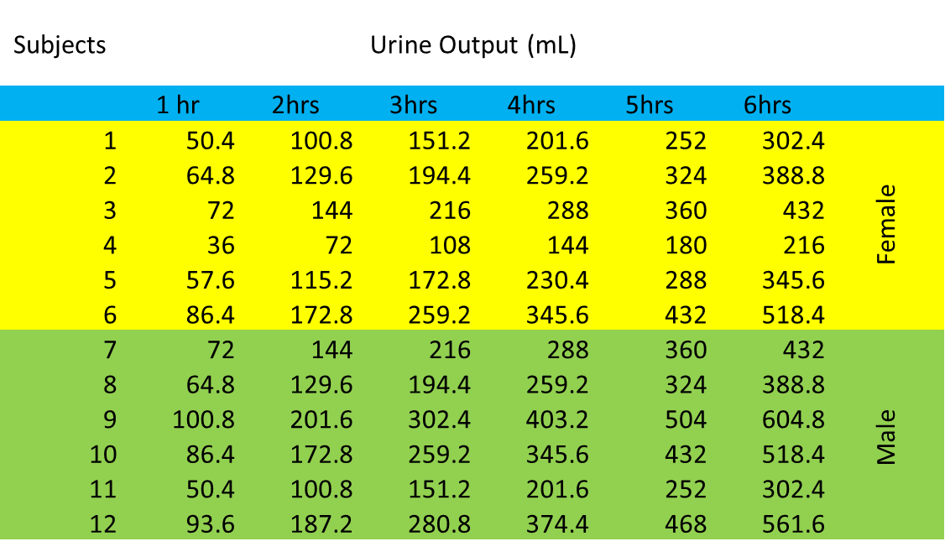

Result and discussion
Females in typically had higher urine output due to much higher levels of water consumption, as previously discussed in the introduction, but in this case both genders were given the same quantity of water so the results would be fair.
After six hours of taking urine samples hourly, the sixth hour sample revealed significant differences towards the male side of the process, revealing that men had significantly higher urinary output and higher mean calculations. It should be noted, however, that these calculations were performed on only 12 people, so the results are not conclusive for all mankind.

Conclusion
According to the results of this study, furosemide was more effective in men than in women after calculating the mean.
The results of this study show that furosemide is preferred by men to women, as shown by calculating the mean values ​​of men and women. The exact cause of these differences is unknown, but may be due to the male receptors that furosemide acts on more than the female receptors.⁵
Average hourly urine sample
Also, the P value is 0.142, so it's more like 0.05 which means it's insignificant.
In another study,
people took furosemide orally and IV to 6 women and 6 men, no difference in outcomes was noted, but when furosemide was given based on body weight, men did. more different in women.⁶

References
1.DIFFERENCE BETWEEN MALE AND FEMALE URINARY SYSTEM. (2015, May 25). Theydiffer. Retrieved May 25, 2015, from https://theydiffer.com/difference-between-male-and-female-urinary-system/
2.Zhang B, Li Q, Shi C, Zhang X. Drug-Induced Pseudoallergy: A Review of the Causes and Mechanisms. Pharmacology. 2018;101(1-2):104-110. doi:10.1159/000479878

3.Encyclopædia Britannica, inc. (n.d.). Defecation. Encyclopædia Britannica. Retrieved June 20, 2022, from https://www.britannica.com/science/defecation-physiology

4 “Diuretics in the Treatment of Hypertension.” Physiopedia, https://www.physio-pedia.com/Diuretics_in_the_Treatment_of_Hypertension.
5.Y. Yoshimura, F.schmidt*, Rx. Ni, S. Kneesel, CE. Constantinou. https://www.ics.org/Abstracts/Publish/37/000291.pdf.

6. AH;, Franson KL;Kuk JM;Lam NP;Lau. “Gender Effect on Diuretic Response to Hydrochlorothiazide and Furosemide.” International Journal of Clinical Pharmacology and Therapeutics, U.S. National Library of Medicine, https://pubmed.ncbi.nlm.nih.gov/8705087/.

