

Asymptomatic bacteriuria in LIMU students

Libyan International Medical University
Faculty of Applied Medical Science

Laila Tuwahni
2451
Supervised by: Dr. Khadija Mansour
Assistant by: Dr. Ahmed Jebani

Abstract:

Urinary tract infections (UTIs) are a frequent infection that affects nearly three times as many women as they do men. One end of the urinary tract leads to the waste orifice, while the other leads to the bladder. This indicates that the urinary tract is inundated with microorganisms. When the wrong sort of bacteria enters the body from the wrong end of the gastrointestinal tract, the problem emerges. The shorter female urethra permits germs from the urethral meatus and perineum to travel a shorter distance to the bladder, making asymptomatic bacteriuria more common in women than in men. The most prevalent bacterium recovered from patients with asymptomatic bacteriuria is Escherichia coli. Infections can be caused by a variety of bacteria. Enterobacteriaceae, Pseudomonas aeruginosa, Enterococcus species, and group B streptococcus are among them.
Introduction:

When fecal bacteria enters the urethra, the tube that which the urine is discharged from the bladder will lead to an a urinary tract infection. Bacteria transmitted through sexual contact can potentially enter the urethra and cause illness.
Urinary tract infections are classified into three kinds.⁽¹⁾ The first is urethritis, which is an inflammation of the urethra. ⁽¹⁾ Cystitis occurs when an infection travels from the urethra to the bladder. These are the most common and readily treated diseases, however an infection can migrate from the bladder to the kidneys. ⁽¹⁾ The kidneys filter waste from the blood and send it to the bladder for collection. ⁽¹⁾ Finally, it could lead to an a kidney infection is even more dangerous and uncommon .⁽¹⁾
Urinary tract infections are classified different in pregnancy , it could be classified into two categories which are asymptomatic or symptomatic. Asymptomatic bacteriuria is defined as the presence of significant bacteriuria without the symptoms of an acute urinary tract infection .⁽³⁾ Symptomatic urinary tract infections are divided into lower tract (acute cystitis) or upper tract (acute pyelonephritis) infections. ⁽³⁾
Escherichia coli is the most common microorganism isolated from patients with asymptomatic bacteriuria. Urinary tract infections could be caused by many types of bateria. Some of these include Enterobacteriaceae, Pseudomonas aeruginosa, Enterococcus species, and group B streptococcus. ⁽²⁾ In clinical practice, asymptomatic bacteriuria is very common, and its prevalence rises with age. The incidence is 15% or higher in women and men aged 65 to 80 years, and it can reach 40% to 50% after age 80.⁽³⁾ Most patients with asymptomatic bacteriuria will never develop symptomatic urinary tract infections and will suffer no negative consequences as a result of their condition. ⁽³⁾ The cause of asymptomatic bacteriuria has not been determined conclusively. Only patients with asymptomatic bacteriuria who will benefit from treatment should be treated, most patients will not.⁽⁴⁾ However, there are a few exceptions. A pregnant woman with asymptomatic bacteriuria should be treated, according to the evidence. Patients undergoing urologic procedures,where mucosal bleeding is expected, as well as those in the first three months after a kidney transplant, should be treated for asymptomatic bacteriuria.

Materials and methods:
This study's samples include 24 volunteers, 12 male and 12 female. Questionnaire bio data for the participants include name, gender, age, parents' occupation, number of brothers and sisters, and UTI history. A chi-square statistic test was performed in this study to investigate how a model compares, and the SPSS version software program was used for data administration and statistical analysis. inspection of the body: The appearance of the urine sample from the patient is normally clear cloudiness or an unusual odor may suggest a problem such as an infection. Blood in the urine will be shown as red or brown. What you've recently eaten can affect the color of your urine. Dipstick is a thin plastic stick with chemical strips. Then, it is placed in the urine to detect any abnormalities, the way of knowing this is when the chemical strips change colors. A microscope was used to examine the sample. If any of the following are detected, such as white blood cells or red blood cells, as well as bacteria or yeasts casting crystals, create a culture media.
Results and statistical analysis:

Chi-Square Tests
 | Value | df | Asymptotic Significance (2-sided) | Monte Carlo Sig. (2-sided) |  |  | Monte Carlo Sig. (1-sided)
 |  |  |  | Significance | 99% Confidence Interval |  | Significance | 99% Confidence Interval
 |  |  |  |  | Lower Bound | Upper Bound | Significance | Lower Bound | Upper Bound
Pearson Chi-Square | 8.727ª | 2 | .013 | .018^{b} | .014 | .021
Likelihood Ratio | 9.949 | 2 | .007 | .012^{b} | .009 | .015
Fisher's Exact Test | 8.180 |  |  | .018^{b} | .014 | .021
Linear-by-Linear Association | 8.065^{c} | 1 | .005 | .006^{b} | .004 | .008 | .004^{b} | .003 | .006
N of Valid Cases | 24
a. 2 cells (33.3%) have expected count less than 5. The minimum expected count is 1.00.
b. Based on 10000 sampled tables with starting seed 2000000.
c. The standardized statistic is -2.840.
Table 1

CFUcat * Gender Crosstabulation
 |  |  | Gender |  | Total
 |  |  | Female | Male | Total
CFUcat | No growth | Count | 2 | 9 | 11
CFUcat | No growth | Expected Count | 5.5 | 5.5 | 11.0
CFUcat | No growth | % within Gender | 16.7% | 75.0% | 45.8%
CFUcat | Overall no significant growth | Count | 8 | 3 | 11
CFUcat | Overall no significant growth | Expected Count | 5.5 | 5.5 | 11.0
CFUcat | Overall no significant growth | % within Gender | 66.7% | 25.0% | 45.8%
CFUcat | Significant growth | Count | 2 | 0 | 2
CFUcat | Significant growth | Expected Count | 1.0 | 1.0 | 2.0
CFUcat | Significant growth | % within Gender | 16.7% | 0.0% | 8.3%
Total |  | Count | 12 | 12 | 24
 |  | Expected Count | 12.0 | 12.0 | 24.0
 |  | % within Gender | 100.0% | 100.0% | 100.0%

Case Processing Summary
 | Cases
 | Valid |  | Missing |  | Total
 | N | Percent | N | Percent | N | Percent
CFUcat * Gender | 24 | 64.9% | 13 | 35.1% | 37 | 100.0%

Table 2: correlation between gender and ABU expressed using percentages

Table 3: summary of case

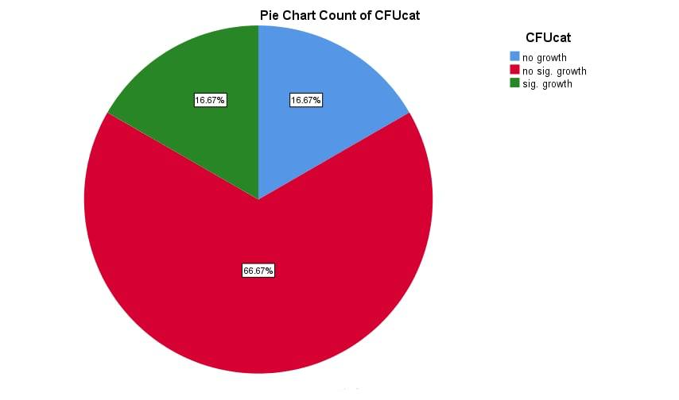

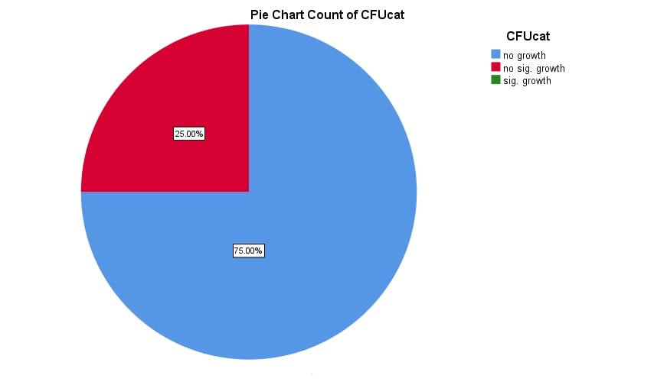

Discussion:

Urinary tract infections are a common type of infection, and women are about three times more likely to get them than men are. ⁽¹⁾ The urinary tract has two ends - one goes to the waste orifice, and the other goes to the bladder. This means that the urinary tract sees a lot of bacteria. The problem arises when the wrong type of bacteria enters the body from the wrong end of the tract. Asymptomatic bacteriuria is more common in women than in men, most likely due to the shorter female urethra, which allows bacteria from the urethral meatus and perineum to travel a shorter distance to the bladder. ⁽²⁾ So, in this experiment we can see that our null hypothesis is rejected because the most prominent into getting infections are females. The P value is 0.019 so its less than 0.5 that plays an important role because it gives us the evidence that leads us to this result.
The infection's prevalence among children and the elderly is unknown and is currently being researched. Although bacteria are the primary cause of infection in humans, the role of certain fungi and viruses cannot be overlooked. However, UTI caused by a viral or fungal infection is thought to be a rare occurrence. Though the infection appears to be harmless in the early stages, the patient develops a variety of symptoms as the stage progresses, which can result in death in severe case. According to research, urinary tract infection is the most common type of bacterial infection. ⁽⁴⁾ Urinary tract infection is also the most common hospital acquired infection and can be caused by poor diagnosis. The infection encompasses a wide range of clinical syndromes and diseases that differ in epidemiology, etiology, location, and severity. In addition to the factors listed above, it varies in terms of expressed local symptoms, frequency of recurrence, extent of damage caused, the presence of complicating factors, and the risk of recurrence. ⁽²⁾ The occurrence of bladder infection is usually followed by kidney infection, which results in blood borne infection and, in severe cases, can lead to death. As a result, UTI is capable of claiming lives under extreme conditions, and proper treatment results in rapid recovery from the contagion. The infection appears between the sixth and twenty-fourth weeks of pregnancy.

Conclusion and future directions:
In this report we discussed how females are projected into getting urinary tract infections more than males. We listed the reason why according to the urethra, pregnancy, and other infections that could lead to it for an example. There are some ways of preventing these infections from occurring in the beginning and there are some ways to prevent it from getting worse. Urinary tract infections could be classified into two types of bacteriuria, it could be asymptomatic or symptomatic. The most common cause of causing urinary tract infections is E.coli. Urinary tract infections if not treated could lead to severe diseases that could be hard to treat so that’s why we need to treat it right away.

References
1. Goecker L, Rakshit D, Rakshit D, Naraharisetty R, Naraharisetty R. Why Women Are More Prone to Urinary Tract Infections Than Men. The Swaddle. https://theswaddle.com/why-are-women-more-prone-to-utis-than-men/. Published 2022. Accessed June 19, 2022.

2. Flores-Mireles AL, Walker JN, Caparon M, Hultgren SJ. Urinary tract infections: epidemiology, mechanisms of infection and treatment options. Nat Rev Microbiol. 2015;13(5):269-284. doi:10.1038/nrmicro3432

3. Givler D, Givler A. Asymptomatic Bacteriuria. Ncbi.nlm.nih.gov. https://www.ncbi.nlm.nih.gov/books/NBK441848/. Published 2022. Accessed June 19, 2022.

4. COLGAN R, NICOLLE L, MCGLONE A, HOOTON T. Asymptomatic Bacteriuria in Adults. Aafp.org. https://www.aafp.org/pubs/afp/issues/2006/0915/p985.html. Published 2022. Accessed June 19, 2022.

