


The effect of gender differences on diuretic pharmacodynamics: (furosemide (Lasix)

Student name : Raja Rajab
Student number : 2388
Supervised by: Dr.Hwuaida Khattab, Dr.Basma Elgatany
Assistant by: Mr.Ahmed Gaibani, Dr.Alsenussi Alsharif
Libyan International Medical University
Faculty of Applied Medical Sciences

Abstract
The average daily urine volume is 1L, The same load of solute can be excreted per 24 hours in a urine volume of 500ml. Normal urine output is 1-2 ml/kg/hr. Furosemide is a potent, short-acting diuretic (Loop Diuretics), and produces a natriuretic response in a 24-hour period. In these experiments, male and female groups experimental groups were used in these experiments, and they were given 40mg/kg of furosemide to quantify urine output after hours. Male subjects showed a greater peak sodium excretion rate than female subjects after treatment with oral and intravenous furosemide. There was no significant difference in urine flow rate, salt and potassium excretion rates between male and female individuals across treatments for natriuretic response.

Introduction

The volume of urine generated per unit of time is referred to as urine volume. Normally, 180 liters of fluid are filtered through the glomeruli each day, while the average daily urine volume is about 1 liter. The same load of solute can be excreted per 24 hours in a urine volume of 500 ml with a concentration of 1400 mosm/kg or in a volume of 23. 3 l with a concentration of 30 mosm/kg.^{1(P713)} Normal urine output is 1-2 ml/kg/hr.² To determine the urine output of your patient , you need to know their weight, the volume of urine produced, as well as the time it took them to generate it. If feasible, urine production should be monitored every four hours. Inadequate fluid intake, dehydration, renal insufficiency, and renal failure are all possible causes of unusually low urine volume (oliguria 400 mL/day). Diabetes, renal diabetes insipidus, central diabetes insipidus, and some forms of kidney failure can all be caused by an abnormally high urine volume (polyuria 2.5 L/day). unusually high fluid intake, diuretic medication use

Furosemide is a potent, short-acting (Loop Diuretics), It is often called a "high-ceiling diuretic" because it is more effective than other diuretics.⁵ They inhibit sodium reabsorption in thick ascending loop of Henle . they cause a marked natriuresis and kaliuresis.^{3,4}

Furosemide increases prostaglandin production (e.g., PGI₂), which increases renal blood flow.⁵ Synthesis of prostaglandins may also cause vasodilation in their tissues.
Commonly used to treat sever edematous conditions, congestive heart failure, cirrhosis of the liver, Hypercalcemia , Emergency HTN ,Acute Pulmonary oedema.

Side effect of furosemide including : Hypokalaemia, Hyponatremia, Hypocalcaemia, Hypomagnesaemia ,Alkalosis ,Reduce UA secretion ,Hyperglycaemia, Increase Cholesterol , Hypersensitivity ,Ototoxicity.
Historically, there has been a scarcity of data on female pharmacokinetics and the likelihood of gender differences in the correlations between dose and efficacy or dose and adverse drug reactions.Sex alters the pharmacokinetics of organic anions, according to research conducted recently in our lab As a result of their poorer renal clearance.

Materials and methods
Physical features of urine analysis are examined: volume, color, odor, pH, and specific gravity. we had an experiment to measure urine volume.
Two experimental groups were employed for these studies; 6 male and 6 female.
First, we took a random specimen sample of different gender, random specimen sample also used in chemical examination, In these experimental conditions, it is necessary to wash your hands, and wear gloves, Label a sterile, screw-top container with your name, date of birth and the date in a different gender.
We also took the weight and measured blood pressure for all subjects, Then they were administered 40mg/kg of furosemide for all subjects, and we took a measure of urine output every hour.
Furosemide was used in the urine dilution test because it inhibits chloride and potassium reabsorption from tubules. These ions are then held in the renal tubule before being delivered to the distal nephron. Dilute urine is produced because water is retained in the tubule when it reaches the distal tubule.

In addition, we used SPSS statistics in the analysis of urine output results in order to get super granular in the most complex data and draw informed conclusions.

Results and statistical analysis

After administration of furosemide In both groups, male and female normal volunteers led to inhibited electrolyte reabsorption from the kidneys and enhanced excretion of water from the body. It can lead to very low amounts of water and electrolytes in your body (such as potassium and sodium). This can cause dehydration. Furosemide is secreted in the proximal tubules and is delivered to its site of action in the thick assenting limp of the loop of henle by the tubule fluid. Because FUR is not reabsorbed in nephron segments.
Furosemide decreased body weight by 1.51 and 0.36 kg (p.001). The difference in extracellular volume and intracellular volume from the baseline ratio was reduced after furosemide administration.

Group Statistic
 | Gender | N | Mean | Std. Deviation | Std. Error Mean
UrineValume | female | 6 | 367.2000 | 104.93244 | 42.83849
UrineValume | male | 6 | 468.0000 | 114.02400 | 46.55010

Table 1: The group statistics of urine output among after 6 hrs. of adult and genders.
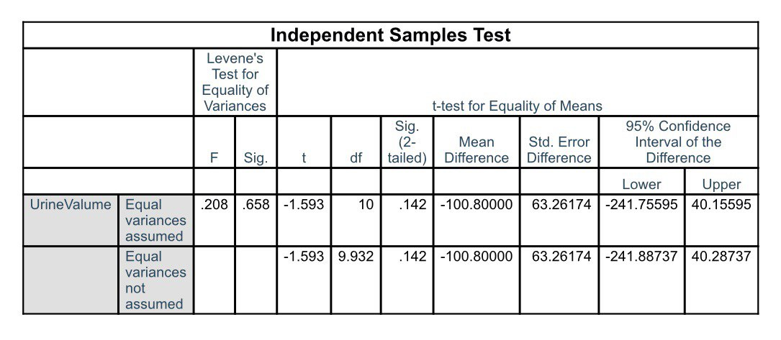Table 2: Independent T sample test of urine out put.

Statistical analysis was performed using the t test (Table 1,2), and the result from these tests (P< 0.05) means there was no significant difference found between male and female in urine output after Lasix consumption. Actually, there was a difference clinically, not
because the amount of sample is small.

Discussion

For medications with limited or vast therapeutic ranges, pharmacodynamics variations might be clinically meaningful.

Furosemide lead to change in urine output in different gender, but no significant different , For example, in female sample 1, the urine output was 50.4ml after 1 hour, 201.6ml after 4 hours, and 302.4ml after 6 hours, as shown by our analysis of sample 5 in the male.

Furosemide decreased GFR from 1.17 to 1.00 mL min-1 in the entire kidney. The flow of urine increased from 0.6 to 17% of GFR. 7 While the arterial blood pressure started to fall, the hematocrit (about 0.48) and plasma protein content (roughly 55 mg mL-1) were maintained.

Pharmacokinetics of furosemide in humans
In healthy subjects, the bioavailability of furosemide ranges from 60 to 69%, but in end-stage renal failure its availability is reduced to 43–46%. Early findings claim that eating has little effect on bioavailability, albeit the rate of absorption is slowed. In a recent study, however, a reduction of approximately 30% in bioavailability, accompanied by a reduced diuretic effect, was observed when furosemide was given at 40 mg to ten healthy volunteers with breakfast as compared to when it was given in the fasting state.⁶
About 99% of furosemide is bound to plasma proteins, almost exclusively to albumin.
Two-compartment models are most often used to describe the kinetics of furosemide. The half-time of the first phase averages 10–15 min and that of the second phase, 47–90 min. The apparent volume of distribution at steady state is approximately 190 ml/kg. The plasma clearance of furosemide is 2.2–3.0 mL/min per kg. A higher non-renal clearance ratio is seen after oral dosing (15.7 ± 4.8%) than after intravenous administration (11.2 ± 4.0%)
In humans, the sole well-documented metabolite of furosemide is glucuronide conjugate.
About 20% of furosemide is eliminated by renal glucuronidation. It has been suggested that the remaining 25–30% may be secreted into the gut in unchanged and/or conjugated form. Liver disease may prolong plasma half-time by up to 4.3 h, depending on the degree of liver failure.

Experimental systems

Absorption, distribution, excretion, and metabolism
About 50% of the dose was absorbed after oral administration of furosemide to dogs . In one study in male Sprague-Dawley rats, the bioavailability of oral furosemide was estimated to be 30%.
In rats, furosemide is cleared from the plasma by the kidneys, is bio transformed by the liver, or is excreted unchanged in the bile, with subsequent intestinal reabsorption. The apparent metabolism per gram of tissue was greater in the stomach than in the small intestine, large intestine, or liver.
Carcinogenicity studies in animals
For 104 weeks, 50 mice were fed furosemide (99% pure, USP grade) at 0, 700, or 1400 mg/kg of diet. Survival in high-dose females was significantly lower than that in controls (p = 0.003). Female mice had a small but statistically significant increase in the incidence of mammary gland carcinomas.⁷
For 104 weeks, 50 rats were fed furosemide (99% pure; USP grade) at 0, 350, or 700 mg/kg of diet. No statistically significant increase in the incidence of tumors at any site was reported. In males, meningioma of the brain was observed in 3/50 low-dose rats versus 2/1928 in historical controls. ⁷

Conclusion

Gender variations in drug disposition and responsiveness to therapeutic treatments have been demonstrated. In 6 male and 6 female normal volunteers, we assessed the diuretic response of oral and intravenous furosemide. On four successive days after fasting overnight, each patient received single doses of the various diuretics or no therapy. Over the next 24 hours, total urine production was collected for volume measurement and salt and potassium content testing. There was no statistically significant difference in urine flow rate, salt, o potassium excretion rates between male and female individuals across treatments. When natriuretic response was corrected for mg/kg of intravenous furosemide dosage, male individuals showed a greater peak sodium excretion rate than female subjects.
There was no study on humans, but in animal models such as dogs, mice, and rate, Sodium, potassium, and water fractional excretions were comparable In the absence of FUR, male and female rats' when expressed in fractional terms, the natriuretic, kaliuretic, and diuretic responses to FUR were dramatically elevated. female rats had greater diuretic, natriuretic, and kaliuretic efficiencies than male rats.

References
- Ganong WF. Review of Medical Physiology. Twenty second ed. Boston: McGraw-Hill; 2005.

- Urine output. Centers for Disease Control and Prevention. https://www.cdc.gov/dengue/training/cme/ccm/page57297.html. Accessed June 20, 2022.

- Huang X, Dorhout Mees E, Vos P, Hamza S, Braam B. Everything we always wanted to know about furosemide but were afraid to ask. American Journal of

- Omudhome Ogbru PD. Furosemide (LASIX): Diuretic uses, Side Effects & Dosage. MedicineNet. https://www.medicinenet.com/furosemide/article.htm. Published December 2, 2019. Accessed June 20, 2022.Physiology-Renal Physiology. 2016;310(10). doi:10.1152/ajprenal.00476.2015

- Furosemide. Furosemide - an overview | ScienceDirect Topics. https://www.sciencedirect.com/topics/agricultural-and-biological-sciences/furosemide#:~:text=Pharmacology%20and%20mechanism%20of%20action&text=Furosemide%20decreases%20the%20sodium%2C%. Accessed June 20, 2022.

- Furosemide (Lasix): Davis's Drug Guide. Furosemide (Lasix) | Davis's Drug Guide. https://nursing.unboundmedicine.com/nursingcentral/view/Davis-Drug-Guide/51345/all/furosemide. Accessed June 20, 2022.

- HE; TOW. Effect of furosemide on local and zonal glomerular filtration rate in the rat kidney. Acta physiologica Scandinavica. https://pubmed.ncbi.nlm.nih.gov/8553883/#:~:text=Furosemide%20reduced%20whole%20kidney%20GFR,0.6%20to%2017%25%20of%20GFR. Accessed June 20, 2022.

