

The Prevalence of Asymptomatic Bacteriuria Between the Male and Female Gender

- Student Name: Mohamed Masoud Tuhami
- Group : A2

- Doctor’s Supervisor Name :
Huwida Khattab

- Assistant by :
Mr. ahmad elgebany

Abstract
A urinary tract infection also known as (UTI) , happens when a bacterium, often from the skin or rectum, enter the urethra and infect the urinary tract. . Symptoms typical of a Urinary Tract Infection are urinary frequency or urgency, dysuria, new onset hematuria, suprapubic pain, costovertebral tenderness or fever. Patients with a urinary catheter in place may have more vague symptoms such as new onset or worsening fever, chills, pelvic discomfort, acute hematuria and altered mental status with no other identifiable etiology. Asymptomatic bacteriuria is another type of UTI that isn’t presented with the typical symptoms of a UTI as the name suggests, and multiple studies have evaluated the prevalence of that type of UTI between different individuals in the population so this report is going to mainly focus on the prevalence of Asymptomatic Bacteriuria in the male and female gender.

Introduction:
A urinary tract infection also known as (UTI) , happens when a bacterium, often from the skin or rectum, enter the urethra and infect the urinary tract. It is an infection that occurs in any part of your urinary system, that can happen in different parts of your urinary tract. Each type has a different name, based on where it is located:
- Cystitis is inflammation of the (bladder)
- Pyelonephritis is inflammation of the (kidneys)
- Urethritis is inflammation of the (urethra)
Asymptomatic bacteriuria is another type of UTI, which is going to be our main focus in this paper.
Asymptomatic bacteriuria occurs in a small number of healthy people.
It affects women more often than men for the reasons mentioned above, the reasons for the lack of symptoms are not well understood. ⁽¹⁾

Diagnosis of asymptomatic bacteriuria is made by urine culture. Either a properly collected clean-catch specimen or a catheterized specimen is acceptable. The Infectious Diseases Society of America (IDSA) has established criteria for diagnosing asymptomatic bacteriuria. ⁽²⁾
for the sake of this report, we will look at different samples acquired from both the male and female gender:

Midstream clean catch urine specimen:
- For women, two consecutive specimens with isolation of the same bacteria species with at least 100,000 colony-forming units (CFUs) per ml of urine.
- For men, a single specimen with isolation of one bacteria species with at least 100,000 CFUs per ml of urine.

Catheterized specimen:
- For women or men, a single specimen with isolation of one bacteria species with at least 100 CFUs per ml of urine.

In the elderly, it is thought that incomplete bladder emptying contributes to the increased incidence of asymptomatic bacteriuria
Most patients with asymptomatic bacteriuria will never develop symptomatic urinary tract infections and will have no adverse consequences from asymptomatic bacteriuria. Only exception where patients with asymptomatic bacteriuria should be treated are pregnant women and patients undergoing urologic procedures. Other non-predisposed patients will not benefit from treatment. ⁽³⁾

Materials and Methods
• Sample
• Wire loop 0.001mL
• Blood and MacConkey agar
• Flame
• Incubator
The anticipate results are E. coli positive, as it is the most common cause of UTI in today’s society.
When collecting the sample, the patient needs to be aware that it can be contaminated by the normal flora in the urethra, for precaution the sample is collected mid-stream.
The sample preferably is collected in the morning due to the high concentration of urine
The culture can be done in a matter of an hour from collection of the sample, but the sample can last for as long as 18 hours in a specific temperature which is 4C because urine is a good media.

The difference in results between the symptomatic and the asymptomatic patient is that the symptomatic 1000ml is enough, but the asymptomatic 100,000ml for bacterial growth
Lastly after the sample has been collected, we need to make the culture by taking the wire loop and streak the culture and leave it in the incubator
Afterwards colonies from different cultures are compared with each other.
The clony forming unit (CFU) is multiplied by 1000(0.001 ml loop used) or by 100 (0.01 ml loopused) to end up with the number of microorganisms.

Results
After performing the previous steps, the results appear to be as following:
• For males: three non-significant, nine of which there was no growth and non-significant growth
• For females: due to the higher incidence as we previously discussed they had two of which had growth, eight of which non-significant growth, lastly 2 without any growth these results are of significant nature and will be discussed later on.
These results were shown to be significant statistically using the chi square with a p-value of .013

Our working Hypothesis is as follows:
H0: no association between gender and asymptomatic bacteriuria
Ha: there is an association between gender and asymptomatic bacteriuria
Assumptions: random and Independence samples were collected
• Random as the name states random samples have been collected from population
• Independent monitoring them from each other

Sample Size:
• No more than 20% of the cells have expected count < 5
• The expected frequency (count) in each cell must be ≥1
Nonetheless; the assumptions were not met as two cells (33.3%) have expected count less than 5, The minimum expected count is 1.00
and a Fisher’ Exact Test had to be done
the null hypothesis (FTR) was turned down
because P-value less than alpha 0.05, we reject the null hypothesis

Chi-Square Tests ⁽³⁾ | Value | df | Asymptotic Significance (2-sided) |  |  |  | Monte Carlo Sig. (1-sided)
 |  |  |  | Significance | 99% Confidence Interval |  | Significance | 99% Confidence Interval
 |  |  |  |  | Lower Bound | Upper Bound | Significance | Lower Bound | Upper Bound
Pearson Chi-Square | 8.727ª | 2 | .013 | .018^{b} | .014 | .021
Likelihood Ratio | 9.949 | 2 | .007 | .012^{b} | .009 | .015
Fisher's Exact Test | 8.180 |  |  | .018^{b} | .014 | .021
Linear-by-Linear Association | 8.065^{c} | 1 | .005 | .006^{b} | .004 | .008 | .004^{b} | .003 | .006
N of Valid Cases | 24
a. 2 cells (33.3%) have expected count less than 5. The minimum expected count is 1.00.
b. Based on 10000 sampled tables with starting seed 2000000.
c. The standardized statistic is -2.840.

Discussion
The results showed that the female gender is more prone to getting asymptomatic bacteriuria than the male gender, with 16.6 percent of the overall 12 women showing substantial growth, compared to 0 percent of the 12 men. This is important in validating our initial premise that females have a higher rate of urinary tract infections because of the anatomical architecture of their urinary system.
On urinalysis, bacteria are routinely detected and cultured from urine samples. Bacteria in the urine could suggest one of three conditions: 1) asymptomatic bacteriuria; 2) specimen contamination; or 3) urinary tract infection (UTI) (ASBU). These three conditions must all be addressed when determining the clinical importance of a urine culture, and classification should be based on history and exam findings as well as urine findings. Contamination of specimens should always be considered, as it is widespread, especially in female patients. A high number of squamous cells on the urine (>20) indicates contamination, and the culture results should be ignored in most cases.
On urinalysis, bacteria are routinely detected and cultured from urine samples. Bacteria in the urine could suggest one of three conditions: 1) asymptomatic bacteriuria; 2) specimen contamination; or 3) urinary tract infection (UTI) (ASBU). These three conditions must all be addressed when determining the clinical importance of a urine culture, and classification should be based on history and exam findings as well as urine findings. Contamination of specimens should always be considered, as it is widespread, especially in female patients. A high number of squamous cells on the urine (>20) indicates contamination, and the culture results should be ignored in most cases.

Only if the bacteriuria has an associated unfavorable consequence (such as the development of a symptomatic urinary tract infection, bacteremia, progression to chronic kidney disease, etc.) that can be averted by antimicrobial medication can ASBU patients be screened and treated. These criteria are obviously met in only two clinical scenarios. Pregnant women should be evaluated and treated for ASBU because they have a higher risk of developing pyelonephritis, having a premature birth, and giving birth to a low-birth-weight baby. Patients should be tested for bacteriuria before to transurethral resection of the prostate (TURP) or any other urologic treatment with a risk of mucosal bleeding, since it has been linked to a significant increase in the risk of post-procedure bacteremia and sepsis.
Treatment of ASBU in both these situations has been demonstrated to prevent these complications. (1)

Table 1 summarizes the prevalence of asymptomatic bacteriuria in selected populations ⁽¹⁾
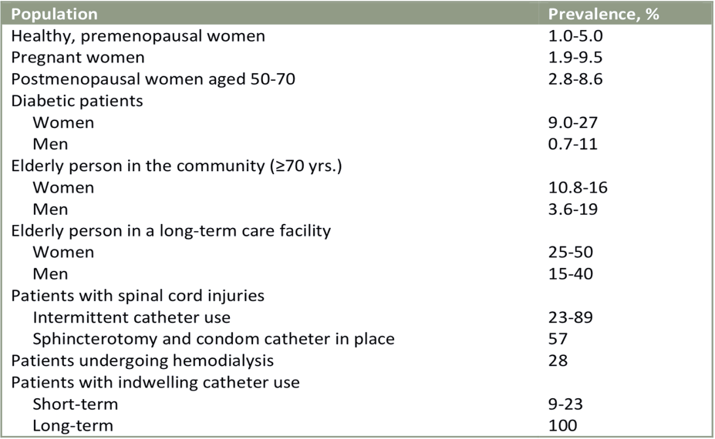

Unfortunately, many ASBU patients are given treatment that does not help them and may even hurt them. Unnecessary treatment of ASBU can result in antibiotic resistance, severe medication reactions, and C. difficile infection, as well as increase medical expenses.
For asymptomatic bacteriuria, who should be screened and treated:
    - Women who are expecting a child or are already expecting a child (at least once in early pregnancy)
    - Patients who are scheduled for a urologic surgery that would result in mucosal bleeding (i.e., TURP Transurethral resection of the prostate, etc.)
    - Patients who have had a kidney transplant are a category for which there is insufficient information to make a recommendation.

Conclusion
This study was conducted solely to demonstrate that, due to differences in the structure of their urinary tracts, females are more likely than males to get UTIs (in this case, asymptomatic bacteriuria). Not taking into account those people who may be predisposed to contracting similar infections. And, as the findings revealed, females are more likely than males to develop a UTI, particularly the asymptomatic variant of Bacteriuria, highlighting the necessity of raising public awareness and doing more research with larger sample sizes.
Asymptomatic bacteriuria is more common in specific patient populations, and its incidence rises with age; it's also linked to sexual activity in young women; and patients with impaired urine voiding or indwelling urinary devices have a considerably higher risk of developing it. It's also crucial to understand when a urine culture should be ordered and how to collect samples correctly for good findings.

References

- Unmc.edu. https://www.unmc.edu/intmed/divisions/id/asp/clinical-pathways/docs/uti-asbu-guidance-final.pdf. Published 2022. Accessed June 19, 2022.

- Gupta K, Hooton T, Naber K, Wullt B, Colgan R, Miller L, Moran G, Nicolle L, Raz R, Schaeffer A, Soper D. International Clinical Practice Guidelines for the Treatment of Acute Uncomplicated Cystitis and Pyelonephritis in Women: A 2010 Update by the Infectious Diseases Society of America and the European Society for Microbiology and Infectious Diseases. Clin Infect Dis.

- Nicolle L, Bradley S, Colgan R, Rice J, Schaeffer A, Hooton T. Infectious Diseases Society of America Guidelines for the diagnosis and treatment of asymptomatic bacteriuria in adults.

