Project management assignment
Fatima Alzhra Eqab Alsanoosi 2573
1-Develop a network diagram for the project specified below. (50 %)
2-Identify the Critical Activities and the total duration of the project. (35%)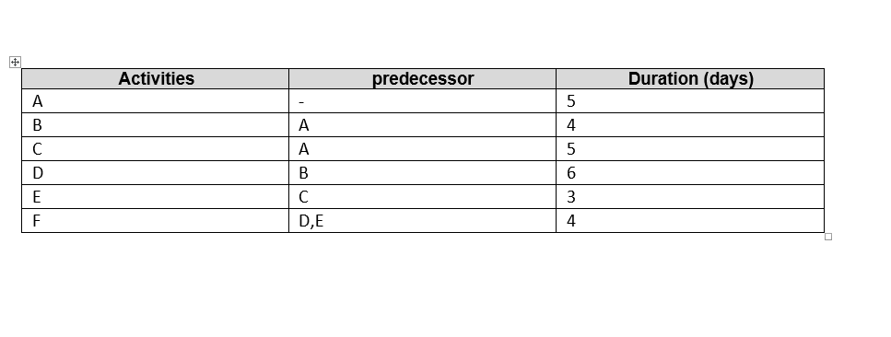
path1: A B D F =5, 4, 6, 4 = 19 days longer path/ the critical path
path2: A, C, E, F = 5, 5, 3, 4 = 17 days

3-Justify which activity would you crash based on some rationale (15%)
We should rise the coast on the critical path (path 1) depending on (high coast = low duration) rule
and we choose the minimum requirements activity.
Activity D should be crashed

