
LIBYAN INTERNATIONAL MEDICAL UNIVERSITY
APPLIED MEDICAL SCIENCES –THIRD YEAR
P.T.S. BLOCK
Assignment
Project management workshop

Name: Amira mohammed alshari Roll number: 2627 Group: A3

- Develop a network diagram for the project specified below. (50 %)
- Identify the Critical Activities and the total duration of the project. (35%)
- Justify which activity would you crash based on some rationale (15%)
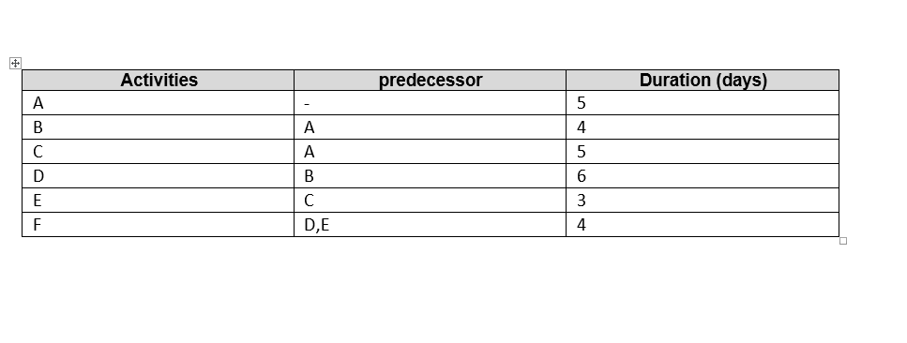

Answer 1: Diagram network for the project
F
E
D

B

A

C

Answer 2: the Critical Activities and the total duration of the project:
- Path number 1: A B D F, = 5 + 4 + 6 + 4 = 19 days, is the longest pathway; the total duration is 19 days.
- Path number 2: A C E F, = 5 + 5 + 3 + 4 = 17 days, the total duration is 17 days.

The critical activities in the project are A, B, D, and F.
The project has a duration of 19 days.

Answer 3: the activity that would be crash is number D
- Because it takes more days.
- Because it is present in the longest path of the project.
- The opposite step it in the project (E) has a few days and this gives it flexibility.

Other factors influence the decision. If there is a cost value for any of the steps, or if some of the steps require a lot of labor and others do not. In addition to the production quantity for each step

