

Libyan International Medical University
Faculty of Information Technology
Department Of Telecommunication Engineering

Dr. Asma Ali Budalal
Head of the department
Contents

The Department of Telecommunication Engineering
• Vision of the department
• Mission of the department
• Program educational objectives
• Educational Outputs
• Courses
Telecommunication Engineering at the IT faculty is keen to provide a distinguished educational environment and follow the rapid and successive developments in communication science by providing a high-quality educational program and providing engineers equipped with scientific foundations, applications, and scientific skills by international standards and the requirements of highly qualified communication engineers
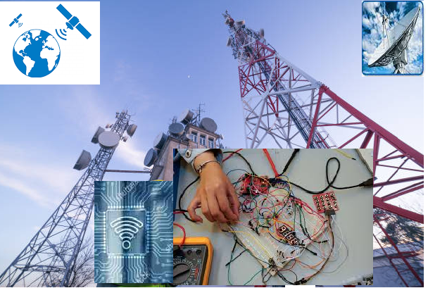
- Department vision
Excellence in teaching communication engineering locally, regionally, and internationally to enrich and develop the lives of individuals, society, and the surrounding environment
- Department mission
provide high-quality education, graduate a distinguished telecommunications engineer who is practically and ethically capable of continuous learning, keeping pace with modern global and digital development, and engage in industry collaborations to address the challenges and opportunities in the telecommunication industry. and contributing in a real way to the growth and development of the surrounding environment in Libya.
- Program educational objectives
* Keeping abet abreast of developments in communication science by constant and continuous evaluation of the Department's study plans to ensure the achievement of the mission and goals approved for engineering colleges and according to quality standards (ABET program)
* Preparing an outstanding graduate who is able to compete in the labor market and is able to research, study, and self-develop himself to follow the rapid development in this vital field
* Commitment to the highest standards of ethics and a high level of awareness of communication issues
* The student is the main focus of the department and is the final product, there is no attention only to him and his qualification requirements.
* Permanent and continuous development of curricula in accordance with the rapid and successive developments in the science of communications and electronics by encouraging research and scientific activities in the Department.
* Continuous communication with the surrounding community and cooperation with various industrial institutions by participating in providing solutions to their problems and training students in the field.
* Optimal use of all that is new and modern in communication technology and management of activities within the Department
* Closer relations between the faculty, graduates, employees, institutions, and telecommunications companies.
* Providing and achieving the means of continuous excellence to develop the system of scientific research and consulting.
- Educational Outputs of the Department
Upon graduation, a communications engineering student is expected to know or can do the following:
* Graduate engineers who have the ability to apply modern technology in the design and implementation of modern communication systems.
* Improvement and development of various communication networks.
* Graduation of engineers with leadership skills and application of basic concepts in the field of Business Administration and engineering projects
* Communication network design.
* Ability to monitor and maintain the quality of communications.
* Teamwork skills, encourage creative thinking, logical analysis, and encourage cooperation between different disciplines.
* Planning and managing communication projects.
- Courses
Students will be introduced to the theories of Informatics, radio wireless and fiber optical communications digital and data communications, signal processing, and their applications in modern communication technologies. Students are also trained to develop new perspectives through the program "expanding perceptions, perceptions, and critical thinking". The program also provides a comprehensive education by learning the basics of Information Technology, Control Engineering, Power Engineering, the basics of network science, and data communication so that they are ready to compete in local and global business fields. The program pays special attention to practical experience, as many laboratories are taught to provide technical depth in the specialty of communications. the Department of Communications Engineering is keen to work on preparing scientific materials that can be continuously updated and related to everything new and modern in this field, thanks to the scientific and technical foundations received by the engineer before he graduated.

