Libyan International Medical University

There is difference between adult male and female in urine output after Lasix consumption

Ahmed nasrallh hamed 2533

Supervisor
1-Huida Khatab
2- Eman Alfirjani
3-Basma Elktani

Abstract:
The purpose of this study is to see if there is a difference in male and female urine production after taking furosemide. Urine production is determined by maintaining homeostasis in terms of fluid balance, solute clearance, and plasma osmolarity, but loop diuretics like furosemide impact it. After computing the p-value, it was discovered that in humans, there is no difference between male and female urine output, although there is in rats.

Introduction:

The need to maintain homeostasis in terms of fluid balance, solute clearance, and plasma osmolarity determine urine output. The usual 24hr urine volume is between 800 and 2,000 milliliters each day. The atria can cause a counter-fluid loss in two ways when blood volume rises. First, increased atrial stretch causes renal arterioles to dilate reflexively, increasing glomerular filtration. Meanwhile, the atria send signals to the hypothalamus, leading to a reduction in antidiuretic hormone (ADH) and, as a result, a reduction in water reabsorption at the tubules. Both effects lead to an overall rise in urine excretion.
Second, the increased stretch in the atria leads atrial natriuretic peptide (ANP) to be released into the blood by cardiac muscle fibers.
ANP produces a slight increase in glomerular filtration rate and a decrease in collecting-duct sodium reabsorption in the kidneys, increasing salt and water excretion.

In both circumstances, increased fluid excretion aids in the reduction of excess blood volume.

Some drugs like furosemide belongs to a class of drugs known as loop diuretics (also known as water pills).It works by increasing urine flow by working on the kidneys. Fluid retention and edema caused by congestive heart failure, liver disease, kidney disease, or other medical disorders are treated with furosemide. Furosemide is also used to treat high blood pressure, either alone or in combination with other medications. High blood pressure increases the workload of the heart and arteries, which can damage the brain, heart, and kidney blood vessels, leading to a stroke, heart failure, or kidney failure. High blood pressure might also raise your chances of having a heart attack. If blood pressure is regulated, these issues may be less likely to arise^{.(1-3)}

Materials and methods: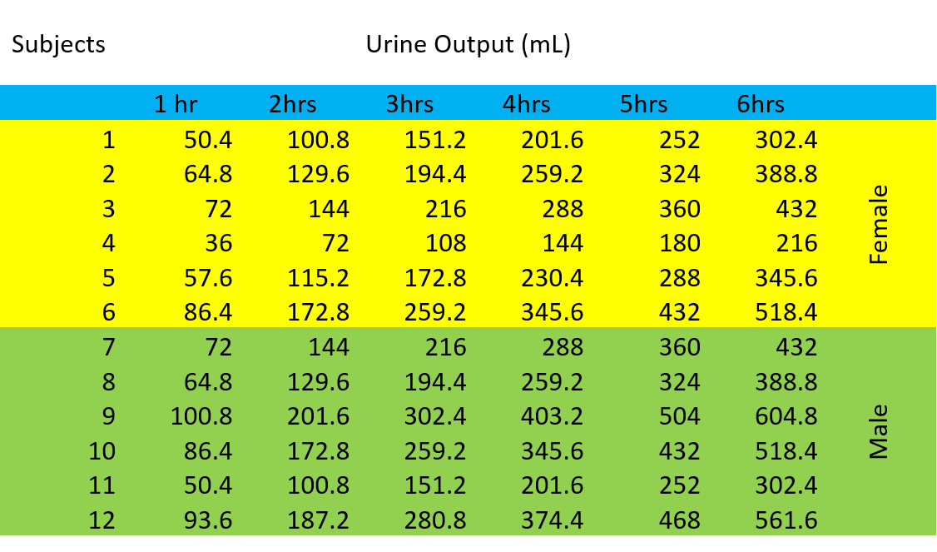In this study We grouped 12 patients into two groups for this investigation. We administered each of the 6 males and 6 females 40ml of Lasix, and the test revealed no significant differences in urine production between males and females. The test was conducted using the T-test method, with all data entered into SPSS software.

Result & Discussion:

In this study, the 12 human volunteers showed no differences in urine output after receiving the Lasix medicine, which is the polar opposite of the other study done on rats, which found a substantial difference in urine output depending on the rats' gender.

The diuretic, natriuretic, and kaliuretic responses to FUR, when expressed in fractional terms, were significantly increased in females rats. Diuretic, natriuretic, and kaliuretic efficiencies of FUR were also higher in female rats as compared with male rats.⁴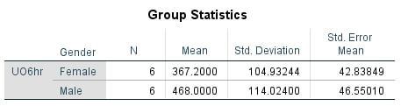
TABLE 1
The difference between the mean and standard deviation can be seen in table 1. not because it chose a higher difference because the study was done on a small sample size, which does not necessarily imply there is a difference between urine output in males and females, but because it chose a higher difference because the study was done on a small sample size, which does not necessarily mean there is a difference between urine output in males and females.
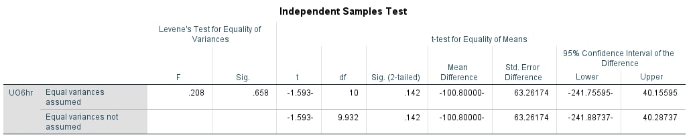
Table 2

Table 2 shows that the p-value is equivalent to.142, which is larger than the.05, indicating that there is no significant difference, thus we reject the hypothesis and conclude that there is no link between the rise or reduction in urine output after taking a loop diuretics prescription.
Conclusion
Because the sample size was too small and it didn't evaluate the entire community, we can't claim it's affirmed because there was no difference in urine production between male and female humans after taking frusemide, although there was a difference in rats. We need to perform additional research to figure out why the medicine just affects rats and has no effect on humans.

Refrences:
1. Burton RD, Post TW (2009) Renal water excretion and reabsorption 2009. Uptodate for Patients. www.uptodate.com. Accessed Dec 1 2010
2. Eaton CD, Pooler J, Vander AJ (2004) “Basic renal processes.” Vander’s renal physiology.
3. Guyton AC, Hall JE (2006) Textbook of medical physiology.
4. Brandoni A, Villar SR, Torres AM. Gender-related differences in the pharmacodynamics of furosemide in rats. Pharmacology. 2004;70(2):107-112.

