



Prepared by: Salem Mohammed Al-Farsi 2346
Supervised by: Dr. Ahmed Gaibani and Dr. Iman Fergani
Date: 18 June 2022
LIBYAN INTERNATIONAL MEDICAL UNIVERSITY APPLIED MEDICAL SCIENCES
The incidence rate of Asymptomatic Bacteriuria among LIMU students

Abstract
Urinary tract infections (UTI) are a common disease caused by the ascent of normal gut flora into the bladder through the urethra. A UTI can be either symptomatic or asymptomatic. Asymptomatic urinary tract infections (AUTI) are widespread in mostly healthy people and can be detected in the lab as significant bacteriuria. The aim of the study is to determine the prevalence rate of asymptomatic bacteruria among students. Twenty-four students of Libyan International Medical University consist of 12 males and 12 females, with an age range between 20 to 23 years. The data was analyzed using descriptive statistics. The findings showed that there exists significant growth in 8% of students. The prevalence of AUTI was significantly (p = 0.018) higher in females than in males.

- Introduction
Urinary tract infections are a group of frequent diseases caused by the ascent of normal intestinal flora into the bladder via the urethra.¹ UTI is one of the leading causes of morbidity in the general population and the second leading cause of hospitalization.² UTI is one of the most prevalent illnesses treated in primary care.³
UTI affects more than 40% of the world's female population at some time in their life. According to the Health Promotion Board Singapore and Foxman, 2002, adult women are 30 times more likely than males to acquire a UTI. Women are more prone to UTIs due to anatomical factors (e.g., shorter urethra length), which allows germs easier access to the bladder, poor hygiene, sexual intercourse, contraceptive usage, and hormonal fluctuations (e.g., menopause).^{3,4} Furthermore, a relatively high pH of vaginal secretions (more than 4.4), the presence of vaginal epithelial cell receptors that may promote bacterial adhesion, and a reduction in the synthesis of particular cervicovaginal antibodies have all been shown to facilitate introital colonization.³
More than 95% of UTI cases are caused by bacteria.⁵ Gram-negative bacteria account for 80% to 85% of uropathogens, with Escherichia coli accounting for roughly 75.5% , whereas Staphylococcus species are the most common Gram positive pathogens.^{6,7}
UTIs can be symptomatic or asymptomatic.⁸ Asymptomatic urinary tract infections (AUTI) are frequent in otherwise healthy people, and they can be detected in the lab as'significant bacteriuria.⁹ (AUTI), also known as asymptomatic bacteriuria (ASBU) is defined as the presence of 10⁵ colony forming units per milliliter (cfu/ml) of a bacteriuria species in a individuals urine culture without any symptoms, and they are generally cleared from the body by the host's defense systems. ¹⁰
A method that differentiates contamination from infection is necessary, and the best appropriate sample is early morning urine.¹¹ Urinalysis is an important part of a patient's initial examination, and the results provide a valuable picture of the patient's overall health. In general, urinalysis reveal: the status of the kidneys and chemical tests of the urinary tract to detect the presence of protein or blood; Along with the physical properties and microscopic examination of casts, cells and certain crystals, they are very useful in the assessment and treatment of kidney and urinary tract diseases.¹²
The aim of study to determine the prevalence rate of asymptomatic bacteruria among LIMU students.

- Materials and Methods
Twenty four students of Libyan International Medical University, consists of 12 males and 12 females within the age ranging from 20 to 23 years. Before collecting samples, students were asked for their name, sex, age, and history of UTI. Each subject's midstream urine was collected in a sterile universal container early in the morning.
Within 1 to 2 hours after collection, the samples were properly labeled against the student's numbers, refrigerated, and analyzed. Participants in the study who were healthy and asymptomatic at the time of sample collection were given instructions on how to collect urine samples in order to avoid contamination. Those taking antibiotics within a week of the study were excluded. Gram staining was done. The samples were examined under a microscope.
The samples were cultured on Cystine Lactose Electrolyte Deficient (CLED) agar and characterized biochemically as presented by Cheesebrough.2000.¹³ The culture plates were then incubated at 37°C for 24 hours before being counted for suspicious colonies.^{13,14} Samples with a colony equal to or higher than roughly 10⁵ cfu/ml were considered to have significant bacteriuria, while those with less than 10⁵ cfu/ml were recorded as insignificant. Table 1 summarize the gender on prevalence and microbial spectrum of asymptomatic bacteriuria in LIMU students.
The prevalence of asymptomatic bacteriuria among male and female students was compared using the Fisher's Exact test, which was carried out using the Statistical Package for Social Sciences (SPSS version 26) software.¹⁵ At p<0.05, the difference was declared significant.

Table 1: Gender differences on prevalence and microbial spectrum of asymptomatic bacteriuria.
Subjects | CFU / mL |  | Subjects | CFU / mL
1 | 10000 | Female | 1 | 0 | Male
2 | 100 | Female | 2 | 0 | Male
3 | 100000 | Female | 3 | 0 | Male
4 | 10000 | Female | 4 | 0 | Male
5 | 100 | Female | 5 | 100 | Male
6 | 0 | Female | 6 | 1000 | Male
7 | 10000 | Female | 7 | 0 | Male
8 | 100 | Female | 8 | 0 | Male
9 | 100000 | Female | 9 | 0 | Male
10 | 10000 | Female | 10 | 100 | Male
11 | 100 | Female | 11 | 0 | Male
12 | 0 | Female | 12 | 0 | Male

- Results and Statistical analysis:
In the statistical analysis, the Fisher's Exact test was used to determine the prevalence of asymptomatic bacteriuria among male and female students instead of the chi-square test due to the presence of expected cells. Two cells (33.3%) have expected count less than 5, as presented in Table 2. The difference was valued statistically significant at p<0.05(0.018).

Table 2: Chi-square test
 | Value | df | Asymptotic Significance (2-sided) | Monte Carlo Sig. (2-sided) |  |  | Monte Carlo Sig. (1-sided)
 |  |  |  | Significance | 99% Confidence Interval |  | Significance | 99% Confidence Interval
 |  |  |  |  | Lower Bound | Upper Bound | Significance | Lower Bound | Upper Bound
Pearson Chi-Square | 8.727ª | 2 | .013 | .018^{b} | .014 | .021
Likelihood Ratio | 9.949 | 2 | .007 | .012^{b} | .009 | .015
Fisher's Exact Test | 8.180 |  |  | .018^{b} | .014 | .021
Linear-by-Linear Association | 8.065^{c} | 1 | .005 | .006^{b} | .004 | .008 | .002^{b} | .001 | .003
N of Valid Cases | 24
a. 2 cells (33.3%) have expected count less than 5. The minimum expected count is 1.00.
b. Based on 10000 sampled tables with starting seed 2000000.
c. The standardized statistic is 2.840.

Urine samples from 24 students within the range of 20 to 23 years old were collected and examined. In total, 9 (75%) of the 12 males showed no growth, 3 (25%) showed no significant growth, and 0 (0.0%) showed no significant growth. While 2 (16.7%) of the total 12 females showed no growth, 8 (66.7%) showed no significant growth, and 2 (16.7%) showed no growth (Table 3).

Table 3: Prevalence of asymptomatic bacteriuria among of LIMU students.
 | No growth | % | Overall no significant growth | % | Significant growth | % | P-value
Male | 9 | 75% | 3 | 25% | 0 | 0% | 0.018
Female | 2 | 16.7% | 8 | 66.7% | 2 | 16.7% | 0.018

The frequency of asymptomatic bacteriuria among LIMU students was 46% had no growth, 46% no had significant growth, and 8% had significant growth, presented on figure 1.

Figure 1: Frequency of asymptomatic bacteriuria among LIMU students.

The urine samples color ranged from pale yellow, light yellow, to clear or turbid in transparency. Based on results of urinalysis, as presented in figure 2.

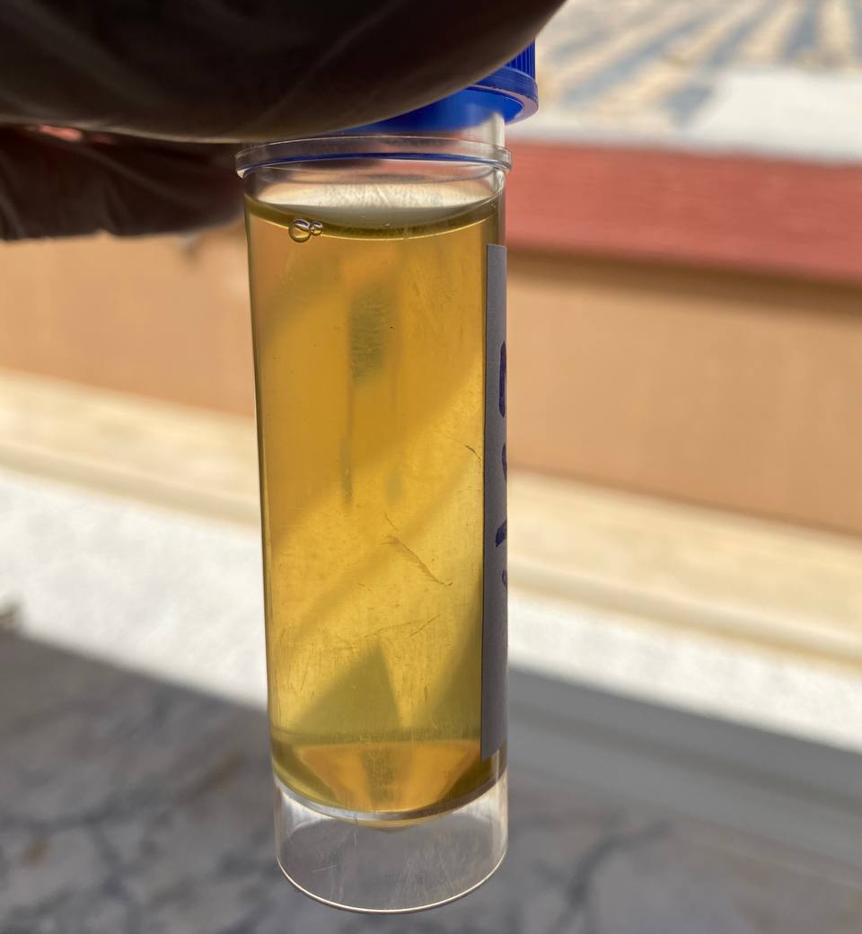
Figure 2: Macroscopic examination of urinanalysis

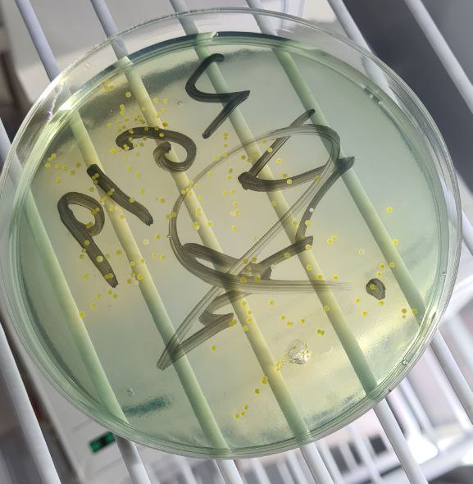
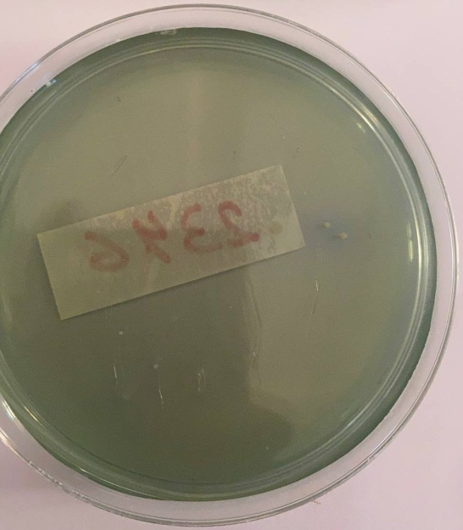
The macroscopic examination of urine culture showed no growth in 46% of samples as presented in figure 3, while there were significant colonies grown in 8% of samples, as presented in figure 4.
Figure 4: Macroscopic examination of urine culture showed significant bacterial growth.
Figure 3: Macroscopic examination of urine culture showed no bacterial growth.
- Discussion
The present study was conducted at Applied Medical Sciences College to determine the presence of asymptomatic bacteriuria among 24 otherwise healthy students at LIMU. UTI is a common form of infectious illness that may affect all populations. However, some people are more susceptible to UTIs than others. For example, females are at a greater risk than males due to the short urethra (3.8cm), which is constantly contaminated with bacteria from the vagina and rectum.^{16,17} The prevalence of asymptomatic bacteriuria in the study was 8%, which contrasts with previous studies that found prevalence rates of 75.2 % and 25%.^{18,19}
The low percentage of bacteriuria in this study might be linked to the college students (24) on campus at the time of the investigation compared to that available in suburban Nigeria.
In this study, only 2 of 12 females had significant bacterial growth, while there was no significant bacterial growth in all 12 males, indicating a greater prevalence rate of bacteriuria in females than in males. This is consistent with previous studies, which found a greater incidence of bacteriuria in females than in males.^{20,21}
Other researchers have found that females had a higher incidence of asymptomatic UTI than males.^{9,22}
Escherichia coli was found to be the most common bacterium in this study. Previous studies have also found that E. coli is the most prevalent aetiological agent of UTI.^{23,24} The close proximity of the anus to the vaginal canal may explain the high frequency of E. coli in females. The inherent virulence of E. coli for urinary tract colonization, such as its ability to adhere to the urinary tract and its ability to associate with other microorganisms moving from fecal microbe-infested perineum areas to the moist, warm environment of the female genitalia, contributes to the high risk of UTIs in females.²⁵
Staphylococcus aureus had the highest frequency of occurrence (48%) compared to another study, whereas Escherichia coli and Staphylococcus saprophytic both had 26%.²⁶
In addition, Staphylococcus saprophytic had a higher incidence rate in females than in males, as previously reported.²⁷ Lack of circumcision, as well as homosexual behaviors, have been suggested as possible explanations for the higher occurrence of Staphylococcus aureus in males than in females, as reported by the current study.²⁸ Other organisms discovered were Klebsiella species, Proteus species, and Pseudomonas aeruginosa. They are less frequent microbes that cause UTIs.²⁵

- Conclusion
The prevalence of asymptomatic bacteriuria among LIMU students in this study was 8%, which reveals the significant growth of two females and no males. Asymptomatic bacteriuria prevalence was significantly (p=0.018) higher in females than males. This is consistent with other studies that suggest a higher prevalence in women than in men. But even so, the number of subjects collected for this study is insufficient. A larger sample size study may give sufficient data and improve the generalizability of the results.

References
- Levinson W, Chin-Hong P. Review of medical microbiology & immunology. 14th ed.
- Ronald AR, Pattullo AL. The natural history of urinary infection in adults. Med Clin North Am. 1991;75(2):299-312.
- Ekwealor PA, Ugwu MC, Ezeobi I, et al. Antimicrobial Evaluation of Bacterial Isolates from Urine Specimen of Patients with Complaints of Urinary Tract Infections in Awka, Nigeria. Int J Microbiol. 2016;2016:9740273.
- Akinsete AM, Ezeaka C. Prevalence and risk factors of asymptomatic bacteriuria among children living with HIV in Lagos, Nigeria. Pan Afr Med J. 2018;31:181. Published 2018 Nov 14.
- Murugan K, Savitha T, Vasanthi S. Retrospective study of antibiotic resistance among uropathogens from rural teaching hospital, Tamilnadu, India. Asian Pacific J Trop Dis. 2012;2(5):375-380.
- Bist R, Sharma V, Mishra A. Study of pervasiveness, antimicrobial vulnerability and resolution of best method for determining extended spectrum beta lactamases Escherichia coli isolates. Hosp Palliat Med Int J. 2019;3(2):56-64.
- Yadav KK, Adhikari N, Khadka R, Pant AD, Shah B. Multidrug resistant Enterobacteriaceae and extended spectrum β-lactamase producing Escherichia coli: a cross-sectional study in National Kidney Center, Nepal. Antimicrob Resist Infect Control. 2015;4:42. Published 2015 Oct 26.
- Frank-Peterside N, Wokoma E. Prevalence of asymptomatic bacteriuria in students of University of Port Harcourt Demonstration Secondary School. J Appl Sci Environ Manag. 2010;13(2).
- Changizi M, Shojaei Zadeh D, Zinat-Motlagh F, Fattahi M, Mahboubi M. Beliefs of Female Teenagers on Prevention of Urinary Tract Infection: Application of Health Belief Model. J Biol Today’s World. 2014;3(10):223-226.
- Ogefere HO, Oluka SO. Asymptomatic bacteriuria among secondary school students in Benin City , Nigeria. 2013;5(February):66-69.
- Baron E, Peterson L, Finegold S. Bailey and Scott's diagnostic microbiology. 9th ed. St. Louis: Mosby; 1994.
- Bulakh, P.M. 2003. “Renal Function Tests and Urine Analysis”. Medical Laboratory Science Theory. 111-151.
- Cheesbrough M. District Laboratory Practice in Tropical Countries part 2. Cambridge, UK: Cambridge University Press. Chapter 7. 2004;105-15.
- Willey JM, Sherwood LM, Woolverton CJ. Prescott‘s Microbiology 8th ed. Asia. McGraw Hill Education. Chapter 6. pp. 150-1.11.
- IBM. SPSS statistics for Windows. Version 28.0. Armonk, NY: IBM; 2021
- Ali Al Youssef S, Ghareeb Mohamed A, Ahmed Abdelrahman R, Mohamed Abo Baker R, Ibrahim Abass N, Khalafalla Ahmed Masaad H. Asymptomatic Urinary Tract Infection among Female University Students. Egypt J Heal Care. 2020;11(4):341-353.
- Wineski, L. and Snell, R., 2019. Snell's clinical anatomy by regions. 10th ed.
- Rossignol L, Vaux S, Maugat S, et al. Incidence of urinary tract infections and antibiotic resistance in the outpatient setting: a cross-sectional study. Infection. 2017;45(1):33-40.
- Ayoade F, Moro DD, Ebene OL. Prevalence and Antimicrobial Susceptibility Pattern of Asymptomatic Urinary Tract Infections of Bacterial and Parasitic Origins among University Students in Redemption Camp, Ogun State, Nigeria. Open J Med Microbiol. 2013;03(04):219-226.
- Otajevwo FD, Eriagbor. Asymptomatic Urinary Tract Infection Occurrence Among Students of a Private University in Western Delta, Nigeria. Online) World J Med Med Sci. 2014;2(5):2330-1341. http://www.wjmms.comhttp//www.wjmms.com
- Ngwai YB, Iliyasu H, Young E, Owuna G. Bacteriuria and antimicrobial susceptibility of escherichia coli isolated from urine of asymptomatic university students in Keffi, Nigeria. Jundishapur J Microbiol. 2012;5(1):323-327.
- Modarres, A and Oskoii, N. (1997). Bacterial etiologic agents of urinary tract infection in children in the Islamic Republic of Iran. Vol 3, Issue 2: 290 – 295.
- De Francesco MA, Ravizzola G, Peroni L, Negrini R, Manca N. Urinary tract infections in Brescia, Italy: etiology of uropathogens and antimicrobial resistance of common uropathogens. Med Sci Monit. 2007;13(6):BR136-BR144.
- Al Sweih N, Jamal W, Rotimi VO. Spectrum and antibiotic resistance of uropathogens isolated from hospital and community patients with urinary tract infections in two large hospitals in Kuwait. Med Princ Pract. 2005;14(6):401-407.
- Odoki M, Aliero AA, Tibyangye J, et al. Prevalence of Bacterial Urinary Tract Infections and Associated Factors among Patients Attending Hospitals in Bushenyi District, Uganda. Int J Microbiol. 2019;2019.
- Ugwu MC, Ezejiegu C, Ogwaluonye UC, Ejikeugwu C. Prevalence and Antibiogram of Asymptomatic Bacteriuria among University Students in Agulu, Anambra, Nigeria OPEN ACCESS. 2019;(August 2021).
- Jhora ST, Paul S. Urinary Tract Infections Caused by Staphylococcus saprophyticus and their antimicrobial sensitivity pattern in Young Adult Women. Bangladesh J Med Microbiol. 2011;5(1):21-25.
- Otajevwo FD, Amedu SS. Community Acquired Urinary Tract Infection Prevalence in a Tertiary Institution Based in Evbuobanosa, Edo State, Nigeria. Glob J med. 2015;15(3):1-13.

