

Assignment
Student name : Taqwa muftah
Student number :2348
1/Develop a network diagram for the project specified below?
2/Identify the Critical Activities and the total duration of the project?
3/Justify which activity would you crash based on some rationale?

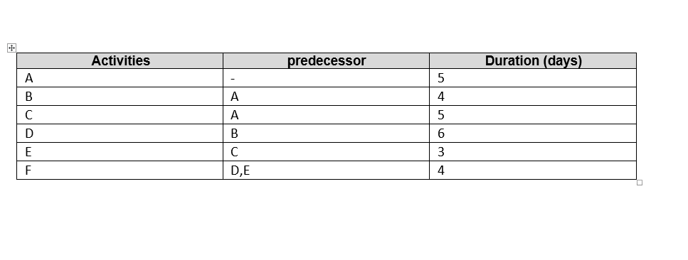Part 1""
C
A
B
D
F
E

Part 2""
1 -A + C + E + F =
5 + 5 + 3 + 4 = 17 days
2 – B + D + F + E =
4 + 6 + 4 + 3 = 17 days

"Part 3"

which activity would Me crash ...?
- so is critical part > bessed on cores matter and time matter
- crash is F Activities { is critical part } because predecessor with D & E

