

The incidence rate of asymptomatic bacteriuria and urinary tract infection

Student Name Dania Ahmed
Student Number 3078
Supervisor Dr. Intisar Alnagi

Abstract
Bacteriuria presence of bacteria in urine is linked to both asymptomatic and symptomatic urinary tract infections, and it underpins a lot of the microbial colonization dynamics in the urinary tract Bacteriuria is prevalent in a wide range of patient categories, including healthy people, institutionalized elderly, pregnant women, and immune-compromised patients determining the significance of significant bacteriuria in infected persons is a diagnostic difficulty partially due to the diversity of causative microorganisms, and necessitates a careful evaluation of the numerous etiologies of bacteriuria in different populations and situations Recent molecular discoveries have revealed how specific bacterial features enable organisms to flourish in human urine, a fitness adaption that may impact the course of bacteriuria in some people.

Introduction
In the absence of signs or symptoms of urinary tract infection, asymptomatic bacteriuria is defined as the presence of one or more species of bacteria growing in the urine at predefined quantitative counts (105 colony-forming units [CFU]/mL or 108 CFU/L) independent of the presence of pyuria (UTI) Asymptomatic bacteriuria (ABU) is a rather prevalent condition. The incidence varies based on characteristics such as age, sex, and underlying illnesses in various groups (eg, diabetes mellitus or spinal cord injury) Obesity and iron deficiency anemia was identified as independent risk factors for asymptomatic bacteriuria in a study of hospitalized patients.
Urinary tract infection is one of the most common bacterial infections managed in general medical practice. It accounts for 1‐3 percent of consultations. Up to 50% women are at greater risk of developing a UTI than men. is uncommon in men except over the age of 60 when urinary tract obstruction due to prostatic hypertrophy. Also there are categorized as uncomplicated or complicated UTI.
Infection limited to the bladder can be painful and annoying A UTI that spreads to the kidneys, on the other hand, can have severe consequences. Predisposing factors for complicated UTI (cUTI) include obstructed urinary flow or congenital causes.
Urinalysis was the first laboratory test performed in medicine and has been used for several thousand years Today urinalysis continues to be a powerful tool in obtaining crucial information for diagnostic purposes in Urinary tract infections are a group of common diseases that occur predominantly by the ascension of normal enteric flora through the urethra into the bladder These infections more frequently affect women due to anatomic differences including a shorter urethra There are different ways of analyzing urine and for different reasons, namely Patient voids into toilet, after which all urine is collected for the following 24 hours This is utilized to assess substances such as hormones, white cells, electrolytes, or urine osmolarity because the body chemistry changes continually The first morning specimen is the first specimen of the day (or eight hours after recumbent position). For pregnancy testing, the best sample is After a time of fasting, the second voided specimen is obtained.
Mid-stream urine (MSU) is a kind of urine that may be utilized for bacterial culture. To prevent contaminating the specimen with organisms present on the skin, the first and final part of the urine stream is voided into the toilet.
A randomly chosen specimen suited for most screening procedures for chemical or microscopic investigation Urine sample taken with a catheter: bacteriological examination if a patient’s symptoms suggest the presence of a UTI.
The study's goal was to determine the incidence rate of asymptomatic bacteriuria among students at Libyan international medical university

Methods and material
We started with materials that provided by Libyan international medical university
We take a urine sample, from 24 participants (12 females and 12 male) then we flame a calibrated wire loop, and we Mix the urine with insert the loop vertically into the urine to allow the urine to adhere to the loop.
spread the urine over the surface of the agar plate without flaming insert the loop vertically into the urine again to transfer of loopful to a second plate.
Then incubate for 24hr at 37 C in air Colonies are counted on each plate. The number of CFUs is multiplied by 1000(if a 0.001 ml loop used) or by 100 (if a 0.01 ml loop was used) to determine the number of microorganisms per ml in the original specimen. Then we analysis the data using SPSS.

Result
P value = 0.013 that means its <0.05 we reject the null hypothesis
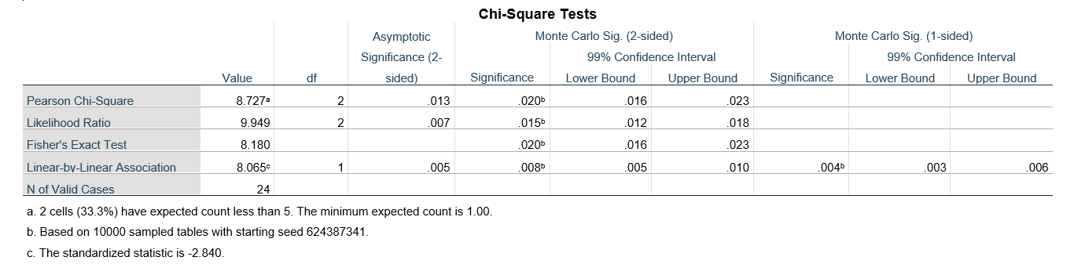Summary table of fisher’s exact test

 |  | UTI colony forming units |  |  | p-value
 |  | No growth | No significant growth | Significant growth | 0.018
Gender | Male | 9 | 3 | 0 | 0.018
Gender | Female | 2 | 8 | 2 | 0.018
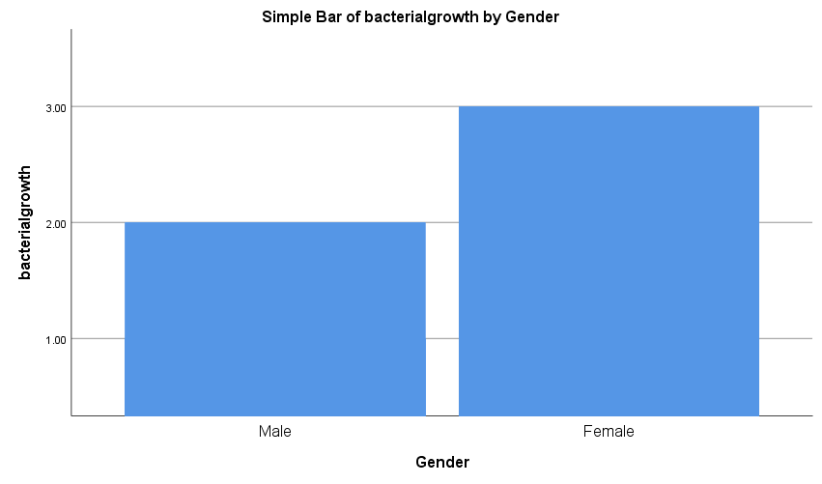
Discussion
As shown in this study there’s significant bacteria overgrowth in urinary sample in college student which means asymptomatic bacteriuria is common, with varying prevalence by age, sex, sexual activity, and the presence of genitourinary abnormalities. In healthy women, the prevalence of bacteriuria increases with age, from about 1 percent in females five to 14 years of age to more than 20 percent in women at least 80 years of age living in the community. Escherichia coli is the most common organism isolated from patients with asymptomatic bacteriuria. Infecting organisms are diverse and include Enterobacteriaceae, Pseudomonas aeruginosa, Enterococcus species, and
Streptococcus group B. Patient characteristics will impact the organisms isolated in individuals with asymptomatic bacteriuria: healthy people are more likely to have E. coli, whereas a nursing home resident with a catheter is more likely to have multidrug–resistant polymicrobic flora (e.g.,P. aeruginosa). Men are susceptible to Enterococcus species and gram-negative bacilli.
Asymptomatic bacteriuria is very common in clinical practice. While few infants and toddlers have asymptomatic bacteriuria, the incidence increases with age. The incidence is up to 15% or greater in women and men age 65 to 80 years and as high as 40% to 50% after age 80. Most patients with asymptomatic bacteriuria will never develop symptomatic urinary tract infections and will have no adverse consequences from asymptomatic bacteriuria.
ASB occurs in less than 1% of full-term infants and in 3% of premature infants. The identification of bacteriuria in these otherwise asymptomatic children is important because these young children may have few signs and symptoms in the face of an infection, and ASB may actually be a marker of underlying genitourinary disease. Given these issues, these infants should be treated with antimicrobial therapy and also should be imaged to evaluate for any congenital issues that could be leading to bacterial colonization. ASB occurs in 0.8% of preschool girls and even fewer preschool boys. Children in this age group who are without genitourinary abnormalities do not require antibiotics to clear their bacteria because they do not appear to be at any risk for recurrent symptomatic infections, renal damage, or impaired renal growth
The annual incidence of ASB in school-age girls ranges from 1% to 2%, although about 5% of all school-age girl.
Because antimicrobial therapy in these individuals is unlikely to prevent later asymptomatic or symptomatic bacteriuria, and untreated individuals appear to be at low risk of developing long-term sequelae related to the bacteriuria, routine antimicrobial therapy is not recommended. Also, routine prophylactic antibiotics could certainly lead to alteration of their microbiota and increased antibiotic resistance in these individuals

Conclusion
In clinical practice, asymptomatic bacteriuria (bacteriuria without clinical signs) is fairly prevalent. While asymptomatic bacteriuria is uncommon in newborns and toddlers, it becomes more common as they become older. In women and men aged 65 to 80 years, the incidence can be as high as 15% or more, and it can be as high as 40% to 50% beyond that. Most people with asymptomatic bacteriuria will never acquire symptomatic urinary tract infections, and asymptomatic bacteriuria will have no negative repercussions. According to a study conducted among college students, there is a considerable amount of bacteria proliferation in urine cultures.

References
- Urinary tract infection (UTI) - Symptoms and causes [Internet]. Mayo Clinic. 2022 [cited 19 June 2022]. Available from: https://www.mayoclinic.org/diseases-conditions/urinary-tract-infection/symptoms-causes/syc-20353447

- TA, Juthani-Mehta M. Urinary tract infection in older adults. Aging health. 2013;9(5):10.2217/ahe.13.38. doi:10.2217/ahe.13.38

- 1. Urinary tract infection (UTI) - Symptoms and causes [Internet]. Mayo Clinic. 2022 [cited 19 June 2022]. Available from: https://www.mayoclinic.org/diseases-conditions/urinary-tract-infection/symptoms-causes/syc-20353447

