BOUZIED boalia_2587 GROUP A3
Assignment
1-Develop a network diagram for the project specified below. (50 %)
2-Identify the Critical Activities and the total duration of the project. (35%)
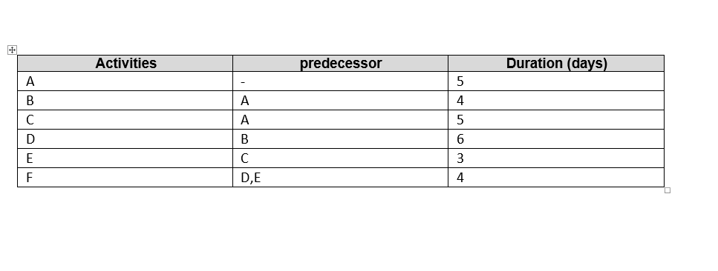
The upper long (A-B-D-F) critical path = 5+4+6+4=19 DAYS

B=4 days
D=6 days
A=5 days
F=4 days

C=5 days
E=3 days

The lower short (A-C-E-F) path =5+5+3+4=17DAYS

3-Justify which activity would you crash based on some rationale (15%)
The E activity the most likely to crash because it takes less days than the others do which ,ean it’s the most important activity.

