
LIBYAN INTERNATIONAL MEDICAL UNIVERSITY
APPLIED MEDICAL SCIENCES –THIRD YEAR
P.T.S. BLOCK
Assignment
Project management workshop

Name: aya Hassan abass Roll number: 2384 Group: A4

- Develop a network diagram for the project specified below. (50 %)
- Identify the Critical Activities and the total duration of the project. (35%)
- Justify which activity would you crash based on some rationale (15%)
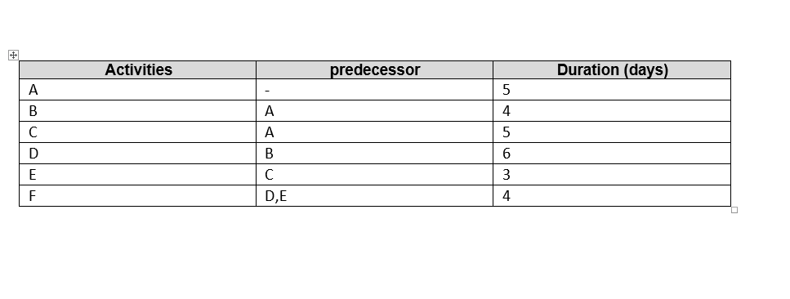

1: Diagram network for the project
F
E
D

B

A

C

2: the Critical Activities and the total duration of the project:
Path number 1: A B D F,;=5+4+6+4= 19 days. So it is the longest pathway

Path number 2: A C E F, 5+5+3+4=17 days.

The total duration of all project is 27 days.

3: the activity that would be crash

Number D Because its take more time than others 6 days and located in the longest path of the project.

