

The Libyan International Medical University
Faculty of Basic Medical Science

Effect of Gender differences on prevalence and
microbial spectrum of asymptomatic bacteriuria
Mohammed Almahdi Ali
Number : 2100
Date of Submission: 20/ 6/ 2022
د . انتصار الناجي : supervisors names
assistant by :
أ . ناجي الحمري
أ . اسماء الكوافي
المشرفيين فنيين المعامل د . لوجين

Abstract :

Bacteriuria, which is the presence of bacteria in the urine, is linked to both asymptomatic and symptomatic urinary tract infections, or (UTIs). It has a significant impact on how microorganisms colonize the urinary system. Men, the elderly, pregnant women, healthy women, and patients with immune system weakness all have considerably varied rates of bacteriuria prevalence, with women and expectant mothers being the most vulnerable. What's intriguing, though, is the distinction between the microbiological spectrum of various microorganisms infecting different genders, as well as the prevalence of asymptomatic bacteriuria, between the male and female genders. In this investigation, we examine information on the prevalence of asymptomatic bacteriuria as well as the microbiological spectrum according to gender. We also cover the value of early detection of asymptomatic bacteriuria (ASB) in preventing health issues in both pregnant and non-pregnant women.

Introduction :

In primary care, asymptomatic bacteriuria (ASB) is the second most frequent bacteria linked to illnesses [1]. Despite affecting millions of people worldwide, it mostly impacts industrialized countries in the same way as it does developing nations, making it a distinct concern. [2] According to estimates, roughly 20% of all women will experience ASB at some point in their lives, and many will experience repeated infections [3]. Due to the urethra's short length and close closeness to the anus, which makes it easier for bacteria like E. Coli to colonize, women are the gender most at risk for ASB. A woman's likelihood of contracting an infection is increased if she has recently engaged in sexual activity and given birth [4]. As indicated by the definition of ASB, this condition occurs when there are active bacteria present in a person's urine but no outward indications of a UTI are present for the person who is experiencing it. With prevalence rates ranging from 5 to 20 percent in healthy women and 10 to 40 percent in pregnant women, ASB is essential since it is a substantial indicator of a future UTI [7] The most frequent bacteria found in urinary tract infections are E. coli, Proteus , Klebsiella , and E. faecalis. Urinary tract infections can be found by sample urine and looking for these bacteria. Asymptomatic bacteriuria is not screened for nearly as often as symptomatic bacteriuria, which is a problem because most people with asymptomatic infections won't experience any signs or symptoms and won't go for screening, which could cause asymptomatic bacteriuria to fester and result in a potential UTI. The purpose of this research lab is to provide an answer to the questions of how common asymptomatic bacteriuria is in both men and women, and whether either gender should consider routine screening for asymptomatic UTIs.

Materials and Methods :

Loop _ Incubator _ Culture media _ slied pipette _ Paper towels _ Dipsticks _ Alcohol Gel _ Gloves _ Containers 63 _ Urine Samples 63

The study collected urine samples from 63 libyan international medical university (LIMU) students (33 Males and 30 female) who were asymptomatic for bacteriuria. The samples were then sent to a lab for testing to determine whether there had been any bacteriuria growth at all, whether it had been overall non-significant growth, or whether it had been overall significant growth. Utilizing sample containers for each kid that were sanitized, spotless, leak-proof, and wide open, we collected recently voided urine samples of around 10-15 mL that were caught midstream. After that, urine was inoculated onto Cysteine Lactose Electrolyte-deficient (CLED) agar and incubated aerobically for roughly 24-48 hours at 37 degrees Celsius. We then looked for bacterial growth on the infected plates.

Results :

gender * bacterialgrowhsignificance Crosstabulation
 |  |  | bacterialgrowhsignificance |  |  |  | Total
 |  |  |  | no growt | overall | signific | Total
gender | female | Count | 0 | 2 | 8 | 2 | 12
gender | female | % within gender | 0.0% | 16.7% | 66.7% | 16.7% | 100.0%
gender | female | % within bacterialgrowhsignificance | 0.0% | 20.0% | 72.7% | 100.0% | 50.0%
gender | male | Count | 1 | 8 | 3 | 0 | 12
gender | male | % within gender | 8.3% | 66.7% | 25.0% | 0.0% | 100.0%
gender | male | % within bacterialgrowhsignificance | 100.0% | 80.0% | 27.3% | 0.0% | 50.0%
Total |  | Count | 1 | 10 | 11 | 2 | 24
 |  | % within gender | 4.2% | 41.7% | 45.8% | 8.3% | 100.0%
 |  | % within bacterialgrowhsignificance | 100.0% | 100.0% | 100.0% | 100.0% | 100.0%

Chi-Square Tests
 | Value | df | Asymptotic Significance (2-sided) | Monte Carlo Sig. (2-sided)
 |  |  |  | Significance | 99% Confidence Interval
 |  |  |  |  | Lower Bound | Upper Bound
Pearson Chi-Square | 8.873ª | 3 | .031 | .019^{b} | .015 | .022
Likelihood Ratio | 10.372 | 3 | .016 | .015^{b} | .012 | .018
Fisher's Exact Test | 8.225 |  |  | .019^{b} | .015 | .022
N of Valid Cases | 24

Hypothesis: H0 : No association between gender status and bacterial growth

Ha : There is an association between gender status and bacterial growth

 | No growth | Overall | Significant growth
Males | 18 | 12 | 0
Females | 17 | 13 | 3

Summary table

P-value is 0.019 Decision: accept to reject the null hypothesis (FTR) Since P-value lesser than alpha 0.05, we accept to reject the null hypothesis. Conclusion there is association between gender status and bacterial growth

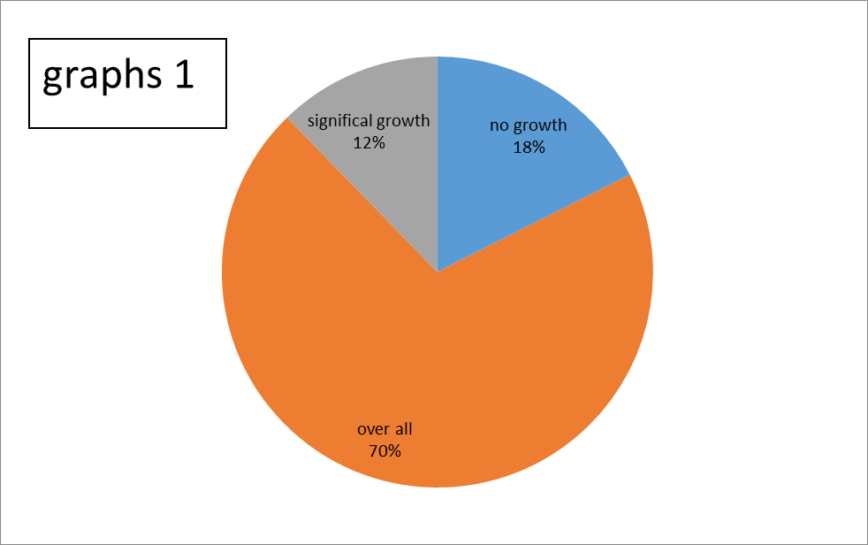
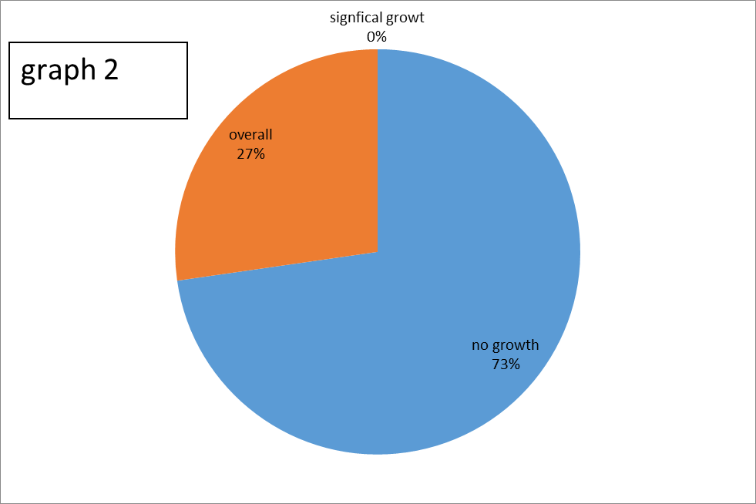

Discussion :

Given that the p-value for this experiment was 0.019, it is possible to reject the null hypothesis and conclude that the data are not polluted. Contrary to what I had anticipated, the results indicate that there is not a very high incidence rate for major bacteriuria increase. The incidence rate is 0% in men, with only 8 men displaying any development at all, much alone growth that would be considered even minimal. Despite a 16.66 percent incidence rate, it is still substantially lower than anticipated for females. Despite this, 10 out of 12 women demonstrated bacteriuria growth, indicating that the majority of them may be at risk for developing it. Infections with UTI.

With the use of this information, we may draw the reasonable conclusion that men are not particularly at risk for bacteriuria infection, which fits with our prior knowledge. It is significantly more difficult for germs to colonize the male urethra than the female one since it is longer and farther from the anus in comparison to the female vagina. In addition, even while women may be more susceptible to bacteriuria, the risk is still not great enough to warrant concern since, on average, only 16 out of every 100 women will experience substantial bacteriuria, and even fewer will experience UTIs. however, the dangeris still present and far more prevalent among women than among men. It's intriguing that 13 out of 23 people in both the male and female groups had some form of bacteriuria growth, even if it's not particularly large. This could be a problem because even non-significant growth has the potential to develop into considerable growth, which could cause UTIs. Despite the fact that non-significant growth does not always indicate the presence of UTIs, this research suggests that both males and females are still at some risk for bacteriuria, as the growth could eventually become large and cause issues with UTIs. The second item

will essentially never result in considerable growth, and we may fairly rule out males for the most part from bacteriuria. The situation for women, however,

While less than 10% will ever have to cope with this significantly greater danger , bacteriuria, which is still severe enough to cause women to have problems since the

UTI and pyelonephritis problems could result from routine

Screening could be useful for detecting ASB before it becomes a problem.

Conclusion :

Even if this lab is not flawless, the results showed that females were

They were the group most at risk of ASB since it was considerably more common in them than in men. The sample size was one of this lab's weaknesses because it was so

the experiment could have been changed if more than 100 participants had been tested

possible standard deviation brought on by a few outliers. The advantages would be that

collection of sterilized urine in containers where both sterilization and

The urine was kept in sealed containers to prevent extraneous interference.

sources. But what we succeeded in the outcomes, in the grand scheme of things, makes sense and leads us to the simple fact that asymptomatic bacteriuria is an infection occurring mostly in women at a rate which, while not high enough to cause mass panic, is still large enough that most women would only benefit from, at the very least, semi-regular screening to reduce the rate of UTIs and potential pyelonephritis from consistent ASB that can occur, and which can be easily prevented with antibiotics.

References :
- Ranjan A., Sridhar S.T.K., Matta N., Chokkakula S., Ansari R.K. Prevalence of UTI among Pregnant Women and Its Complications in Newborns. Indian J. Pharm. Pract. 2017;10:45. doi: 10.5530/ijopp.10.1.10
- Urinary Tract Infections | UTI | UTI Symptoms | MedlinePlus [Internet]. Medlineplus.gov. 2020 [cited 6 March 2020]. Available from
- _ Sakamoto, M., et al. "Molecular analysis of bacteria in asymptomatic and symptomatic endodontic infections." Oral microbiology and immunology 21.2 (2006): 112-122
- Moore E.E., Hawes S.E., Scholes D., Boyko E.J., Hughes J.P., Fihn S.D. Sexual intercourse and risk of symptomatic urinary tract infection in post-menopausal women. J. Gen. Intern. Med. 2008;23:595–599. doi: 10.1007/s11606-008-0535-y.
- Afoakwa P, Domfeh S, Afranie B, Owusu D, Donkor S, Sakyi K et al. Asymptomatic Bacteriuria and Anti-Microbial Susceptibility Patterns among Women of Reproductive Age. A Cross-Sectional Study in Primary Care, Ghana. National Library Of Medicine. 2022. [accessed 4 Jun 2022] Available from: https://www.ncbi.nlm.nih.gov/pmc/articles/PMC6313490/

