

Effect of Gender on the Incidence of asymptomatic bacteriuria.
Name: Roaya Karim
Student number:3143
Libyan International Medical University

Abstract:
Asymptomatic bacteriuria or ASB is the presence of bacteria in urine at a rate more than 100,000 CFU without symptoms. The incidence of asymptomatic bacteriuria is 15% more in females than males with E.coli being the most common cause of ASB.

This experiment shows gender’s association with the incidence of asymptomatic bacteriuria. This study was done on 24 participants 12 males and 12 females. 16.7% of women were seen to have significant bacterial growth while no males had significant growth. This report addresses when ASB need to be treated as well as allow you to understand the difference between UTIs and ASB.

Introduction:
Bacteriuria is a term that refers to the presence of bacteria in urine, if more than 100,000 CFU per ml then it can be categorised into symptomatic and asymptomatic bacteriuria.^{[2]} Symptomatic bacteriuria is related to a urinary tract infection, such as cystitis in the lower urinary tract and pyelonephritis in the upper urinary tract. Asymptomatic bacteriuria is defined as the presence of bacteriuria without symptoms, so it is simply not considered an infection. E-coli is the most common bacteria identified in asymptomatic bacteriuria. One reason for having no symptoms is the organism changing its pathogenic factors making it colonise the bladder and not causing an infection, an example of this is the lack of fimbria in E. coli.
The prevalence of asymptomatic bacteriuria is more common in females than males this experiment aims to assess if gender has an impact on the incidence of asymptomatic bacteriuria. This could be due to the anatomical structure differences as the female urethra is much shorter than the male urethra making women more prone to asymptomatic bacteriuria. Other risk factors of asymptomatic bacteriuria include diabetes, dementia, urethral catheters, iron deficiency, urinary tract abnormalities, and benign prostatic hyperplasia.
Dr. Donald N. Givler stated in his articles that “symptomatic bacteriuria is very common in clinical practice and its incidence increases with age. The incidence is 15 percent or greater in women and men aged 65 to 80 years and as high as 40 to 50 percent after age 80.” This confirms that the incidence rate is higher in women and tells us that the prevalence of ASB is increasing with age.
In most patients’ asymptomatic bacteriuria will not develop into a UTI and it will continue to not have symptoms or consequences, this indicates that treatment for asymptomatic bacteriuria is unnecessary it is not recommended especially in the elderly, diabetes patients, and women who are not pregnant. According to Dr. Rajdip Barman’s research over 50% of antibiotics used for UTIs in older patients were unnecessary and inappropriate. ^{[3]} Therefore treatment of asymptomatic bacteriuria is “A major contributor to inappropriate antimicrobial use”^{[4]} because other than the obvious increase in resistance against antibiotics there are other problems that can be caused by inappropriate use of antibiotics, such as the risk of drug-drug interaction, predisposing the patients to issues like clostridium difficile associated diarrhoea.
However, there are a few exceptions where asymptomatic bacteriuria needs to be treated. For instance, in pregnancy a urine sample is taken at 16 weeks, if the patient has asymptomatic bacteriuria, IDSA recommends a course of three to seven days of antimicrobial therapy for pregnant women with asymptomatic bacteriuria, this is because evidence shows that if not treated there is an increased risk of developing acute pyelonephritis along with premature labour.^{[5]}

Methodology:
An experiment was conducted to see if gender influences the prevalence of asymptomatic bacteriuria. 24 medical students from the Libyan International Medical University participated in this experiment. The urine samples were taken from12 males and 12 females.
After a questionnaire to make sure none of the participants had any symptoms for a UTI, we began showing the participants how to correctly take a urine sample. We made sure all containers are labelled correctly and that the samples were taken with a mid-stream catch method to reduce the risk of contamination. After all the samples were collected, we then proceeded to prepare the samples this was done by mixing the sample well then measuring 5 or 10 ml of it and putting it into a centrifugation test tube. 9 parts of the 10 supernatants are carefully removed, which results in a sediment 10 times more concentrated than to the original urine sample making it easy to view under a microscope. To be able to see bacteria in the sample magnification is switched to 400x at least.
For culturing, urine was mixed, and a 0.01 microliter wire loop was inserted vertically into the container and kept for a few seconds to make sure that some urine adhered to the loop, then the urine was spread on MacConkey and blood agar in a zig-zag pattern multiple times to obtain isolated colonies . The samples were incubated for 24 hours at 37ºC.After 24 hours colonies on the agar in each plate were counted and the number was multiplied by 100 to determine the number of microorganisms per ml in the original sample. The culture samples were counted for each participant and collected in the table below.

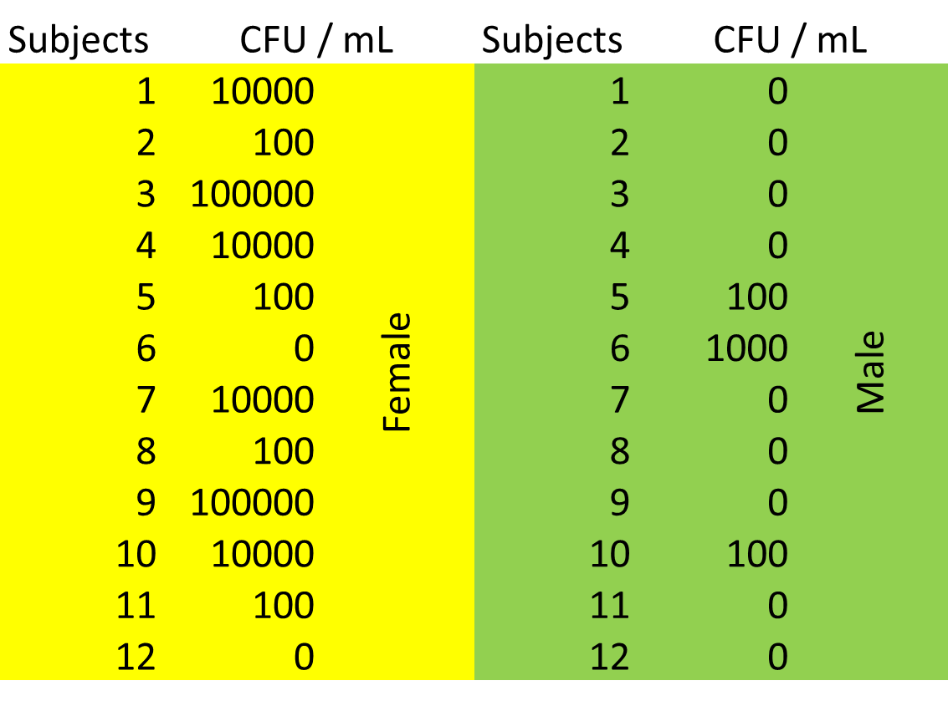
CFU/ml results for each person after collection.
SPSS:
SPSS software was used for the data collection and the Fisher’s exact test was used instead of Chi-square test because of the small sample size.

Results:
Table 1
bacterial growth * Gender Crosstabulation
 |  |  | Gender |  | Total
 |  |  | Male | Female | Total
bacterial growth | No growth | Count | 9 | 2 | 11
bacterial growth | No growth | % Within bacterialgrowth | 81.8% | 18.2% | 100.0%
bacterial growth | No growth | % Within Gender | 75.0% | 16.7% | 45.8%
bacterial growth | No significant growth | Count | 3 | 8 | 11
bacterial growth | No significant growth | % Within bacterialgrowth | 27.3% | 72.7% | 100.0%
bacterial growth | No significant growth | % Within Gender | 25.0% | 66.7% | 45.8%
bacterial growth | Significant growth | Count | 0 | 2 | 2
bacterial growth | Significant growth | % Within bacterialgrowth | 0.0% | 100.0% | 100.0%
bacterial growth | Significant growth | % Within Gender | 0.0% | 16.7% | 8.3%
Total |  | Count | 12 | 12 | 24
 |  | % Within bacterialgrowth | 50.0% | 50.0% | 100.0%
 |  | % Within Gender | 100.0% | 100.0% | 100.0%

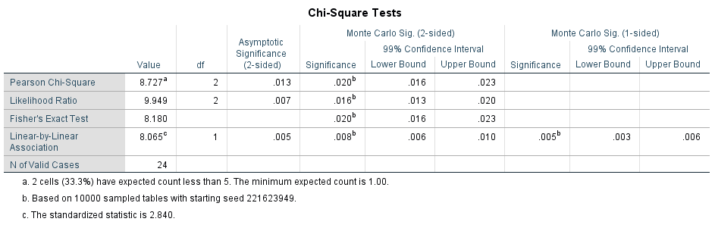
Table 2

Gender | No growth | Overall, no growth | Significant growth | p-value  0.020^{b}
Females | 2 (16.7%) | 8 (66.7%) | 2 (16.7)
Males | 9 (75%) | 3 (25%) | 0 (0%)

Table 3

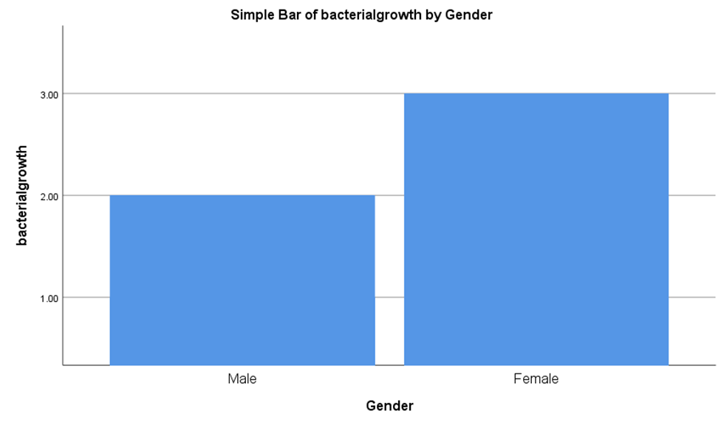
Graph 1

Discussion:
Microscopic examination revealed gram negative rods, while culturing on MacConkey agar revealed lactose-fermenting pink colonies, and on blood agar revealed beta-hemolytic colonies. All these tests reveal that the most likely organism is Escherichia coli.

As presented in table 1 the first category showed no bacterial growth in 75% of males, and 16.7% of females. the second category showed that there was no significant growth in 25% of males and 66.7% of females. This category indicated that there was growth however it was not significant to be recognized as bacteriuria, meaning it could be due to contamination during culturing or taking the sample.
In the last category 16.7% of females and 0% of males had significant growth which is an indication of asymptomatic bacteriuria (ASB). As mentioned earlier females are more likely to have ASB due to the shorter urethra and the nearness of the urethra to the rectum. Making them more susceptible to ASB as well as UTIs.

Fisher’s exact test was the one used for this experiment. Fisher's exact test is a statistical test used to determine if there are associations between two definite variables. We used this test specifically instead of the Chi-square test because the expected value less than 5 meaning one of the assumptions was not met. Another reason was that the sample size was small.

Table 2 shows the results of the Fishers exact test which tells us that the p-value is 0.020 which is less than 0.05 meaning we reject the null hypothesis and indicating that there is a significant difference between males and females and the incidence of ASB. It also shows that there is an association between gender and ASB. This can also be seen in graph1.
Although these results show that there is a significant difference between the two genders and sufficient data was collected to have an estimation with a degree of accuracy, they are not completely conclusive. This is due to the limited equipment and time that we had to proceed with this experiment.
If more time and funding were provided factors we could alter to improve this experiment are the sample size, this is so we can generalise the results and increase precision. Another factor is the range of ages our experiment was done on university students ages 18-24 meaning it was not broad enough to see the increase of ASB incidence with age.

Table 3 shows that the significant growth in women was 16.7%, in this experiment these women were premenopausal, nonpregnant women.
Nonpregnant women with asymptomatic bacteriuria are more likely to experience UTIs than women who do not have asymptomatic bacteriuria. treatment is not recommended as it increases risk of resistance, and it does not decrease the occurrence of symptomatic UTI or prevent further episodes of bacteriuria. However the case would be different if they were pregnant.

Conclusion:
In conclusion we can see that E. coli is the most common agent of both symptomatic and asymptomatic bacteriuria. We also found that ASB is more common in females than males and the incidence of it increases with age in both genders, but that does not mean it should be treated as ASB unlike UTIs usually doesn’t need to be treated in most patients. Treatment has been seen to increase the bacterial resistance to antibiotics. A further direction to be given is that health professionals should be cautious with the administration of antibiotics in the case of asymptomatic bacteriuria as it is important in cases like pregnant women and children with diabetes, however if administered to healthy adults or elderly it can cause more harm than good in terms of antibiotic resistance and drug-drug interactions in elderly patients.

Bibliography:
- 1. Gu J, Chen X, Yang Z, Bai Y, Zhang X. Gender differences in the microbial spectrum and antibiotic sensitivity of uropathogens isolated from patients with urinary stones. J Clin Lab Anal. 2021;36(1). doi:10.1002/jcla.24155
- 2. Stephen I. Margaret Leslie Stephen (nee Macalister). BMJ. 2002;324(7338):680g-680. doi:10.1136/bmj.324.7338.680/g
- 3. Barman R, Emtman R, Bruno-Murtha L. Deceptive urine studies and inappropriate antibiotic use in geriatric psychiatry: The impact of bundled interventions. International Journal of Applied and Basic Medical Research. 2021;11(3):166. doi:10.4103/ijabmr.ijabmr_599_20
- 4. Nicolle L. Symptomatic urinary tract infection or asymptomatic bacteriuria? Improving care for the elderly. Clinical Microbiology and Infection. 2019;25(7):779-781. doi:10.1016/j.cmi.2019.03.013
- 5. Smaill F, Vazquez J. Antibiotics for asymptomatic bacteriuria in pregnancy. Cochrane Database of Systematic Reviews. 2019;2019(11). doi:10.1002/14651858.cd000490.pub4
- 6. Givler D, Givler A. Asymptomatic Bacteriuria. Ncbi.nlm.nih.gov. https://www.ncbi.nlm.nih.gov/books/NBK441848/#:~:text=Asymptomatic%20bacteriuria%20is%20very%20common,50%20percent%20after%20age%2080. Published 2022. Accessed May 31, 2022.

