
LIBYAN INTERNATIONAL MEDICAL UNIVERSITY
APPLIED MEDICAL SCIENCES –THIRD YEAR

Assignment
Project management workshop

Name: Tebra yousef number: 2386 G: A2

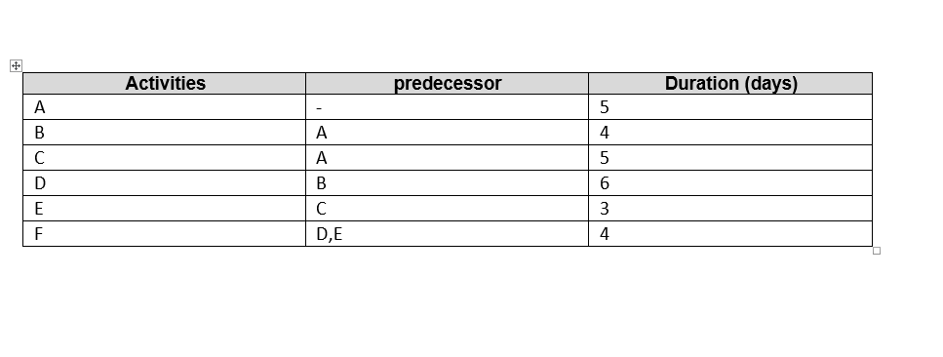

Diagram network for the project
D
E
F

B

A

c

the Critical Activities and the total duration of the project:

1-Path number 1: A → B → D → F, it is the longest pathway; total duration is 19 days.

2-Path number 2: A → C → E → F, the total duration is 17 days.

3-The total duration of all project is 27 days.

Q3:

_the activities number (D)it takes more day and present in the longest path of the project.

_ the project (E) has 3 days it makes it more flexible and shorter period of time.

