
Libyan International Medical University
Second Year Basic Medical science

Asymptomatic bacteriuria among secondary school students

Name Essra Jalal
Roll NO. 2834
Supervisor asmaa alkawafie

Assisted by Lujien shakmak

ABSTRACT
The presence of bacteria in urine without any indications or symptoms is known as asymptomatic bacteriuria (ASB). This illness affects people of all ages, but women, especially pregnant women, are more vulnerable than males due to a small urethra and easy fecal flora contamination of the tract. The goal of this study is to find out how common asymptomatic bacteriuria is among LIMU students. After being cultured, 13 samples exhibited bacterial growth, with 3 samples belonging to the male gender and 9 samples belonging to the female gender, with 25.0 percent and 83.3 percent respectively. A P value was determined to check whether there was any association between gender differences (P=0.004). According to a study conducted in Iran, the overall prevalence of ASB among pregnant women was found to be 12%.

Introduction

A bacterial infection will infect your bladder and cause (cystitis), urethra (urethritis), or kidneys (pyelonephritis). It is one every of the most general microorganism infections. In addition, one out of every five women may have it at a moment in their life. Because female urethras is shorter and towards the anus, where E. coli thrives so females have higher incidents than male. Symptoms of tract infections not usually reason signs, but when they are doing, they will accommodate the subsequent. Excretion cravings that square measure excessive and protracted, additionally to a burning feeling while urinating. Urine passing in very little volume or it may contains Blood with inside the urine (hematuria).
Urine may be a waste factory-made from the filtration mechanism of our kidneys. Microorganism square measure rarely visible within the urine is made while your kidneys matter waste and obtain obviate further water out of your blood. It usually goes via your urinary device while not inflicting any issues. Bacteria, on the alternative hand, have the cap potential to invade the body. Microorganism input the tract via the channel and proliferate with inside the bladder, succeeding in tract infections. Despite the fact that the urinary device is meant to take care of out similar invaders, those defenses typically fail. once this happens, within the urinary device, germs will stabilize and develop right into a full-blown infection.
The maximum common UTIs have an effect on the bladder and tract, and they preponderantly have an effect on women. Tract contamination (cystitis). E. coli a kind of bacteria typically determined with inside the channel (GI) tract, is the most commonplace place reason for this form of UTI. Another being might, however, be at blame.
Cystitis could also be a result of sexual issues. thanks to their anatomy — notably, the tiny distance between the channel and also the arsehole and also the duct access to the bladder — all women square measure vulnerable to urinary tract infection. The urine manner takes a glance at is employed to develop and find organisms that will reason tract contamination, typically microorganisms and fungi. Even so, germs from the urinary device will input the channel and reason a UTI contamination. However, the croaker can advocate a urine manner and insight take a glance at to determine if there's contamination and to what extent, If the signs persist for further than an infinite vary of days (perhaps 3–four days)

Aim
The purpose of this report is to compare between female and male having UTI.

Materials and Methods
A urine sample was collected in a sterile container, the samples were cultured and incubated (24-48 hours) to detect any observable bacterial growth, and each specimen was checked to determine its color, growth , and bubbling after the samples were collected. Urine culture is then used to determine the existence of bacteria in a urine sample by culturing. the samples were cultured on blood agar by manually striking and dispersing them on a Petri-dish, then in Mueller–Hinton agar we culture the bacterial to do antibiotic sensitivity test and
determines the specific treatment for the case.

Materials:
_loop wire
_ Culture media
_flame
_urine sample from the patient
_ Mueller_hinton agar

Discussion
Based on the results of the culture tests - in which the bacteria were grown on both a MacConkey and blood agar - it was concluded that the bacterium was Escherichia Coli, which is the most common bacterium causing urinary tract infections (UTI). It gave lactose-fermenting colonies on MacConkey agar, while beta-hemolytic colonies formed on blood agar.
As shown in the table above, the assumption is wrong because the P value is less than 0.05. Which suggests that there is a clear difference between bacterial growth in women and men. About 16.7% of women had no bacterial growth; while compared to men about 75%. Also, about 66.7% of women overall had no significant growth, while men had only 25%. This indicates that there is no asymptomatic bacteriuria; however, there is bacterial growth and this may be due to insufficient sterilization during culture growth or simply normal flora.
However, significant growth (N) percentage values ​​show that women are more at risk of developing asymptomatic bacteriuria (due to E. coli) than men. The (N) percentage value for females is around 16.7%, while for males it is simply 0%. E coli is by far the most common cause of UTIs.
• Lactose-fermenting colonies on MacConkey's.
Women are particularly at risk for UTIs because their urethra is close to the anus, where E. coli is present. It is also shorter than a man is, allowing bacteria easier access to the bladder, where most UTIs occur, and the rest of the urinary tract.
Klebsiella species
Lactose-fermenting mucoid colonies on MacConkey. The gram-negative bacteria of Escherichia coli and Klebsiella Pneumonia were the most common uropathogenic bacteria that caused uses. According to statistical calculations, there was a significant association between UTI caused by Escherichia coli and female gender (p <0.05)
According to major complication based on UTI Pregnant, mothers are more likely to have low birth weight or preterm babies. Narrowing of the urethra, Acute or chronic kidney infection (pyelonephritis) caused by an untreated UTI can cause permanent kidney damage.
On the other side, preventing it is not difficult. Drink lots of water and other beverages. Drinking water dilutes your urine and encourages you to pee more frequently, allowing germs in your urinary system to be cleared out before an illness develops.

Drink lots of water and other beverages. Drinking water dilutes your urine and encourages you to urinate more frequently, allowing germs in your urinary system to be cleared out before an illness develops.
Cranberry juice should be consumed. Although research on cranberry juice's ability to prevent UTIs are inconclusive, it is unlikely to be hazardous.
Wipe the whole surface from front to back. After urinating and having a bowel movement, do so to avoid germs from migrating from the anal area to the vagina and urethra. After intercourse, empty your bladder as quickly as possible. Additionally, drink a full glass of water to aid in the flushing of germs. Avoid using any feminine items that might irritate you. Using deodorant sprays or other feminine items in the genital area, such as douches and powders, might irritate the urethra.
Alter your birth control method.

Result
Table 1: Urine sample results
 | No growth  (N) % | Overall no significant growth  (N) % | Significant growth  (N) % | P-value
Females | (2) 16.7% | (8) 66.7% | (2) 16.7% | 0.020^{b}
Males | (9) 75% | (3) 25% | (0) 0%

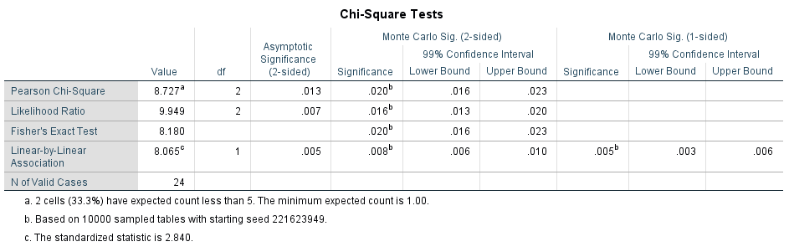
Table 2:

Conclusion
Urinary tract infection is a common infection that affects both men and women female have more incidence because female urethra is shorter and and near the anus. Age plays a role, as older persons who use urinary devices such as catheters are more susceptible to infection.

References
- Ghafari M, Baigi V, Cheraghi Z, Doosti-Irani A. The Prevalence of Asymptomatic Bacteriuria in Iranian Pregnant Women: A Systematic Review and Meta-Analysis. Rosenfeld CS, ed. PLOS ONE. 2016;11(6):e0158031. doi:10.1371/journal.pone.0158031
- Shaikh N, Osio VA, Wessel CB, Jeong JH. Prevalence of Asymptomatic Bacteriuria in Children: A Meta-Analysis. The Journal of Pediatrics. 2020;217:110-117.e4. doi:10.1016/j.jpeds.2019.10.019
- Trautner BW. Asymptomatic bacteriuria: when the treatment is worse than the disease. Nat Rev Urol. 2011 Dec 6;9(2):85-93. doi: 10.1038/nrurol.2011.192. PMID: 22143416.

