Analysis of Urine Culture Test to Identify the Effect of Gender on Asymptomatic Bacteriuria
Libyan International Medical University
Faculty of Applied Medical Sciences
Tahani Hilali_2722
Supervisor: Dr. Intisar Alnaji
Assistant by:
Prof.Naji Al-Hamri
Prof.Asmaa Al-Kwafi
Dr. Loujain Al-Shakmak

Abstract: Urinary tract infections (UTIs) are among the most common bacterial infections. Although the distribution of pathogens that cause UTIs is changing, enteric bacteria (particularly Escherichia coli) remain the most common cause of UTIs. Urine culture is the gold standard, but a urine dipstick test can aid in the early detection of UTI and thus avoid the complications of UTI. The study aims to compare the asymptomatic UTIs between males and females and most types of bacteria can cause infection. For this experiment choose randomly 24 clean-catch midstream urine samples of the college-age students. After distributing the samples to the dishes; incubating at 37ºC for about 24 hours appear bacterial growth in about 54% of the total samples. The percentage of sample growth in females is 41%, while in males 1.25%, but not considered all of them as significant growth. Using chi-square and fisher’s exact tests in statistical analysis, all data indicate that females are more susceptible to UTIs.

Introduction:
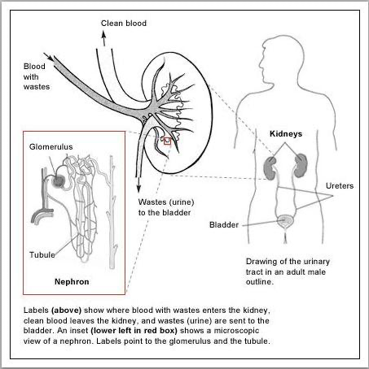
The urinary system is one of the most intricate systems in the human body, it is also one of the hardest systems to understand. The upper part includes the two kidneys and ureters, while the lower part includes one urinary bladder and urethra (Figure 1). Further, the main functional unit of the kidneys is the nephron, the kidneys contain approximately one million nephrons.
(Figure 1): The parts of the urinary system.

Certainly, we know their function is urination but not only this; in addition to filtration of the blood and creating urine as a waste by-product, it plays a major role in numerous processes in the body all working together to maintain the homeostasis. The kidneys work to regulate blood pressure and acid-base balance, production of erythropoietin, also to maintain fluid and electrolyte balance, and PH.

In addition, normal urine is a sterile, odorless, and pale yellow to deep amber. All of these traits change when the individual's health is abnormally and suffering from some health conditions, such as urinary tract infection (UTI), which refers to an infection in any part of the urinary system; the infection involves the kidneys (called pyelonephritis), bladder (called cystitis), or urethra (urethritis). Further, the urethra has habitant microflora that colonizes the epithelium in the peripheral part. The infection can affect any part of the urinary system either upper or lower parts, in different two ways either hematogenous (Descending) or exogenous infection (Ascending).

The presence of bacteria in the urine of a patient who has no signs or symptoms of a urinary tract infection is known as asymptomatic bacteriuria.
This experiment aimed to compare males and females who are more affected by asymptomatic bacteriuria and the main organisms that can do it.
Null hypothesis: No association between gender and UTIs.
Alternative hypothesis: There is an association between gender and UTIs.

Methods and Materials:
This experiment involves a total of 24 college-aged students (12 females and 12 males). The experiment took place at approximately 10:00 am at the microbiology lab on the LIMU university campus. Urine in a healthy person's bladder is sterile, but it picks up germs from the normal flora as it flows through the distal region of the urethra. To stay away from these organisms, a midstream specimen is discharged after cleaning the external orifice the urine cultures are performed through it. In exceptional circumstances, is possible that suprapubic aspiration or catheterization will be committed, to obtain a sample.

All urine samples collected from participations students were cultured on Then culture (blood and MacConkey agar plates), using a sterile standard loop (1m) then incubated at 37ºC for 24 hours. Because urine is an excellent culture medium, cultures must be performed within 1 hour of collection or held in a refrigerator at 4°C for no longer than 18 hours. (1) a calibrated loop holding 0.001 mL of urine was used to streak the culture; (2) serial 10-fold dilutions were prepared and samples from the dilutions were streaked; then (3) the culture was incubated in the centrifuge for around 24 hours.
Materials: (Urine samples, Petri dish, Agars, Inoculating loop 10µL, Bunsen burner, Incubator).
Statistical Methods: Was performed using SPSS version (26.0). The Pearson chi-square test or Fisher’s exact test were used to compare categorical variables. Statistical significance was defined as the P-value <0.05.

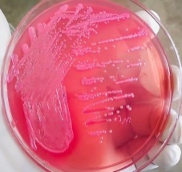
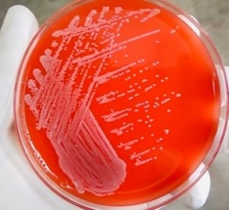
Results and Statistical Analysis: The growth of bacteria appears in most of the samples, most of them arrangement smooth, mucoid and pink color of rods in a MacConkey agar, while in blood agar appears grayish-white appearance. (Figure 2).
Figure 2: culture growth of lactose-fermenting organism, Such as E.coli on urine sample plates; blood agar (L); McCloskey (R).
The bacterial growth is measured by colony-forming units (CFUs), To confirm infection, a number threshold of colony-forming units (CFUs) per milliliter has been defined. A concentration of 100,000CFU/mL or equal is consistent with infection in samples taken from a midstream void. 100CFU/mL or equal in catheterized samples indicates infection. To conclude that considerable bacteriuria is present, a bacterial count of at least 100,000/mL is typically recognized (in asymptomatic persons). In symptomatic patients, even as little as 100/mL is meaningful.

Bacterial growth on culture media for all females' samples except for two does not appear, while in the samples of males just on three plates arise growth. All total of 24 students participated in this experiment; 13/24 occurred growth in their culture samples, whereas 11/24 did not happen growth, but just 2/24 considered significant growth. Table (1). In general, the statistical test used the chi-square test. But the assumption is not meted so, it is replaced by Fissure’s Exact Test. (Table 1); SPSS results (Tables 2 and 3).

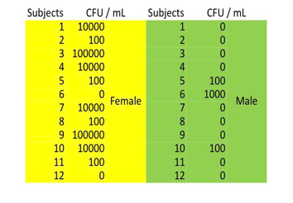
Table 1: The bacterial growth measured by CFUs.

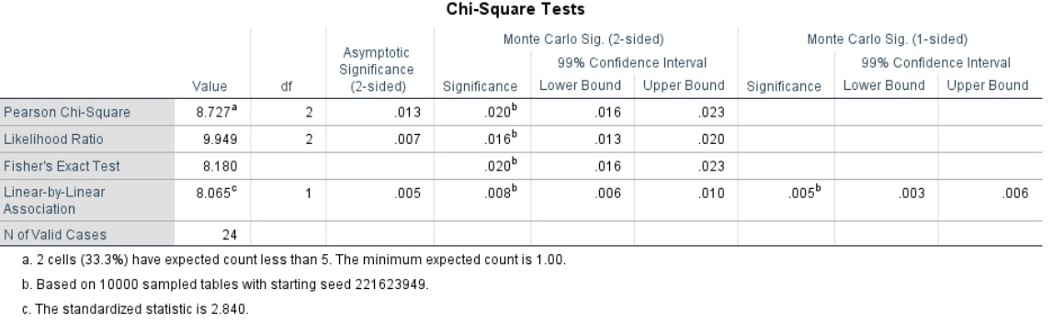
Table 2:

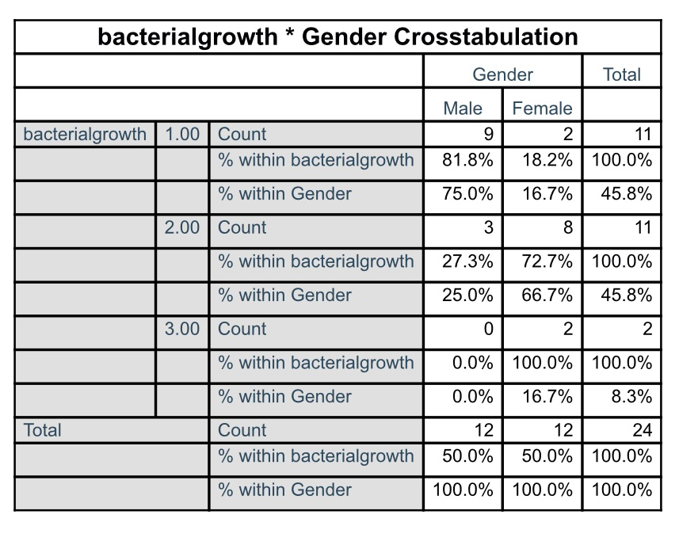
Table 3:

Summary Table:
P-value | Female (%) | Male (%) | Bacterial growth
0.02 | 2 (16.7%) | 9 (75%) | Non growth
0.02 | 8 (66%) | 3 (25%) | Growth
0.02 | 2 (16.7%) | 0 (0.0%) | Significant growth
A P-value of fisher's exact test.
Discussion: Reject Ho. Since the p-value is less than alpha 0.05 we reject null hypothesis.
Interpretation: There is an association between gender and bacterial growth.

Discussion:
This experiment was an attempt to determine the incidence of UTIs, microbial pathogens implicated in UTIs, and asymptomatic microbial infection; to assess the effect of gender on UTIs compared to the results of samples were measured at the same time and under the same conditions. The results of the experiment show according to statistical tests there was a significant difference between males and females affected by the UTIs since the p-value is <0.05 there is an association between gender and bacteriuria. So rejected the null hypothesis because, of the p-value of fisher’s exact test=0.02.
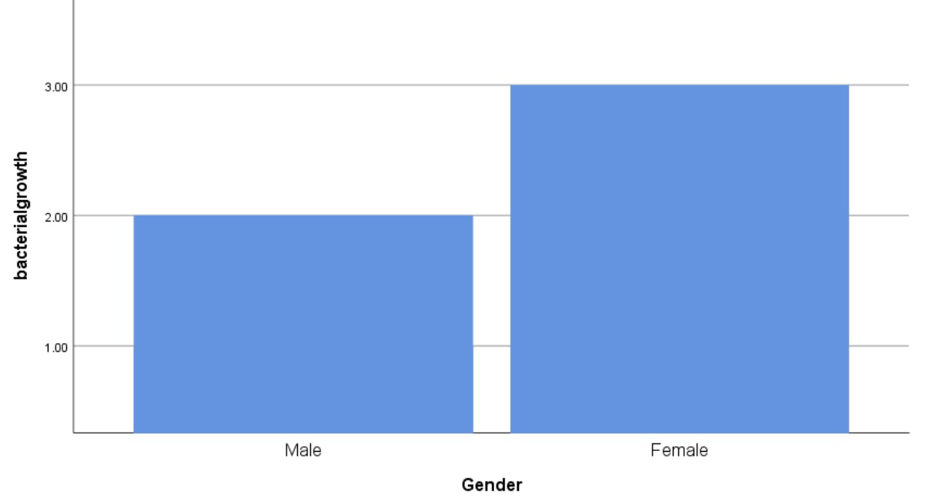
Figure 3: The relation between gender and bacterial growth.

Asymptomatic bacteriuria vs urinary tract infections occur at variable rates in different patient groups. Asymptomatic bacteriuria can occur in younger, healthy people, but it is uncommon in elderly people. Women are more prone than men to have UTIs, while men begin to develop them around the age of 50. Approximately half of all women will get at least one UTI during their lives, with one in every three women experiencing one by the age of 24. UTI recurrence is 25% in younger women within 6 months after the first incident. Although up to 40% of pregnant women with asymptomatic bacteriuria will develop a UTI if they are not treated, the actual rate of UTIs in pregnancy is as low as 4%. UTIs are the second most prevalent illness among older people who do not live in a nursing home, accounting for 25% of all infections. [4]

However, due to the proximity of the urethra to the vaginal and rectum, females are more likely to acquire UTIs, which can result in the inadvertent introduction of fecal microbes into the urinary tract. In cystitis, bacteria move from the urethra to the bladder. Pyelonephritis occurs when germs go from the bladder to the kidneys via the ureters. In addition, most women have temporary bacteriuria following sexual intercourse, however, only a small percentage of these women will acquire symptomatic infections since the body's natural defense mechanisms usually prevent symptomatic infection.

To confirm this, several studies have been conducted on the subject, for example; In a study in Egypt's Menoufiya Governorate, 314 (62.8%) of 500 children were males and 186 (37.2%) were females, with a prevalence of UTI of 4.8 percent among children aged 3-12 years attending the pediatric outpatient clinic at Menoufia University Hospital.[5]
The current study found a statistically significant difference between males and females in terms of UTI prevalence, with females having 54.8 percent (46 females from 84 having UTI) and males having 45.2 percent (38 males from 84 having UTI) (P =0.014). Females in the age group five to seven years had the highest number of cases (31 percent) compared to males (28.6 percent) in the age group five to seven years.[5]

Although UTIs can be caused by a variety of bacteria, the majority are caused by Escherichia coli (E. coli), a kind of bacteria that is widespread in the digestive tract and frequently detected in stool. Proteus, Klebsiella, Enterobacter, Staphylococcus, and Acinetobacter are some of the bacteria that usually cause UTIs. A yeast infection, such as Candida albicans, can cause a UTI on rare occasions.

Conclusion and future directions:
In a measure of the incidence rate of asymptomatic bacteriuria among LIMU students; at the level of p-value=0.05 there is an association between gender and asymptomatic bacteriuria.
Urinary tract infections affect women and girls more frequently than men and boys. E.coli is the most common bacteria causing UTI, the UTI can be treated with antibiotics but recurrent infection is common. Poor hygiene considers one of the major causes of urinary tract infections and can be reduced by education and following instructions such as drink plenty of water, wash and wipe from front to back, urinate as soon as possible after having sex, consume cranberry juice among others. In the future, there may be an increase in the percentages due to a rise in the consumption of antibiotics without need and prescription. The female urethra's architecture is particularly important in the etiology of UTIs as bacteria can more easily access the bladder in the female host due to the shorter Urethra.

Referencing:
- Isolation and Diagnosis of Some Bacteria That Cause Urinary Tract Infection and The Effect of Some Antibiotics on Them in Nasiriyah In the Shattera General Hospital. International Journal of Pharmaceutical Research. 2020;12(sp2). doi:10.31838/ijpr/2020.sp2.150.
- El-Gamasy M, Amin E, Abo Zaid A, I. Kotb A. Incidence, risk factors and causative bacteria of urinary tract infections and their antimicrobial sensitivity patterns in toddlers and children: A report from two tertiary care hospitals. Saudi Journal of Kidney Diseases and Transplantation. 2020;31(1):200. doi:10.4103/1319-2442.279941.
- LEVINSON W. REVIEW OF MEDICAL MICROBIOLOGY AND IMMUNOLOGY. 14th ed. [S.l.]: MCGRAW-HILL EDUCATION; 2016.
- Crader M, Kharsa A, Leslie S. Bacteriuria. Ncbi.nlm.nih.gov. https://www.ncbi.nlm.nih.gov/books/NBK482276/#_NBK482276_pubdet_. Published 2022. Accessed June 20, 2022.
- Givler D, Givler A. Asymptomatic Bacteriuria. Ncbi.nlm.nih.gov. https://www.ncbi.nlm.nih.gov/books/NBK441848/. Published 2022. Accessed June 20, 2022.

