
LIBYAN INTERNATIONAL MEDICAL UNIVERSITY
APPLIED MEDICAL SCIENCES –THIRD YEAR
P.T.S. BLOCK
Assignment
Project management workshop

Name: Rawan Yousri Elgerbi Roll number: 2504 Group: A3

- Develop a network diagram for the project specified below. (50 %)
- Identify the Critical Activities and the total duration of the project. (35%)
- Justify which activity would you crash based on some rationale (15%)
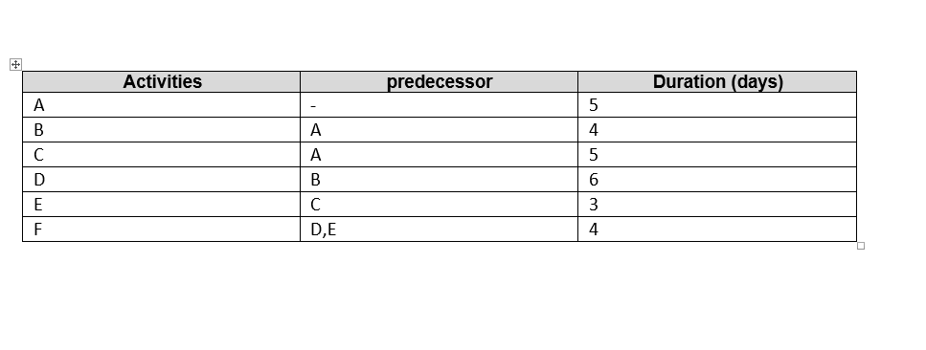

Answer 1: Diagram network for the project
F
E
D

B

A

C

Answer 2: the Critical Activities and the total duration of the project:

Route 1: A B D F, it is the longer route with a total duration of 19 days.
Route 2: A C E F, the total duration is 17 days.
The total duration of all activities of the 2 routes combined is 27 days.
The critical activities are the beginning and end activities which determine whether the project is going to succeed or not and have no alternatives.

Answer 3: the activity that would be crash is number D

Because it’s the activity that takes the longest duration which is 6 days and it’s also present in the longer route of the project.
On the contrary activity E which is the shortest activity of the project and also the reason the other route takes a shorter amount of time.
The most rational reason is in the scenario where activity F needing both activities D and E to be complete therefore wasting days just on activity D because it’s takes twice the duration of activity E.

