
Use of urinary gram stain for detection of urinary tract infection in childhood
Student name: Hunaydah Hani Ben ghuzzi
Student number: 3003
Supervisor name: Drs. Entesar Alnagi , Asma Alkawafi , Alsenussi , Iman Alfarjani , Laboratory Technician .
Date: June 20,2022

Abstract :
Urinary culture, Gram stain, and urine analysis assays were used in this investigation. "Leucocyte esterase, nitrate, Microscopy for bacteria, and pyuria" were tested in 100 children with signs of urinary tract infection.
Goal was to compare the validity and benefits of a urinary Gram stain to a combination of Gram stain and total urine analysis, such as nitrate positireness , leukocyte esterase, bacteria microscopy, and white blood cell microscopy.
Of 100 children (age: 2 days-15 years), 70% had a positive urinary culture : 43% boys and 57% girls .
E. coli was the most commonly isolated agent (Escherichia coli) .
The urinary Gram stain has a sensitivity and specificity of 80% and 83 percent, respectively, for both pyuria and Gram positivity.
A positive urinary culture was found in 70 percent of 100 children (aged 2 days to 15 years): 43 percent of boys and 57 percent of girls . E .coli was the most commonly isolated agent (Escherichia coli) .The urinary Gram stain has a sensitivity and specificity of 80% and 83 percent, respectively, for both pyuria and Gram positivity .
accounted for 42 percent and 90 percent of the whole urine analysis, respectively, while the entire urine analysis accounted for 3.5 percent. In symptomatic individuals, no urine screen can replace a urine culture, according to finding .

Introduction :
Urinary tract infection (UTI) is a frequent pediatric ailment that affects 3-5 percent of girls and 1% of males . Prompt treatment is critical in this age range because even a little delay might result in long-term consequences.
However, quick therapy is contingent on accurate diagnosis. Although there are various fast screening techniques available, including urine analysis (microscopic pyuria), enhanced urine analysis (white blood cell "WBC" count per cubic millimeter + Gram stain), urine dipstick (leukocyte esterase or nitrate), and urine screen (catalase test). None of them have shown to be adequate .Urinary culture, urinary Gram stain, and four tests within the urine analysis, leukocyte esterase, nitrate, microscopy for bacteria, and microscopy for viruses, were used in this investigation .The goal of this study was to compare the urinary Gram stain to a combination of pyuria positive Gram stain and total urine analysis to see how accurate it was.
Materials and Methods:
The study included 100 children who were admitted to the hospital , department of popocliatrics , between January 1999 and Jun 1999 with symptoms suggesting UTI . Physical examinations were performed on all children, and urine samples were collected using a sterile procedure. An automated urine analyzer was used to perform leukocyte esterase and nitrate investigations in fresh and non-centrifuged urine. On a centrifuged urine specimen, microscopy for microorganisms and pyuria was done. In automated urinalysis, leukocyte esterase was judged positive if at least a (trace) was present, and nitrate was read qualitatively as (positive) or (negative).
Pyuria was considered present if there were more than fine WBCs on unstained microcopy, and bacteria was present if there was at least a (slight) reading pre-average high-powered field (40 x magnification).Inoculating sheep blood agar and eosin metilen blue agar culture plates with quantitative urine culture was done using a loop calibrated to deliver 0.01 ml. For bacterial identification and colony count, all plates were incubated at 35°C for 48 hours and read.
Gram stain were performed on all specimens using of :
• Centrifuged urine.
• Solutions of crystal violet , Gram’s iodine (2 g potassium iodine in 300 ml distilled water plus 1g iodine crystals) ,95% ethanol and/or isopropanol _ acetone mixture (1:3) and safrarin .
• Clean glass slides .
• Inoculating loop .
• Bunsen burner.
• Bibulous paper .
• Immersion oil .
• Staining rack .
• Bacto Gram stain reagents from difco for the three _ step gram stain .
Figure :
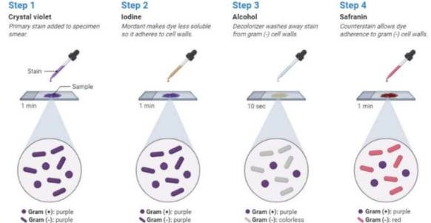

If a culture contained more than 100.000 colonies of a single pathogen, it was termed positive. The data was evaluated, and the X square test was used to perform statistical analysis.
According to SPSS , use Fisher’s law because it shows the UTI difference between male and female .

Results :
The study comprised 100 children ranging in age from 2 days to 15 years old, with 48 percent boys and 52 percent girls. A positive urinary culture was found in 70% of the children, with 43 percent of boys and 57 percent of girls. The majority of these children were under the age of five.
There is a clear distinction between gender and age groupings (Table 1).
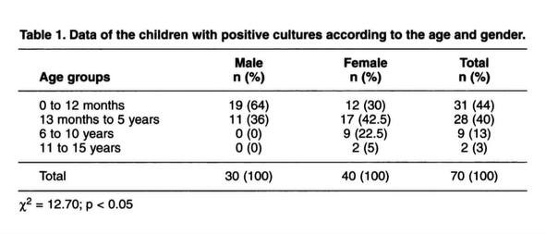
47 percent of the cultures tested positive for E. coli, 18.5 percent for Klebsiella pneumonia, 10% for Proteus mirabilis, and 8.5 percent for staphylococci, among other bacteria. (Table 2 ) .
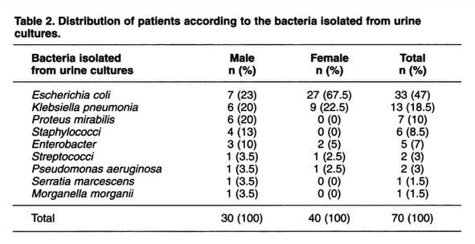
The sensitivity, specificity, and predictive values for Gram stain, pyuria with Gram stain, and overall urine analysis are summarized in (Table 3).
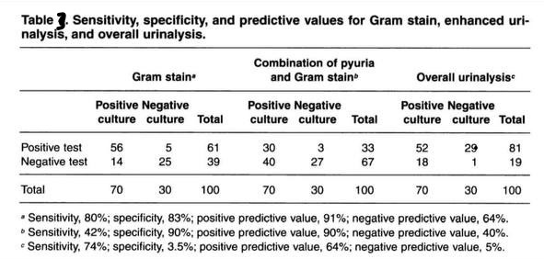

The combination of pyuria and Gram stain has the highest specificity of 90 percent.
Results and Statistical analysis :
The goal of this study was to look for germs in urine samples from 24 LIMU understudies in their middle years. There were twelve young females and twelve young males in attendance. A group of young males 54.2 percent of LIMU students have a disability. Bacteriouria with asymptoms was identified. There were 7 (29.2%) understudy whose urine tests , developed less than 10,000 CFU/mL, 6 (25%) cases with10,000 CFU/mL and more, and 11 (45.8%) with no development. As a result, asymptomatic bacteriuria was found to be prevalent in 18% of LIMU understudies (75%) and, as seen in table 1, as follows:
Case Processing Summary
 | Cases
 | Valid |  | Missing |  | Total
 | N | Percent | N | Percent | N | Percent
Gender * UTICATS | 24 | 100.0% | 0 | 0.0% | 24 | 100.0%

Gender * UTICATS Crosstabulation
 |  |  | UTICATS |  |  | Total
 |  |  | No growth | No significant growth | Significant growth | Total
Gender | Male | Count | 9 | 3 | 0 | 12
Gender | Male | Expected Count | 5.5 | 5.5 | 1.0 | 12.0
Gender | Male | % within Gender | 75.0% | 25.0% | 0.0% | 100.0%
Gender | Male | % within UTICATS | 81.8% | 27.3% | 0.0% | 50.0%
Gender | Female | Count | 2 | 8 | 2 | 12
Gender | Female | Expected Count | 5.5 | 5.5 | 1.0 | 12.0
Gender | Female | % within Gender | 16.7% | 66.7% | 16.7% | 100.0%
Gender | Female | % within UTICATS | 18.2% | 72.7% | 100.0% | 50.0%
Total |  | Count | 11 | 11 | 2 | 24
 |  | Expected Count | 11.0 | 11.0 | 2.0 | 24.0
 |  | % within Gender | 45.8% | 45.8% | 8.3% | 100.0%
 |  | % within UTICATS | 100.0% | 100.0% | 100.0% | 100.0%
Table 1: the difference between bacterial growth in males and females .
Chi-Square Tests
 | Value | df | Asymptotic Significance (2-sided) | Exact Sig. (2-sided) | Exact Sig. (1-sided)
Pearson Chi-Square | 8.224ª | 1 | .004
Continuity Correction^{b} | 6.042 | 1 | .014
Likelihood Ratio | 8.795 | 1 | .003
Fisher's Exact Test |  |  |  | .012 | .006
Linear-by-Linear Association | 7.881 | 1 | .005
N of Valid Cases | 24
a. 2 cells (33.3%) have expected count less than 5. The minimum expected count is 1.00.
b. Based on 10000 sampled tables with starting seed 2000000.
c. The standardized statistic is 2.840.

Summary table of fisher’s exact test:
 |  | UTI colony forming units |  |  | p-value
 |  | No growth | No significant growth | Significant growth | 0.018
Gender | Male | 9 | 3 | 0 | 0.018
Gender | female | 2 | 8 | 2 | 0.018

Discussion:
Despite the fact that a number of research have been conducted to explain the usage of urine gram stain in infants and children, the outcomes of these investigations have been mixed.
The Gram stain had a sensitivity of 94 percent and specificity of 92 percent in a trial of 207 symptomatic infants younger than 6 months of age, and the total urine analysis test had a sensitivity of 67 percent and specificity of 79 percent.
A study of 1,019 symptomatic pediatric patients found that Gram-stained smears were somewhat more sensitive than dipsticks (97.6% vs. 90.2%), although both had a modest positive predictive value.
Conclusion:
Findings revealed that a combination of pyuria and Gram stain had the highest specificity of 90 percent but the lowest sensitivity of 42 percent .So the urinary gram stain had the highest specificity of 90 percent, while the overall urine analysis had the lowest specificity of 3.5 percent. In light of these data, we believe that neither urine screening nor urine culture should be used in symptomatic pediatric patients.

References :
Arslan S, Caksen H, Rastgeldi L, Uner A, Oner AF, Odabaş D. Use of urinary gram stain for detection of urinary tract infection in childhood. Yale J Biol Med. 2002;75(2):73-78
Levinson, Warren. Review of medical microbiology and immunology. 14rd ed. The McGraw-Hill Companies, 2016
Gorelick MH, Shaw KN. Screening tests for urinary tract infection in children: A meta-analysis. Pediatrics. 1999;104(5):e54. doi:10.1542/peds.104.5.e54
Lockhart GR, Lewander WJ, Cimini DM, Josephson SL, Linakis JG. Use of urinary gram stain for detection of urinary tract infection in infants. Ann Emerg Med. 1995;25(1):31-35. doi:10.1016/s0196-0644(95)70351-9

