
LIBYAN INTERNATIONAL MEDICAL UNIVERSITY
APPLIED MEDICAL SCIENCES –THIRD YEAR
P.T.S. BLOCK
Assignment
Project management workshop

Name : Mariam Mahmoud Altarhouni Student number : 2405

- Develop a network diagram for the project specified below. (50 %)
- Identify the Critical Activities and the total duration of the project. (35%)
- Justify which activity would you crash based on some rationale (15%)
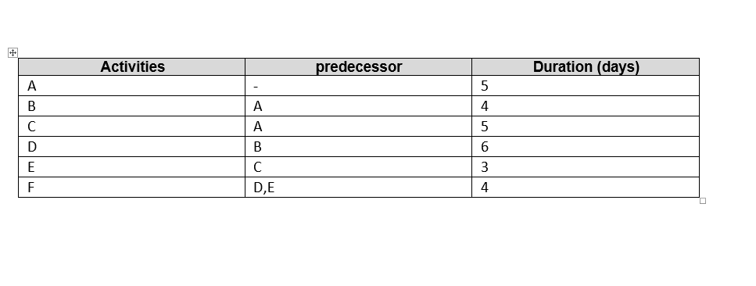
6 d
4 d
D
B
answer 1 :
A
4 d
5 d
3 d
5 d
F
E
C

answer 2:
path 1 : A – B –D-F :19 days
path 2 : A-C-E-F :17 days
path 1 is the critical path because it requires the longest duration.
-if we took the critical path the time will be spent is 19 days.
-If we took the path2 the time will be spent is 17 days
- all the activities require 27 days.
Answer3 :
The activity that would be crashed it is the longest duration , lowest cost , and included in the critical path so it would be D

