

The Prevalence of Asymptomatic Bacteriuria Between the Male and Female Gender

Student Name: Yaken Masoud Tuhami, 2743
Libyan International Medical University, Faculty of
Applied Medical Science (AMS)

Supervised by:

د. انتصار الناجي
Assisted by:
أ. ناجي الحمري -

Introduction:
A urinary tract infection also known as (UTI) , happens when a bacterium, often from the skin or rectum, enter the urethra and infect the urinary tract. It is an infection that occurs in any part of your urinary system, that can happen in different parts of your urinary tract. Each type has a different name, based on where it is located:
- Cystitis is inflammation of the (bladder)
- Pyelonephritis is inflammation of the (kidneys)
- Urethritis is inflammation of the (urethra)
Asymptomatic bacteriuria is another type of UTI, which is going to be our main focus in this paper.
First it is important to know who’s at high risk of acquiring a UTI infection?
Some are at higher risk of getting a urinary tract infection than others, in general UTIs are more common in females than males due to the anatomical differences in the length and proximity of the urethra to the rectum in females (the urethra being shorter in females), which gives bacteria transversing from the urethral meatus and the perineum a shorter distance to the bladder, facilitating their entry to the urinary tract.
Asymptomatic bacteriuria occurs in a small number of healthy people.
It affects women more often than men for the reasons mentioned above, the reasons for the lack of symptoms are not well understood. ⁽¹⁾

Diagnosis of asymptomatic bacteriuria is made by urine culture. Either a properly collected clean-catch specimen or a catheterized specimen is acceptable. The Infectious Diseases Society of America (IDSA) has established criteria for diagnosing asymptomatic bacteriuria. ⁽²⁾
for the sake of this report, we will look at different samples acquired from both the male and female gender:

Midstream clean catch urine specimen:
- For women, two consecutive specimens with isolation of the same bacteria species with at least 100,000 colony-forming units (CFUs) per ml of urine.
- For men, a single specimen with isolation of one bacteria species with at least 100,000 CFUs per ml of urine.

Catheterized specimen:
- For women or men, a single specimen with isolation of one bacteria species with at least 100 CFUs per ml of urine.

In the elderly, it is thought that incomplete bladder emptying contributes to the increased incidence of asymptomatic bacteriuria
Most patients with asymptomatic bacteriuria will never develop symptomatic urinary tract infections and will have no adverse consequences from asymptomatic bacteriuria. Only exception where patients with asymptomatic bacteriuria should be treated are pregnant women and patients undergoing urologic procedures. Other non-predisposed patients will not benefit from treatment. ⁽³⁾

Materials and Methods
• Sample
• Wire loop 0.001mL
• Blood and MacConkey agar
• Flame
• Incubator
The anticipate results are E. coli positive, as it is the most common cause of UTI in today’s society.
When collecting the sample, the patient needs to be aware that it can be contaminated by the normal flora in the urethra, for precaution the sample is collected mid-stream.
The sample preferably is collected in the morning due to the high concentration of urine
The culture can be done in a matter of an hour from collection of the sample, but the sample can last for as long as 18 hours in a specific temperature which is 4C because urine is a good media.

The difference in results between the symptomatic and the asymptomatic patient is that the symptomatic 1000ml is enough, but the asymptomatic 100,000ml for bacterial growth
Lastly after the sample has been collected, we need to make the culture by taking the wire loop and streak the culture and leave it in the incubator
Afterwards colonies from different cultures are compared with each other.
The clony forming unit (CFU) is multiplied by 1000(0.001 ml loop used) or by 100 (0.01 ml loopused) to end up with the number of microorganisms.

Results
After performing the previous steps, the results appear to be as following:
• For males: three non-significant, nine of which there was no growth and non-significant growth
• For females: due to the higher incidence as we previously discussed they had two of which had growth, eight of which non-significant growth, lastly 2 without any growth these results are of significant nature and will be discussed later on.
These results were shown to be significant statistically using the chi square with a p-value of .013

Our working Hypothesis is as follows:
H0: no association between gender and asymptomatic bacteriuria
Ha: there is an association between gender and asymptomatic bacteriuria
Assumptions: random and Independence samples were collected
• Random as the name states random samples have been collected from population
• Independent monitoring them from each other

Sample Size:
• No more than 20% of the cells have expected count < 5
• The expected frequency (count) in each cell must be ≥1
Nonetheless; the assumptions were not met as two cells (33.3%) have expected count less than 5, The minimum expected count is 1.00
and a Fisher’ Exact Test had to be done
the null hypothesis (FTR) was turned down
because P-value less than alpha 0.05, we reject the null hypothesis

Chi-Square Tests ⁽³⁾ | Value | df | Asymptotic Significance (2-sided) |  |  |  | Monte Carlo Sig. (1-sided)
 |  |  |  | Significance | 99% Confidence Interval |  | Significance | 99% Confidence Interval
 |  |  |  |  | Lower Bound | Upper Bound | Significance | Lower Bound | Upper Bound
Pearson Chi-Square | 8.727ª | 2 | .013 | .018^{b} | .014 | .021
Likelihood Ratio | 9.949 | 2 | .007 | .012^{b} | .009 | .015
Fisher's Exact Test | 8.180 |  |  | .018^{b} | .014 | .021
Linear-by-Linear Association | 8.065^{c} | 1 | .005 | .006^{b} | .004 | .008 | .004^{b} | .003 | .006
N of Valid Cases | 24
a. 2 cells (33.3%) have expected count less than 5. The minimum expected count is 1.00.
b. Based on 10000 sampled tables with starting seed 2000000.
c. The standardized statistic is -2.840.

Discussion
The results shown proved valid in regards to our hypothesis, it shows that the female gender is more prone to contracting asymptomatic bacteriuria than that of the male gender, with 16.6% of the overall 12 women shown to have significant growth, whereas 0% of the 12 men had significant growth. This is significant in the proving of our initial hypothesis that females have a higher incidence of urinary tract infections due to the anatomical nature of there urinary system

Bacteria are frequently noted on urinalysis and cultured from urine specimens. The presence of bacteria in the urine may indicate one of 3 conditions: 1) specimen contamination; 2) urinary tract infection (UTI); or 3) asymptomatic bacteriuria (ASBU). When evaluating the clinical significance of a urine culture these 3 conditions must each be considered and classification should be based upon history and exam findings coupled with urine findings. Specimen contamination should always be considered as this is common, particularly in female patients. High numbers of squamous cells on the urinalysis (>20) suggests contamination and results of the culture should generally be ignored.

In patients with a positive urine culture, where no contamination exists, clinicians must determine if the patient is exhibiting symptoms of a Urinary Tract Infection . Symptoms typical of a Urinary Tract Infection are urinary frequency or urgency, dysuria, new onset hematuria, suprapubic pain, costovertebral tenderness or fever. Patients with a urinary catheter in place may have more vague symptoms such as new onset or worsening fever, chills, pelvic discomfort, acute hematuria and altered mental status with no other identifiable etiology.

Screening for and treating ASBU patients should only occur if the bacteriuria has an associated adverse outcome (such as development of a symptomatic urinary tract infection, bacteremia, progression to chronic kidney disease, etc.) that can be prevented by antimicrobial therapy. There are only 2 clinical situations where these criteria are clearly met. Pregnant women should be screened and treated for ASBU, as they have a significantly increased risk of developing pyelonephritis as well as experiencing a premature delivery and delivering a low-birth-weight infant. Prior to transurethral resection of the prostate (TURP) or any other urologic procedure with a risk of mucosal bleeding, patients should be screened for bacteriuria, as it has been associated with a major increase in the risk for post-procedure bacteremia and sepsis. Treatment of ASBU in both these situations has been demonstrated to prevent these complications. ⁽¹⁾

Table 1 summarizes the prevalence of asymptomatic bacteriuria in selected populations ⁽¹⁾
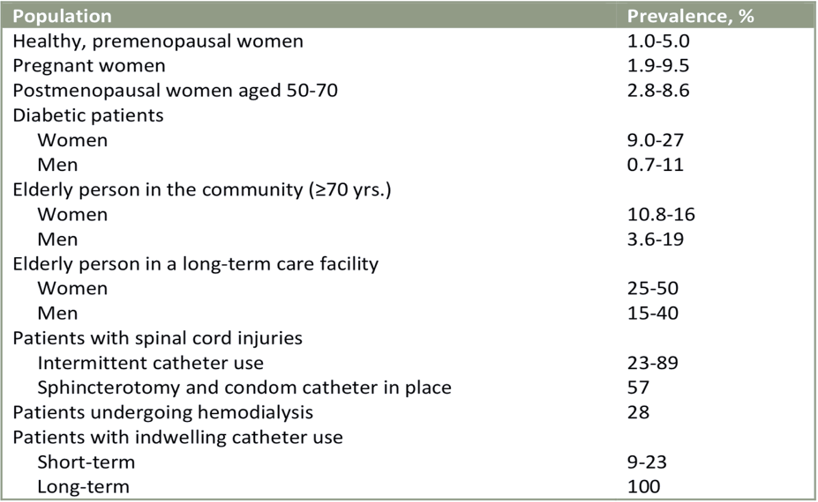
Unfortunately, many patients with ASBU receive treatment which they do not benefit from and in fact are likely harmed by. The unnecessary treatment of ASBU can lead to antibiotic resistance, adverse drug effects, C. difficile infection, and contribute unnecessarily to the costs of medical care.
Who to screen and treat for asymptomatic bacteriuria:
• Pregnant women (at least once in early pregnancy)
• Patients prior to a urologic procedure for which mucosal bleeding is anticipated (i.e., TURP Transurethral resection of the prostate, etc.)
• Kidney transplant patients are a group where the data is unclear and no recommendation can be made

Conclusion
This Research was done for the sole reason of proving that in general, Females are more prone to acquiring UTIs (in this case asymptomatic bacteriuria) than men due to the difference in the anatomy of their urinary tract. Not putting in account other possible predisposed people capable of acquiring such infections. And as the results showed females do in fact have a higher incidence in acquiring a UTI more specifically the asymptomatic form of Bacteriuria indicating the importance of increasing the public awareness and for further research to be done with greater sample sizes.
Asymptomatic bacteriuria is more common in some patient populations and the prevalence increases with advancing age, it is also associated with sexual activity in young women, patients with impaired urinary voiding or indwelling urinary devices have a much higher prevalence of acquiring asymptomatic bacteriuria. It is also very important to note the proper indications for ordering a urine culture and the proper way to collect samples to give accurate results.

References

- Unmc.edu. https://www.unmc.edu/intmed/divisions/id/asp/clinical-pathways/docs/uti-asbu-guidance-final.pdf. Published 2022. Accessed June 19, 2022.

- Gupta K, Hooton T, Naber K, Wullt B, Colgan R, Miller L, Moran G, Nicolle L, Raz R, Schaeffer A, Soper D. International Clinical Practice Guidelines for the Treatment of Acute Uncomplicated Cystitis and Pyelonephritis in Women: A 2010 Update by the Infectious Diseases Society of America and the European Society for Microbiology and Infectious Diseases. Clin Infect Dis.

- Nicolle L, Bradley S, Colgan R, Rice J, Schaeffer A, Hooton T. Infectious Diseases Society of America Guidelines for the diagnosis and treatment of asymptomatic bacteriuria in adults.

