Libyan International Medical University
Faculty of Applied Medical Science
ASYMPTOMATIC BACTERIURIA

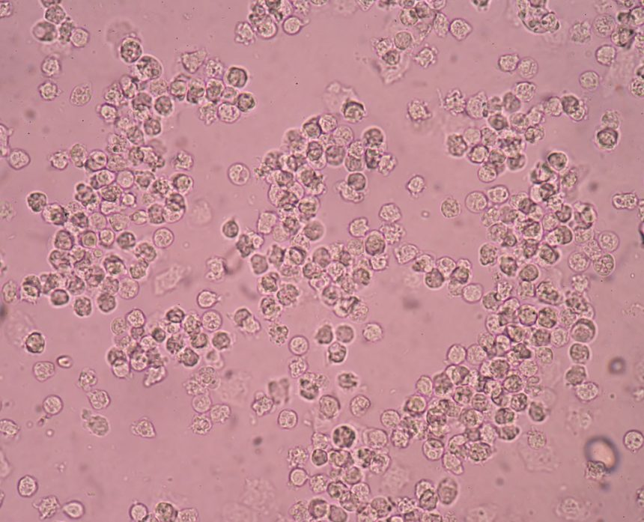

Student name : Sierag Monier Sharif
Student number: 2509
Supervisor name and any tutors/ teaching staff: Dr. Asma

● Abstract:
Urine is normally sterile. Asymptomatic bacteriuria (ASBU) is a condition in which a significant number of bacteria appear in the urine, without the presence of typical symptoms of a urinary tract infection. Escherichia coli is the single most common cause of ASBU. ASBU is more common in elderly and its prevalence increase with age. ASBU has been slightly more common in black population. Screening for asymptomatic subjects is considered if bacteriuria is associated with preventable adverse outcomes such as symptomatic urinary infection, progression to chronic kidney disease or hypertension, development of urinary tract cancer, and decreased duration of survival. If left untreated ASBU normally cures on its own and active treatment is not required except in those who are pregnant, require renal transplantation or are supposed to undergo a urinary tract procedure. In patients who acquire ASBU early in their pregnancy, there is a minute chance of issues related to pregnancy like low birth weight etc or pyelonephritis. Most cases resolve postpartum. The diagnosis of bacteriuria in an asymptomatic individual is based on the culture results of urine collected in a manner that minimizes the possibility of contamination and limits the period between sampling and testing the specimen to avoid false positivity due to bacterial growth. Conditions that might require the ASBU to be treated are pregnancy, before transurethral prostatic resection, and renal transplant follow-up.

● Introduction
Patients with ASBU are, by definition, asymptomatic. They have no symptoms that can be attributed to bacteria in the urine. This is completely different from the evaluation and management of symptomatic bacteriuria or urinary tract infections.² To explain more precisely, the term ASBU refers to isolation of bacteria in an appropriately collected urine specimen from an individual without symptoms of urinary tract infection (UTI).¹ The incidence is 15 percent or greater in women and men age 65 to 80 years and as high as 40 to 50 percent after age 80.² ASBU is common, but most patients with ASBU have no adverse consequences and derive no benefit from antibiotic therapy. With few exceptions, nonpregnant patients should not be screened or treated for ASBU.¹
In an age when decreasing unnecessary antibiotic use is emphasized, the important clinical question is this: Which patients with ASBU benefit from treatment? The answer is that most patients with ASBU do not benefit from treatment. There are, however, a few exceptions. There is sufficient evidence that a pregnant woman with ASBU should be treated. Also, patients undergoing urologic procedures in which mucosal bleeding is expected and patients who are in the first three months following renal transplantation should probably be treated for ASBU.²

● Causes of ASBU and sex predilection
The etiology of ASBU has not been conclusively determined. ASBU is more common among women than among men probably because of the shorter female urethra, which gives bacteria from the urethral meatus and the perineum a shorter distance to the bladder. In fact, most women have transient bacteriuria after sexual intercourse, but few of these women will develop symptomatic infections because the body's normal defense mechanisms prevent symptomatic infection in most cases. In the elderly, it is thought that incomplete bladder emptying contributes to the increased incidence of ASBU.³
ASBU is a common clinical finding. While less than 0.5% of infants and toddlers have ASBU, the incidence increases with age. The incidence is 5% or less among healthy premenopausal women, up to 15% or greater in women and men age 65-80 years, and it continues to climb after age 80 to as high as 40% to 50% of long-term care residents. At any age, the incidence of ASBU is higher among females than among males. Escherichia coli is the most common bacteria identified in ASBU.⁴
Several factors are thought to increase the likelihood of ASBU.²
These factors are include:
- Obstructive uropathy (stones, prostatic hypertrophy, cystocele, etc.).
- Fecal soiling of the perineum (especially in women).
- Indwelling urinary catheters.
- Frequent instrumentation of the urinary tract.

● Biostatistics of ASBU
Screening for and treating ASBU patients should only occur if the bacteriuria has an associated adverse outcome (such as development of a symptomatic urinary tract infection, bacteremia, progression to chronic kidney disease, etc.) that can be prevented by antimicrobial therapy. There are only 2 clinical situations where these criteria are clearly met. Pregnant women should be screened and treated for ASBU, as they have a significantly increased risk of developing pyelonephritis as well as experiencing a premature delivery and delivering a low birth weight infant. Prior to transurethral resection of the prostate (TURP) or any other urologic procedure with a risk of mucosal bleeding, patients should be screened for bacteriuria, as it has been associated with a major increase in the risk for post-procedure bacteremia and sepsis. Treatment of ASBU in both these situations has been demonstrated to prevent these complications.
Unfortunately many patients with ASBU receive treatment which they do not benefit from and in fact are likely harmed by. The unnecessary treatment of ASBU can lead to antibiotic resistance, adverse drug effects, C. difficile infection, and contribute unnecessarily to the costs of medical care.⁸
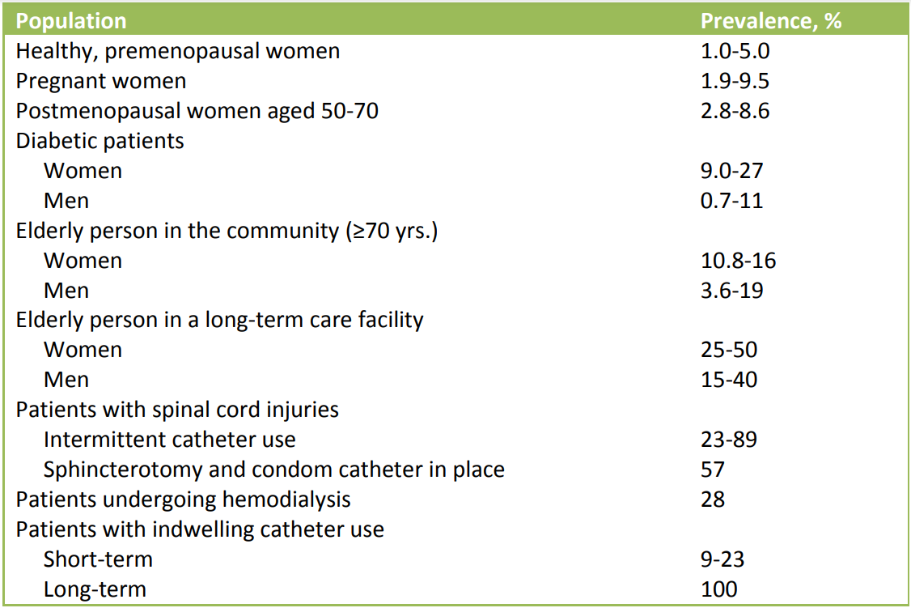

gender * bacterialgrowhsignificance Crosstabulation
 |  |  | bacterialgrowhsignificance |  |  |  | Total
 |  |  |  | no growt | overall | signific | Total
gender | female | Count | 0 | 2 | 8 | 2 | 12
gender | female | % within gender | 0.0% | 16.7% | 66.7% | 16.7% | 100.0%
gender | female | % within bacterialgrowhsignificance | 0.0% | 20.0% | 72.7% | 100.0% | 50.0%
gender | male | Count | 1 | 9 | 3 | 0 | 12
gender | male | % within gender | 8.3% | 66.7% | 25.0% | 0.0% | 100.0%
gender | male | % within bacterialgrowhsignificance | 100.0% | 80.0% | 27.3% | 0.0% | 50.0%
Total |  | Count | 1 | 10 | 11 | 2 | 24
 |  | % within gender | 4.2% | 41.7% | 45.8% | 8.3% | 100.0%
 |  | % within bacterialgrowhsignificance | 100.0% | 100.0% | 100.0% | 100.0% | 100.0%

Chi-Square Tests
 | Value | df | Asymptotic Significance (2-sided) | Monte Carlo Sig. (2-sided)
 |  |  |  | Significance | 99% Confidence Interval
 |  |  |  |  | Lower Bound | Upper Bound
Pearson Chi-Square | 8.873ª | 3 | .031 | .019^{b} | .015 | .022
Likelihood Ratio | 10.372 | 3 | .016 | .015^{b} | .012 | .018
Fisher's Exact Test | 8.225 |  |  | .019^{b} | .015 | .022
N of Valid Cases | 24
a. 4 cells (50.0%) have expected count less than 5. The minimum expected count is .50.
b. Based on 10000 sampled tables with starting seed 2000000.

Result

Hypothesis: H0 : No association between gender status and bacterial growth
Ha: There is an association between gender status and bacterial growth

 | No growth | Overall | Significant growth
Males | 9 | 3 | 0
Females | 2 | 8 | 2
Summary table

p-value of Fisher’s is 0.019
Decision: except to reject the null hypothesis (FTR) Since the P-value lesser than alpha 0.05, we except to reject the null hypothesis.
Conclusion there is association between gender status and bacterial growth

● Samples and methods for diagnosis
The diagnosis of ASBU is made by urine culture. Either a properly collected clean-catch specimen or a catheterized specimen is acceptable. The Infectious Diseases Society of America (IDSA) has established criteria for diagnosing ASBU.

  - Urine samples:
            - Midstream clean catch urine specimen:
For women, two consecutive specimens with isolation of the same bacteria species with at least 100,000 colony-forming units (CFUs) per ml of urine.
For men, a single specimen with isolation of one bacteria species with at least 100,000 CFUs per ml of urine.
            - Catheterized specimen:
For women or men, a single specimen with isolation of one bacteria species with at least 100 CFUs per ml of urine.

  - Methods for diagnosis:
            - Urinary dipstick tests:
Urine dipstick for leukocyte esterase will reliably identify pyuria, but it is not specific for ASBU. (Pyuria may result from other inflammatory disorders of the genitourinary tract.) Urinary dipstick for nitrites is also of limited usefulness because of infection with non-nitrite-producing organisms, the delay between collection and testing of the specimen, and insufficient time since the last voiding for nitrites to be produced at detectable levels. The combination of the dipstick for leukocyte esterase and nitrites is more specific for ASBU than either test alone.^{5&6}
Anyway, some studies revealed that the sensitivity of the urine dipstick test was poor while the ability of the urine dipstick test to correctly rule out urinary tract infection (specificity) was high.⁶

            - Microscopic examination:
Urinalysis with microscopic exam for bacteria is a useful, but non-quantitative, way to identify bacteriuria.²

            - Microbial culture:
Urine culture is the gold standard for the detection of urinary tract infection. However, ASBU is common, particularly in older women, and should not be treated with antibiotics. Conversely, in symptomatic women, even growth as low as 102 colony-forming unit/mL could reflect infection.⁷
Pregnant women should be screened for ASBU with a urine culture. The optimal timing and frequency of screening urine cultures in pregnancy have not been established, but obtaining a screening urine culture at the end of the first trimester of pregnancy is recommended.⁵
Other than in pregnancy, there are few indications to screen for ASBU. Two possible clinical scenarios in which a screening urine culture might be appropriate include patients undergoing urological procedures in which mucosal bleeding is expected, such as resection of the prostate, and patients who are in the first three months following renal transplantation.⁵

● Treatment:
Most patients with ASBU will not develop symptomatic urinary tract infections and will have no adverse consequences from ASBU. Specifically, children, patients with diabetes, older patients, patients with spinal cord injuries, and patients with indwelling urinary catheters do not benefit from treatment with antibiotics for ASBU. Treatment in these patients does not decrease the incidence of symptomatic urinary tract infections or improve survival. However, it does increase the likelihood of adverse effects from antibiotics and the development of antibiotic-resistant bacteria.

In contrast, treatment of pregnant women with ASBU has been shown to be beneficial. Antimicrobial treatment of ASBU in pregnancy decreases the risk of pyelonephritis, low-birthweight infants, and preterm delivery. In addition, patients undergoing urologic procedures in which mucosal bleeding is expected, such as with resection of the prostate, and patients who are in the first three months following renal transplantation probably should be treated. There is evidence that treatment of ASBU in these patients decreases the risk of symptomatic urinary tract infection.

Treatment should be guided by the results of urine culture and sensitivity. Amoxicillin, amoxicillin/clavulanate, cefuroxime, cephalexin, and nitrofurantoin are considered safe for use in pregnancy. Treatment duration should be for 3 to 7 days for pregnant women, and at least one follow-up urine culture should be performed.²
Who to screen and treat for ASBU:
      - Pregnant women (at least once in early pregnancy).
      - Patients prior to a urologic procedure for which mucosal bleeding is anticipated.
      - Kidney transplant patients are a group where the data is unclear and no recommendation can be made.⁸

● Conclusions
Cost-effective use of health care resources necessitates careful scrutiny to avoid unnecessary tests and treatments. "Antibiotic stewardship," or the appropriate use of antibiotics in a way that improves patient outcomes, reduces microbial resistance, and decreases the spread of infections caused by multi-drug-resistant organisms, is essential. As such, a rational and evidence-based approach to the evaluation and treatment of ASBU is important. It is not appropriate to routinely order a urinalysis and urine culture and sensitivity test on every patient admitted to the hospital unless there is a clinical reason to suspect a symptomatic or an occult urinary tract infection. Additionally, when the clean-catch urine culture of a 70-year-old female (who is admitted for a diagnosis unrelated to her urinary tract and has no urinary symptoms) increases to >100,000 CFU/ml of Escherichia coli, which it often will, it is appropriate to resist the temptation to treat the culture results. Treatment is unnecessary, and may even be harmful.
The management of ASBU is not simple and requires clinical acumen. When encountering such patients, an interprofessional approach with an infectious disease expert, emergency department physician, nurse practitioner, internist, pharmacist, and a nurse is recommended.

Most patients with ASBU will not develop symptomatic urinary tract infections and will have no adverse consequences from ASBU. Specifically, children, patients with diabetes, older patients, patients with spinal cord injuries, and patients with indwelling urinary catheters do not benefit from treatment with antibiotics for ASBU. Treatment in these patients does not decrease the incidence of symptomatic urinary tract infections or improve survival. However, it does increase the likelihood of adverse effects of antibiotics and the development of antibiotic-resistant bacteria.

In contrast, treatment of pregnant women with ASBU has been shown to be beneficial. There is evidence that treatment of ASBU in these patients decreases the risk of symptomatic urinary tract infection.

The nurse should focus on assisting with patient education and assisting the family in learning to help the patient. The pharmacist may provide guidance to the clinician regarding medication choices as needed and help prevent drug-drug interactions. The clinical team of pharmacist, nurse, and clinician working together to educate and assist the patient and family will result in the best outcomes.

● References:

- Stephen B Calderwood, Allyson Bloom (eds). ASBU in adults. https://www.uptodate.com/contents/asymptomatic-bacteriuria-in-adults#:~:text=The%20term%20asymptomatic%20bacteriuria%20refers,urinary%20tract%20infection%20(UTI)
- Givler DN, Givler A. ASBU. [Updated 2022 May 1]. In: StatPearls [Internet]. Treasure Island (FL): StatPearls Publishing; 2022 Jan-. Available from: https://www.ncbi.nlm.nih.gov/books/NBK441848/
- Bigotte Vieira M, Alves M, Costa J, Vaz-Carneiro A. [Bacteriuria. Cochrane Database Syst Rev. 2015;4:CD009534.] Acta Med Port. 2018 Feb 28;31(2):76-79.
- Dahiya A, Goldman RD. Management of ASBU in children. Can Fam Physician. 2018 Nov;64(11):821-824.
- Moore A, Doull M, Grad R, Groulx S, Pottie K, Tonelli M, Courage S, Garcia AJ, Thombs BD., Canadian Task Force on Preventive Health Care. Recommendations on screening for ASBU in pregnancy. CMAJ. 2018 Jul 09;190(27):E823-E830.
- Eigbefoh JO, Isabu P, Okpere E, Abebe J. The diagnostic accuracy of the rapid dipstick test to predict asymptomatic urinary tract infection of pregnancy. J Obstet Gynaecol. 2008 Jul;28(5):490-5. doi: 10.1080/01443610802196914. PMID: 18850421.
- Chu CM, Lowder JL. Diagnosis and treatment of urinary tract infections across age groups. Am J Obstet Gynecol. 2018 Jul;219(1):40-51. doi: 10.1016/j.ajog.2017.12.231. Epub 2018 Jan 2. PMID: 29305250.
- Andrea Green Hines MD, Mark E Rupp MD, and Trevor C Van Schooneveld. Urinary Tract Infection and ASBU Guidance. Nebraska Medical Center, July 2014. https://www.unmc.edu/intmed/divisions/id/asp/clinical-pathways/docs/uti-asbu-guidance-final.pdf

