


Prepared by: Fares Mohammed Al-Farsi 2345
Supervised by: Dr. Ahmed Gaibani and Dr. Iman Fergani
Date: 18 June 2022
LIBYAN INTERNATIONAL MEDICAL UNIVERSITY APPLIED MEDICAL SCIENCES
The incidence rate of Asymptomatic Bacteriuria among LIMU students
Abstract:
A urinary tract infection (UTI) might be symptomatic or asymptomatic. Asymptomatic urinary tract infections (AUTI) are common in largely healthy adults, and considerable bacteriuria can be found in the lab. The aim of this study was to find out how often asymptomatic bacteruria occurs among students. Twenty-four students of Libyan International Medical University consist of 12 males and 12 females, with an age range between 20 to 23 years. Descriptive statistics were used to analyze the data. As a result of the findings, 8% of pupils demonstrated considerable progress. Females had a considerably greater frequency of AUTI (p = 0.018) than males.

- Introduction:
Urinary tract infections (UTI) are an inflammatory response of the urinary tract epithelium to microbes. Invasiveness is usually attributed to bacteriuria or pyuria. More than 95% of UTIs are caused by bacteria.¹ Urinary tract infection is one of the most common types of infection.^{2,3}
Urinary tract infection affects more than 40% of people worldwide. Women get UTIs 30 times more often than men. This is due to factors such as the shorter urethra length of about 2.5 inches (3.8cm ) that makes it easier for bacteria to reach, as opposed to the male's urethra which is about 8 inches (20cm ) long, poor hygiene, intercourse, contraceptive use and hormonal changes (such as puberty and menopause).^{3,4}
The most common urinary pathogens are Gram-negative bacteria 80% to 85% with Escherichia coli around 75.5%, while Staphylococcus . species Common Gram-positive pathogens.^{5,6} Other known causative organisms in UTIs include but are not limited to It is restricted to Klebsiella, Proteus, Pseudomonas, Enterococcus and Enterobacter spp.³ Asymptomatic UTIs occur after an invasion by the urinary pathogen which enters the bladder. Usually diagnosed by culture media.
Asymptomatic Bacteriuria (ASB) is defined as the presence of (10⁵ or more) colony forming units per milliliter (cfu/ml) of a bacteriuria species in a patient urine culture but no symptoms, and they are normally removed from the body by the host defense systems.⁷ UTI treatment depends on identifying the type of pathogen, based on which medications are prescribed.
Most cases of UTI are treated with penicillin after a sensitivity test is done. In severe cases, should use broad-spectrum antibiotics.
The aim of study to determine the prevalence rate of asymptomatic bacteruria among LIMU students.
- Materials and Methods:
Twenty-four students from Libyan International Medical University, consisting of 12 males and 12 males within range of age from 20 to 23 years. Before collecting samples take information's about their name, sex, age, history of UTI and if they have taken any antibiotics or diuretics. Each subject's midstream urine was collected in a sterile universal container early in the morning during lab and was checked it macroscopically if there were any changes in color or consistency. Within 1 to 2 hours after collection, The samples were classified according to the student's academic numbers.
The students were in good health, without any symptoms, and fully aware of the method of taking the sample to avoid the presence of any contamination. even though they didn't take any medications. The samples were examined under a microscope and gram staining was done.
The samples were cultured on Cysteine lactose electrolyte deficient (CLED) agar and characterized biochemically as presented by Cheesebrough.2000.⁸ The culture plates were then incubated at 37°C for 24 hours before being counted for suspicious colonies.^{8,9} Samples with a colony equal to or higher than roughly 10⁵ cfu/ml were considered to have significant bacteriuria, while those with less than 10⁵ cfu/ml were recorded as insignificant.
The prevalence of asymptomatic bacteriuria among male and female students was compared using Fisher’s exact test to describe analysis between all samples as growth, significant growth, or not significant growth, which was carried out using the Statistical Package for Social Sciences (SPSS version 26) software.¹⁰ At p<0.05, the difference was declared significant.
Table 1: Gender differences on prevalence and microbial spectrum of asymptomatic bacteriuria.
Subjects | CFU / mL |  | Subjects | CFU / mL
1 | 10000 | Female | 1 | 0 | Male
2 | 100 | Female | 2 | 0 | Male
3 | 100000 | Female | 3 | 0 | Male
4 | 10000 | Female | 4 | 0 | Male
5 | 100 | Female | 5 | 100 | Male
6 | 0 | Female | 6 | 1000 | Male
7 | 10000 | Female | 7 | 0 | Male
8 | 100 | Female | 8 | 0 | Male
9 | 100000 | Female | 9 | 0 | Male
10 | 10000 | Female | 10 | 100 | Male
11 | 100 | Female | 11 | 0 | Male
12 | 0 | Female | 12 | 0 | Male

- Results and Statistical analysis:
Due to the presence of expected cells, the Fisher's Exact test was used instead of the chi-square test to determine the prevalence of asymptomatic bacteriuria among male and female students in the statistical analysis. Table 2 shows that two cells (33.3 %) have an expected count of less than five. At p0.05, the difference was statistically significant (0.018).

Table 2: Chi-square test
 | Value | df | Asymptotic Significance (2-sided) | Monte Carlo Sig. (2-sided) |  |  | Monte Carlo Sig. (1-sided)
 |  |  |  | Significance | 99% Confidence Interval |  | Significance | 99% Confidence Interval
 |  |  |  |  | Lower Bound | Upper Bound | Significance | Lower Bound | Upper Bound
Pearson Chi-Square | 8.727ª | 2 | .013 | .018^{b} | .014 | .021
Likelihood Ratio | 9.949 | 2 | .007 | .012^{b} | .009 | .015
Fisher's Exact Test | 8.180 |  |  | .018^{b} | .014 | .021
Linear-by-Linear Association | 8.065^{c} | 1 | .005 | .006^{b} | .004 | .008 | .002^{b} | .001 | .003
N of Valid Cases | 24
a. 2 cells (33.3%) have expected count less than 5. The minimum expected count is 1.00.
b. Based on 10000 sampled tables with starting seed 2000000.
c. The standardized statistic is 2.840.

Urine samples were collected and analyzed from 24 students ranging in age from 20 to 23 years old. Nine (75%) of the 12 males exhibited no growth; three (25%) showed no significant growth, without any significant growth (0.0%).While two (16.7%) of the total 12 females exhibited no growth, eight (66.7%) showed no significant growth, and two (16.7%) showed significant growth at all (Table 3).

Table 3: Prevalence of asymptomatic bacteriuria among of LIMU students.
 | No growth | % | Overall no significant growth | % | Significant growth | % | P-value
Male | 9 | 75% | 3 | 25% | 0 | 0% | 0.018
Female | 2 | 16.7% | 8 | 66.7% | 2 | 16.7% | 0.018

Figure 1 depicts the frequency of asymptomatic bacteriuria among LIMU students, with 46% having no growth, 46% having no substantial growth, and 8% having considerable growth.
Figure 1: Frequency of asymptomatic bacteriuria among LIMU students

The urine samples ranged in color from pale yellow to bright yellow, and in clarity from clear to cloudy. Based on urine findings, as shown in figure 2.
Figure 2: Macroscopic examination of urinanalysis.
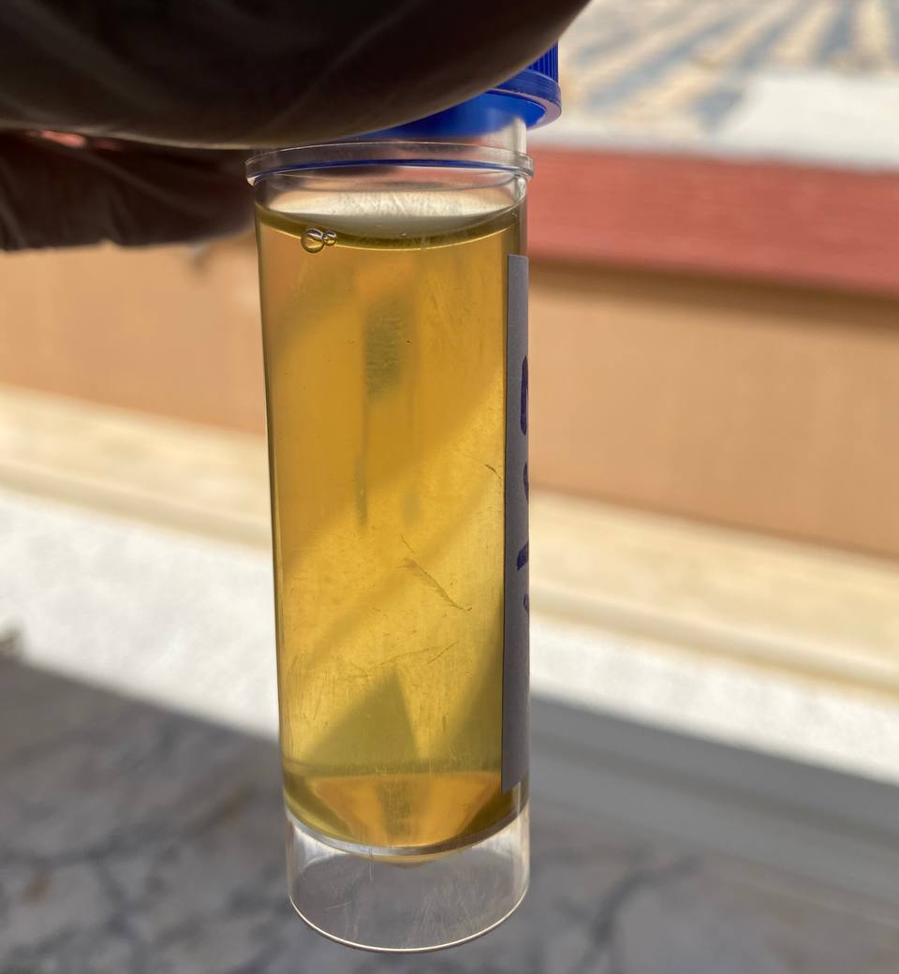

The macroscopic inspection of urine culture revealed no growth in 46% of samples , showed in figure 3, whereas substantial in 8% of samples ,showed in figure 4.
Figure 3: Macroscopic examination of urine culture showed no bacterial growth.
Figure 4: Macroscopic examination of urine culture showed significant bacterial growth.

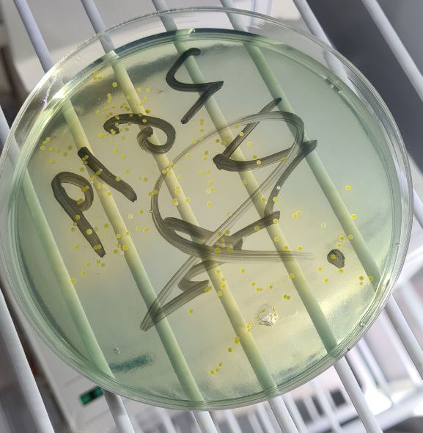
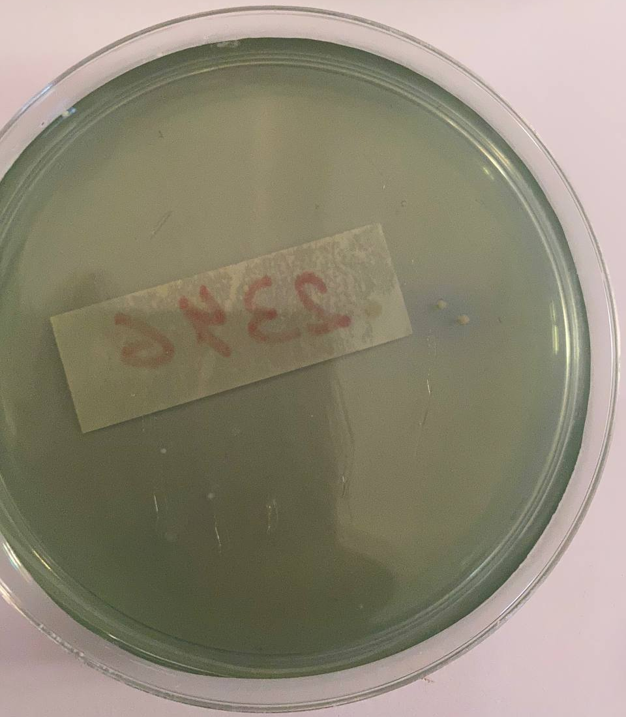

The results of macroscopic urinanalysis do not show any difference between males and females. But, in macroscopic urine culture showed a clear difference in the number and variation in size of colonies between males, of whom only 3 samples were positive, and they were not significant growth, and the females, most of whom had positive 10 samples, with two samples having significant growth.

- Discussion:
A urinary tract infection (UTI) is a common infectious condition that can affect people of all ages.However, some people are more prone to UTIs than others. Because of the small urethra (3.8 cm), which is frequently polluted with germs from the vagina and rectum, girls are at a higher risk than males.^{11,12}
The research reported an 8% prevalence of asymptomatic bacteriuria, compared to prior studies that found prevalence rates of 75.2% and 25%, respectively.
Only two of the 12 females in this research showed substantial bacterial growth, without any significant bacterial growth in all 12 males, showing that females had a higher prevalence of bacteriuria than males .This has been confirmed statistically. In Fisher’s exact test P-value = 0.018.
This means there is a significant difference between males and females (reject null hypothesis and accept alternative hypothesis).We know that the sample size in this study is small and that it must be increased in the future to obtain more accurate and better results.
The most prevalent bacteria detected in this investigation was Escherichia coli. In previous research, E. coli has also been identified as the most common aetiological agent of UTI.^{13,14}
The close closeness of the anus to the vaginal canal might explain why females have such a high E. coli infection rate. The capacity of E. coli to attach to the urinary system and interact with other germs traveling from fecal microbe-infested perineum regions to the moist, warm environment of the female genitalia adds to the elevated risk of UTIs in females.¹⁵
In comparison to another study, Staphylococcus aureus had the highest frequency of occurrence (48%), whereas Escherichia coli and Staphylococcus saprophytic both had 26%.¹⁶
Furthermore, as previously reported, females exhibited a greater incidence rate of Staphylococcus saprophytic than men.¹⁷ According to the current study, lack of circumcision and homosexual practices have been postulated as plausible causes for the greater prevalence of Staphylococcus aureus in men than in girls.¹⁸ Klebsiella species, Proteus species, and Pseudomonas aeruginosa were among the other microbes detected. UTIs are caused by microorganisms that are less common.¹⁵

- Conclusion:
In this study, the prevalence of asymptomatic bacteriuria among LIMU students was 8%, indicating a considerable increase of two girls and no men. Females had a substantially greater prevalence of asymptomatic bacteriuria (p = 0.018) than males. This is in line with recent research that suggests women have a higher frequency than males. Nonetheless, the number of participants for this study is minimal. A bigger sample size of research might provide enough data and increase the conclusions' generalizability.

References:
- Murugan K, Savitha T, Vasanthi S. Retrospective study of antibiotic resistance among uropathogens from rural teaching hospital, Tamilnadu, India. Asian Pacific J Trop Dis. 2012;2(5):375-380.
- Ronald AR, Pattullo AL. The natural history of urinary infection in adults. Med Clin North Am. 1991;75(2):299-312.
- Ekwealor PA, Ugwu MC, Ezeobi I, et al. Antimicrobial Evaluation of Bacterial Isolates from Urine Specimen of Patients with Complaints of Urinary Tract Infections in Awka, Nigeria. Int J Microbiol. 2016;2016:9740273.
- Akinsete AM, Ezeaka C. Prevalence and risk factors of asymptomatic bacteriuria among children living with HIV in Lagos, Nigeria. Pan Afr Med J. 2018;31:181. Published 2018 Nov 14.
- Bist R, Sharma V, Mishra A. Study of pervasiveness, antimicrobial vulnerability and resolution of best method for determining extended spectrum beta lactamases Escherichia coli isolates. Hosp Palliat Med Int J. 2019;3(2):56-64.
- Yadav KK, Adhikari N, Khadka R, Pant AD, Shah B. Multidrug resistant Enterobacteriaceae and extended spectrum β-lactamase producing Escherichia coli: a cross-sectional study in National Kidney Center, Nepal. Antimicrob Resist Infect Control. 2015;4:42. Published 2015 Oct 26.
- Ogefere HO, Oluka SO. Asymptomatic bacteriuria among secondary school students in Benin City , Nigeria. 2013;5(February):66-69.
- Cheesbrough M. District Laboratory Practice in Tropical Countries part 2. Cambridge, UK: Cambridge University Press. Chapter 7. 2004;105-15.
- Willey JM, Sherwood LM, Woolverton CJ. Prescott‘s Microbiology 8th ed. Asia. McGraw Hill Education. Chapter 6. pp. 150-1.11.
- IBM. SPSS statistics for Windows. Version 28.0. Armonk, NY: IBM; 2021
- Ali Al Youssef S, Ghareeb Mohamed A, Ahmed Abdelrahman R, Mohamed Abo Baker R, Ibrahim Abass N, Khalafalla Ahmed Masaad H. Asymptomatic Urinary Tract Infection among Female University Students. Egypt J Heal Care. 2020;11(4):341-353.
- Wineski, L. and Snell, R., 2019. Snell's clinical anatomy by regions. 10th ed.
- De Francesco MA, Ravizzola G, Peroni L, Negrini R, Manca N. Urinary tract infections in Brescia, Italy: etiology of uropathogens and antimicrobial resistance of common uropathogens. Med Sci Monit. 2007;13(6):BR136-BR144.
- Al Sweih N, Jamal W, Rotimi VO. Spectrum and antibiotic resistance of uropathogens isolated from hospital and community patients with urinary tract infections in two large hospitals in Kuwait. Med Princ Pract. 2005;14(6):401-407.
- Odoki M, Aliero AA, Tibyangye J, et al. Prevalence of Bacterial Urinary Tract Infections and Associated Factors among Patients Attending Hospitals in Bushenyi District, Uganda. Int J Microbiol. 2019;2019.
- Ugwu MC, Ezejiegu C, Ogwaluonye UC, Ejikeugwu C. Prevalence and Antibiogram of Asymptomatic Bacteriuria among University Students in Agulu, Anambra, Nigeria OPEN ACCESS. 2019;(August 2021).
- Jhora ST, Paul S. Urinary Tract Infections Caused by Staphylococcus saprophyticus and their antimicrobial sensitivity pattern in Young Adult Women. Bangladesh J Med Microbiol. 2011;5(1):21-25.
- Otajevwo FD, Amedu SS. Community Acquired Urinary Tract Infection Prevalence in a Tertiary Institution Based in Evbuobanosa, Edo State, Nigeria. Glob J med. 2015;15(3):1-13.

