


Student name: Omar Yousef Omar
Roll number: 2591
Supervisor: Dr. Huida Khatab
Assistant by: Mr. Ahmed Gaibani
Date: June 2ed 2022

There is Difference Between Adult Male and Female in Urine Output After Lasix Consumption
LIBYAN INTERNATIONAL MEDICAL UNIVERSITY APPLIED MEDICAL SCIENCES
FACULTY OF APPLIED MEDICAL SCLIENCES

Abstract

This current research aims to explore the difference between adult male and female in urine output after lasix consumption. Furosemide is a loop diuretic and has the ability to inhibit the sodium-potassium-s chloride (Na+/K+/2Cl-) cotransport of the ascending limb of the loop of Henle (NKCC2). The normal urine output (UO) is 800 to 2500 mL per day when there is a rapid reduction in its level pointing to a problem in the kidney. Several studies have reported whether gender has an effect on urine output after receiving a dose of furosemide, and other studies have ruled out this effect. In this study, 12 volunteers received 40 mg of furosemide intravenously and monitored the urine output for 6 hours continuously, and the results were recorded. There was no statistically significant difference in urine output for males and females according to P-value (=0.142) obtained from using the T-test, which was conducted using the Statistical Package for Social Sciences (SPSS).

Introduction

Urine output (UO) is a rapid bedside check for kidney function, and decreased output is the oldest recognized biomarker for acute kidney injury (AKI); historically defined by Garabed Eknoyan (200 CE).¹ The normal UO is 800 to 2500 mL per day. When there is rapid reduction in UO, it can be the earliest indication of reduced kidney function.^{2,3}

Furosemide belongs to a class of medicines called loop diuretics.⁴ The ability to directly inhibit the sodium-potassium-s chloride (Na+/K+/2Cl-) cotransport of the ascending limb of the loop of Henle (NKCC2) is summarized as its mechanism of action.^{5,6} The normal systemic clearance of furosemide is about 19 ml/kg (1.min).⁷

According to the Department of Medicine, University of Natal and King Edward VIII Hospital, 1972, the study included about 36 patients with both acute and chronic renal insufficiency, and all cases were injected with a high dose of furosemide. A maximal dosage of 2500 mg of furosemide in 24 hours was given in the study. Twenty of these patients responded to furosemide, and the differences between male and female results were noticed according on what is observed in the results.⁸

In another study, 6 male and 6 female normal participants were given intravenous furosemide. On four days, each participant received single doses of the different diuretics or no treatment at all after fasting overnight. Between the treatments, there was no statistically significant change in urine flow rate, sodium, or potassium excretion rates between male and female individuals. Male participants showed a greater peak sodium excretion rate than female subjects when natriuretic response was adjusted for mg/kg of intravenous furosemide dosage administered. The findings show that the natriuretic response to diuretics differs depending on gender.⁹

Furthermore, in Rosario, Santa Fe, Argentina, in 2004, the study was on experimental animals, a type of rodent, which included 12 rodents, 6 males and 6 females. They were injected with a dose of 10 mg/Kg of furosemide to prove the effect of gender on the drug. The results showed female rats had significantly better natriuretic, kaliuretic, and diuretic responses to furosemide while expressed in fractional terms. Female rats also responded better to furosemide in terms of diuretic, natriuretic, and kaliuretic effects than male rats. This result is explained by the lower number of the Na-K-2Cl cotransporter in female kidney homogenates compared to male kidney homogenates.¹⁰

The aim this study is to find out the difference between adult male and female in urine output after Lasix consumption.

Material and Methods

The study was performed in an analysis lab at the Libyan International University of Medical Sciences on 14 April 2022, which included 12 volunteers, 6 males and 6 females, in good health, and they did not have any previous or chronic diseases. Their ages were not taken and biometrics only recorded weight and urine output.

The volunteers were divided into two groups according to gender , then each one of the two groups received a single dose intravenous administration of furosemide in a dosage of 40 mg during lab stay , and a period of not less than 6 hours of urinary observation after administration to find out the amount of urine output every hour and record it.

After 6 hours were completed and all the readings of the volunteers were collected for each hour separately in addition to their weights, the urine output was compared between the two groups, males and females, using the T-test, which was conducted using the Statistical Package for Social Sciences (SPSS) , the difference was declared significant.

Result

Furosemide was administered to 12 volunteers in good health, and the equation was used to calculate the urine output every hour over a period of 6 hours to find out the amount of urine output every hour separately by taking the amount of urine divided by the number of hours by dividing the weight. The results obtained were clearly and noticeably different. The lowest result of urine output recorded for a female (Subject 4) was 216 ml at a constant rate of 36 mL per hour, while the highest result of urine output recorded for a male (Subject 9) was 604.8 mL at a constant rate of 100.8 mL per hour, and there were not any extreme values in either group, males or females, was normal distribution, as shown in fig.1 and fig.2. The results of urine output are summarized in table 1.

The mean for the urine output of females (n = 6) was 367.2, while for males (n = 6) it was 468, as shown in table 2. With a dosage of 40 mg of furosemide, there was no significant difference in urine output between the male and female groups depending on the result of the P-value, which was P = 0.142 (P > 0.05). All statistical results are completed by using the Two Independent Samples t-test in SPSS software, as shown in table 3.
Group Statistics
 | Gender | N | Mean | Std. Deviation | Std. Error Mean
UO6hr | Female | 6 | 367.2000 | 104.93244 | 42.83849
UO6hr | Male | 6 | 468.0000 | 114.02400 | 46.55010

Table 1. Urine output every hour for a period of 6 hours for both groups, male (n = 6) and female (n = 6)
Subjects | Urine Output (mL)
 | 1hr | 2hrs | 3hrs | 4hrs | 5hrs | 6hrs
1 | 50.4 | 100.8 | 151.2 | 201.6 | 252 | 302.4 | Female
2 | 64.8 | 129.6 | 194.4 | 259.2 | 324 | 388.8 | Female
3 | 72 | 144 | 216 | 288 | 360 | 432 | Female
4 | 36 | 72 | 108 | 144 | 180 | 216 | Female
5 | 57.6 | 115.2 | 172.8 | 230.4 | 288 | 345.6 | Female
6 | 86.4 | 172.8 | 259.2 | 345.6 | 432 | 518.4 | Female
7 | 72 | 144 | 216 | 288 | 360 | 432 | Male
8 | 64.8 | 129.6 | 194.4 | 259.2 | 324 | 388.8 | Male
9 | 100.8 | 201.6 | 302.4 | 403.2 | 504 | 604.8 | Male
10 | 86.4 | 172.8 | 259.2 | 345.6 | 432 | 518.4 | Male
11 | 50.4 | 100.8 | 151.2 | 201.6 | 252 | 302.4 | Male
12 | 93.6 | 187.2 | 280.8 | 374.4 | 468 | 561.6 | Male

Table 2. The mean, median and std. deviation for both groups, male (n= 6) and female (n= 6)

Table 3. The P-value (P = 0.142) was calculated in this study, which included 12 volunteers, to determine whether there was a difference in urine output between the sexes.
Independent Samples Test
 |  | Levene's Test for Equality of Variances |  | t-test for Equality of Means
 |  | F | Sig. | t | df | Sig. (2-tailed) | Mean Difference | Std. Error Difference | 95% Confidence Interval of the Difference
 |  |  |  |  |  |  |  |  | Lower | Upper
UO6hr | Equal variances assumed | .208 | .658 | -1.593- | 10 | .142 | -100.80000- | 63.26174 | -241.75595- | 40.15595
 | Equal variances not assumed |  |  | -1.593- | 9.932 | .142 | -100.80000- | 63.26174 | -241.88737- | 40.28737
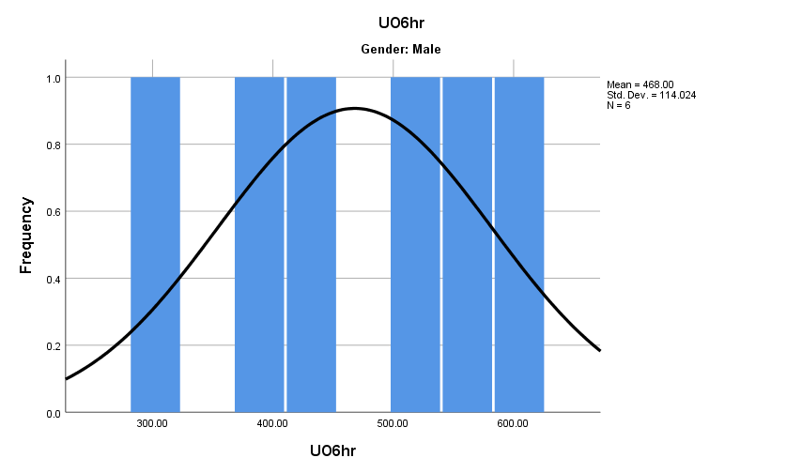
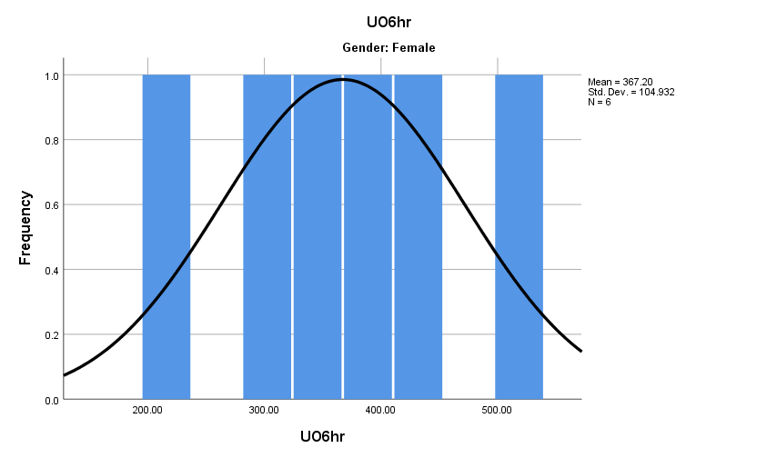
Fig. 2. Frequency of urine output at 6 hours of males, show normal distribution ( no extreme values )
Fig. 1. Frequency of urine output at 6 hours of females, show normal distribution ( no extreme values )

Discussion
These results show the amount of urine output after administering furosemide and whether there is an effect of gender in this study or not. Depending on the P-value, which was 0.142, there is no significant difference, so the hypothesis is rejected as there is no effect on urine output by gender. Comparing the findings of this present research with other studies mentioned above, the researcher indicates that there is agreement with some previous studies. Women have always been underrepresented in clinical drug trials. When both women and men were investigated, the data was pooled together in the majority of cases, with no study of gender differences.
The results showed inconsistency with a study conducted in 1972 at the Department of Medicine, University of Natal and King Edward VIII Hospital, about patients with acute and chronic kidney insufficiency who received high doses of furosemide, where the results showed that there are differences in the amount of urine output for both sexes,⁸ but this study cannot be adopted to fully reconcile the results of this study, and the reason is that there are factors affecting the result of the study, the most important of which is that it was conducted on ill people and the use of high doses of furosemide. On the other hand, another study confirmed the validity of these current results, showing that there was no effect on gender on the effectiveness of furosemide and on the amount of urine output in both males and females.⁹ However, when the dose was adjusted to be mg/kg of the intravenous furosemide received, males showed an effective response to furosemide and an increase in urine output than females, as the weight of males, which is always greater than females, in turn, it indicates clear difference in this result.
- Conclusion
This study was carried out to find if there is difference between adult male and female in urine output after lasix consumption. Statistically, was proven that there is no significant difference in the urine output at the level of males and females based on the p-value (=0.142) after volunteers received furosemide and recorded the results. Finally, There is little information about these gender-related differences, so the researcher recommend further studies as well as use large and different implications to reach a more accurate and clear answers.

References
- Eknoyan G: Emergence of the concept of acute renal failure. Am J Nephrol 2002, 22:225-230.
- Khurana I. Medical Physiology For Undergraduate Students. London: Elsevier Health Sciences APAC; 2014.
- Bellomo R, Ronco C, Kellum JA, Mehta RL, Palevsky PM, Acute Dialysis Quality Initiative Workgroup: Acute renal failure - definition, outcome measures, animal models, fluid therapy and information technology needs: the Second International Consensus Conference of the Acute Dialysis Quality Initiative (ADQI) Group. Crit Care 2004, 8:R204-R412.
- Katzung B, Vanderah T. Basic & Clinical Pharmacology. New York, N.Y.: McGraw-Hill Education LLC.; 2021
- Obermuller N, Kunchaparty S, Ellison DH, Bachmann S. Expression of the Na-K-2Cl cotransporter by macula densa and thick ascending limb cells of rat and rabbit nephron. J Clin Invest. 1996;98:635–40.
- Nielsen S, Maunsbach AB, Ecelbarger CA, Knepper MA. Ultrastructural localization of Na–K–2Cl cotransporter in thick ascending limb and macula densa of rat kidney. Am J Physiol. 1998;275:F885–93.
- Pichette V, du Souich P. Role of the kidneys in the metabolism of furosemide: its inhibition by probenecid. Journal of American Society of Nephrology 1996; 7: 345–9.
- Seedat YK. High-dose furosemide (Lasix) in renal insufficiency. S Afr Med J. 1972;46(38):1371-1374.
- Franson KL, Kuk JM, Lam NP, Lau AH. Gender effect on diuretic response to hydrochlorothiazide and furosemide. Int J Clin Pharmacol Ther. 1996;34(3):101-105.
- Brandoni A, Villar SR, Torres AM. Gender-related differences in the pharmacodynamics of furosemide in rats. Pharmacology. 2004;70(2):107-112. doi:10.1159/000074675.

