

The Libyan International Medical University
Faculty of Basic Medical Science

Effect of Gender differences on prevalence and
microbial spectrum of asymptomatic bacteriuria
student name :zayn alabdeen
Number : 2137
Assisted by:alnajy ahomry
Date of Submission: 20/ 6/ 2022

Abstract :

The presence of bacteria in urine, known as bacteriuria, has been linked to both asymptomatic and symptomatic urinary tract infections (UTIs). It has a significant impact on how microorganisms colonize the urinary system. Men, the elderly, pregnant women, healthy women, and patients with immune system weakness are all at risk for bacteriuria, with women and expectant mothers being the most vulnerable. The difference in the microbiological spectrum of different microorganisms infecting different genders, as well as the prevalence of asymptomatic bacteriuria between the male and female genders, is intriguing. We look at data on the prevalence of asymptomatic bacteriuria as well as the microbiological spectrum by gender in this study. We also talk about how early detection of asymptomatic bacteriuria (ASB) in pregnant and non-pregnant women can help prevent health problems.

Introduction :

The second most common bacteria linked to illnesses in primary care is asymptomatic bacteriuria (ASB) [1]. Despite the fact that it affects millions of people worldwide, it primarily affects both developed and developing countries, making it a major concern. [2] According to estimates, approximately 20% of all women will have ASB at some point in their lives, with many having multiple infections [3]. Because of the urethra's short length and close proximity to the anus, bacteria such as E. Coli are more easily colonized in women. A woman is more likely to contract an infection if she has recently engaged in sexual activity and given birth. [4] As indicated by the definition, ASB occurs when active bacteria are present in a person's urine but no outward signs of a UTI are present for the person experiencing it. ASB is important because it is a significant predictor of future UTI, with prevalence rates ranging from 5 to 20% in healthy women and 10 to 40% in pregnant women. [7]. The most common bacteria found in urinary tract infections are E. coli, Proteus, Klebsiella, and E. faecalis. Collecting urine samples and looking for these bacteria can help detect urinary tract infections. Asymptomatic bacteriuria is not as frequently screened for as symptomatic bacteriuria, which is a problem because most people with asymptomatic infections have no signs or symptoms and do not seek screening, allowing asymptomatic bacteriuria to fester and result in a potential UTI. The purpose of this research lab is to determine the prevalence of asymptomatic bacteriuria in men and women, as well as whether either gender should consider routine screening for asymptomatic UTIs.

Materials and Methods :

Pipette for incubator culture media Toilet paper Dipsticks Alcohol Gel Gloves Containers 63 Urine Tests 63 urine samples were collected from 63 LIMU students (33 males and 30 females) who had no symptoms of bacteriuria. The samples were then sent to a lab for analysis to determine whether there was any bacteriuria growth, whether it was non-significant growth overall, or whether it was significant growth overall. We collected recently voided urine samples of around 10-15 mL caught midstream in sanitized, spotless, leak-proof, and wide open sample containers for each child. Urine was then inoculated onto Cysteine Lactose Electrolyte-deficient (CLED) agar and incubated aerobically at 37 degrees Celsius for 24-48 hours. The infected were then examined plates for bacterial growth.

Results :

gender * bacterialgrowhsignificance Crosstabulation
 |  |  | bacterialgrowhsignificance |  |  |  | Total
 |  |  |  | no growt | overall | signific | Total
gender | female | Count | 0 | 2 | 8 | 2 | 12
gender | female | % within gender | 0.0% | 16.7% | 66.7% | 16.7% | 100.0%
gender | female | % within bacterialgrowhsignificance | 0.0% | 20.0% | 72.7% | 100.0% | 50.0%
gender | male | Count | 1 | 8 | 3 | 0 | 12
gender | male | % within gender | 8.3% | 66.7% | 25.0% | 0.0% | 100.0%
gender | male | % within bacterialgrowhsignificance | 100.0% | 80.0% | 27.3% | 0.0% | 50.0%
Total |  | Count | 1 | 10 | 11 | 2 | 24
 |  | % within gender | 4.2% | 41.7% | 45.8% | 8.3% | 100.0%
 |  | % within bacterialgrowhsignificance | 100.0% | 100.0% | 100.0% | 100.0% | 100.0%

Chi-Square Tests
 | Value | df | Asymptotic Significance (2-sided) | Monte Carlo Sig. (2-sided)
 |  |  |  | Significance | 99% Confidence Interval
 |  |  |  |  | Lower Bound | Upper Bound
Pearson Chi-Square | 8.873ª | 3 | .031 | .019^{b} | .015 | .022
Likelihood Ratio | 10.372 | 3 | .016 | .015^{b} | .012 | .018
Fisher's Exact Test | 8.225 |  |  | .019^{b} | .015 | .022
N of Valid Cases | 24

Hypothesis: H0 : No association between gender status and bacterial growth

Ha : There is an association between gender status and bacterial growth

 | No growth | Overall | Significant growth
Males | 18 | 12 | 0
Females | 17 | 13 | 3

Summary table

The P-value is 0.019. Accept or reject the null hypothesis (FTR) We accept rejecting the null hypothesis because the P-value is less than alpha 0.05. Conclusion: There is a link between gender and bacterial growth. 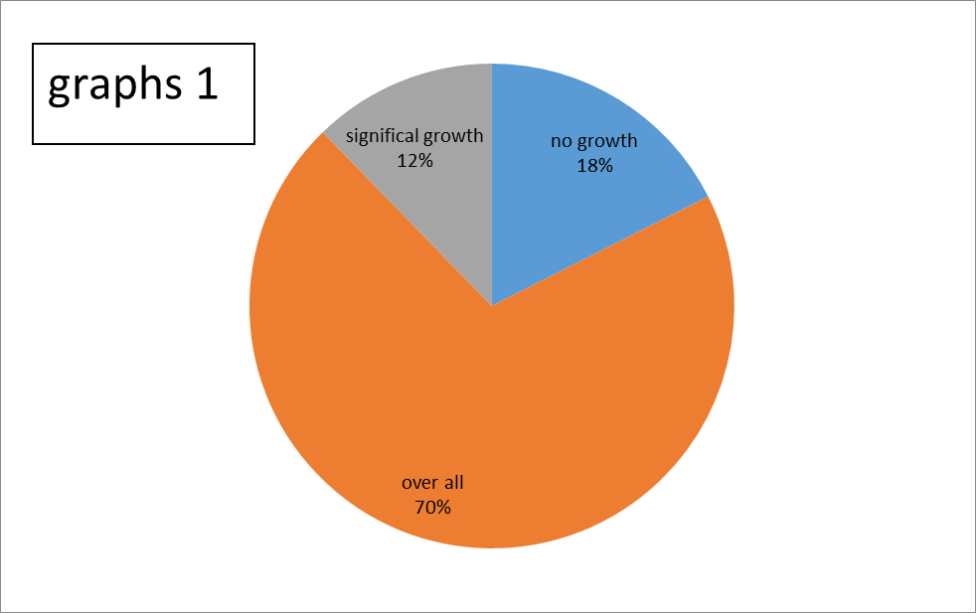
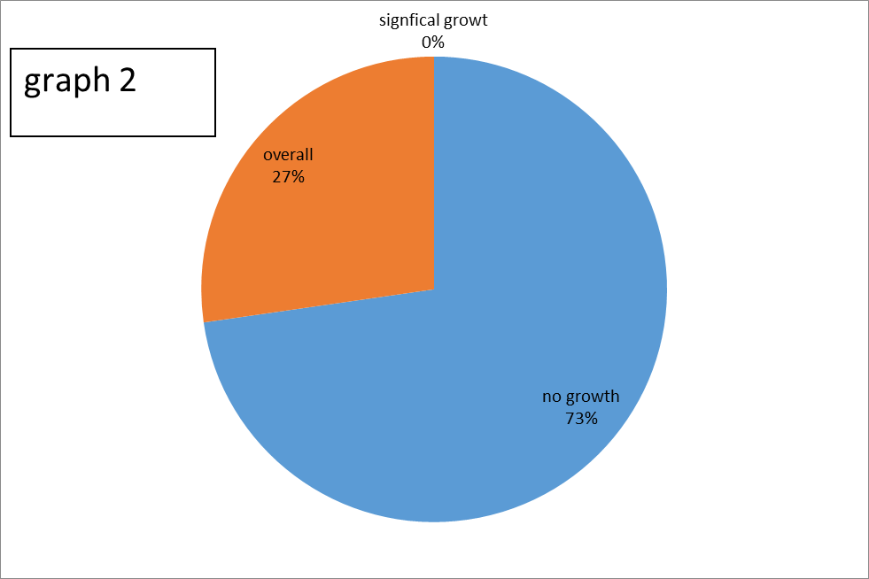

Discussion :

Given the p-value of 0.019 for this experiment, the null hypothesis can be rejected and the data are not contaminated. Contrary to my expectations, the results show that significant increases in bacteriuria do not occur at a high rate. Men have a 0% incidence rate, with only 8 men showing any development, let alone growth that would be considered even minimal. Females are significantly less affected than expected, despite a 16.66 percent incidence rate. Despite this, bacteriuria growth was observed in 10 of the 12 women, indicating that the vast majority are at risk of developing it. UTI-caused infections.

We can reasonably conclude from this data that men are not particularly vulnerable to bacteriuria infection, which corresponds to our prior knowledge. Germs have a much more difficult time colonizing the male urethra than the female urethra due to its length and distance from the anus. Furthermore, while women are more vulnerable to bacteriuria, the risk is still low enough to be concerned, with only 16 out of every 100 women experiencing significant bacteriuria and even fewer experiencing UTIs. The threat, however, persists and is far more prevalent among women than among men. It's intriguing that 13 of the 23 people in both the male and female groups had bacteriuria growth, even if it was minor. This could be a problem because even minor growth has the potential to develop into significant growth, which could lead to UTIs. Although non-significant growth does not always indicate the presence of UTIs, this study suggests that both males and females are at risk for bacteriuria, as the growth could eventually become large and cause UTI problems.. The second point is

will almost never result in significant growth, and males are safe from bacteriuria. However, the situation is different for women.

While less than 10% will ever face this significantly increased risk, bacteriuria, which is still severe enough to cause problems for women due to UTI and pyelonephritis problems that could result from routine Screening, could be useful for detecting ASB before it becomes a problem.

Conclusion :

Even though this lab was not perfect, the results showed that females were the group most at risk of ASB because it was much more common in women than in men. One of this lab's flaws was the small sample size, which was so small that the experiment could have been changed if more than 100 people had been tested for possible standard deviation caused by a few outliers. The advantages would be that sterilized urine was collected in containers where both sterilization and The urine was kept in sealed containers to prevent outside interference..

.
sources. But, in the grand scheme of things, what we accomplished in the outcomes makes sense and leads us to the simple fact that asymptomatic bacteriuria is an infection that primarily affects women at a rate that, while not high enough to cause widespread panic, is still high enough that most women would benefit from, at the very least, semi-regular screening to reduce the rate of UTIs and potential pyelonephritis caused by consistent ASB that can occur, and which can be

References :

- Ranjan A., Sridhar S.T.K., Matta N., Chokkakula S., Ansari R.K. Prevalence of UTI among Pregnant Women and Its Complications in Newborns. Indian J. Pharm. Pract. 2017;10:45. doi: 10.5530/ijopp.10.1.10
- Urinary Tract Infections | UTI | UTI Symptoms | MedlinePlus [Internet]. Medlineplus.gov. 2020 [cited 6 March 2020]. Available from
- _ Sakamoto, M., et al. "Molecular analysis of bacteria in asymptomatic and symptomatic endodontic infections." Oral microbiology and immunology 21.2 (2006): 112-122
- Moore E.E., Hawes S.E., Scholes D., Boyko E.J., Hughes J.P., Fihn S.D. Sexual intercourse and risk of symptomatic urinary tract infection in post-menopausal women. J. Gen. Intern. Med. 2008;23:595–599. doi: 10.1007/s11606-008-0535-y.
- Afoakwa P, Domfeh S, Afranie B, Owusu D, Donkor S, Sakyi K et al. Asymptomatic Bacteriuria and Anti-Microbial Susceptibility Patterns among Women of Reproductive Age. A Cross-Sectional Study in Primary Care, Ghana. National Library Of Medicine. 2022. [accessed 4 Jun 2022] Available from: https://www.ncbi.nlm.nih.gov/pmc/articles/PMC6313490/

