Title - The incident rate of asymptomatic bacteriuria among LIMU students

Name- Aseil Abdalla
Student#- 2873
University - Libyan international medical university
Faculty- Applied medical science

Abstract
Asymptomatic bacteriuria is widespread; however, it is typically harmless. Asymptomatic bacteriuria screening and therapy are only advised for pregnant women or patients ahead forward certain invasive urogenital procedures. Asymptomatic bacteriuria in healthy women is associated with increased bouts of symptomatic infection, although antibiotic therapy of asymptomatic bacteriuria does not reduce the likelihood of these episodes. Clinical trials in patients with spinal cord injuries, diabetic women, patients with indwelling urethral catheters, and senior nursing home residents have repeatedly demonstrated no benefit from treating asymptomatic bacteriuria. Antimicrobial therapy can have bad repercussions, such as unpleasant medication effects including re-infection with organisms with developing resistance. The successful management of asymptomatic bacteriuria demands the immediate application of screening tools to support the identiﬁcation of the chosen patients for whom medication is advantageous, as well as the avoiding of antimicrobial medication when no benefit has been demonstrated.

Introduction
The goal of this study is to find a connection involving gender and asymptomatic bacteriuria. If there are no signs or symptoms of a urinary tract infection, yet uncontaminated urine tests reveal bacteria, the term asymptomatic bacteriuria is applicable. When bacteria are found with a quantitative value of 100,000 CFU or greater in two consecutive micturition samples taken in a contamination-free way in women, the term asymptomatic bacteriuria is used. Only one clean-catch void sample is required to detect the bacterial species with a quantitative count of at least 100,000 CFU to effectively use the term asymptomatic bacteriuria. Asymptomatic bacteriuria is more common in women than in men. Age and comorbidities, including diabetes and catheterization, are other risk factors. The microbiology of the patient is also influenced by patient characteristics. bacteriuria with no symptoms. The most common bacteria are Escherichia coli, which is most commonly seen in healthy persons. However, germs such as Enterococcus species and group B streptococcus might be found. Males are usually seen with Enterococcus species and gram-negative bacilli. Authorized nursing care residents may have a polymicrobial silent urinary tract infection (1). ASB treatment has been identified as a major contributor to inappropriate antibiotic use, which leads to resistance to antimicrobial stewardship efforts. A positive urine culture frequently supports the treatment of antimicrobials, regardless of the symptoms. Obtaining urine cultures, even for routine screening, promotes needless antibiotic prescription when it is not clinically required. Assumed the potential social consequences of antibiotic resistance, the guideline committee recommended that bacteriuria monitoring and antibiotic-resistant testing should be done and unless there is a specific group, treating asymptomatic bacteriuria should be avoided. This advice is suitable for persons who prefer tackling the problem of emerging antimicrobial resistance and other difficulties connected with antimicrobial exposure over extremely minimal unknown individual advantages.

Methodology
An experiment was carried out on LIMU students about asymptomatic urinary tract infections. Twenty-four samples were collected from students, 12 of them were male, and the rest were female. Samples were collected by mid-stream clean catch. The first thing I did was put on a pair of gloves, then I grabbed the calibrated loop, which was 0.01, and sterilized it with the Bunsen burner. After a few seconds under the flame, I grabbed the urine sample and vertically interjected the calibrated loop into it. This mechanism ensures that the right amount of urine is sticking into the loop. Samples were cultivated on a MacConkey Agar plate. The urine was placed across the surface of plate agar. I grasped the loop again and vertically inserted it into the urine sample to transfer a loopful of urine to a second plate, then the plates were placed in the incubator for twenty-four hours at 37 degrees Celsius. After twenty-four hours, I counted the colonies on the agar. Several tests were performed to identify the microorganisms, including gram staining to determine if it is gram-negative or positive, as well as under the microscope to examine the morphology of bacteria and various biochemical assays.
For biostatistics, the spss program was used and the tests that were done were chi but didn’t end up working out because there was more than 20 percent of cells with an expected value of less than five, so Fisher’s test was used instead.
Result and Statistics analysis

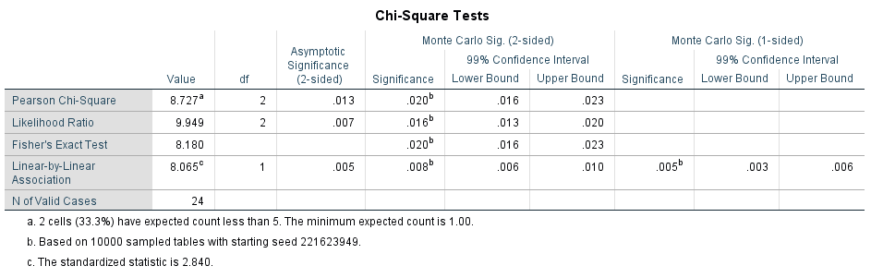

bacterial growth * Gender Crosstabulation
 |  |  | Gender |  | Total
 |  |  | Male | Female | Total
bacterial growth | 1.00 | Count | 9 | 2 | 11
bacterial growth | 1.00 | % Within bacterial growth | 81.8% | 18.2% | 100.0%
bacterial growth | 1.00 | % Within Gender | 75.0% | 16.7% | 45.8%
bacterial growth | 2.00 | Count | 3 | 8 | 11
bacterial growth | 2.00 | % Within bacterial growth | 27.3% | 72.7% | 100.0%
bacterial growth | 2.00 | % Within Gender | 25.0% | 66.7% | 45.8%
bacterial growth | 3.00 | Count | 0 | 2 | 2
bacterial growth | 3.00 | % Within bacterial growth | 0.0% | 100.0% | 100.0%
bacterial growth | 3.00 | % Within Gender | 0.0% | 16.7% | 8.3%
Total |  | Count | 12 | 12 | 24
 |  | % Within bacterial growth | 50.0% | 50.0% | 100.0%
 |  | % Within Gender | 100.0% | 100.0% | 100.0%

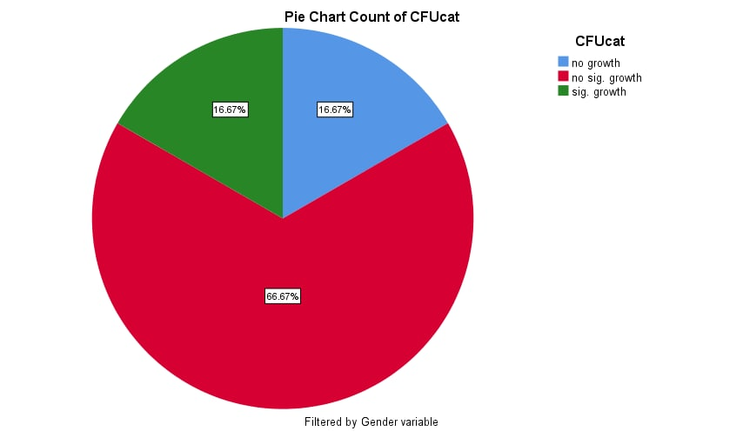Female
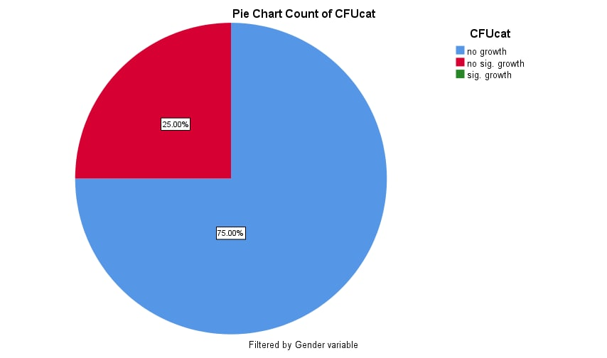 Male

As previously stated, chi-square would not be utilized because 20% is less than the predicted count of fewer than five, hence a fisher's test would be employed instead. Nine of the men had no microbial growth, whereas just two of the females did. There has been no major increase. Only three men are positive, while eight women are. No males tested positive for considerable growth, while two females tested positive for significant growth.

Characteristic | No growth | Overall, no significant growth | Significant growth | P-value
 | 11 | 11 | 2
Gender |  |  |  | 0.020
male | 9(75%) | 3(25%) | 0(0.0%)
female | 2(16.7%) | 8(66.7%) | 2(16.7%)

Discussion

The significance value is less than 0.05. The null hypothesis was rejected, demonstrating that there is a correlation between gender and bacteriuria without symptoms. I found a lot of evidence that shows that there is a link between gender and asymptomatic bacteriuria. The shorter female urethra allows germs from the urethral opening and the perineum to travel a shorter distance to the bladder, making asymptomatic bacteriuria more likely in women than in males. Most women experience temporary bacteriuria following sexual contact, but only a small percentage of these women will acquire symptomatic infections since the body's natural defensive systems usually prevent symptomatic infection. Incomplete bladder emptying is considered to have a role in the increased frequency of asymptomatic bacteriuria in the elderly. Aside from gender, other risk factors for asymptomatic bacteriuria include increasing age, immunosuppression diseases, immune-suppressing medicines, performing urinary tract surgeries, obtaining a kidney transplant, and urinary tract blockage such as stone formation.
The laboratory results showed two cultures had more than 100,000 CFU and under the microscope the organism was pink and rod-shaped, indicating that it was a gram-negative bacillus. The first thought was that it was either pseudomonas aeruginosa or E. coli, but the microorganism was lactose fermenting which means it is E. coli. According to my awareness, E. coli is the most frequent bacterium that causes asymptomatic community-acquired bacteriuria. The source of the E. coli that causes urinary tract infections is the patient’s colonic flora that colonizes the urogenital area. Uropathogenic strains are characterized by pili with adhesin proteins that attach to particular receptors on the urinary tract epithelium which is a- d- galactopyranosyl-beta-d glactopyranoside, which might lead to asymptomatic urinary tract infection. The capacity of E. coli to ascend the urethra into the bladder and ascend the ureter into the kidney may also be aided by its motility against the flow of urine. The target protein on these receptors is made up of galactose dimers (Gal-Gal dimers). Cranberry juice contains flavonoids that inhibit pili binding to receptors and may be effective in preventing recurring urinary tract infections.
At Usmanu Danfodiyo University Teaching Hospital in Sokoto, there have previously been no studies on asymptomatic bacteriuria in pregnancy. The purpose of this study was to determine the prevalence and frequency of organisms associated with asymptomatic bacteriuria in pregnancy among booked patients at Usmanu Danfodiyo University Teaching Hospital in Sokoto, as well as their sensitivity patterns. According to this study, the frequency of asymptomatic bacteriuria in pregnancy was 8.0 percent at Usmanu Danfodiyo University Teaching Hospital in Sokoto, and it was caused mostly by Escherichia coli, Klebsiella spp., and Coliform spp. These pathogens are sensitive to the antibiotics nitrofurantoin and gentamicin, which are both widely available and affordable. Asymptomatic bacteriuria should be frequently tested in pregnant women (3). The reason pregnant women are at a higher risk than healthy young women is because of urine stasis caused by uterine compression on the bladder and ureters. The study conducted at Usmanu Danfodiyo University Teaching Hospital in Sokoto revealed that E. coli is the most common bacterium, as were the positive samples at LIMU.

Conclusion
The optimal management of asymptomatic bacteriuria necessitates the prompt application of screening tools to encourage rapid identification of the chosen patients for whom treatment is advantageous, as well as the avoidance of antimicrobial medication when no benefit has been demonstrated. except for pregnant women and patients scheduled for urologic operations involving bleeding, such as transurethral resection of the prostate in such cases, begin antibacterial prophylaxis the evening before surgery with an antibiotic chosen based on culture findings and persist only if catheter removal is delayed.

Reference
- Givler D, Givler A. Asymptomatic Bacteriuria. Ncbi.nlm.nih.gov. https://www.ncbi.nlm.nih.gov/books/NBK441848/. Published 2022. Accessed June 10, 2022.
- All You Need to Know About Pregnancy. Healthline. https://www.healthline.com/health/pregnancy. Published 2022. Accessed June 10, 2022.
- Kuźniar A. O pojęciu zdarzenia będącego złamaniem prawa przyrody. Filozofia Nauki. 2021;29(3):107-123. doi:10.14394/filnau.2021.0017

