


The incidence rate of Asymptomatic Bacteriuria (ABU) among LIMU students.

Name: Mawada Ali Alfaia
Student number:2799
Instructor: Dr. Najee Alhemri
Course title: P.T.S
Date of submission: 04/06/2022

Abstract
Asymptomatic bacteriuria is loosely defined as a ‘UTI of no clinical symptoms’, in which the individual has a significant growth of bacterial on their urine culture media but no apparent symptoms of UTI are to be recorded. In this study the incidence rate of asymptomatic bacteriuria among 24 male and female students within LIMU is assessed to test for an association between: - gender and ASB. Later on, it was proved through the use of urine samples that females are at a greater risk of developing asymptomatic UTI when compared with males of the same age. These results highlight the predisposition of females to developing UTI which can be explained by many factors.

Introduction
Asymptomatic bacteriuria (ASB) is defined as the presence of bacterial within a correctly collected urine sample of an individual that is showing no signs and symptoms of UTI. It is clinically common and can increase in risk with age, in which incomplete bladder emptying can increase the incidence of asymptomatic bacteriuria. Many studies revealed that the incidence rate of asymptomatic bacteriuria in females is about 40% greater than males after the age of 80 (2). Females being at a higher risk than males can probably be explained by their shorter urethra, lack of prostatic secretions (bactericidal action) and the proximity of vagina from anus. which may result in the guts microbiome (E.g.: E. coli) to attack the genitourinary system. Males are thereby significantly less likely to be affected, in which a study outlined that: ASB is rarely seen in middle aged males and is mostly recorded only in patients over 50 years of age with prostatic infections.
E. coli being the most common causing organism of both asymptomatic bacteriuria and acute UTI. But they must be distinguished from each other, as acute UTI is a symptomatic genitourinary tract infection that is presented with symptoms like dysuria, urgency and suprapubic pain.
Based on previous findings it is predicted that female students are to be notably more affected with ASB than the males of the same age. An experiment conducted among the 24 LIMU students, 12 females and 12 males in the following lab research tests to prove the previous findings. Highlighting if females have a higher incidence of asymptomatic urinary infection due to their biological disposition…

Materials and method:
The study included a total of 24 urine samples obtained from students within LIMU to support the diagnosis of asymptomatic UTI. Materials that used to carry out the experiment include: urine sample, wire/plastic loops, Bunsen burner, incubator, growth media (5% sheep blood agar plate). Media used in urine culture can vary between: - 5% sheep blood agar plate, MacConkey agar and CLED as all 3 allow for the detection of many staphylococci, streptococci, gram negative bacilli, and enterococci.
The first step was to collect urine from each subject through midstream clean catch method. Samples assessed within an hour from collection, to keep tests valid. The wire loop was heated under the flame, then inserted within the urine sample to collect a measured volume of urine. Next the wire loop was dragged throughout the growth media using a specific technique of inoculation appropriate for urine culture. Furthermore, without flaming, the wire loop was dipped into the urine culture for the second time and applied carefully on a new growth plate. Finally, the cultures were incubated for 24hr at a temperature of about 37 °C to encourage visible growth.
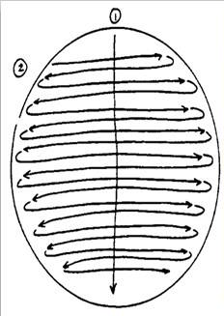

*This figure Shows the streaking pattern of urine culture.
Adopted from reference 1.

If a microorganism was present within the urine culture it will feed on the agar and grow into colonies called colony forming units (CFU). Since a 0.01mm wire loop was used the number of colonies is multiplied by 100 to obtain the value of CFU/ml in each specimen.
To gather the collected data a Pearson Chi-Square was used to test for independence between the 2 qualitative variables. However, more than 20% of the cells have expected a count less than 5 as the expected frequency was too small, so Fisher’s exact text was used instead.

Results and Statistical analysis:
Taking into consideration the method of urine collection, a CFU/ml greater or equal to 100,000 is considered a significant growth and the individual is diagnosed with UTI
Summery table: -
Gender * CFUcat Crosstabulation
 |  |  | CFUcat |  |  | Total
 |  |  | No growth | No significant growth | Significant growth | Total
Gender | Male | Count | 9 | 3 | 0 | 12
Gender | Male | % Within CFUcat | 81.8% | 27.3% | 0.0%
Gender | Female | Count | 2 | 8 | 2 | 12
Gender | Female | % Within CFUcat | 18.2% | 72.7% | 100.0%
Total count |  |  | 11 | 11 | 2 | 24
Table 1:
A total of 24 students, equally from both genders were assessed on the bases of: No growth within their culture medias, had some growth but was insignificant to diagnose with UTI (CFU 0 < 100000), significant growth was observed (CFU ≥ 100000).
As outlined in (table 1), within the urine cultures that had no growth 81.8% (9 /11) of them were obtained from male students and only 18.2% (2/11) are from female students. 100% of the cultures that had significant growth of bacteria were gathered from the female students. Highlighting that the only 2 significant growth culture medias were from the female students and none of the males were diagnosed with asymptomatic bacteriuria.
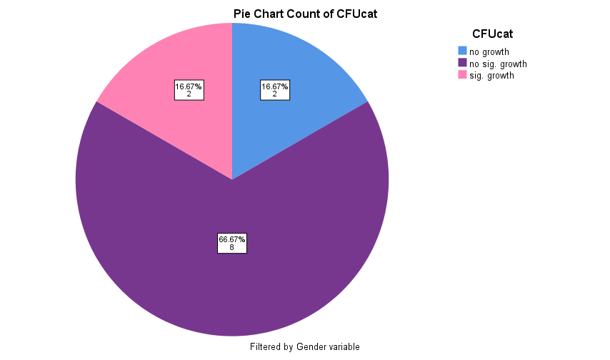
A pie chart showing the CFU categories of the female students only. Indicating that 16.67% of females had no growth and 66.67% had no significant growth, 16.67% had significant bacterial growth on urine culture and were diagnosed with ASB.
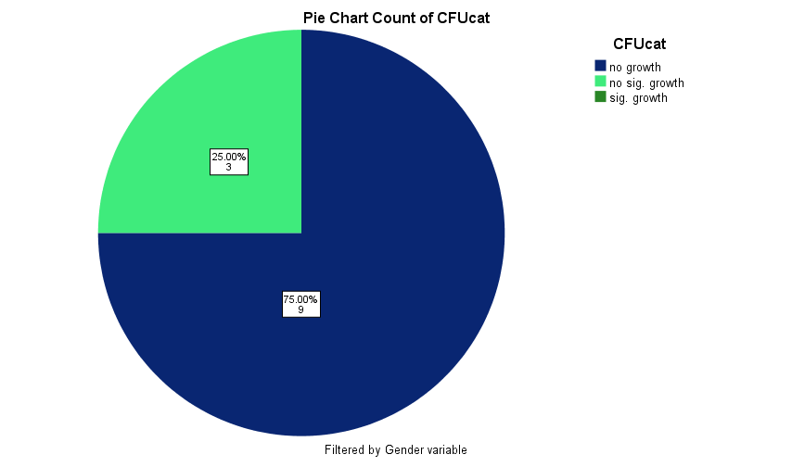
This pie chart counts the CFU of the male students only. 75% (9 of the 12) of the male students had No growth, 25% had No significant growth and zero had significant growth.
Table 2 :

Discussion
Knowing that a Positive urine microbiological culture is the main indicator for the diagnosis of urinary infections, the final results show that females were clearly more affected with asymptomatic urinary infections. The significance of our starting hypothesis was further supported with a P value of 0.018 using fisher’s exact test, a statistically significant difference (P < 0.05). Thereby the hull hypothesis was rejected and an association with asymptomatic bacteriuria and gender is met.
An aiding statement in which a reliable study has said that “In healthy women, asymptomatic bacteriuria increases with age, from <1% in newborns to 10% to 20% of women age 80 years, but is uncommon in men until after age 50 years (2).”
There are many factors that keep females at a greater risk of developing UTI. Female anatomic structure plays the major role as the length of their urethra provides a shorter distance of travel for the pathogen to the bladder. The proximity of the female urethra to the anus which holds many of the organisms that are typical in causing UTI increases their changes of infection, especially when appropriate hygiene is absent (3) . Pregnancy is seen to increase risk of infection as hormones can cause changes in the urinary tract and the expanding uterus presses on the urinary bladder making it difficult to fully empty the bladder, the leftover urine can be a source of infection. A higher susceptibility to UTIs is seen after menopause as estrogen levels drop the vaginal tissue becomes thinner and more prone to infection (4).
Recent studies outlined that “Genetic variation in the host innate immune response appear to influence the risk of bacteriuria as well as the clinical presentation of infection.” (2) Specifically genetic polymorphisms of TLR-2 and CXCR1 have been associated with acute uncomplicated urinary infection in healthy girls and women!
As for men UTI is usually associated with prostate disease, kidney stones, dehydration, indwelling catheter, diabetes and not been circumcised. Aging increases the risk in both genders.
Because the test conducted in this lab research included the results of only 24 subjects, providing a narrowed down sample size that is inappropriate to asses an accurate microbial spectrum. However, through numerous past researches it was proved that Escherichia coli (E. coli) is the leading cause of both symptomatic and asymptomatic UTI. E. coli occurred in 72% of bacteriuric school-aged girls and in 77% of young, sexually active American women (2). Other organisms commonly isolated from urine cultures are Klebsiella spp. and P. mirabilis, Streptococcus agalactiae.
As to why E. coli this main cause of UTI is explained by the fact that it is the most abundant facultative anaerobe in the colon and feces and the motility of this microorganism aids its ability to ascend to the urethra and cause UTI. Other virulence factors, such as specific lipopolysaccharide types, adhesins (pili), toxins, endotoxin and other proteins make E. coli the leading cause. However, E. coli strains isolated from asymptomatic bacteriuria may be of clonal lineage lacking the virulence genes generally associated with uropathogenic E. coli (UPEC) thereby no symptoms arise in the infected patient. It was noted by other researches that treatment with antibiotic therapy is nonbeneficial to the patient unless severe adverse effects are to develop.
Conclusion
Finally, it was shown in this experiment that males were at a lesser risk of asymptomatic bacteriuria when compared with females within the same age, and this is due to mainly their anatomic predisposition. E. coli was recognized as the leading cause of both symptomatic and asymptomatic UTI which is explained by its presence in the colon as normal flora and its virulence factors that aid its infection of the genitourinary tract. The starting hypothesis was met in which a P value proved a significant association between ABU and gender, the null hypothesis was rejected. However due to the small sample size used in the investigation, of only 24 students, caused a limitation in the accuracy of analysis of the microbial spectrum. Further researches must increase sample size for more valid results that strongly support findings.

Reference (AMA)
1. Streaking pattern of urine specimen | Medical Laboratories. Medical-labs.net. http://www.medical-labs.net/streaking-pattern-of-urine-specimen-1565/. Published 2022. Accessed June 11, 2022.
2. Nicolle L. Asymptomatic Bacteriuria and Bacterial Interference. Microbiol Spectr. 2015;3(5). doi:10.1128/microbiolspec.uti-0001-2012.
3. 7 Reasons Why Women Get More UTIs Than Men. Virginia Physicians for Women. https://vpfw.com/blog/7-reasons-why-women-get-more-utis-than-men/. Published 2022. Accessed June 11, 2022.
4. What if I Get a Urinary Tract Infection (UTI) While I’m Pregnant?. WebMD. https://www.webmd.com/women/guide/pregnancy-urinary-tract-infection. Published 2022. Accessed June 11, 2022.

