Libyan International Medical University

Faculty of Applied Medical Science

Year 2 med

Lab Report

(Urinanry Tract Infection )

asymptomatic urinary infection

Student name: Azza Hassan…….

Student No: 3104……

Supervisor's name :

أ ناجي الحمري

ABSTRCT :
One of the most prevalent infections that affect individuals is urinary tract infection. When uropathogenic bacteria, mainly Escherichia coli, rise from the perineum into the bladder and overcome the host's innate immunity, uncomplicated infections occur most commonly in otherwise healthy women. Complicated infections can occur in patients who have a urinary tract anatomical or functional abnormalities. The diagnosis is made based on the symptoms, and urinalysis improves diagnostic precision. Urine culture is critical in cases of severe recurrent, or complicated infection, as well as in cases when the diagnosis is ambiguous, such as in children and the elderly. Most ladies with short-term symptoms don't need to see a doctor.

1
INTERODUCTION :
Asymptomatic bacteriuria, commonly known as bacteriuria or asymptomatic urinary infection, is the presence of bacteria in normally sterile urine in the bladder or kidneys with no clinical signs or symptoms of urinary tract infection. It's mostly present in healthy women, as well as males and women with genitourinary tract problems. Regardless of age or gender, people with underlying genitourinary problems, such as indwelling devices, may have a high rate of asymptomatic bacteriuria.
In the absence of signs or symptoms of urinary infection, asymptomatic bacteriuria is identified when voided urine specimens contain at least 105 cfu/ml of a uropathogen isolated. The most common isolated organism is Escherichia coli, however a wide range of other organisms can also be found.
Bacteriuria can be short-term or long-term, lasting days to years and involving the same or various species. Bacteriuria can go away on its own or as a result of antimicrobial medication given for any reason. Bacteriuria recurrence is common. Bacteriuria has been linked to negative outcomes in a few well-studied populations, for whom bacteriuria screening and treatment avoids negative consequences.
Bacteriuria that causes no symptoms is usually harmless. Bacteriuria-related morbidity is only assessed in pregnant women and patients who have had invasive urologic procedures with mucosal damage.
The goal of this study is to find out how often asymptomatic bacteriuria is among Libyan International Medical University students, both male and female.
2

Materials and Methods:
1.Urine sample.
2.Urine dipstick.
3.Calibrated loop (20μl).
4.Cled agar
Medical students contributed to the conclusions of this report investigation. There were a total of 24 individuals who were of both genders, male and female, with 12 females and 12 men. Participants were asked about their health and given permission to participate. After the samples were collected, each specimen was analyzed to determine its color, curd, and foaming. Urine culture is then used to identify bacteria or other microorganisms in a urine sample. The specimen is thoroughly mixed, then a drop is threaded onto a sheep agar plate and allowed to dry, then multiple lines are drawn in a zigzag shaped pattern within the agar, and it is finally placed in the incubator for 24 hours ,The next stage is to count the colonies; each colony is multiplied by 1000 (10X4), and considerable growth is confirmed if there are more than 50000 (10X5) colonies. To avoid the spread of too many germs, the gram stain is applied to the sample by lightly dipping the colony of bacteria. Allowing it to dry before passing it three times into the flame, one second between each pass. After adding a few drops of crystal violet stain, wait one minute for the slide to dry before dipping it three times in water. After that, we add a few drops of iodine, then wash with alcohol, and last add safranin, after repeating the procedures done with crystal violet earlier. Allow the sample to dry before inspecting it under a microscope.
3
RESULTS : .
Chi-Square Tests
 | Value | df | Asymptotic Significance (2-sided)
Pearson Chi-Square | 8.727ª | 2 | .013
Likelihood Ratio | 9.949 | 2 | .007
Linear-by-Linear Association | 8.065 | 1 | .005
N of Valid Cases | 24
a. 2 cells (33.3%) have expected count less than 5. The minimum expected count is 1.00.

CFUcat * Gender Crosstabulation
 |  |  | Gender |  | Total
 |  |  | Female | Male | Total
CFUcat | No growth | Count | 2 | 9 | 11
CFUcat | No growth | Expected Count | 5.5 | 5.5 | 11.0
CFUcat | No growth | % within Gender | 16.7% | 75.0% | 45.8%
CFUcat | Overall no significant growth | Count | 8 | 3 | 11
CFUcat | Overall no significant growth | Expected Count | 5.5 | 5.5 | 11.0
CFUcat | Overall no significant growth | % within Gender | 66.7% | 25.0% | 45.8%
CFUcat | Significant growth | Count | 2 | 0 | 2
CFUcat | Significant growth | Expected Count | 1.0 | 1.0 | 2.0
CFUcat | Significant growth | % within Gender | 16.7% | 0.0% | 8.3%
Total |  | Count | 12 | 12 | 24
 |  | Expected Count | 12.0 | 12.0 | 24.0
 |  | % within Gender | 100.0% | 100.0% | 100.0%

Case Processing Summary
 | Cases
 | Valid |  | Missing |  | Total
 | N | Percent | N | Percent | N | Percent
CFUcat * Gender | 24 | 64.9% | 13 | 35.1% | 37 | 100.0%

5
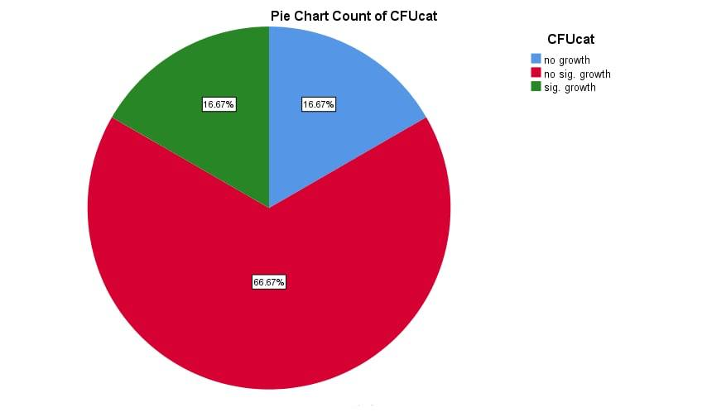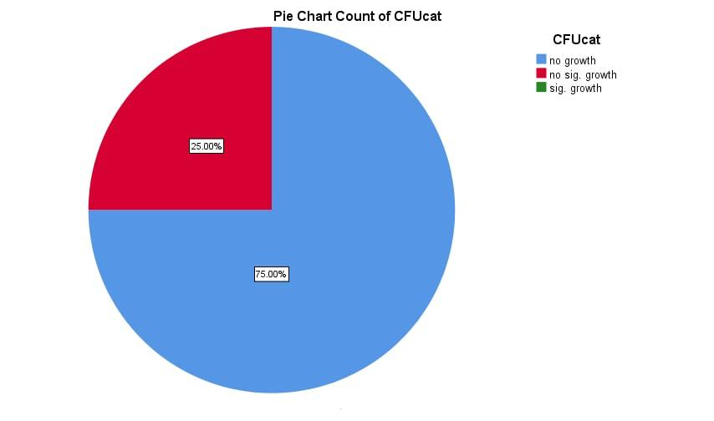
6

As seen in Tables above, there is a link between gender and asymptomatic bacteriuria. To see if the correlation was significant, a Chi-Square test was used. The hypothesis was that the two variables have a link, but the null hypothesis was that they don't. Because the criteria of having less than 20% of cells with an expected value of less than five was not met, a fisher test was used instead.
The null hypothesis is rejected since the p-value is less than 0.05, showing that there is a link between gender and bacteriuria prevalence.

7
DISCUSSION;

The prevalence of asymptomatic bacteriuria varies with age, sex, sexual activity, and the presence of genitourinary disorders. The prevalence of bacteriuria in healthy women rises with age, from around 1% in girls aged 5 to 14 to more than 20% in women aged 80 and up living in the community.
The difference in the incidence of asymptomatic bacteriuria between males and females has a significant P-value because it is less than one (0.05). As a result, females experience much more asymptomatic bacteriuria than males.
Because the P-value is less than 0.05, the null hypothesis is rejected (0.05).
This is attributable to a variety of factors, including the female urinary system's anatomical design.
Females have a smaller urethra, which is responsible for carrying urine out of the body. Germs enter the urinary tract through the urethra, and a shorter urethra makes it easier for bacteria to enter because it needs to travel a less distance. Another source of urinary tract infections is the proximity of the urethra to the rectum, which harbors Escherichia coli, the most prevalent cause of asymptomatic bacteriuria and urinary tract infections. Females are more susceptible to urinary tract infections and asymptomatic bacteriuria due to the anatomical configuration of their reproductive system

8
CONCLUSION :
The findings of this study have highlighted the importance of recognizing asymptomatic bacteriuria as part of university medical screening. Even if they were suffering from an asymptomatic sickness, students would usually avoid going to a clinic. More research is needed to determine the prevalence of bacteriuria, infecting species, and risk factors. Because it comes from the colon's normal flora, E. coli is the most common causative agent. More research is needed to establish if there is a link between bacteriuria and age, or if it is linked to immune-related illnesses. Females have a much higher rate of asymptomatic bacteriuria than males.

REFERENCES:
- Urinary Tract Infections | UTI | UTI Symptoms | MedlinePlus [Internet]. Medlineplus.gov. 2020 [cited 6 March 2020]. Available from

- Geerlings SE. Clinical Presentations and Epidemiology of Urinary Tract Infections. Microbiol Spectr. 2016;4(5): 10.1128/microbiolspec.UTI-0002-2012. doi:10.1128

- Saka _ Sakamoto, M., et al. "Molecular analysis of bacteria in asymptomatic and symptomatic endodontic infections." Oral microbiology and immunology 21.2 (2006): 112-122

- moto, M., et al. "Molecular analysis of bacteria in asymptomatic and symptomatic endodontic infections." Oral microbiology and immunology 21.2 (2006): 112-122
9

