Effect of Gender differences on prevalence and microbial spectrum .

Student name: Rahaf sulima
Student number: 3083
Supervisors: Dr.Iman Fergani
Mr. Alhomr
Dr. Intisar alnaji
Mr. Alshrif
Libyan International Medical University
Second Year Basic Medical science
2021 - 2022

ABSTRACT:
asymptomatic bacteriuria (ABUS) is the presence of bacteria in the properly collected urine of
a patient that has no signs or symptoms of a urinary , The aim of this study was to investigate the prevalence of asymptomatic bacteriuria among LIMU students. Urine samples were collected from 24 males and females in this study .The samples were cultured on CLED agar were examined for the presence of bacteria was negative . The organisms were E. coli wish is the most common costive in asymptomatic bacteriuria and the P-value was statistic significant .

INTRODCATION:

A typical person urinates between 800 and 2,000 milliliters every day. It means Urinary system in both male and female consist of : tow kidneys and ureter – upper urinary tract – one bladder and urethra- lower urinary tract - which responsible for urine formation and execration .$^{(1)}$
A urinary tract infection (UTI) is an infection in any part of urinary system , it can cause Pyelonephritis ( inflammation of kidney ) , Cystitis ( inflammation of urinary bladder ) and Urethritis ( inflammation of urethra ) $^{(2)}$..
Infection of lower urinary tract can ascends to the upper part of urinary tract .
And this infection can be complicated or not , patients may be symptomatic or asymptomatic
The most common causative microorganism of UTI is Escherichia coli , and it is introduced into the urethra, often in fecal contamination.
Millions of people in the United States, suffer bacterial urinary tract infections (UTIs) each year. $^{(3)}$
nonpathogenic facultative flora of the human intestine is dominated by Escherichia coli. Some E. coli strains, on the other hand, have gained the potential to induce gastrointestinal, urinary, and central nervous system disease in even the most resistant human hosts $^{(4)}$.
After E. coli is introduced into the urethra , E. coli adhere to epithelial cells in the urethra , and begin to multiply and the infection action start $^{(5)}$.
The Urine analysis test can help us to identify this type of infection and others , it can also detect the amount of a lot of minerals in the body , normal range of some substances (proteins , vitamins ..) , and some of diseases ( prostate cancer $^{(6)}$ , and kidney injury for example $^{(7)}$

MATERIALS AND METHODS:
A 35 sample was taken from different genders..
18 from males, and 17 from females.

There are many ways to collect the urine sample from the patient and put it in sterile bottle which is: sterile urine bag, suprapubic aspiration, urethral catheterization (CATH) and Midstream clean-catch.

Basic examinations of urine sample include :
Physical examinations (samples color , smell and volume )
Chemical examination ( specific gravity, pH degree and some substances that used to detect a lot of primary and secondary diseases )
And microscopic examinations ( the types of cells found in the sample ) .

The samples are placed in different media to see the type of organism ( maCconcky agar and blood agar for example ).
Loops with specific diameters (0.001ul - 0.01ul) were used to put the bacteria in the agar with zigzag motion .

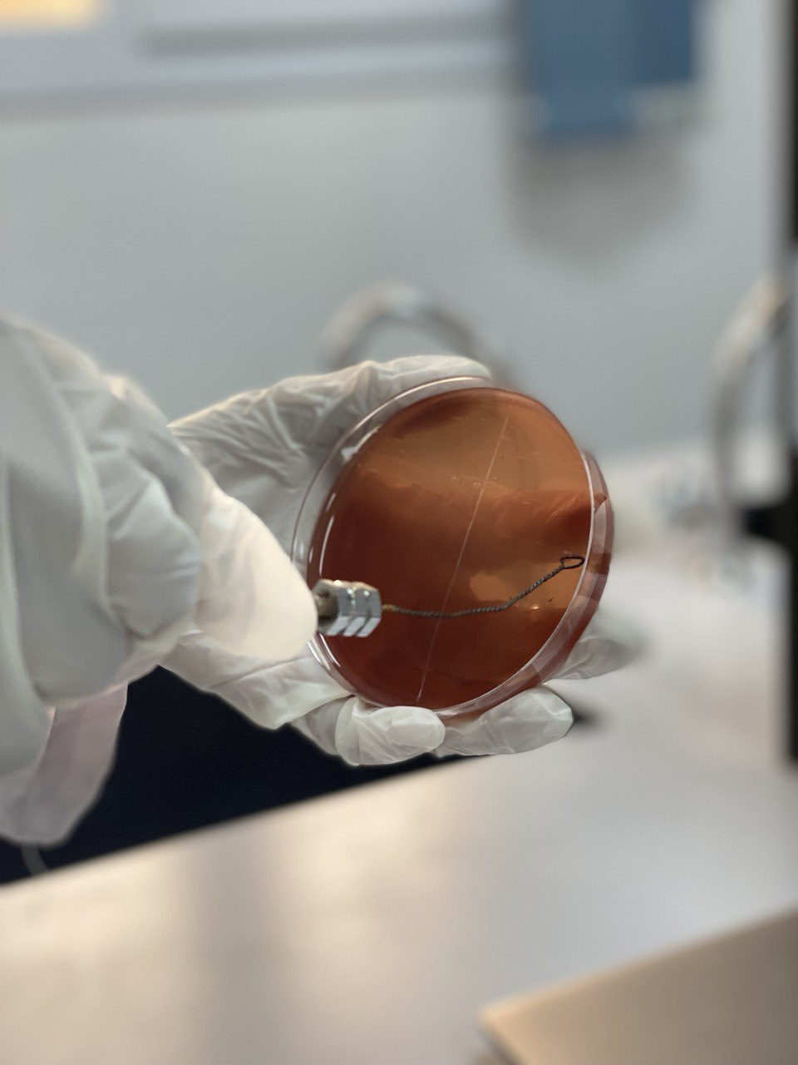
Figure (1)
Shows a zigzag motion

Cultures should be done within 1 hour after collection or kept in the refrigerator for no more than 18 hours at 4°C .

Result and statistical analysis
Gender * UTICATS Crosstabulation

 |  |  | UTICATS |  |  | Total
 |  |  | No growth | No significant growth | Significant growth | Total
Gender | Male | Count | 9 | 3 | 0 | 12
Gender | Male | Expected Count | 5.5 | 5.5 | 1.0 | 12.0
Gender | Male | % within Gender | 75.0% | 25.0% | 0.0% | 100.0%
Gender | Male | % within UTICATS | 81.8% | 27.3% | 0.0% | 50.0%
Gender | Female | Count | 2 | 8 | 2 | 12
Gender | Female | Expected Count | 5.5 | 5.5 | 1.0 | 12.0
Gender | Female | % within Gender | 16.7% | 66.7% | 16.7% | 100.0%
Gender | Female | % within UTICATS | 18.2% | 72.7% | 100.0% | 50.0%
Total |  | Count | 11 | 11 | 2 | 24
 |  | Expected Count | 11.0 | 11.0 | 2.0 | 24.0
 |  | % within Gender | 45.8% | 45.8% | 8.3% | 100.0%
 |  | % within UTICATS | 100.0% | 100.0% | 100.0% | 100.0%

Chi-Square Tests
 |  | Value | df | Asymptotic Significance (2-sided) | Monte Carlo Sig. (2-sided) |  |  | Monte Carlo Sig. (1-sided)
 |  |  |  |  | Significance | 99% Confidence Interval |  | Significance | 99% Confidence Interval
 |  |  |  |  |  | Lower Bound | Upper Bound | Significance | Lower Bound | Upper Bound
 | Pearson Chi-Square | 8.727ª | 2 | .013 | .018^{b} | .014 | .021
 | Likelihood Ratio | 9.949 | 2 | .007 | .012^{b} | .009 | .015
 | Fisher's Exact Test | 8.180 |  |  | .018^{b} | .014 | .021
 | Linear-by-Linear Association | 8.065^{c} | 1 | .005 | .006^{b} | .004 | .008 | .002^{b} | .001 | .003
 | N of Valid Cases | 24

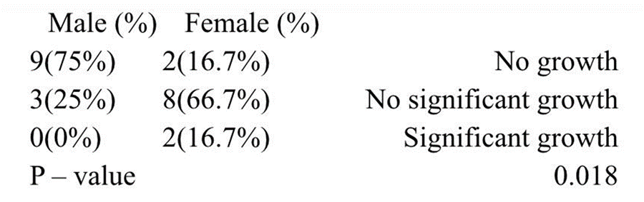

As shown in the previous table there are 3 stages according to colony forming units (CFUs) per ml of urine as follow:
The first is no growth, or CFUs was zero
The second is no significant growth CFUs <100,000 colonies
The third stage is significant growth CFUs ≥100,000 colonies
12 females ( total ) , 2 of them have had significant growth ( about 16.7%). Males had no significant growth at all .
Females : (50)% represented with bacterial growth generally .
The p value shows significant relationship between the gender differences and asymptomatic bacterial infection in urine .

Discussion:

Urinary tract infection is prevalent, is a worldwide health care problem with frequency increasing with age, gender female are more risk than the , The incidence of bacteriuria in healthy women increases with age, and in girls more than in women in the community. The recurrence rate is high, and often the infections tend to become chronic with many episodes .
The presence of a significant quantity of bacteria in a urine specimen properly collected from a person without symptoms or signs of a UTI characterizes asymptomatic bacteriuria .Quantitative criteria for identifying significant bacteriuria in an asymptomatic person are :at least 100,000 colony-forming units (CFUs) per mL of urine in a voided midstream clean-catch specimen; and (2) at least 100 CFUs per mL of urine from a catheterized specimen. Throughout this research, result shows there was a definite bacterial colony in the cutler in females, and the number of colonies bacteria in urinalysis growth ranged from 0 to 100000 CFU/ml, with 25% of students reaches 100 colonies. In urine cultures, any growth of 10,000 CFU/mL or more was found to be negative. There were 7(29.2%) students whose urine samples grew less than 10,000 CFU/mL, 6 (25%) cases with 10,000 CFU/mL and more, and 11(45.8%) with no growth, indicating that females are more likely to ASBU. According to one study
According to one study, the exact pathophysiology of this condition has not been adequately defined. The most prevalent bacterium recovered from patients with asymptomatic bacteriuria is Escherichia coli. The most common bacteria associated with asymptomatic bacteriuria is Escherichia coli (ABU). Unlike uropathogenic E. coli (UPEC), which causes symptomatic urinary tract infections (UTI), nothing is known about how these strains invade the human urinary tract.
However Studies of women with diabetes show no difference between initially asymptomatic bacteriuria and non bacteriuria women in the incidence of UTI, mortality, or progression to diabetic complications at 18 months 25 or 14 years.
There are varying views on whether or not to test for asymptomatic bacteriuria. Asymptomatic bacteriuria examination, according to the authors, should be included as part of medical standards since they may be increasing asymptomatic infection. The presence of bacteria in samples verified the diagnostic criteria for a significant urinary tract infection (UTI), which is the most common cause of UTI. According to the findings of this investigation, some bacterial isolates are more responsive to antibiotic therapy than others. This should be considered while choosing an antibiotic. The most effective antibiotics for Gram negative and Gram positive pathogens were identified to be ciprofloxacin, gentamycin, and streptomycin. If asymptomatic bacteria are discovered, they should be examined and treated with suitable antibiotics. Early detection and treatment may be beneficial. $^{(8)}$

Conclusion

In conclusion, ASBU disease is more common among female LIMU university students than among males. It is caused by the most common prevalent pathogenic bacterium witch is ,E. coli lead to asymptomatic bacteriuria , Because the P-value was considerable, the female is at high risk to get infected ,Physical cleanliness should be encouraged and self-prescription of antibiotics,. which could result in antibiotic resistance should be minimized .

References:

1 – clinical Atlas of human anatomy , 7th edition
2- robbins basic pathology
3- robbins basic pathology
4- James P. Nataro, James B. Kaper. Diarrheagenic Escherichia coli. (1998)
5-ROPERT , W ,PhD.MICROBIOLOGY WITH DISEASES BY BODY SYSTEM
6- Fradet Y, Saad F, Aprikian A, Dessureault J, Elhilali M, Trudel C, Mâsse B, Piché L, Chypre C. uPM3, a new molecular urine test for the detection of prostate cancer. Urology. 2004 Aug
7-Vaidya VS, Ford GM, Waikar SS, Wang Y, Clement MB, Ramirez V, Glaab WE, Troth SP, Sistare FD, Prozialeck WC, Edwards JR. A rapid urine test for early detection of kidney injury. Kidney international. 2009 Jul
8- LINDSAY E. NICOLLE, M.D., ANDREW MCGLONE, M.D., AND THOMAS M. HOOTON, M.D. American Family Physician,(2006).

