

Asymptomatic bacteriuria in LIMU students

Libyan International Medical University
Faculty of Applied Medical Science

Mutaz jafaar
1701
Group : A1

Doctor’s Supervisor name :
Huwida khattab

Assistant by :
Mr. ahmad Algebne

Abstract:

UTIs (urinary tract infections) are a common infection that affects approximately three times as many women as males. The waste orifice is on one end of the urinary tract, while the bladder is on the other. This suggests that germs have infested the urinary tract. The issue arises when the wrong type of bacteria enters the body from the wrong end of the gastrointestinal track. Asymptomatic bacteriuria is more common in women than in males due to the shorter female urethra, which allows germs from the urethral meatus and perineum to travel a shorter distance to the bladder. Escherichia coli is the most common bacterium found in patients with asymptomatic bacteriuria. Bacteria can cause infections in a variety of ways. Pseudomonas aeruginosa, Enterococcus species, Enterobacteriaceae , and also group B streptococcus are included with it .
Introduction:
A urinary tract infection occurs when fecal bacteria enter the urethra, the tube via which urine is evacuated from the bladder. Bacteria can enter the urethra and cause sickness if they are introduced through sexual intercourse.
There are three types of urinary tract infections. The first is urethritis, which is a urethral irritation. (1) When an infection spreads from the urethra to the bladder, it is called cystitis. Although these are the most common and easily treated disorders, an infection in the bladder can spread to the kidneys. (1)Waste from the blood is filtered by the kidneys and sent to the bladder for collection. (1) A kidney infection is even riskier and less prevalent.
Asymptomatic or symptomatic urinary tract infections can occur during pregnancy. Asymptomatic presence of substantial bacteriuria without the signs of an acute urinary tract infection is referred to as bacteriuria. (3) Urinary tract infections can be split into two types: lower tract (acute cystitis) and upper tract (acute pyelonephritis). (3)

The most prevalent bacterium recovered from patients with asymptomatic bacteriuria is Escherichia coli. Infections can be caused by a variety of bacteria. Enterobacteriaceae, Pseudomonas aeruginosa, Enterococcus species, and group B streptococcus are among them. Asymptomatic bacteriuria is fairly prevalent in clinical practice, and its prevalence increases with age. In women and men aged 65 to 80 years, the incidence is 15% or higher, and it can rise to 40% to 50% after that age. The majority of patients with asymptomatic bacteriuria will never acquire symptomatic urinary tract infections, and their disease will have no harmful repercussions. (3) The exact cause of asymptomatic bacteriuria has yet to be discovered. Only asymptomatic bacteriuria patients who will benefit from treatment should be treated; the majority of patients will not (4) . however , There are a few exceptions, though. According to the data, a pregnant lady with asymptomatic bacteriuria should be treated. Asymptomatic bacteriuria should be addressed in patients having urologic operations that are likely to cause mucosal bleeding, as well as those in the first three months after a kidney transplant.

Materials and methods:
This study's samples include 24 volunteers, 12 male and 12 female. Questionnaire bio data for the participants include name, gender, age, parents' occupation, number of brothers and sisters, and UTI history. A chi-square statistic test was performed in this study to investigate how a model compares, and the SPSS version software program was used for data administration and statistical analysis. inspection of the body: The appearance of the urine sample from the patient is normally clear cloudiness or an unusual odor may suggest a problem such as an infection. Blood in the urine might cause it to appear red or brown. What you've recently eaten can affect the color of your urine. Dipstick is a thin plastic stick with chemical strips. Then, it is placed in the urine to detect any abnormalities, the way of knowing this is when the chemical strips change colors. A microscope was used to examine the sample. If any of the following are detected, such as white blood cells or red blood cells, as well as bacteria or yeasts casting crystals, create a culture media.
Results and statistical analysis:

Chi-Square Tests
 | Value | df | Asymptotic Significance (2-sided) | Monte Carlo Sig. (2-sided) |  |  | Monte Carlo Sig. (1-sided)
 |  |  |  | Significance | 99% Confidence Interval |  | Significance | 99% Confidence Interval
 |  |  |  |  | Lower Bound | Upper Bound | Significance | Lower Bound | Upper Bound
Pearson Chi-Square | 8.727ª | 2 | .013 | .018^{b} | .014 | .021
Likelihood Ratio | 9.949 | 2 | .007 | .012^{b} | .009 | .015
Fisher's Exact Test | 8.180 |  |  | .018^{b} | .014 | .021
Linear-by-Linear Association | 8.065^{c} | 1 | .005 | .006^{b} | .004 | .008 | .004^{b} | .003 | .006
N of Valid Cases | 24
a. 2 cells (33.3%) have expected count less than 5. The minimum expected count is 1.00.
b. Based on 10000 sampled tables with starting seed 2000000.
c. The standardized statistic is -2.840.
Table 1

CFUcat * Gender Crosstabulation
 |  |  | Gender |  | Total
 |  |  | Female | Male | Total
CFUcat | No growth | Count | 2 | 9 | 11
CFUcat | No growth | Expected Count | 5.5 | 5.5 | 11.0
CFUcat | No growth | % within Gender | 16.7% | 75.0% | 45.8%
CFUcat | Overall no significant growth | Count | 8 | 3 | 11
CFUcat | Overall no significant growth | Expected Count | 5.5 | 5.5 | 11.0
CFUcat | Overall no significant growth | % within Gender | 66.7% | 25.0% | 45.8%
CFUcat | Significant growth | Count | 2 | 0 | 2
CFUcat | Significant growth | Expected Count | 1.0 | 1.0 | 2.0
CFUcat | Significant growth | % within Gender | 16.7% | 0.0% | 8.3%
Total |  | Count | 12 | 12 | 24
 |  | Expected Count | 12.0 | 12.0 | 24.0
 |  | % within Gender | 100.0% | 100.0% | 100.0%

Case Processing Summary
 | Cases
 | Valid |  | Missing |  | Total
 | N | Percent | N | Percent | N | Percent
CFUcat * Gender | 24 | 64.9% | 13 | 35.1% | 37 | 100.0%

Table 2: correlation between gender and ABU expressed using percentages

Table 3: summary of case

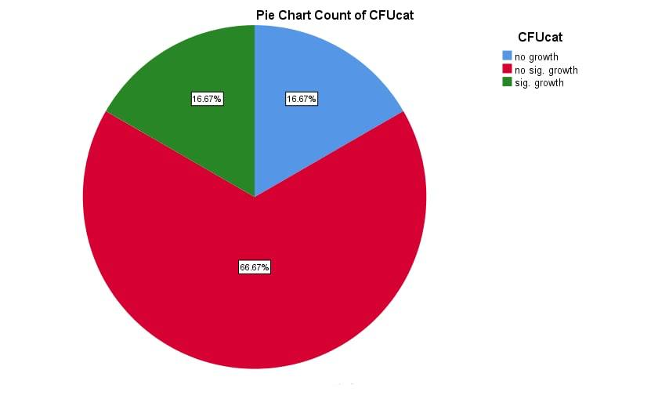

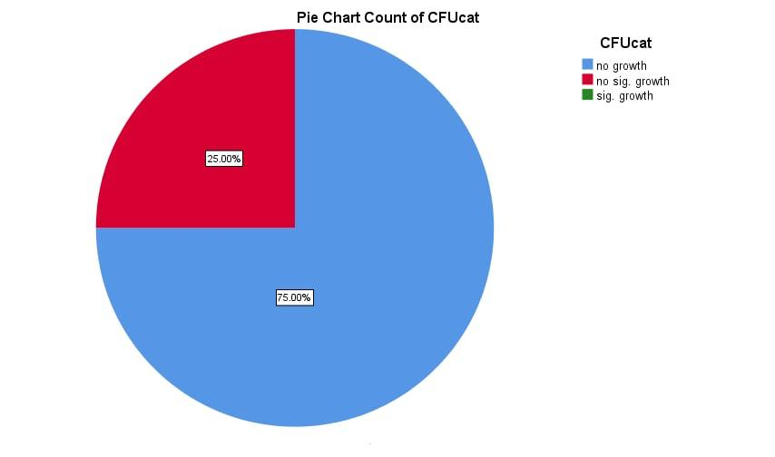

Discussion:

Urinary tract infections (UTIs) are a frequent infection that affects nearly three times as many women as they do men. (1)There are two ends to the urinary tract: one leads to the waste orifice and the other to the bladder. This indicates that the urinary tract is inundated with microorganisms. When the wrong sort of bacteria enters the body from the wrong end of the gastrointestinal tract, the problem emerges. The shorter female urethra permits germs from the urethral meatus and perineum to travel a shorter distance to the bladder, making asymptomatic bacteriuria more common in women than in men. (2) As a result, we can see that our null hypothesis is rejected in this experiment , because the most prominent into getting infections are females. The P value is 0.019 so its less than 0.5 that plays an important role because it gives us the evidence that leads us to this result. The incidence of the infection among youngsters and the elderly is unknown, and it is currently being investigated. Although bacteria are the most common cause of illness in humans, fungi and viruses play an important role as well. UTIs caused by a viral or fungal infection, on the other hand, are regarded to be uncommon. Though the infection looks to be harmless at first, the patient develops a variety of symptoms as the illness continues, which can lead to death in severe cases. The most prevalent sort of bacterial infection, according to studies, is urinary tract infection. (4) Poor diagnosis can lead to a urinary tract infection, which is the most frequent infection acquired in hospitals. A wide spectrum of clinical symptoms and illnesses are associated with the infection.
The infection can cause a variety of clinical syndromes and disorders, each with its own epidemiology, origin, location, and severity. It varies in terms of expressing local symptoms, frequency of recurrence, level of damage produced, the presence of complicating conditions, and the risk of recurrence, in addition to the characteristics described above. (2) When a bladder infection occurs, it is frequently followed by a kidney infection, which can result in a blood infection and, in severe circumstances, death. As a result, UTI has the potential to claim lives in extreme circumstances, and correct treatment leads to a quick recovery from the infection. Between the sixth and twenty-fourth weeks of pregnancy, the infection emerges.

Conclusion and future directions:
In this report we discussed how females are projected into getting urinary tract infections more than males. We listed the reason why according to the urethra, pregnancy, and other infections that could lead to it for an example. There are some ways of preventing these infections from occurring in the beginning and there are some ways to prevent it from getting worse. Urinary tract infections could be classified into two types of bacteriuria, it could be asymptomatic or symptomatic. The most common cause of causing urinary tract infections is E.coli. Urinary tract infections if not treated could lead to severe diseases that could be hard to treat so that’s why we need to treat it right away.

References
1. Goecker L, Rakshit D, Rakshit D, Naraharisetty R, Naraharisetty R. Why Women Are More Prone to Urinary Tract Infections Than Men. The Swaddle. https://theswaddle.com/why-are-women-more-prone-to-utis-than-men/. Published 2022. Accessed June 19, 2022.

2. Flores-Mireles AL, Walker JN, Caparon M, Hultgren SJ. Urinary tract infections: epidemiology, mechanisms of infection and treatment options. Nat Rev Microbiol. 2015;13(5):269-284. doi:10.1038/nrmicro3432

3. Givler D, Givler A. Asymptomatic Bacteriuria. Ncbi.nlm.nih.gov. https://www.ncbi.nlm.nih.gov/books/NBK441848/. Published 2022. Accessed June 19, 2022.

4. COLGAN R, NICOLLE L, MCGLONE A, HOOTON T. Asymptomatic Bacteriuria in Adults. Aafp.org. https://www.aafp.org/pubs/afp/issues/2006/0915/p985.html. Published 2022. Accessed June 19, 2022.

