

INCIDENCE RATE OF BACTERIURIA AMONG LIMU STUDENT

Student Name: Saad Mohammed Altawel
Student Number: 2849
University: Libyan International Medical University
Faculty: Applied Medical Science

Abstract:
The aim of this report to increase the awareness of the asymptomatic bacteriuria and control the incidence of this disease in selected populations, unfortunately, no previous research were taken in Libya to put the light and emphasize the need to know the risk factors for asymptomatic urinary tract infection. This was made by cohort-study to discovered a link between gender and asymptomatic bacteriuria, revealing that females are more common for a variety of reasons, it is rarely treated, with the exception of pregnancies, where it can be fatal for both the child and the mother, and kidney transplant patients, where treatment should be avoided to avoid antibiotic resistance. E.coli is the most common causative agent because it is a typical normal flora in the colon.

Introduction:
Asymptomatic bacteriuria, also well known by bacteriuria or asymptomatic urinary infection; it is defined by the presence of pathogenic bacteria within a correctly collected urine sample of people that is showing no signs and symptoms of UTI It is clinically common and can increment in chance with age, is a typical observation in healthy women and it is around 40% more prominent than in males after the age of 80, men are subsequently altogether less likely to be influenced, in which a ponder laid out that: ASB is once in a while seen in center matured guys and is, for the most part, recorded as it were in patients over 50 a long time of age with prostatic diseases equally with females affected with this disease.
In the absence of signs or symptoms of urinary infection, asymptomatic bacteriuria is defined as at least 105 CFU/ml of a uropathogen isolated from voided urine specimens.
For women, two consecutive positive voided specimens are recommended, whereas for men, a single specimen is sufficient. At least 102 CFU/ml is required for an in and out catheter specimen, including specimens from patients who use clean intermittent catheterization.
The presence of biofilm along the catheter complicates the detection of bacteriuria in people who have chronic indwelling catheters. For these patients, a quantitative count of at least 105 CFU/ml is likely to be acceptable for these patients.
E. coli being the most common causing organism of both asymptomatic bacteriuria and acute UTI. However, they must be distinguished from each other, as acute UTI is a symptomatic genitourinary tract infection that is presented with symptoms like dysuria, urgency and supra-pubic pain.
Bacteriuria that is asymptomatic is usually harmless. Only pregnant women and people who have had invasive urologic procedures with mucosal injuries are considered to have bacteriuria-related morbidity. Recent papers have added to our awareness of bacteriuria's various characteristics and refined our grasp of how to manage this disease in specific populations.
Based on past discoveries it is anticipated that female understudies are to be strikingly more influenced by ASB than the males of the same age. A try was conducted among the 24 LIMU students, 12 females and 12 males within the taking after lab inquire about tests to demonstrate the past discoveries. Highlighting if females have a higher frequency of asymptomatic urinary infection due to their biological disposition

Materials and the Method:
To acquire the best results, urine samples were taken midway through the urination process from 24 persons, 12 males and 12 females. The culture was started just a few minutes after the sample was taken, with the intention of finishing in less than an hour. A urine sample test tube, a calibrated wire loop, a Bunsen burner, an incubator, and an agar plate containing culture media, preferably CLED or MacConkey agar, to detect most gram-negative bacilli, staphylococci, streptococci, and enterococci, are all required.
The loop was heated and the urine was steered, then the loop was inserted vertically into the urine to allow it to adhere to the loop, then it was spread by touching the tip to the center of the plate and dragging across the diameter, the loop was placed in the urine again and spread in a Zig-Zag pattern, and the plate was incubated in the air at 37 C for 24 hours. The number of colonies was counted and multiplied by 100 due to the use of a 0.01 ml loop; if the colony forming unit is 1 105 CFU/mL, then there has been a considerable increase.
Results and statistical analysis:

Table 1
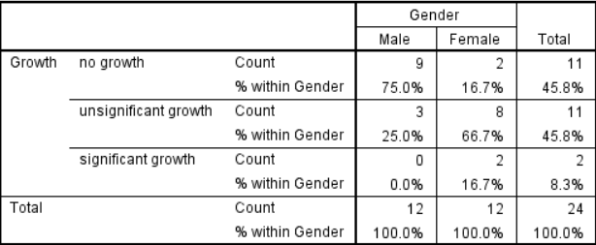
Table 2
There is a relationship between gender and asymptomatic bacteriuria, as indicated in Table 1. A Chi-Square test was conducted to assess if the association was significant. The hypothesis was that there is a link between the two variables, whereas the null hypothesis is that there isn't. However, because the requirement of less than 20% of cells having an anticipated value of less than five was not met, a fisher test was utilized instead.
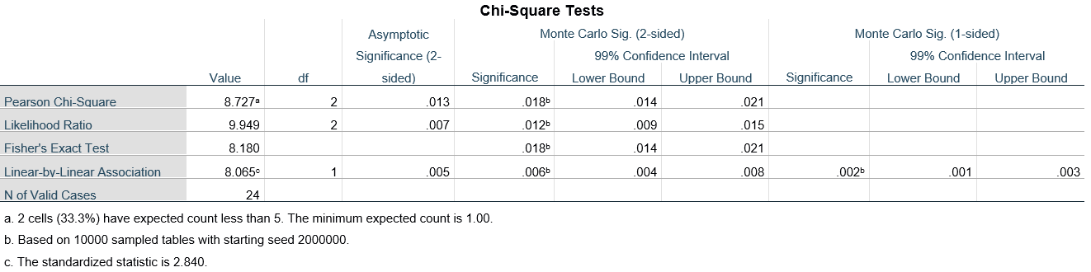
Table 3
We reject the null hypothesis since the p-value in Table 3 was less than 0.05, indicating that there is a relationship between gender and the prevalence of bacteria Because the p-value was less than 0.05 in Table 3, we reject the null hypothesis, meaning that there is a link between gender and the prevalence of bacteriuria Uria.

Graph 1
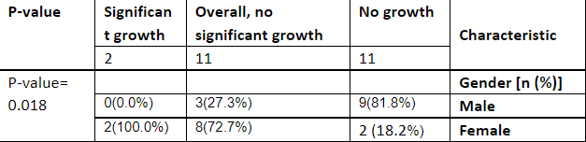
Table 4

Discussion:
The findings support the hypothesis that there is a link between gender and asymptomatic bacteriuria. Females have a higher rate than males, as shown in Graph 1, with 75 percent of males having no growth, 25% having unsignificant growth, and none having asymptomatic bacteriuria, whereas only about 17 percent of females had no growth, 67 percent had unsignificant growth, and about 17 percent had asymptomatic bacteriuria.
This is due to a number of variables, including the physical shape of the female urinary system. The urethra, which is responsible for transporting urine out of the body, is smaller in females. The urethra is where bacteria enter the urinary tract, and a shorter urethra makes it easier for bacteria to enter because it has to travel a less distance. The proximity of the urethra to the rectum, which contains Escherichia coli, the most common cause of asymptomatic bacteriuria and urinary tract infections, is another reason (UTIs). Because of the anatomical structure of their reproductive system, females are more susceptible to UTIs and asymptomatic bacteriuria.
The likelihood of asymptomatic bacteriuria increases during menopause. Estrogen levels diminish during menopause, resulting in weakened vaginal tissue that is more prone to infection. Pregnancy increases the risk of asymptomatic bacteriuria, which can lead to vesicoureteral reflux, in which urine flows back to the bladder and subsequently to the kidney, due to hormonal changes. This raises the risk of pyelonephritis, a potentially fatal condition. Some medications, such as spermicide, can increase the risk of asymptomatic bacteriuria by inducing vaginal irritation, which can create an environment that is conducive to bacterial growth. The majority of persons who have asymptomatic bacteriuria don't have any symptoms. Children, diabetics, and the elderly are among the patients. Patients who are at risk of mucosal bleeding during urologic surgery should be addressed, Patients in the first three months following a kidney transplant should do the same. To avoid pyelonephritis, low birth weight, and premature birth, pregnant women must be treated as well. It's recommended not to treat patients who don't need antibiotics because this increases the risk of antibiotic resistance.
E.Coli is the most common cause of asymptomatic bacteriuria, as previously indicated. This is due to E.coli being a natural part of the flora of the colon. Other pathogens include Klebsiella pneumoniae, Pseudomonas aeruginosa, Staphylococcal, and Enterococcal specie

Conclusion:
This study discovered a link between gender and asymptomatic bacteriuria, demonstrating that females are more susceptible to the condition for a variety of reasons, including the anatomical anatomy of the female reproductive system. Because asymptomatic infection rarely progresses to a serious infection that causes another disease, it is rarely treated, with the exception of pregnancies, where it can be fatal for both the child and the mother, and kidney transplant patients, where treatment should be avoided to avoid antibiotic resistance. E.coli is the most common causative agent because it is a typical part of the colon's flora. More research is needed to see if there is a correlation between bacteriuria and age, or if it has anything to do with immune-related disorders such as AIDS.
Referencing:
- https://journals.asm.org/doi/10.1128/microbiolspec.UTI-0001-2012?url_ver=Z39.88-2003&rfr_id=ori:rid:crossref.org&rfr_dat=cr_pub%20%200pubmed. Published 2022. Accessed June 19, 2022.-
2. Imop.med.auth.gr. http://imop.med.auth.gr/sites/default/files/reference-3.pdf. Published 2022. Accessed June 19, 2022.

