
Name: Rana.Hussin.Shembesh
Stud.NO:2347
Group A1 -

1- Develop a network diagram for the project specified below

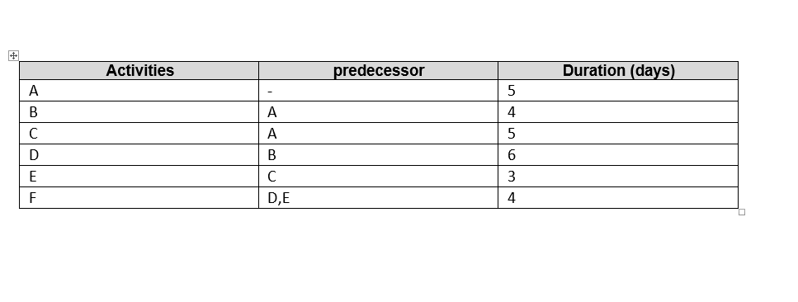

A
C
E
F
D
B
2- Identify the Critical Activities and the total duration of the project
- Path number 1: A B D F, it is the longest pathway and considerate as the critical path the total duration in this path is 19 days.
- Path number 2: A C E F, the total duration is 17 days.
- The total duration of all project is 27 days. As recorded all the duration in the table above

3- Justify which activity would you crash based on some rationale
The activity would be crashed is ( D) because
- When we determine the critical path we going to reduce the duration because it’s the longest path and the important path in the project
- This activity is having the longest duration ( 6 days)
- Also the cost is important when the project is crashed we should choice the activity with lowest cost (but the cost in this table are not recorded)
- The reason of crashed is due to
- When there is a delay
- When the project has a fixed final date
- Get the most compression on the duration of a project.

