

Prevalence of asymptomatic bacteriuria in LIMU males and females.

Student name: Muna Hassan Elzeadani.
Student number: 2842
Instructor: Dr. Naji Alhomry and Dr. Asma.
Course title: PTS.
Due date: 4th / June /2022

Abstract:
Asymptomatic bacteriuria is a very common clinical condition, having an incidence of 15% or greater in females and males in the age group of 65 to 80, and higher with 40% to 50% after the age of 80 [3]. Urinary tract infections (UTIs) are responsible for an estimated 7 million office visits, 1 million emergency room visits, and 100,000 hospitalizations each year, and account for 25% of all infections in elderly patients [1].
This study has tested the prevalence of asymptomatic bacteriuria on 24 students, 12 males and 12 females, 22 of the students had a healthy urinary tract, whereas 2 females had significant bacterial growth with E.coli. This study also supported that asymptomatic bacteriuria is more common in females due to several reasons discussed later.
In this report, we will show the difference between asymptomatic bacteriuria and urinary tract infections to help understand the risk factors associated with both asymptomatic bacteriuria and UTIs, as this will help in improving the quality of life. We will also be able to learn the right methods to diagnose asymptomatic bacteriuria, therefore preventing confusion between both asymptomatic bacteriuria and UTI.

Introduction:
The urinary system is divided into upper and lower urinary tract; the upper part involving the kidneys and ureters, and lower part involving the bladder and urethra. Urinary tract infections (UTIs) are defined as an inflammatory response to a bacterial infection at the level of the urothelium; infection to the upper part is called pyelonephritis, while to the lower part cystitis [4]. Asymptomatic bacteriuria (ASB) is the presence of bacteria in the urine (positive urine culture) without having any symptoms.

Anatomical difference of the genital tract between females and males, specifically the length of the urethra contributes in developing a UTI. Females urethra is 1-2 inches compared to a 6 inches longer urethra in males; a very common theory for inoculation is the ascending route, in which enteric bacteria colonize the perineum and ascend into the urethra and bladder [4]. Furthermore, the location of the urethra being closer to the rectum in females, which carries the waste and bacteria as E.coli, also contributes in developing a UTI.

Both MacConkey agar (MAC) and 5% sheep blood agar were used in this experiment, MAC is a selective and differentiating agar that only grows gram negative bacterial species and furthermore, can differentiate between them based on their lactose metabolism. Examples of Lactose fermenting species which turn the pH indicator to pink are: Escherichia coli, Enterobacteria, and Klebsiella. Non-lactose fermenting will produce white colonies are for example: Salmonella, Proteus, Yersinia, and Pseudomonas. Besides, some species like Klebsiella and enterobacter produce mucoid, sticky, wet colonies [5]. 5% sheep blood agar differentiate hemolytic bacteria, exhibiting a classification of complete (beta hemolysis) e.g: E.coli, and S.aureus. Partial (alpha hemolysis) e.g: S.agalactiae. And none (gamma hemolysis) e.g: S.saprophyticus. Whereas some species such as Proteus are very motile and produce a swarming appearance on blood agar [6].

Studies have shown that UTI doesn’t only affect a person’s health, but also his mental health. More than half of UTI patients suffered from clinical depression, and 38.5% suffered from anxiety, with an improvement after proper treatment and prophylaxis [4]. The aim of this study is to know the prevalence of asymptomatic bacteriuria in LIMU students, to determine the association between asymptomatic bacteriuria and the gender, and to provide specific methods for culturing to prevent the confusion of diagnosis, consequently living a happy, healthy life.

Materials and methods:
A urine sample was obtained from the patients through midstream void in the early morning. The urine sample was collected by midstream clean catch, in which the patient should void a small amount in the toilet and then collect the rest portion in the container, therefore avoiding contamination with normal flora. After collection, the urine sample was tested within an hour, or kept for a maximum of 18 hours in a refrigerator at 4º C; so that the bacteria in the urine do not multiply and give a false diagnosis of UTI. For microscopic examination, urine was mixed well, and 5 to 10 ml of it was measured into a centrifugation tube. 9 parts of 10 of the supernatant was carefully removed, resulting in a 10-times concentrated sediment than the original urine sample. The sediment was then viewed under microscope with a lower magnification 100-200x, at which distribution of elements can be estimated. Magnification was switched to 400x, on at least 10 randomly chosen visual fields, checking for leukocytes, casts, crystals, bacteria, and RBCs.
For culturing, urine was mixed well, and a wire loop of 0.01 microliter was inserted vertically into the container and kept for seconds to make sure that the urine adhered to the loop, then the urine was spread on two different agars; MacConkey and blood agar in a specific technique. The loop was touched to the centre of the plate and spread across the diameter in a line, then the loop was crossed left and right (in a zig-zag pattern) multiple times to obtain isolated colonies. The samples were incubated for 24 hours at 37º C, to check for visible growth and isolate microbials in UTI’s. Colonies on the agar in each plate were counted and the number was multiplied by 100 to determine the number of microorganisms per ml in the original sample [6].
For biostatistics, IBM SPSS 25 program was used. To determine the association between the gender and bacterial growth, fisher’s exact test was used.

Results:
24 samples were tested, 2 females had significant growth with Escherichia coli species.
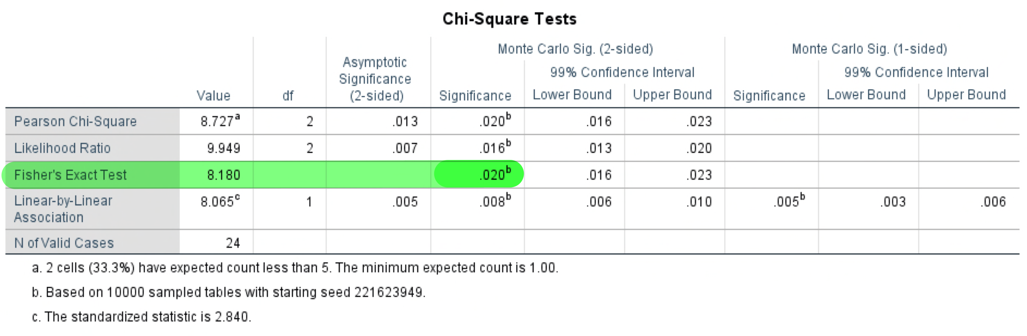
Table 1: p-value of Fisher’s exact test.

bacterialgrowth * Gender Crosstabulation
 |  |  | Gender |  | Total
 |  |  | Male | Female | Total
Bacterial growth | 1 | Count | 9 | 2 | 11
Bacterial growth | 1 | % within bacterial growth | 81.8% | 18.2% | 100.0%
Bacterial growth | 1 | % within Gender | 75.0% | 16.7% | 45.8%
Bacterial growth | 2 | Count | 3 | 8 | 11
Bacterial growth | 2 | % within bacterial growth | 27.3% | 72.7% | 100.0%
Bacterial growth | 2 | % within Gender | 25.0% | 66.7% | 45.8%
Bacterial growth | 3 | Count | 0 | 2 | 2
Bacterial growth | 3 | % within bacterial growth | 0.0% | 100.0% | 100.0%
Bacterial growth | 3 | % within Gender | 0.0% | 16.7% | 8.3%
Total |  | Count | 12 | 12 | 24
 |  | % within bacterial growth | 50.0% | 50.0% | 100.0%
 |  | % within Gender | 100.0% | 100.0% | 100.0%

Table 2: bacterial growth association with gender differences; 1= no growth. 2= overall no significant growth. 3= significant growth.

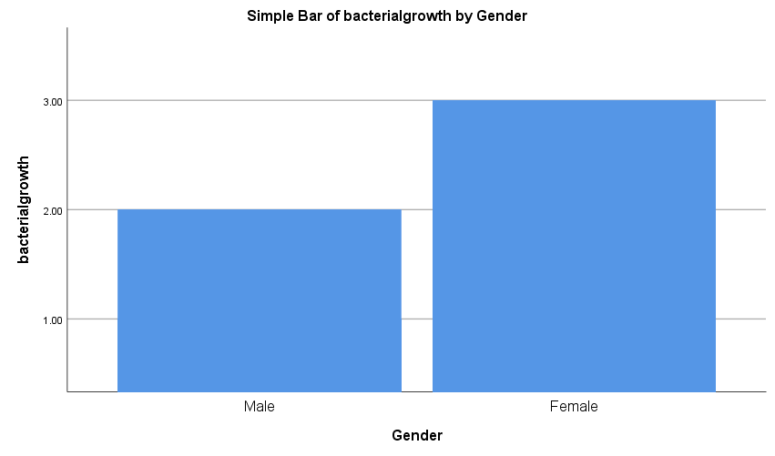Graph 1: simple Bar chart of bacterial growth by gender; 1= no growth. 2= overall no significant growth. 3= significant growth.
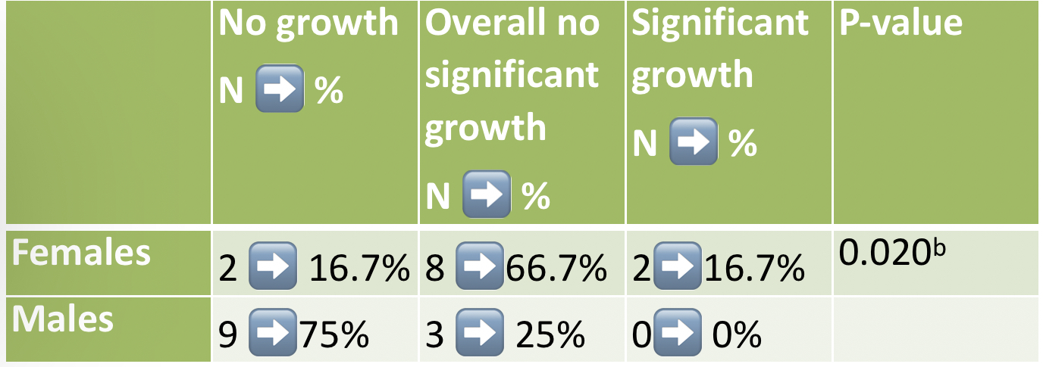

Table 3: summary of the output of Fisher’s exact test.

Discussion:
Most of health care providers mix up between ASB and UTIs, therefore to prevent this confusion, specific measures and guidelines were introduced, including that the diagnosis of ASB is based on results of culture of a urine sample collected in a way that minimizes contamination. For asymptomatic females, bacteriuria is defined as 2 consecutive voided urine specimens with isolation of the same bacterial strain in quantitative counts ⩾10⁵ cfu/mL; and for identification of ASB in males, a single, clean-catch voided urine specimen with 1 bacterial species isolated in a quantitative count ⩾10⁵ cfu/mL [2].
Microscopic examination revealed gram negative rods, MAC agar revealed lactose-fermenting pink colonies, and blood agar revealed beta-hemolytic colonies, all summed up points to the bacterium Escherichia coli.

Fisher’s exact test was used instead of Chi-square test because the assumptions were not met in the latter, due to the small sample size.
Since the p-value is less than 0.05 as shown in {table 3}, the null hypothesis is rejected. As a result the test has proved that there is association between developing asymptomatic bacteriuria and the gender, and there is significant difference between females and males in having ASB.
In the first category, 75% of males, Compared to 16.7% of females had no bacterial growth after incubating the sample for 24 to 48 hours, revealing a healthy urinary tract. In the second category 25% of males, compared to 66.7% of females had no significant bacterial growth, the little growth might have been due to contamination of the sample by normal flora or aseptic technique in the urine collection. In the third category, only 16.7% of females had significant growth, manifesting ASB, compared to 0% males. Consequently ASB is more common in females, due to the shorter urethra and the proximity of the urethra to the rectum, causing an infection in the urinary tract by E.coli, which is considered to be the most common cause of community acquired UTI [6]. Furthermore UTIs are twice more likely to occur in females compared to males and its prevalence increases with increasing age [4], predisposing risk factors associated with developing a UTI are shown in {table 4}. Isolated E.coli strains from females with ASB has been found to have fewer virulence characteristics than from those isolated from females with symptomatic infection [2]. Although individuals of ASB are at high risk of developing symptomatic urinary infection, but it hasn’t shown to be harmful to adults of all populations. In contrast, pregnant women and patients who undergo traumatic urologic interventions with mucosal bleeding, should be screened for ASB and treated immediately if test results were positive, therefore preventing any harmful complications [2].
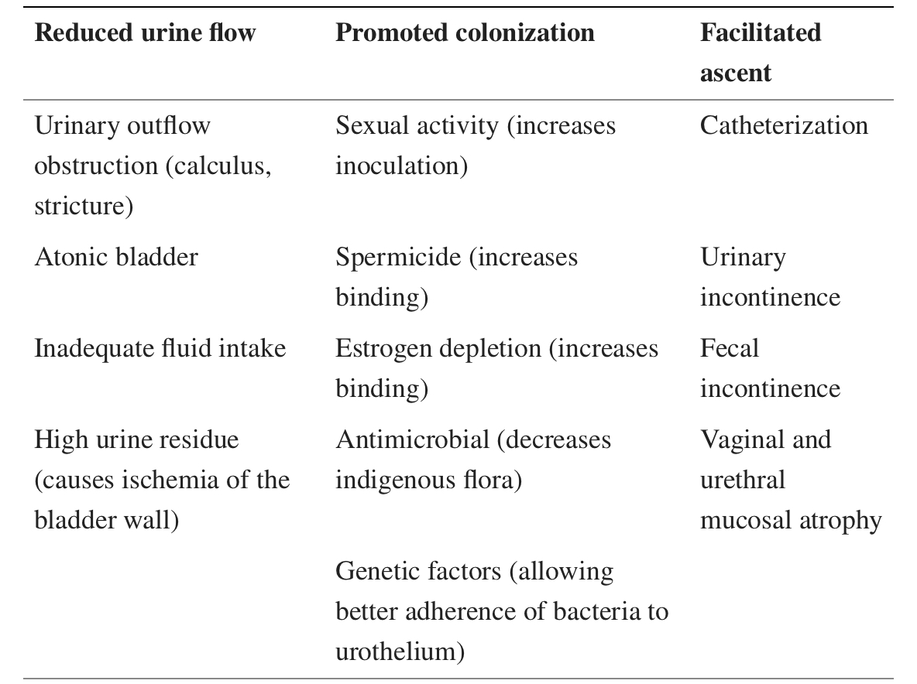

Table 4: the risk factors associated with UTIs and recurrent UTIs [4].

Conclusion:
Asymptomatic bacteriuria is a common manifestation caused mainly by colonization of E.coli. It is present more in females than males. Diagnosing ASB should be based on results of urine sample culture, collected in a way that minimizes contamination. In this applied experiment 16.7% of total females had significant bacterial growth, ASB patients may develop a UTI; ASB in adults usually resolve without treatment, while UTI needs to be treated. In addition, we need to diffuse awareness about the causes of both ASB and UTI, minimizing the number of new cases and the inappropriate use of antibiotics. Taking a larger sample size in the future will help improve this experiment. Raising the community awareness about the risk factors and the symptoms of UTI, will help detect the infection in its early stages, thus providing the appropriate treatment, and reducing mental health issues associated with UTIs.

List of references:
- Ruben FL, Dearwater SR, Norden CW, et al. Clinical infections in the noninstitutionalized geriatric age group: methods utilized and incidence of infections. The Pittsburgh Good Health Study. Am J Epidemiol. 1995;141(2):145-157. doi:10.1093/oxfordjournals.aje.a117402
- Nicolle LE, Bradley S, Colgan R, et al. Infectious Diseases Society of America guidelines for the diagnosis and treatment of asymptomatic bacteriuria in adults [published correction appears in Clin Infect Dis. 2005 May 15;40(10):1556]. Clin Infect Dis. 2005;40(5):643-654. doi:10.1086/427507
- Givler DN, Givler A. Asymptomatic Bacteriuria. In: StatPearls. Treasure Island (FL): StatPearls Publishing; May 1, 2022.
- Abou Heidar NF, Degheili JA, Yacoubian AA, Khauli RB. Management of urinary tract infection in women: A practical approach for everyday practice. Urol Ann. 2019;11(4):339-346. doi:10.4103/UA.UA_104_19
- Jung B, Hoilat GJ. MacConkey Medium. In: StatPearls. Treasure Island (FL): StatPearls Publishing; October 5, 2021
- Levinson, Warren. Review of medical microbiology and immunology. 13rd ed. The McGraw-Hill Companies, 2014.

