

The Libyan International Medical University
Faculty of Basic Medical Science

The incidence rate of Asymptomatic Bacteriuria among LIMU students
Ahmed hasan alsahili
2805
Instructor: dr. asma

Report Submitted to fulfill the requirements for Scientific Research Activity
teaching
Date of Submission: 18/06/ 2022

Abstract :
Asymptomatic bacteriuria(ASB ) is characterized as a 'UTI without clinical symptoms,' in which the person has significant growth of bacteria on their urine culture medium but no obvious signs of UTI. The incidence rate of asymptomatic bacteriuria is examined in this study among 24 male and female students at LIMU to see if there is a link between gender and Asymptomatic bacteriuria. Females are at a higher risk of having asymptomatic UTI when compared to males of the same age, according to research using urine samples. These findings point to a female susceptibility to UTI, which can be explained by a variety of reasons.

Introduction :
Asymptomatic bacteriuria (ASB) is the presence of bacteria in the urine, but patient has no UTI symptoms , in the culture the colonies less than 10⁵ , Most patients with asymptomatic bacteriuria will never develop symptomatic urinary tract infections and will have no adverse consequences from asymptomatic bacteriuria. The term asymptomatic bacteriuria is used when bacteria with a quantitative value of 100,000 CFU or larger are discovered in two consecutive micturition samples obtained in a contamination-free manner in women. To properly utilize the term asymptomatic bacteriuria, only one clean-catch void sample is necessary to detect the bacterial species with a quantitative count of at least 100,000 CFU.
The main objective of this study is to find out if there is a relationship between infectious with asymptomatic bacteriuria and sex.
In clinical practice, asymptomatic bacteriuria is fairly prevalent. While asymptomatic bacteriuria becomes more common as they become older. In women and men aged 65 to 80 years, the incidence can be as high as 15% or more, and it can be as high as 40% to 50% beyond that. That means it is more common in females than males (1).
Women get UTIs up to 30 times more often than men; due to many reasons: 1. long of the urethra ( the female urethra is much shorter in length in women than men), 2. placement of urethra ( the female urethra is located closer to rectum), 3. sexual contact, 4. menopause, and 5. Pregnancy (2).
The most common bacterium is Escherichia coli, which is found in the majority of healthy people. Germs such as Enterococcus species and group B streptococcus, on the other hand, may be discovered. Enterococcus species and gram-negative bacilli are commonly seen in males (1).
Materials and Methods :
This study analyzed 24 urine samples taken from LIMU students. 12 samples from males and 12 samples from females. To detect asymptomatic UTI and to confirm that there is a relationship between sex and ASB.
Urine sample, wire/plastic loops, Bunsen burner, incubator, and culture media (5% sheep blood agar plate) are all part of the experiment. Media used in urine culture can vary between - 5% sheep blood agar plate, and MacConkey agar. or CLED to allow for the detection of many staphylococci, streptococci, gram-negative bacilli, and enterococci.
steps of urine culture:
1-Urine collection: this urine sample should be the first sample in the morning, and it was collected from each student by the midstream clean-catch method. To keep tests legitimate, samples must be analyzed within an hour of collection.
2- After heating the wire loop over a flame, it was put into the urine sample to collect a measured volume of urine (As shown in figure1 and figure2 ).
Figuer 1: Figure 2:
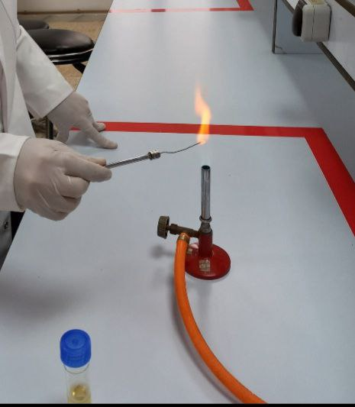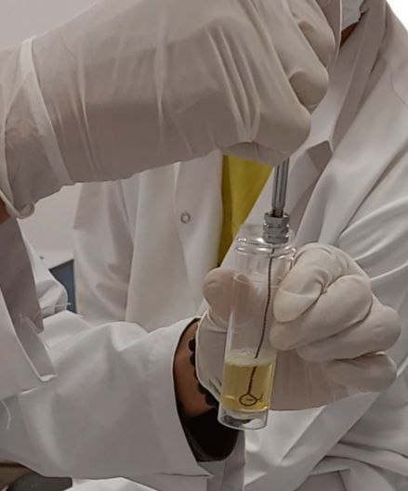
3- spread the urine over the surface of the agar plate, by urine plate technique (as showon in figure 3 , figure 4, and figure 5 )
Figure 3 :
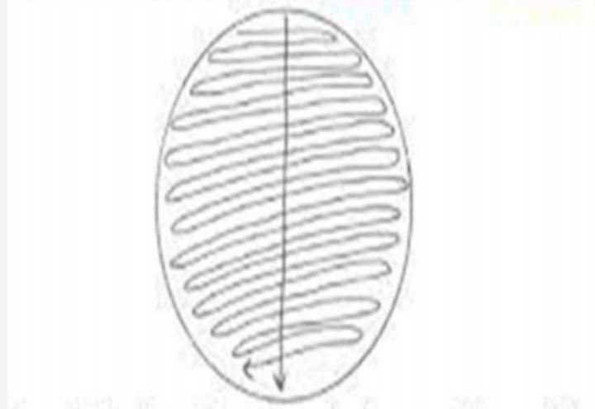

Figure 4: Figure 5:
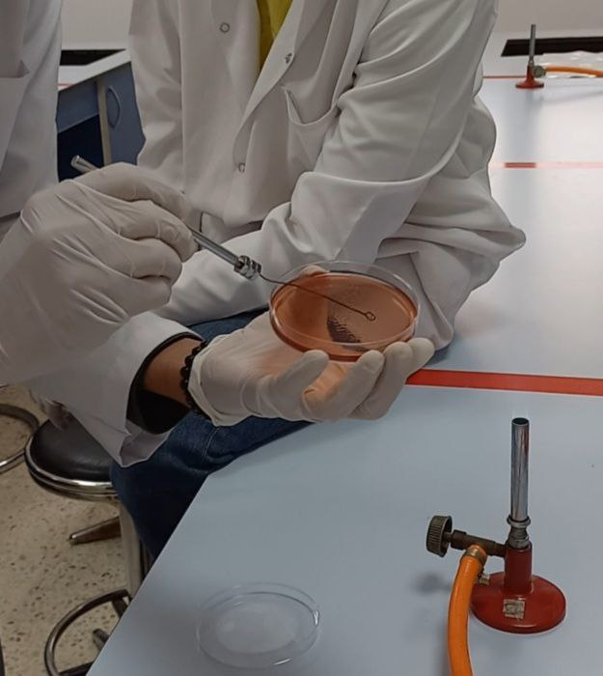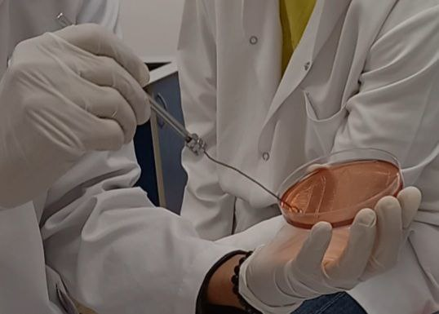
4- without flaming insert the loop vertically into the urine again to transfer of loopful to a second plate.
5- Finally, the cultures were incubated for 24 hours at 37 degrees Celsius to promote observable growth (3)(4).
The data was gathered using a Pearson Chi-Square test to see if the two qualitative variables were independent. However, because more than 20% of the cells projected a count lower than 5, the expected frequency was too low, and Fisher's precise text was used instead.

Results and Statistical analysis:
Taking into consideration the method of urine collection, a CFU/ml greater or equal to 100,000 is considered a significant growth and the individual is diagnosed with UTI .
Table 1: summary table
Gender * CFUcat Crosstabulation
 |  |  | CFUcat |  |  | Total
 |  |  | No growth | No significant growth | Significant growth | Total
Gender | Male | Count | 9 | 3 | 0 | 12
Gender | Male | % Within CFUcat | 81.8% | 27.3% | 0.0%
Gender | Female | Count | 2 | 8 | 2 | 12
Gender | Female | % Within CFUcat | 18.2% | 72.7% | 100.0%
Total count |  |  | 11 | 11 | 2 | 24

According to (table 1), male students accounted for 81.8 percent (9/11) of the urine cultures that did not develop, whereas female students accounted for just 18.2 percent (2/11). The female students provided 100 percent of the cultures with significant bacterial growth. The only two significant growth culture medias came from female students, and none of the men had asymptomatic bacteriuria.
Figure 6:
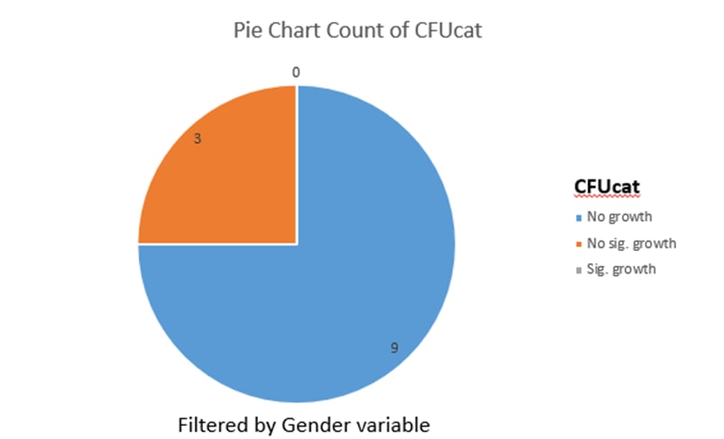
This pie chart only shows the CFU of male students. There was no growth in 75% (9 of 12) of the male students, 25% (3 of 12) had insignificant growth, and zero had significant growth.
Figure 7:
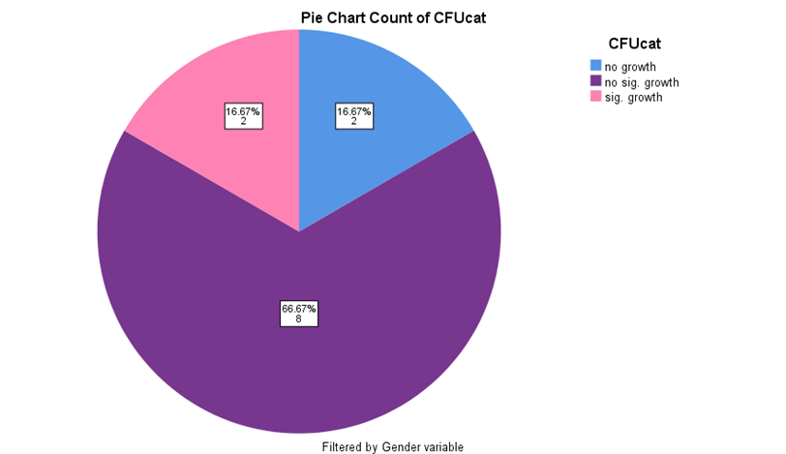
This pie chart counts the CFU of the female students only. Indicating that 16.67% of females had no growth and 66.67% had no significant growth, 16.67% had significant bacterial growth on urine culture and were diagnosed with ASB.
Table 2:
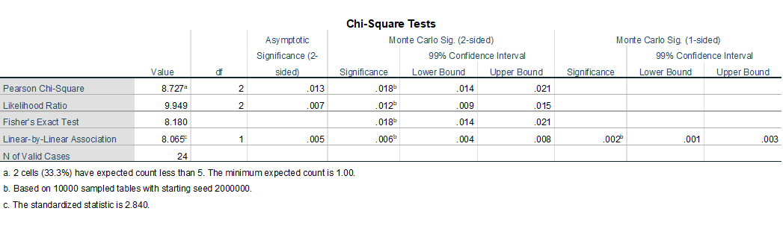
Discussion :
As shown, the p-value is 0.018, which is less than 0.05, indicating that there is a link between gender and CFU, which supports our hypothesis. Comparing values in Figure 6 and Figure 7 reveals that females are more likely to develop asymptomatic bacteriuria, which could be due to a variety of factors, including sexual intercourse and the use of spermicidal contraceptives, as well as anatomical factors (5).
Though our initial hypothesis was met, the results and data obtained are lacking in terms of illustrating a more descriptive comparison between males and females, in addition to the data encountering a few difficulties during analysis, which is due to a variety of factors, the most significant of which is the sample size. Including additional students in the sample would enhance the results and give a more statistically valid comparison. It should be noted, however, that increasing the sample size makes the experiment more expensive and difficult to carry out. Another aspect that contributed to our poor results was the fact that the subjects were all in the same age range. Varying the age group within the sample would provide stronger data to illustrate a more precise comparison.
Even though the sample size was limited, the findings were consistent with earlier research suggesting that females are more prone to asymptomatic bacteriuria. According to one study, premenopausal women had a 5% chance of asymptomatic bacteriuria, whereas men and women between the ages of 65 and 80 have a 15% risk, which rises to 40-50 percent by the age of 80. Regardless, women are more likely than males to develop asymptomatic bacteriuria at any given age (1).
The experiment's goal of assessing the microbial spectrum of asymptomatic bacteriuria was not achieved because the sample size was too small and inappropriate for such a finding, as only two samples showed significant E. coli growth, which according to multiple researchers is the most common pathogen of asymptomatic bacteriuria, accounting for roughly 70-80 percent of clinical cases (3).
Klebsiella, Proteus mirabilis, and pseudomonas aeruginosa are among the gram-negative bacteria that can cause asymptomatic bacteriuria. In addition to candida species, Gram positive bacteria such as enterococcus species, staphylococcus saprophyticus, and group B streptococci can produce asymptomatic bacteriuria (1).
Conclusion :
This experiment was conducted on 24 students at the Libyan International Medical University, half of whom were male and the other half were female, and found that there were bacteria with significant bacterial growth in two female samples and non-significant growth in 8 samples. of females. this indicates there is a significant difference in the growth of bacteriuria in females more than in males, and it means that there is a link between infection with asymptomatic bacteria and sex.
Most patients with asymptomatic bacteriuria will never develop symptomatic urinary tract infections and will have no adverse consequences from asymptomatic bacteriuria. Only patients with asymptomatic bacteriuria that will benefit from treatment should be treated, and most patients will not benefit from treatment. There are, however, a few exceptions. There is sufficient evidence that a pregnant woman with asymptomatic bacteriuria should be treated.
References :
- Givler D, Givler A. Asymptomatic Bacteriuria. Ncbi.nlm.nih.gov. https://www.ncbi.nlm.nih.gov/books/NBK441848/. Published 2022. Accessed June 10, 2022.
- 7 Reasons Why Women Get More UTIs Than Men. Virginia Physicians for Women. https://vpfw.com/blog/7-reasons-why-women-get-more-utis-than-men/. Published 2022. Accessed June 11, 2022
- Levinson, Warren. Review of medical microbiology and immunology. 13rd ed. The McGraw-Hill Companies, 2014.
- Bailey&scotts, diagnostic microbiology,12th ed
- RD H, TM H. Urinary tract infection risk factors and gender [Internet]. PubMed. 2022 [cited 31 May 2022]. Available from: https://pubmed.ncbi.nlm.nih.gov/11253265/

