

Libyan International Medical University

Student Name: Saad ALawami
Student number: 2368
Supervisor name: Dr. Khadija Mansour
Assistant: DR. Ahmed Gaibani

The Incidence Rate of Asymptomatic Bacteriuria Among LIMU Students

- Abstract: -
Urinary tract infections (UTIs) are common illnesses that develop when bacteria enter the urethra and infect the urinary system, typically through the skin or the rectum. The aim of the study is to find the difference in asymptomatic bacteriuria between males & females. The first test was a macroscopic urine-analysis test, the second test was a microscopic gram staining, and the third test was a culture media, the statistical data was analyzed by SPSS v26 software, on which a chi-square test was performed, and the study showed that the prevalence of asymptomatic bacteriuria among LIMU students is higher in females than males (the P value = 0.004).

- Introduction: -
UTIs are frequent infections that occur when bacteria enter the urethra and infect the urinary system, usually through the skin or the rectum. The infections can affect any region of the urinary system, although the bladder infection is the most prevalent (cystitis).
Another kind of UTI is kidney infection (pyelonephritis). They're less prevalent than bladder infections, but they're more dangerous.
Some people are more susceptible to UTIs than others. Females have shorter urethras that are closer to the rectum, making UTIs more likely. Bacteria can more easily enter the urinary system as a result of this.
Bacteria enter the urinary tract via the urethra and proliferate in the bladder, causing urinary tract infections. Despite the fact that the urinary system is meant to keep such small intruders out, these defenses occasionally fail. Bacteria may take hold and develop into a full-fledged infection in the urinary system if this happens.
The bladder and urethra are affected by the most frequent UTIs.
Urinary bladder infection (cystitis). E. coli, a kind of bacterium often present in the gastrointestinal tract, is the most prevalent cause of this form of UTI. Other bacteria, though, are occasionally at blame.¹
Cystitis can be caused by sexual activity, but you don't have to be sexually active to have it. Because of the small distance between the urethra and the anus, and the urethral entrance to the bladder, all women are at risk of cystitis.
Urinary tract infection (urethritis). When GI bacteria travel from the anus to the urethra, this form of UTI develops. Sexually transmitted illnesses including herpes, gonorrhea, chlamydia, and mycoplasma can also induce urethritis since the female urethra is so near to the vagina.
Aim of the study: to find the difference in asymptomatic bacteriuria between males & females.
- Materials and methods: -
A total of 24 samples were examined, 12 of which were males and 12 of which were females.
The first test was a macroscopic urine-analysis test, which is done by taking a urine sample from the patient and placing it in a specimen cup. Urinalysis testing usually requires a modest sample of urine (30-60 mL).
The second test was a microscopic gram staining, which is a common technique used to differentiate between Gram positive and Gram negative bacteria, the process involves three steps: -
- Crystal violet dye is used to stain the cells. Then, to build a combination between the crystal violet and iodine, a Gram's iodine solution (iodine and potassium iodide) is added.
- A decolorizer, such as ethyl alcohol or acetone, is applied to the sample, shrinking and tightening the peptidoglycan layer.
- The sample is stained red using a counterstain (safranin).
The third test was a culture media, is a liquid or gel that aids in the development of microorganisms, the culture revealed a number of colonies, which are described in table number 1.
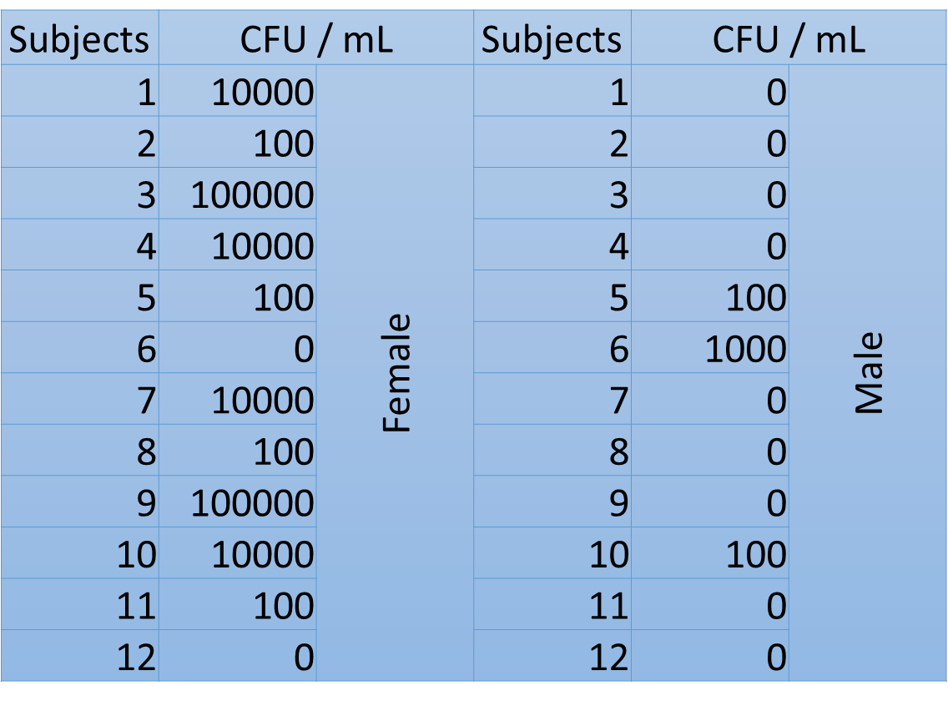
The statistical data was analyzed by SPSS version 26 software, on which a chi-square test was performed to compare the significant growth of bacteria between the male and female groups.

Table number 1: Gender variations in asymptomatic bacteriuria prevalence and microbiological spectrum.
- Results and discussion: -
The result of macroscopic urine analysis was clear in most samples and cloudy in some samples, and the color of the urine varied from pale yellow to brown. The brown color in samples may indicate the presence of blood or protein in urine, and a pale yellow indicates a large concentration of water in urine. In the visual inspection, there wasn’t a difference between the male and female samples. An issue, such as an infection, might be indicated by cloudiness or an odd odor. The presence of protein in the urine might cause it to seem foamy, a urine culture is usually required as a follow-up test to confirm the diagnosis and identify the bacteria causing the infection, because a urinalysis by itself does not always produce a conclusive diagnosis.
There is no appearance of bacteria in most of the samples under the light microscope, and there is no RBC or WBC. The presence of leukocytes might indicate the presence of an infection. Erythrocytes can indicate renal illness, a blood issue, or some underlying medical condition such bladder cancer. Infections can be detected by bacteria, yeast, or parasites. Kidney problems can cause casts, which are tube-shaped proteins. Crystals in urine that develop as a result of chemicals in the urine might be a symptom of kidney stones.
The culture media showed a large amount of growth in most of the female samples and less growth in the male samples. The equation of multiplying the number of colonies by 10⁵ and the results is described in table number 1. As it is described in table 2, the significant growth in females is much higher than in males, which means that females have a higher incidence of UTIs, because a woman's urethra (the tube that connects the bladder to the exit point for urine) is shorter than a man's, bacteria have an easier time getting into the bladder as a result of this. E. coli strains are the most common isolates, found in 80% of urine samples from patients with a simple UTI (cystitis), followed by Staphylococcus saprophyticus (5-15%), whereas Klebsiella, Enterobacter, or Proteus cause infection only rarely (5- 10%).
The SPSS chi-square test (see table number 2) showed a p-value of 0.004, indicating that there is a significant difference between males and females, so we reject the null hypothesis and accept the alternative hypothesis. 0% of the male samples showed significant growth, 25% showed no significant growth, and 75% showed no growth at all. For the female samples, the significant growth was 16.7%, the overall no significant growth was 66.7%, and 16.7% showed no growth at all. This result means that there is a difference in the incidence rate of asymptomatic bacteriuria between males and females, and there is a higher rate of asymptomatic bacteriuria in females than in males. This is consistent with studies by [2,3], which found that females had a greater frequency of bacteriuria than males, Especially among teenagers and young adults.

Chi-Square Tests
 | Value | df | Asymptotic Significance (2-sided) | Monte Carlo Sig. (2-sided) |  |  | Monte Carlo Sig. (1-sided)
 |  |  |  | Significance | 99% Confidence Interval |  | Significance | 99% Confidence Interval
 |  |  |  |  | Lower Bound | Upper Bound | Significance | Lower Bound | Upper Bound
Pearson Chi-Square | 8.727ª | 2 | .013 | .018^{b} | .014 | .021
Likelihood Ratio | 9.949 | 2 | .007 | .012^{b} | .009 | .015
Fisher's Exact Test | 8.180 |  |  | .018^{b} | .014 | .021
Linear-by-Linear Association | 8.065^{c} | 1 | .005 | .006^{b} | .004 | .008 | .002^{b} | .001 | .003
N of Valid Cases | 24
a. 2 cells (33.3%) have expected count less than 5. The minimum expected count is 1.00.
b. Based on 10000 sampled tables with starting seed 2000000.
c. The standardized statistic is 2.840.
Table number 2: chi-square test.

Bacteriuria is preceded by colonization by the specific type of bacteria that causes Urinary Tract infection, according to research. Bacteria in asymptomatic bacteriuria have been shown to have a significant role in the spread of urinary tract infections. bacteriuria can be caused by a variety of bacteria. According to another study, asymptomatic bacteriuria affects 4% of University students. The most common organism found among patients with substantial bacteriuria was Staphylococcus aureus. ⁴
Except in pregnant women and those having an invasive genitourinary operation, asymptomatic bacteriuria treatment is not ideal. Antimicrobial resistance and recurrence rates among uropathogens are increasing, posing a significant threat to the economic burden of these infections. Asymptomatic microorganisms should be researched and appropriate antibiotic therapy supplied if they are discovered. Early detection and treatment may be beneficial. to prevent more severe urinary tract disorders.


Table 3: the different of growth between male & female
- Conclusions: -
The study showed that the prevalence of asymptomatic bacteriuria among the LIMU students is higher in females than males, in healthy women, the prevalence of bacteriuria rises with age, from around 1% in girls aged five to fourteen to more than 20% in women aged 80 and over living in the community.⁵
The majority of persons with bacteria in their urine but no symptoms do not require treatment. This is due to the fact that the germs are harmless. In fact, treating the majority of patients with this condition may make subsequent infections more difficult to cure. We recommend that researchers do more studies about asymptomatic bacteriuria in the near future.
- References: -
- Urinary tract infection (UTI) - Symptoms and causes. Mayo Clinic. Published 2022. Accessed June 16, 2022.
- Otajevwo F, Eriagbor C. Asymptomatic urinary tract infection occurrence among university students of a private University in Western Delta, Nigeria. World J Med Medical Sci. 2014:1-26.
- Ngwai YB, Ilyasu H, Young E, Owuna G. Bacteriuria and Antimicrobial susceptibility of E. coli isolated from urine of asymptomatic university students in Keffi, Nigeria. Jundishapur J Microbiol. 2012;5(1):323-7.
- Ugwu MC, Nnoli A, Ezejiegu CK, Jibuaku C, Ogwaluonye UC, Ejikeugwu CP, et al. Prevalence and Antibiogram of Asymptomatic Bacteriuria among University Students in Agulu, Anambra, Nigeria. Ann Clin Immunol Microbiol. 2019;1(2):1009.
- Nicolle LE. Asymptomatic bacteriuria: when to screen and when to treat. Infect Dis Clin North Am. 2003;17:367-94.

