Asymptomatic Bacteriuria:

A Lab Report of Urine Collection and Incidence Rate between Female and Males

Fatma El Gaoud 3144
Dr. Naji Alhomry
AMS
LIMU
PTS 2022

Abstract 3
Introduction 4
Method 6
Procedure 7
Results 8
Discussion 12
Conclusion 13
References 15

Abstract:
This report focuses on the bacteria culture growth collected from random samples of 12 females and 12 males, total 24 individuals. Using the CFU method to count the samples grown and incubated for 48 hours. Asymptomatic bacteriuria occurs, regardless of pyuria, in the absence of signs or symptoms of a urinary tract infection. Asymptomatic bacteriuria is very common in clinical practice and its incidence increases with age and gender. In this report, the incidence rate correlated to the female gender, regardless of the small sample size collected; 22 of the students had a healthy urinary tract, whereas two females had significant bacterial growth with E.coli amounting to 16.7% of the collected sample. The bacterium E.coli identified through the Primary Set-Up/Pour Plate method collection and growth on the Blood agar first then on MacConkey agar for its lactose fermenting property.

Introduction:
Asymptomatic bacteriuria (ASB/ABU) is the presence of bacteria in the properly collected urine of a patient that has no signs or symptoms of a urinary tract infection. Asymptomatic bacteriuria is very common in clinical practice and its incidence increases with age.‎³ Most patients with asymptomatic bacteriuria will never develop symptomatic urinary tract infections and will have no adverse consequences from asymptomatic bacteriuria. ^{‎3} On the other hand Urinary tract infection (UTI) is a serious health problem affecting millions of people each year; where there are more than 10 million cases in Western Europe alone per year.‎ ⁷ UTI is classified into categories according to the site of infection: cystitis is of the bladder، pyelonephritis is of the kidney، and bacteriuria of the urine itself. Colonization of urine in the absence of clinical symptoms is called asymptomatic bacteriuria (ABU). ABU strains generally do not cause symptoms, and most patients with ABU do not need treatment.‎⁸ UTI occurs when bacteria invade the urinary tract; kidneys, bladder, ureters, and urethra. The ureters are the tubes connecting the kidneys to the bladder. The urethra is the tube carrying urine from the bladder to outside your body.^{‎1,‎2}
Bacteriuria: defined as the presence of bacteria in urine، is associated with ABU and Symptomatic UTI.^{‎4} Most individuals who suffer persistent UTI do not manifest the same strain of organism. However, colonizing strains during bacteriuria are studied for Escherichia coli (E. coli), the most common cause of ABU.^{‎4,‎5,‎9} Clinical isolates of Enterococcus faecalis, Proteus vulgaris, Pseudomonas aeruginosa, Klebsiella pneumoniae, Staphylococcus saprophyticus, and Streptococcus agalactiae have been shown to grow in human urine as well.^{‎1‎,3} Human urine is highly variable in chemical constituency and different levels of components such as glucose may influence microbial growth; for example, glucosuria enhances growth of E.coli.‎⁴ However, it still remain that E. coli is the most common microbe that grows in ABU, with many different strains that are divided between uropathogenic E.coli (UPEC )and ABU-E.coli. UPEC are common for UTI along with the previously mentioned list of microbes.
Inflammation is a critical part of UTI pathogenesis and involves thousands of genes that drive antibacterial responses within hours of infection. Pathogenesis of bacteriuria depends on a microbes’ ability to survive the antimicrobial properties of urine. Urine survival and growth of colonizing organisms despite the following: adherence factors to host cells, and urodynamic properties; urine flow rates and voiding, differ between individuals causing the huge spectrum of UTI colonies. ^{‎4‎,2} In addition the design of the urinary tract between genders can increase the possibility of UTI, especially since women have a shorter urethra and it sits close to the anus, where E. coli is present in stool.
As mentioned, ABU is common, with varying prevalence by age, sex, sexual activity, and the presence of genitourinary abnormalities.‎⁶ In healthy women, the prevalence of bacteriuria increases with age, from about one percent in females five to 14 years of age, to more than 20% in women at least 80 years of age.‎⁶ The criteria for identifying significant bacteriuria in ABU in a person are: 1) at least 100,000 colony-forming units (CFU) per mL of urine in a midstream clean-catch specimen, specifically used in this report; and 2) at least 100 CFUs per mL of urine from a catheterized specimen.^{‎1,‎6}
Table 1: Prevalence of Asymptomatic Bacteriuria in Populations: This is a table illustrating gender has a high correlation with ABU (with women 30 times more than men‎⁶).
Prevalence of Asymptomatic Bacteriuria in Selected Populations
Population | Prevalence (%)
Healthy premenopausal Women | 1.0-5.0
Pregnant Women | 1.9-9.5
Postmenopausal Women (50-70 years of age) | 2.8-8.6
Patients with diabetes
Women | 9.0-27.0
Men | 0.7-1.0
Older Community-dwelling Patients
Women (>70 years of age) | >15.0
Men | 3.6-19.0
Older Long-term Care Residents
Women | 25.0-50.0
Men | 15.0-40.0
Patients with Spinal Cord Injuries
Intermittent Catheters | 23.0-89.0
Sphincterotomy and Condom Catheters | 57.0
Patients Undergoing Hemodialysis | 28.0
Patients with Indwelling Catheter
Short-term | 9.0-23.0
Long-term | 100

The objective of this report, which can either be rejected or supported: is to test the hypothesis that gender has a significant correlation to ABU, where females have a higher chance of ABU compared to males. Based on the analysis of media cultures and CFU analysis through SPSS. The null hypothesis: Gender has no effect on the ABU incidence rate between males and females.

Method:
For this lab, midstream clean-catch specimen is used to collect samples of human urine specimens from 12 females and 12 males, 24 individuals. All participants are not diagnosed with UTI and have not taken any antibiotics. The urine was pooled, filter sterilized, centrifuged then stored at 4°C, and used within the next 18 hours to 1 day.‎¹
For microscopic examination, the sample is mixed well and 5 or 10 ml of it is measured into a centrifugation test tube. Then 9 parts of 10 of the supernatant is carefully removed, which results in suspension of sediment 10-times concentrated compared to the original urine.^{‎1} The examination starts with lower magnification of 100-200x, at which distribution of elements can be assessed and rare particles such as casts and epithelial cells can be seen. Microorganisms can be seen, where the urine is cultured firstly on a Blood agar (BA) or Luria-Bertani (LB) medium. Both of the respectively mentioned medias are widely used to culture a wide range of microorganisms due to their highly enriched composition. LB medium commonly used to culture members of the Enterobacteriaceae as well as for coliphage plaque assays; used extensively in recombinant DNA work and other molecular biology procedures.^{‎4} On the other hand, BA used to grow a wide range of fastidious pathogens particularly those that are more difficult to grow such as Haemophilus influenzae, Streptococcus pneumoniae and Neisseria species. It is also required to detect and differentiate haemolytic bacteria, especially Streptococcus species.^{‎5} It is a differential media in allowing the detection of haemolysis, destroying the red blood cells by cytolytic toxins secreted by certain strains of Bacillus, Streptococcus, Enterococcus, Staphylococcus, and Aerococcus.^{‎1‎,5,‎7} For this labs purpose BA was used, composed of five percent sheep blood and has an average pH of 7.4. ‎⁸
MacConkey agar (MAC) is a selective and differential media used for the isolation and differentiation of non-fastidious gram-negative rods, particularly members of the family Enterobacteriaceae and the genus Pseudomonas.^{‎1‎,5} MAC used for the isolation of gram-negative enteric bacteria and the differentiation of lactose fermenting from lactose non-fermenting gram-negative bacteria. Lactose fermenting strains grow as red or pink and may be surrounded by a zone of acid precipitated bile. The red colour is due to production of acid from lactose, absorption of neutral red and a subsequent colour change of the dye when the pH of medium falls below 6.8.^{‎5‎,7} For this labs purpose it is used to differentiate E.coli.
Urine in the bladder is normally sterile; because contamination of samples can occur as urine passes through the outer third of the urethra; a numeric threshold of colony-forming units (CFUs) per millilitre has been established to confirm infection.^{‎1} In samples obtained from a midstream void, ≥1 × 10⁵ CFU/μL is consistent with infection. In samples collected via catheterization, ≥1 × 10² CFU/μL is consistent with infection. For women, two consecutive specimens with isolation of the same species in quantitative counts of at least 100,000 CFUs per mL of urine. For men, a single specimen with one bacterial species isolated in a quantitative count of at least 100,000 CFUs per mL.^{‎6} The number of colonies per mL recovered on urine culture can differentiate diagnosis of UTI or ABU.
CFU were collected and organised in a table, analysed using SPSS. The analysis test used for this report either Fischer or chi-square. Chi-Square test, is a test for independence between two qualitative variables. If the expected frequencies are too small then Fischer’s test should be used in place of the Pearson Chi-square.

Procedure:
Using plastic loops calibrated to deliver known volume of liquid, yellow loop equal 10 µL and blue loop equal 1µL; the loop was dipped straight in the centre of the cup of urine sample. Then take the loop and streak down the centre of the blood agar first and then down centre of MAC agar. Using another plastic loop with same calibration, streak horizontal lines across both medias passing through the line created previously. This helps spread the microbes all around the petri-dish with isolating the colonies so that CFU count can be taken through distinguished units. Incubate the medias in incubator for 24 to 48 hours to ensure colony growth on dish.
Colonies are counted and multiplied by 1000 to find the number of organism in 1mL. The microorganism morphology on media observed and identified. E.coli growing on MAC creates fermentation of lactose producing organic acids, particularly lactic acid, which decreases the pH of the agar. MAC contains a pH indicator that turns pink under acidic conditions. E.coli is also non-mucoidal on the agar thus easily differentiated from Klebsiella.
Collected values of CFU are organized in a spread-sheet and analysed. This is to find the correlation between gender and ABU.
Evidence or Proof
P-value (Sig) | If p-value≤ 0.05, reject the null hypothesis
P-value (Sig) | If p-value> 0.05, fail to reject the null hypothesis
Table 2: Analysis used to conclude if gender and ABU are correlated: To reject or support the hypothesis that females have a higher rate of ABU.

Results:
The results obtained from the SPSS analysis conducted through Fischers’ test, observed the difference between the female and the male samples of the 24 individuals.

 |  | Frequency | Percent | Valid Percent | Cumulative Percent
Valid | no growth | 11 | 45.8 | 45.8 | 45.8
Valid | growth | 11 | 45.8 | 45.8 | 91.7
Valid | significant growth | 2 | 8.3 | 8.3 | 100.0
Valid | Total | 24 | 100.0 | 100.0
Table 3: Showing the significance growth that was equal to 10⁵ CFUs.

The collected samples showed a value of 8.3% (Table3) of the 24 individuals having a significant growth of ABU microbe E.coli. This significant growth implies that 10⁵ CFU count was obtained.
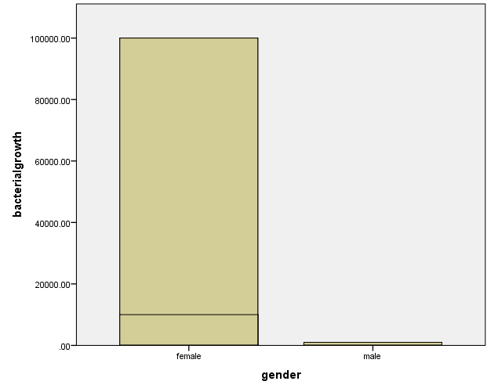
Figure 1: Comparison between female and male samples showcasing that females had a higher count of CFU while the male count has not exceeded 10⁴ CFU bacterial growth.

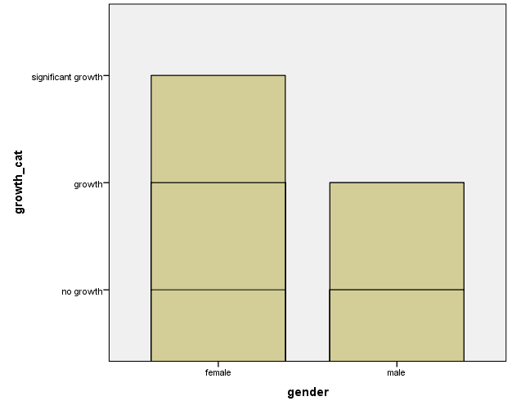
Figure 2: Categorizing the sample between growths, no growth and significant growth, demonstrates that male samples collected had growth but not significant enough CFU to be associated with ABU. Males growth was ≤10⁵. Females growth was ≥10⁵.

Table 4: Seperating the both genders and counting seperatley the growth; 16.7% Significant growth in females and 0% in males. 66% growth in females and 25% in males.
 |  |  | gender |  | Total
 |  |  | female | male | Total
growth_cat | no growth | Count | 2 | 9 | 11
growth_cat | no growth | Expected Count | 5.5 | 5.5 | 11.0
growth_cat | no growth | % within gender | 16.7% | 75.0% | 45.8%
growth_cat | Growth | Count | 8 | 3 | 11
growth_cat | Growth | Expected Count | 5.5 | 5.5 | 11.0
growth_cat | Growth | % within gender | 66.7% | 25.0% | 45.8%
growth_cat | Significant growth | Count | 2 | 0 | 2
growth_cat | Significant growth | Expected Count | 1.0 | 1.0 | 2.0
growth_cat | Significant growth | % within gender | 16.7% | 0.0% | 8.3%
Total |  | Count | 12 | 12 | 24
 |  | Expected Count | 12.0 | 12.0 | 24.0
 |  | % within gender | 100.0% | 100.0% | 100.0%

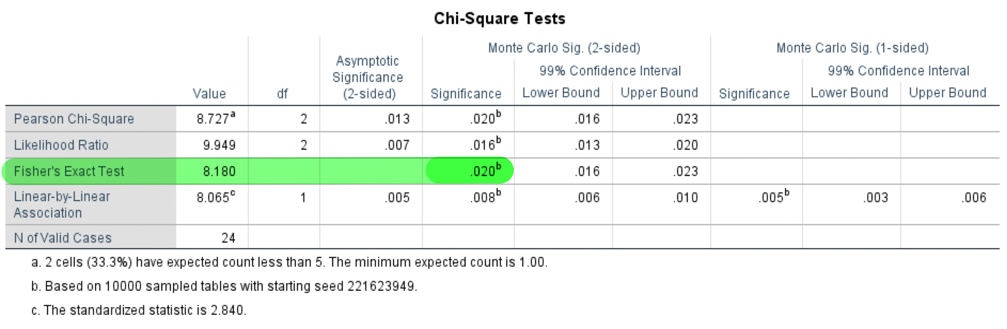
Table 5: Fisher’s Exact test: to find correlation between gender and ABU growth counted by CFU method.

Discussion:
Bacteriuria: defined, as the presence of bacteria in urine, is associated with ABU and Symptomatic UTI.^{‎4} Colonization of urine in the absence of clinical symptoms is called asymptomatic bacteriuria (ABU). However, the colonizing strains during bacteriuria that were studied are E.coli, the most common cause of ABU.^{‎4,‎5,‎9} The criteria for identifying significant bacteriuria in ABU in a person are: 1) at least 100,000 colony-forming units (CFU) per mL of urine in a midstream clean-catch specimen, specifically used in this report; and 2) at least 100 CFUs per mL of urine from a catheterized specimen.^{‎1,‎6} The diagnosis of ABU based on a quantitative urine culture yielding greater than 100,000 CFU of bacteria per mL of urine, is termed “significant bacteriuria”.^{‎7,‎8} The largest patient population at risk for ABU is the elderly. Up to 40 percent of elderly men and women may have bacteriuria without symptoms (Table 1).
Collected samples from the 24 individuals with a ratio of 1:1 between females and males; samples cultured, colonized and analysed showed that there was a 45.8% of ABU cases; Table 3: Showing the significance growth that was equal to 10⁵ CFUs in total of sample size, in accordance to the criteria.
Looking within the sample has proven that there is correlation between ABU and a gender population seen in Figure 1: Comparison between female and male samples showcasing that females had a higher count of CFU while the male count has not exceeded 10⁴ CFU bacterial growth. Categorizing the CFU between no-growth = 0, growth/non-significant growth (0≤) and significant-growth (≥10⁵) in the two genders in Figure 2: demonstrates that male samples collected had growth but not significant enough CFU to be associated with ABU. Males growth was ≤10⁵. Females growth was ≥10⁵.
Another analysis of counting the significant-growth within the genders sample summarized in Table 4: Seperating the both genders and counting seperatley the growth; 16.7% Significant growth in females and 0% in males.66% non-significant groth in females and 25% in males.
However, this analysis was not conclusive enough to show the correlation between gender and ABU. To have a conclusive and significant analysis; a p-value must be calculated. To find the p-value, Fischers’ analysis test was used; looking at Table 2: calculation value used to conclude if gender and ABU are correlated: To reject or support the hypothesis that females have a higher rate of ABU. If p-value> 0.05, fail to reject the null hypothesis; therefore ABU growth counted by CFUs, incidence rate correlated with a specific gender. Pearson Chi-square was inadequate since the frequencies developed from the sample were too small (Table 4).
The resulted value from the Fischers’ test as seen in Table 5. The p-value is less than 0.05 (p-value> 0.05). Therefore, null hypothesis is rejected; and the hypothesis that there is a correlation between gender and ABU is proven. Females have a high incidence rate of ABU in a sample population.
The cultured colonies upon microscopic examination revealed gram negative rods, while, MAC agar revealed lactose-fermenting pink colonies, and blood agar revealed β-hemolytic colonies all conclusive of E.coli. This is in accordance with previous studies allocating that E.coli is the most common microorganism in ABU cases.^{‎2‎,3,‎5,‎8}
Although early studies noted an association between bacteriuria and excess mortality, however studies that are more recent have failed to demonstrate this. Additionally, frequently screening patients for ABU and subsequent treatment of the infection has not been found to reduce either infectious complications or mortality.^{‎3,‎4,‎7,‎8}
The groups of patients with ABU to benefit from treatment are, (1) pregnant women, (2) patients with renal transplants and (3) patients who are about to undergo genitourinary tract procedures.‎⁹ Therefore, pregnant women with ABU should be treated with a three- to seven-day course of antibiotics, hence urine should consequently be cultured to ensure cure and avoid relapse. Although amoxicillin is suggested as the agent of choice, E.coli is now commonly resistant to ampicillin, amoxicillin and cephalexin. Thus, treatment should be based on the results of susceptibility tests.^{‎2‎,9}

Conclusion:
Asymptomatic bacteriuria (ABU) is a common manifestation mainly caused by colonization of E.coli. More prevalent in the elderly^{‎4‎,7,‎8} and females(16.7%) compared to males(0%). ABU diagnostics through the sample collection and colony-forming units (CFU) is used in many studies and it is a sufficient method to base results of urine samples. However, such collection and result must follow the criteria. Most patients with asymptomatic bacteriuria will not develop symptomatic UTIs and will have no concerns from ABU. The management of asymptomatic bacteriuria is not simple and requires clinical expertise. When encountering effected patients, an inter-professional approach with an infectious disease expert, emergency department physician, nurse practitioner, internist, pharmacist, and a nurse is recommended.^{‎3}

References:
- Alnagi, Intisar. "Urine Analysis." LIMU Microbiology, Renal Block Med Year 2. Benghazi: LIMU, March 2022.
- Christiano, Donna. E.coli and UTIS (Urinary Tract Infections): The Common Connection. Dec 16, 2019. https://www.healthline.com/health/e-coli-uti#E.-coli-and-UTIs. (accessed June 10, 2022).
- Givler, Donald N., and Amy Givler. "Asymptomatic Bacteriuria." StatPearls Treasure Island. Jan 2022. https://www.ncbi.nlm.nih.gov/books/NBK441848/ (accessed May 26, 2022).
- Ipe, Deepak S., Ella Horton, and Glen C. Ulett. "The Basics of Bacteriuria: Strategies of Microbes for Persistence in Urine." Frontiers in Cellular and Infection Microbiology. Feb 8, 2016. https://www.frontiersin.org/articles/10.3389/fcimb.2016.00014/full (accessed May 24, 2022).
- Levinson, Warren E. Medical Microbiology and Immunology. United States of America : McGraw-Hill Education, 2016.
- Orenstein, R., and E.S. Wong. "Urinary Tract Infections in Adults." American Family Physician, 1999: 59(5):1225-1237.
- Roos, Viktoria, Glen C. Ulett, Mark A. Schembri, and Per Klemm. "The Asymptomatic Bacteriuria Escherichia coli Strain 83972 Outcompetes Uropathogenic E. coli Strains in Human Urine." Infect Immun, Jan 2006: 615-625.
- Schnarr, J., and F Smaill. "Asymptomatic Bacteriuria and Symptomatic Urinary Tract Infections in Pregnancy." European Journal of Clinical Investigation, 2008: 38:50-57.
- Wiley, Z., J.T. Jacob, and E.M. Burd. "Targeting Asymptomatic Bacteriuria in Antimicrobial Stwerdship: The Role of the Microbiology Labratory." Journal of Clinical Microbiology. 2020. https://doi.org/10.1128/JCM.00518-18 (accessed June 5, 2022).

