Name : abdulrhman elhouni
Student number : 2431

1. Develop a network diagram for the project specified below. (50 %)
2. Identify the Critical Activities and the total duration of the project. (35%)
3. Justify which activity would you crash based on some rationale (15%)
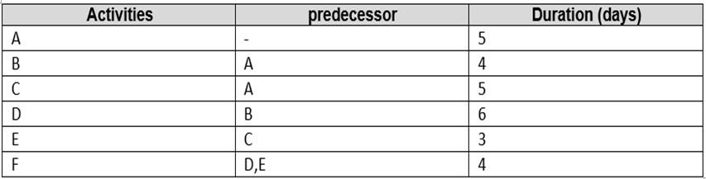

Answer 1 :

C  D
A F
B E

Answer 2:
1st path way :ACD F , it’s the longest duration / about 20 days
2nd path way: ABEF , duration of this pathway is 16 days
(total duration is 27 days )

Answer 3 : the safe activity that we can crash it is D
Because It takes more days so it will be at the longest path way

