


Libyan International Medical University
Faculty of Applied Medical Science
There is Difference Between Adult Male and Female in Urine Output After Lasix Consumption

Name: Imbarak Abd Bseit Al Barasi
Number: 2327
Supervisor: Dr. Ahmed Gaibani
Date: June 7th 2022

Abstract

Urine volume is generally determined by fluid consumption, ambient conditions, food, and human activity. Above normal (polyuria) urine volume (2.5-3L/Day) owing to excessive amounts of liquids, diuretics, alcohol, insufficient urinary doctrine absorption of water and urine concentrated as in diabetes mellitus.Furosemide is a loop diuretic and has the ability to inhibit the sodium-potassium-s chloride (Na+/K+/2Cl-) cotransport of the ascending limb of the loop of Henle (NKCC2). According to P-value (=0.142) obtained from using the T-test, which was conducted using the Statistical Package for Social Sciences (SPSS). There was no Significant different between urine output male and female.

Introduction
Urine volume is generally determined by fluid consumption, ambient conditions, food, and human activity.
Above normal (polyuria) urine volume (2.5-3L/Day) owing to excessive amounts of liquids, diuretics, alcohol, insufficient urinary ducts in reabsorption of water and urine concentrated as in diabetes mellitus or diabetes insipid us, but it should be accompanied with clinical and laboratory testing.¹
- when urine volume is under normal (Oliguria) (<400 ml/day)
- Anuria, low urine volume (less than 50 mL/day), caused by hot weather, perspiration, insufficient water intake, or illness of the kidneys or urinary ducts.²
Furosemide has been licensed by the Food and Drug Administration (FDA) for the treatment of volume overload and oedema caused by congestive heart failure exacerbation, liver failure, or renal failure, including nephritic syndrome.³
It works by forcing the kidneys to excrete excess water and salt from the body through the urine. By blocking the sodium-chloride cotransport system, furosemide prevents sodium and chloride reabsorption in the proximal and distal tubules, as well as the thick ascending loop of Henle, resulting in increased excretion of water, sodium, chloride, magnesium, and calcium.⁴
Diuretics are a class of medications that includes furosemide. A drug class is a set of pharmaceuticals that all operate in the same way. These medicines are frequently used to treat illnesses that are similar to each other. Furosemide aids in the removal of excess salt and water from the body. It accomplishes this by boosting the volume of urine produced by your body. This aids in the reduction of oedema as well as the reduction of blood pressure.⁵
Methods
For our trial tests, we brought 12 subjects, 6 of them male and 6 female, to administer the dosage of Lasix (40mg) to Inform or Direct the patient to completely empty the bladder and discard urine exactly at the beginning of the 24 hour time collection (let say at 6:00 a.m.).
Collect all urine voided during the following 24 hours, including that voided exactly at the end of the 24 hour period in a container (at6:00 a.m.) of the following (second) day.
All the urine collected must be preserved.
The container should be labeled with :
- The test order
- The patient’s name
- Time of collection
- The preservative added
Physical Method
- Refrigeration
- Freezing
b. Chemical Method
Use of chemical preservatives such as :
- Thymol
- Toluene
- Formaldehyde
- Hydrochloric acid ( HCl)
- Chloroform
- Boric acid
- Chlorhexidine
- Sodium carbonate
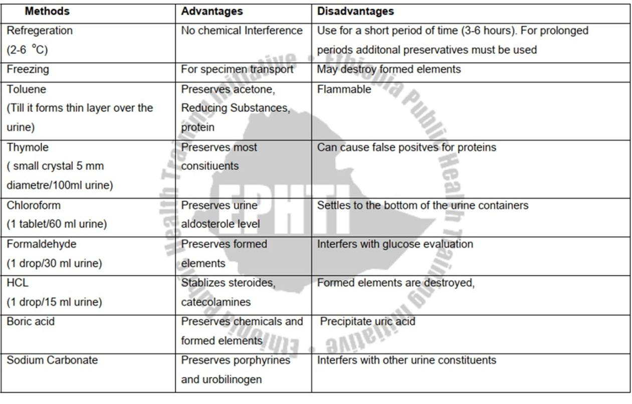
Physical Examination of Urine
Volume, Colour, Odour, Appearance, pH, Specific gravity, Chemical Examination of Urine, Glucose, Protein, Ketones, Bilirubin, Urobilinogen, Blood, Nitrite, Leukocyte Esterase and Melanin.
Colour: Can be seen in a urinometer tube or a test tube.
The colour ranges from yellow to amber (Normal); the colour is mostly due to the presence of urobilin.
Urobilin is a waste product formed when heme from hemoglobin is broken down during the demise of aged blood cells.
Polyuria and colorless to pale yellow urine with a low specific gravity.
Urine that is dark yellow or yellow brown in color and has a high specific gravity and a small volume.
When urine is shaken, it produces a golden brown or greenish yellow froth.
Urobilinoids are chromagons made up of heme green biliverdin yellow-brownbilirubin, and urobilin.
Fresh voided urine specimens are generally clear and transparent in appearance.
It becomes turbid after a lengthy period of time due to chemical changes that occur in typical constituents of urine over time, as mentioned in the introduction section of this lecture note.
pH:
A test that determines if a solution is acidic, neutral, or alkaline.
The number 7 denotes neutrality.
Acidity is indicated by a pH of less than 7.
A pH greater than 7 indicates alkalinity. In healthy people, freshly voided urine pH ranges between 5-7, with an average of pH 6.
Urine Specific Gravity:
The weight of a fixed volume of solution divided by the weight of the same volume of water at a given temperature (typically 20 C) is known as specific gravity.
1.010–1.030 is the normal range.
Refractometer:
The urine dipstick is a narrow plastic strip with numerous colored squares attached to it. Each small square represents a part of the urinalysis interpretation test.
Each pad's colours are visually compared to a variety of colours on brand-specific colour charts.Colour variations in each square are noticed once the entire strip is dipped in the urine sample.
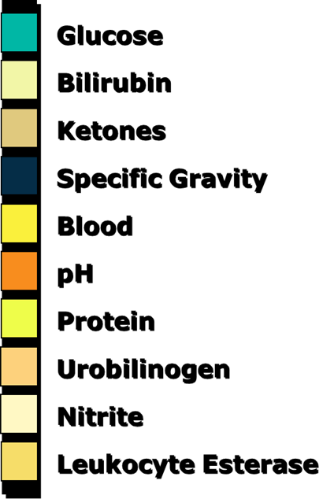

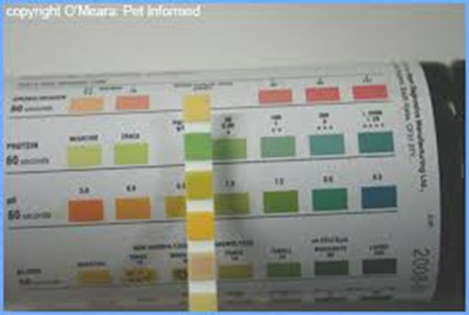

Results
 | sex | 1hr | 2hrs | 3hrs | 4hrs | 5hrs | 6hrs
1 | female | 50.4 | 100.8 | 151.2 | 201.6 | 252 | 302.4
2 | female | 64.8 | 129.6 | 194.4 | 259.2 | 324 | 388.8
3 | female | 72 | 144 | 216 | 288 | 360 | 432
4 | female | 36 | 72 | 108 | 144 | 180 | 216
5 | female | 57.6 | 115.2 | 172.8 | 230.4 | 288 | 345.6
6 | female | 86.4 | 172.8 | 259.2 | 345.6 | 432 | 518.4
1 | male | 72 | 144 | 216 | 288 | 360 | 432
2 | male | 64.8 | 129.6 | 194.4 | 259.2 | 324 | 388.8
3 | male | 100.8 | 201.6 | 302.4 | 403.2 | 504 | 604.8
4 | male | 86.4 | 172.8 | 259.2 | 345.6 | 432 | 518.4
5 | male | 50.4 | 100.8 | 151.2 | 201.6 | 252 | 302.4
6 | male | 93.6 | 187.2 | 280.8 | 374.4 | 468 | 561.6

Group Statistics
sex |  | N | Mean | Std. Deviation | Std. Error Mean
1hr | male | 6 | 78.0000 | 19.00400 | 7.75835
1hr | female | 6 | 61.2000 | 17.48874 | 7.13975

Independent Samples Test
 |  | Levene's Test for Equality of Variances |  | t-test for Equality of Means
 |  | F | Sig. | t | df | Sig. (2-tailed) | Mean Difference | Std. Error Difference | 95% Confidence Interval of the Difference
 |  |  |  |  |  |  |  |  | Lower | Upper
1hr | Equal variances assumed | .208 | .658 | 1.593 | 10 | .142 | 16.80000 | 10.54362 | -6.69266 | 40.29266
1hr | Equal variances not assumed |  |  | 1.593 | 9.932 | .142 | 16.80000 | 10.54362 | -6.71456 | 40.31456

sex |  |  |  |  | N |  | Mean |  |  |  | Std. Deviation |  |  | Std. Error Mean
2hrs |  |  | male |  | 6 |  | 156.0000 |  |  |  | 38.00800 |  |  | 15.51670
 |  |  | female |  | 6 |  | 122.4000 |  |  |  | 34.97748 |  |  | 14.27950
 | Independent Samples Test
 |  |  |  | Levene's Test for Equality of Variances |  |  |  | t-test for Equality of Means
 |  |  |  | F |  | Sig. |  | t | df | Sig. (2-tailed) |  | Mean Difference | Std. Error Difference |  | 95% Confidence Interval of the Difference
 |  |  |  |  |  |  |  |  |  |  |  |  |  |  | Lower | Upper
 | 2hrs | Equal variances assumed |  | .208 |  | .658 |  | 1.593 | 10 | .142 |  | 33.60000 | 21.08725 |  | -13.38532 | 80.58532
 | 2hrs | Equal variances not assumed |  |  |  |  |  | 1.593 | 9.932 | .142 |  | 33.60000 | 21.08725 |  | -13.42912 | 80.62912

Group Statistics
sex |  | N | Mean | Std. Deviation | Std. Error Mean
3hrs | male | 6 | 234.0000 | 57.01200 | 23.27505
3hrs | female | 6 | 183.6000 | 52.46622 | 21.41924

Independent Samples Test
 |  | Levene's Test for Equality of Variances |  | t-test for Equality of Means
 |  | F | Sig. | T | df | Sig. (2-tailed) | Mean Difference | Std. Error Difference | 95% Confidence Interval of the Difference
 |  |  |  |  |  |  |  |  | Lower | Upper
3hrs | Equal variances assumed | .208 | .658 | 1.593 | 10 | .142 | 50.40000 | 31.63087 | -20.07797 | 120.87797
3hrs | Equal variances not assumed |  |  | 1.593 | 9.932 | .142 | 50.40000 | 31.63087 | -20.14368 | 120.94368

Group Statistics
sex |  | N | Mean | Std. Deviation | Std. Error Mean
hrs_4 | male | 6 | 312.0000 | 76.01600 | 31.03340
hrs_4 | female | 6 | 244.8000 | 69.95496 | 28.55899

Independent Samples Test
 |  | Levene's Test for Equality of Variances |  | t-test for Equality of Means
 |  | F | Sig. | t | df | Sig. (2-tailed) | Mean Difference | Std. Error Difference | 95% Confidence Interval of the Difference
 |  |  |  |  |  |  |  |  | Lower | Upper
4hrs | Equal variances assumed | .208 | .658 | 1.593 | 10 | .142 | 67.20000 | 42.17449 | -26.77063 | 161.17063
4hrs | Equal variances not assumed |  |  | 1.593 | 9.932 | .142 | 67.20000 | 42.17449 | -26.85824 | 161.25824

 | Group Statistics
 | sex |  |  |  | N |  | Mean |  |  |  | Std. Deviation |  |  | Std. Error Mean
 | 5hrs |  | male |  | 6 |  | 390.0000 |  |  |  | 95.02000 |  |  | 38.79175
 |  |  | female |  | 6 |  | 306.0000 |  |  |  | 87.44370 |  |  | 35.69874
Independent Samples Test
 |  |  |  | Levene's Test for Equality of Variances |  |  |  | t-test for Equality of Means
 |  |  |  | F |  | Sig. |  | T | df | Sig. (2-tailed) |  | Mean Difference | Std. Error Difference |  | 95% Confidence Interval of the Difference
 |  |  |  |  |  |  |  |  |  |  |  |  |  |  | Lower | Upper
5hrs |  | Equal variances assumed |  | .208 |  | .658 |  | 1.593 | 10 | .142 |  | 84.00000 | 52.71812 |  | -33.46329 | 201.46329
 |  | Equal variances not assumed |  |  |  |  |  | 1.593 | 9.932 | .142 |  | 84.00000 | 52.71812 |  | -33.57281 | 201.57281

Group Statistics
sex |  | N | Mean | Std. Deviation | Std. Error Mean
6hrs | male | 6 | 468.0000 | 114.02400 | 46.55010
6hrs | female | 6 | 367.2000 | 104.93244 | 42.83849

Independent Samples Test
 |  | Levene's Test for Equality of Variances |  | t-test for Equality of Means
 |  | F | Sig. | t | df | Sig. (2-tailed) | Mean Difference | Std. Error Difference | 95% Confidence Interval of the Difference
 |  |  |  |  |  |  |  |  | Lower | Upper
6hrs | Equal variances assumed | .208 | .658 | 1.593 | 10 | .142 | 100.80000 | 63.26174 | -40.15595 | 241.75595
6hrs | Equal variances not assumed |  |  | 1.593 | 9.932 | .142 | 100.80000 | 63.26174 | -40.28737 | 241.88737

Discussion

 | sex | 1hr | 2hrs | 3hrs | 4hrs | 5hrs | 6hrs
1 | female | 50.4 | 100.8 | 151.2 | 201.6 | 252 | 302.4
2 | female | 64.8 | 129.6 | 194.4 | 259.2 | 324 | 388.8
3 | female | 72 | 144 | 216 | 288 | 360 | 432
4 | female | 36 | 72 | 108 | 144 | 180 | 216
5 | female | 57.6 | 115.2 | 172.8 | 230.4 | 288 | 345.6
6 | female | 86.4 | 172.8 | 259.2 | 345.6 | 432 | 518.4
1 | male | 72 | 144 | 216 | 288 | 360 | 432
2 | male | 64.8 | 129.6 | 194.4 | 259.2 | 324 | 388.8
3 | male | 100.8 | 201.6 | 302.4 | 403.2 | 504 | 604.8
4 | male | 86.4 | 172.8 | 259.2 | 345.6 | 432 | 518.4
5 | male | 50.4 | 100.8 | 151.2 | 201.6 | 252 | 302.4
6 | male | 93.6 | 187.2 | 280.8 | 374.4 | 468 | 561.6

We will run the moderation test to find out whether the data follows a normal distribution or not by means of the Kolmogorov-Smirnov or Shapiro-Wilk test. By performing the moderation test, we get the following results:
 | Tests of Normality
 |  | Kolmogorov-Smirnova |  |  | Shapiro-Wilk
 |  | Statistic | df | Sig. | Statistic | df | Sig.
1hr |  | .139 | 12 | .200* | .972 | 12 | .927
2hrs |  | .139 | 12 | .200* | .972 | 12 | .927
3hrs |  | .139 | 12 | .200* | .972 | 12 | .927
4hrs |  | .139 | 12 | .200* | .972 | 12 | .927
5hrs |  | .139 | 12 | .200* | .972 | 12 | .927
6hrs |  | .139 | 12 | .200* | .972 | 12 | .927

It is clear from the table that the significance value of the Kolmogorov-Smirnova test reached (0.2), which is a value higher than (0.05), and the significance value of the Shapiro-Wilk test reached (0.927), which is a value higher than (0.05), which means that the data follow Normal distribution, for all hours.
Thus, we will use an Independent-Samples T Test on the sample to determine the differences between the total mean
1- Are there any statistically significant differences between the average urine output of adult males and adult females after taking Lasix in the first hour?
Null hypothesis H0: The average urine output of an adult male when taking Lasix after the first hour is equal to the average urine output of an adult female.
Alternative Hypothesis H1: The average urine output of adult males when taking Lasix after the first hour is not equal to the average urine output of adult females.

Group Statistics
sex |  | N | Mean | Std. Deviation | Std. Error Mean
1hr | male | 6 | 78.0000 | 19.00400 | 7.75835
1hr | female | 6 | 61.2000 | 17.48874 | 7.13975

Independent Samples Test
 |  | Levene's Test for Equality of Variances |  | t-test for Equality of Means
 |  | F | Sig. | t | df | Sig. (2-tailed) | Mean Difference | Std. Error Difference | 95% Confidence Interval of the Difference
 |  |  |  |  |  |  |  |  | Lower | Upper
1hr | Equal variances assumed | .208 | .658 | 1.593 | 10 | .142 | 16.80000 | 10.54362 | -6.69266 | 40.29266
1hr | Equal variances not assumed |  |  | 1.593 | 9.932 | .142 | 16.80000 | 10.54362 | -6.71456 | 40.31456

Summary of results and commentary for the Independent Samples T Test
Calculated T value | degree of freedom (df) | sample average |  | Significant value (Sig.)
Calculated T value | degree of freedom (df) | male | female | Significant value (Sig.)
1.593 | 10 | 78.00 | 61.2 | 0.142

We note from the test results that the significance value equals (0.142), or 14.5%, which is greater than the level of significance 5%. Hence, we accept the null hypothesis that the average urine production in adult males when taking Lasix after the first hour is equal to the average urine production in adult females, meaning that the differences which is insignificant between them

2- Are there statistically significant differences between the average urine production of adult males and adult females after taking Lasix after two hours.
Null hypothesis H0: The average urine output of an adult male when taking Lasix after two hours is equal to the average urine output of an adult female.
Alternative Hypothesis H1: The average urine output of an adult male when taking Lasix after two hours is not equal to the average urine output of an adult female.

sex |  | N | Mean | Std. Deviation | Std. Error Mean
2hrs | male | 6 | 156.0000 | 38.00800 | 15.51670
2hrs | female | 6 | 122.4000 | 34.97748 | 14.27950

Independent Samples Test
 |  | Levene's Test for Equality of Variances |  | t-test for Equality of Means
 |  | F | Sig. | t | df | Sig. (2-tailed) | Mean Difference | Std. Error Difference | 95% Confidence Interval of the Difference
 |  |  |  |  |  |  |  |  | Lower | Upper
2hrs | Equal variances assumed | .208 | .658 | 1.593 | 10 | .142 | 33.60000 | 21.08725 | -13.38532 | 80.58532
2hrs | Equal variances not assumed |  |  | 1.593 | 9.932 | .142 | 33.60000 | 21.08725 | -13.42912 | 80.62912

Summary of results and commentary for the Independent Samples T Test
Calculated T value | degree of freedom (df) | sample average |  | Significant value (Sig.)
Calculated T value | degree of freedom (df) | male | Female | Significant value (Sig.)
1.593 | 10 | 156.00 | 122.40 | 0.142

We note from the test results that the significance value equals (0.142), or 14.5%, which is greater than the level of significance 5%. Hence, we accept the null hypothesis that the average urine production for adult males when taking Lasix after two hours is equal to the average urine production for adult females, meaning that the differences that between them is insignificant

3- Are there any statistically significant differences between the average urine production of adult males and adult females after taking Lasix after 3 hours.
Null hypothesis H0: The average urine output of an adult male when taking Lasix after three hours is equal to the average urine output of an adult female.
Alternative Hypothesis H1: The average urine output of an adult male when taking Lasix after three hours is not equal to the average urine output of an adult female.

Group Statistics
sex |  | N | Mean | Std. Deviation | Std. Error Mean
3hrs | male | 6 | 234.0000 | 57.01200 | 23.27505
3hrs | female | 6 | 183.6000 | 52.46622 | 21.41924

Independent Samples Test
 |  | Levene's Test for Equality of Variances |  | t-test for Equality of Means
 |  | F | Sig. | t | df | Sig. (2-tailed) | Mean Difference | Std. Error Difference | 95% Confidence Interval of the Difference
 |  |  |  |  |  |  |  |  | Lower | Upper
3hrs | Equal variances assumed | .208 | .658 | 1.593 | 10 | .142 | 50.40000 | 31.63087 | -20.07797 | 120.87797
3hrs | Equal variances not assumed |  |  | 1.593 | 9.932 | .142 | 50.40000 | 31.63087 | -20.14368 | 120.94368

Summary of results and commentary for the Independent Samples T Test
Calculated T value | degree of freedom (df) | sample average |  | Significant value (Sig.)
Calculated T value | degree of freedom (df) | male | Female | Significant value (Sig.)
1.593 | 10 | 234.00 | 183.60 | 0.142

We note from the test results that the significance value equals (0.142), or 14.5%, which is greater than the level of significance 5%. Hence, we accept the null hypothesis that the average urine production in adult males when taking Lasix after three hours is equal to the average urine production in adult females, meaning that the differences which is insignificant between them

4- Are there any statistically significant differences between the average urine production of adult males and adult females after taking Lasix after 4 hours.
Null hypothesis H0: The average urine output of an adult male when taking Lasix after four hours is equal to the average urine output of an adult female.
Alternative Hypothesis H1: The average urine output of adult males when taking Lasix after four hours is not equal to the average urine output of adult females.

Group Statistics
sex |  | N | Mean | Std. Deviation | Std. Error Mean
hrs_4 | male | 6 | 312.0000 | 76.01600 | 31.03340
hrs_4 | female | 6 | 244.8000 | 69.95496 | 28.55899

Independent Samples Test
 |  | Levene's Test for Equality of Variances |  | t-test for Equality of Means
 |  | F | Sig. | t | df | Sig. (2-tailed) | Mean Difference | Std. Error Difference | 95% Confidence Interval of the Difference
 |  |  |  |  |  |  |  |  | Lower | Upper
4hrs | Equal variances assumed | .208 | .658 | 1.593 | 10 | .142 | 67.20000 | 42.17449 | -26.77063 | 161.17063
4hrs | Equal variances not assumed |  |  | 1.593 | 9.932 | .142 | 67.20000 | 42.17449 | -26.85824 | 161.25824

Summary of results and commentary for the Independent Samples T Test
Calculated T value | degree of freedom (df) | sample average |  | Significant value (Sig.)
Calculated T value | degree of freedom (df) | male | Female | Significant value (Sig.)
1.593 | 10 | 312.00 | 244.80 | 0.142

We note from the test results that the significance value equals (0.142), or 14.5%, which is greater than the level of significance 5%. Hence, we accept the null hypothesis that the average urine production in adult males when taking Lasix after three hours is equal to the average urine production in adult females, meaning that the differences which is insignificant between them

5- Are there any statistically significant differences between the average urine output of adult males and adult females after taking Lasix after 5 hours.
Null hypothesis H0: The average urine output of an adult male when taking Lasix after five hours is equal to the average urine output of an adult female.
Alternative Hypothesis H1: The average urine output of adult males when taking Lasix after five hours is not equal to the average urine output of adult females.

Group Statistics
sex |  | N | Mean | Std. Deviation | Std. Error Mean
5hrs | male | 6 | 390.0000 | 95.02000 | 38.79175
5hrs | female | 6 | 306.0000 | 87.44370 | 35.69874

Independent Samples Test
 |  | Levene's Test for Equality of Variances |  | t-test for Equality of Means
 |  | F | Sig. | t | df | Sig. (2-tailed) | Mean Difference | Std. Error Difference | 95% Confidence Interval of the Difference
 |  |  |  |  |  |  |  |  | Lower | Upper
5hrs | Equal variances assumed | .208 | .658 | 1.593 | 10 | .142 | 84.00000 | 52.71812 | -33.46329 | 201.46329
5hrs | Equal variances not assumed |  |  | 1.593 | 9.932 | .142 | 84.00000 | 52.71812 | -33.57281 | 201.57281

Summary of results and commentary for the Independent Samples T Test
Calculated T value | degree of freedom (df) | sample average |  | Significant value (Sig.)
Calculated T value | degree of freedom (df) | male | Female | Significant value (Sig.)
1.593 | 10 | 390.00 | 306.00 | 0.142

We note from the test results that the significance value equals (0.142), or 14.5%, which is greater than the level of significance 5%. Hence, we accept the null hypothesis that the average urine production in adult males when taking Lasix after three hours is equal to the average urine production in adult females, meaning that the differences which is insignificant between them

6- Are there any statistically significant differences between the average urine production of adult males and adult females after taking Lasix after 6 hours?
Null hypothesis H0: The average urine output of an adult male when taking Lasix after six hours is equal to the average urine output of an adult female.
Alternative Hypothesis H1: The average urine output of adult males when taking Lasix after six hours is not equal to the average urine output of adult females.

Group Statistics
sex |  | N | Mean | Std. Deviation | Std. Error Mean
6hrs | male | 6 | 468.0000 | 114.02400 | 46.55010
6hrs | female | 6 | 367.2000 | 104.93244 | 42.83849

Independent Samples Test
 |  | Levene's Test for Equality of Variances |  | t-test for Equality of Means
 |  | F | Sig. | t | df | Sig. (2-tailed) | Mean Difference | Std. Error Difference | 95% Confidence Interval of the Difference
 |  |  |  |  |  |  |  |  | Lower | Upper
6hrs | Equal variances assumed | .208 | .658 | 1.593 | 10 | .142 | 100.80000 | 63.26174 | -40.15595 | 241.75595
6hrs | Equal variances not assumed |  |  | 1.593 | 9.932 | .142 | 100.80000 | 63.26174 | -40.28737 | 241.88737

Summary of results and commentary for the Independent Samples T Test
Calculated T value | degree of freedom (df) | sample average |  | Significant value (Sig.)
Calculated T value | degree of freedom (df) | male | Female | Significant value (Sig.)
1.593 | 10 | 468.00 | 367.20 | 0.142

We note from the test results that the significance value equals (0.142), or 14.5%, which is greater than the level of significance 5%. Hence, we accept the null hypothesis that the average urine production in adult males when taking Lasix after three hours is equal to the average urine production in adult females, meaning that the differences which is insignificant between them.

Conclusion
Through the results of the census, the Lasix has no effect in a man or in females within 6 hours of the test based on the p-value (=0.142). So the researcher recommend further studies as well as use large and different implications to reach a more accurate and clear answers.

Reference

1.Hall J, Hall M. Guyton And Hall Textbook Of Medical Physiology. 14th ed. Philadelphia: Elsevier; 2021:587-592.Pereira JC Jr, AlvesRC.
2.RachlinH. What Müller's law of specific nerve energies says about the mind. Behavior and Philosophy. 2005 Jan 1:41-54.
3.Katzung B. G.,(2019), Basic & clinical pharmacology, 14th ed.
4.LE T. & HWANG W.L.,(2017), USMLE organ system, 3rd ed. McGraw-Hill Education
5.RANG H. P., etal, (2007) Rang & Dale's Pharmacology, 6th ed. Elsevier Limited

