Done by: Masara Almahdi
Stu NO:2907

Libyan International Medical University
Faculty of Applied Medical Science
2021-2022

Asymptomatic bacteriuria

Supervisor: انتصار الناجي
Assistant by: ناجي الحمري

(Abstract)

This paper will explain urinary tract infections and how they can pose a serious health risk to women around the world. The cause of this type of infection is still unknown, despite recognition of the materials and procedures used to identify the microorganism, as well as counting the colonies > 1 105 CFU/ml and determining whether it is positive or negative, as well as if it is
linked to asymptomatic bacteriuria, which is a bacterial class that is divided into two distinct
urine cultures in a patient who has no signs or symptoms of a urinary tract infection.¹
It's crucial to keep in mind that it affects more young females than younger boys.¹, and in this report, by selecting students at random, we found that 25% of male samples had no significant growth and 75% of female samples had no significant growth, while 16.67 percent of female samples had major growth, 16.67 percent no growth, and 66.67 percent no significant growth.

(Introduction)
Urinary tract infections (UTI) are one of the most common infections around the world. At least 10% of females will have been diagnosed with a UTI by the age of 18. Females have a shorter urethra compared to males [1] (F 1). That is why, By the age of 24, around one in three females will have had a UTI due to the anatomical structure of the uterus. UTIs account for 35–40% of all hospital-acquired infections, making them one of the most common nosocomial infections. One of the most common nosocomial infections is catheter-associated urinary tract infection (CAUTI)[2], [2] Over 1 million cases in hospitals and nursing homes are not properly accounted for each year. A urine culture is the gold standard test for determining the type of bacteria that causes a UTI.[1,2]. To compare all collection methods, the sterile method is frequently used [2]. Despite the fact that the urine in the bladder is sterile, contamination of samples can occur as urine passes through the urethra's outer third [1]. Clean catch midstream urine, indwelling catheter, straight catheterization urine, and suprapubic bladder aspiration are all examples of contamination prevention methods. Gram-positive bacteria like Staphylococcus saprophytic, Enterococcus faecalis, and Streptococcus agalactia are a common cause of urinary-tract infection (UTI), especially in the elderly, pregnant women, and those with other UTI risk factors. On the other hand, their Escherichia coli is the most common cause of urinary infection in the general public [1]. which is a gram-negative rod. Strong persistent urges to urinate, pain, frequency with strong smelling and cloudy appearance are the most common symptoms associated with UTI. In some cases, the urine can appear in a reddish color, indicating the presence of red blood cells in the urine (hematuria) alongside the presence of white blood cells in the urine (pyuria), which can indicate diseases such as pyelonephritis and cystitis. However, they don't show up in asymptomatic bacteriuria until later
the figures above show the difference between the male and female urethra ²

(Methods and materials)
To perform the urine culture, we'll need the following materials:
  - Wire loop
  - Agar plate
  - Urine sample
  - Flame
  - Incubators

For the procedure it begins by:
- Collecting fresh urine from the patient, particularly first In the morning
- The wire loop is sterilized by applying heat from a flame to it.
- Then, to attach the wire loop to the urine sample, insert it vertically into the urine sample
- The next step is to spread the urine sample on the plate agar by the wire loop.
- Then again, insert the wire loop in the urine sample again without appealing heat to it and transfer it to another plate of agar.
- After that, it will be incubated in air for 24 hours at 37 degrees Celsius.
- Finally, count the colonies that appeared on the plate. The colony forming units (CFUs) are multiplied by 1000 if the wire loop was 0.001 ml or by 100 if the wire loop was 0.01 ml to detect the number of the microorganism per ml in the original specimen.

(Results and analysis)
The effect of gender differences on prevalence and microbial spectrum of asymptomatic bacteriuria.
 | No growth | Overall, no significant growth | Significance growth
Males | 9 | 3 | 0
Females | 2 | 8 | 2

Table 1
The samples gathered from the students are displayed in the table below (table1). The group consisted of 12 ladies and 12 males in total. Because the samples were drawn at random from the students, they are qualitative variables, and if they support the null hypothesis, which states that there is no Relationship between the two variables, or the alternative hypothesis, which states that there is, the chi-square test was used to determine whether the results were significant. The sample's independence, whether the sample was randomly picked, and the sample size all influence the assumptions.
Chi-Square Tests
 | Value | df | Asymptotic Significance (2-sided)
Pearson Chi-Square | 8.727ª | 2 | .013
Likelihood Ratio | 9.949 | 2 | .007
Linear-by-Linear Association | 8.065 | 1 | .005
N of Valid Cases | 24
a. 2 cells (33.3%) have expected count less than 5. The minimum expected count is 1.00.

CFUcat * Gender Crosstabulation
 |  |  | Gender |  | Total
 |  |  | Female | Male | Total
CFUcat | No growth | Count | 2 | 9 | 11
CFUcat | No growth | Expected Count | 5.5 | 5.5 | 11.0
CFUcat | No growth | % Within Gender | 16.7% | 75.0% | 45.8%
CFUcat | Overall, no significant growth | Count | 8 | 3 | 11
CFUcat | Overall, no significant growth | Expected Count | 5.5 | 5.5 | 11.0
CFUcat | Overall, no significant growth | % Within Gender | 66.7% | 25.0% | 45.8%
CFUcat | Significant growth | Count | 2 | 0 | 2
CFUcat | Significant growth | Expected Count | 1.0 | 1.0 | 2.0
CFUcat | Significant growth | % Within Gender | 16.7% | 0.0% | 8.3%
Total |  | Count | 12 | 12 | 24
 |  | Expected Count | 12.0 | 12.0 | 24.0
 |  | % Within Gender | 100.0% | 100.0% | 100.0%

Case Processing Summary
 | Cases
 | Valid |  | Missing |  | Total
 | N | Percent | N | Percent | N | Percent
CFUcat * Gender | 24 | 64.9% | 13 | 35.1% | 37 | 100.0%

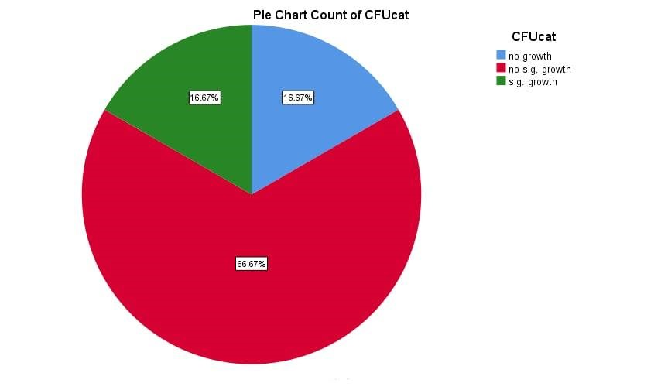F3(pie chart for the female's sample)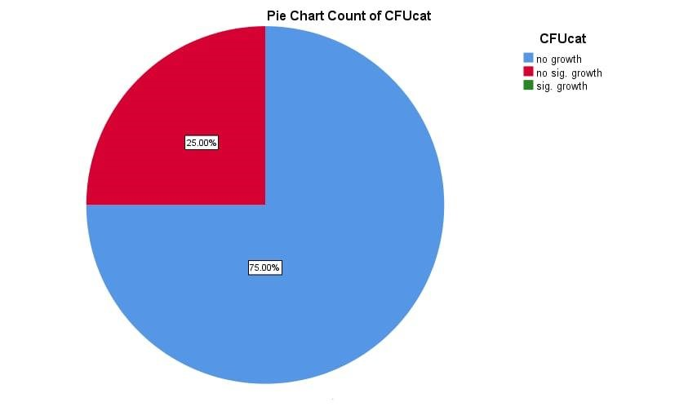 F4(pie chart for the male's sample)
- Female samples were exposed to significantly more growth than male samples, according to the findings. In total, 16.67% of the samples showed significant growth; 16.67% showed no growth at all, which counts 2 samples; and 67.67% showed no significance growth, which counts 8 samples, as shown in the graph (F 3).

- The male samples, on the other hand, were not exposed to the growth, and the results were 25% for no significant growth (three samples) and 75% for no growth (nine samples), as shown in. (F 4).

- We can reject the null hypothesis because the p values are 0.013 and 0.05, indicating that there is an association between the two variables. As a result of this discovery, we can conclude that, as previously stated, females are more susceptible to urinary tract infections than males.

(Conclusion)
  - As a result of this study, we can deduce that females are more susceptible to UTIs.
  - Asymptomatic bacteriuria occurs when bacteria colonize the urinary tract without causing symptoms.

  - The chi square test confirmed this hypothesis, and there is a link between the two variables.
  - There have been no forecasts to lower the incidence of urinary tract infection in females till now, except than preventative techniques and therapy.

References: if the reader interested in the topic
1. Levinson W, York N, San C, Athens F, Madrid L. Medical Microbiology and Immunology Review of. Published online 2016. www.mhprofessional.com.
2. Drake RL (Richard L, Vogl Wayne, Mitchell AWM, Gray H, Gray H. Gray’s Anatomy for Students. Churchill Livingstone/Elsevier; 2010.

3. Kline KA, Lewis AL. Gram-Positive Uropathogens, Polymicrobial Urinary Tract

