
Libyan International Medical University
Gender-Related Differences in the Pharmacodynamics of Furosemide

3rd year medical science

Student Name: Rawya Barrani
Student Number : 2511
Supervisor : Dr. Basma
Assisted by: Mr.Ahmed Gaibani And Mr.Al-Senussi Al-Sharif
Date of submission: 20June 2022

- Abstract
Many years ago theories has been established to request to involve females in all types of clinical drug development in order to investigate the potential gender differences of pharmacokinetics and pharmacodynamics of most of therapeutic agents specially the newly one. Since then, a lot of reports have been published that evaluate the potential existence and impact of gender differences on all phases of clinical pharmacology. In this research we focus on the pharmacodynamics of diuretics based on gender response. The results of these reports may will change the administration guidelines of these drug involve dose and mode of administration depends on the gender of patients.

- Introduction
Pharmacokinetics, sometimes known as how the body reacts to drugs, refers to the transport of drugs into, through, and out of the body. The time course of its absorption, metabolism, distribution, bioavailability, and excretion is also mentioned. The pharmacokinetics of every medicine are determined by patient circumstances as well as the chemical features of the drug. Some patient states or variables, such as sex, renal function, age, and genetic polymorphism, can be utilized to generate population pharmacokinetic parameters. For example, the half-life of some medications, particularly those that need both metabolism and excretion, may be prolonged in older persons as a result of the aging process. ⁽¹⁾ Furosemide (frusemide) is a powerful loop diuretic used to treat edema associated with renal, cardiac, and hepatic failure, as well as hypertension. The specific mechanism of action is unknown, although it is thought to block active chloride reabsorption by acting at the luminal surface of the ascending limb of the loop of Henle. The individual's fluid and electrolyte balance influences the reaction to a particular dose. Both delayed and acute tolerance have been established in humans and animals, and are thought to be the result of homeostatic systems controlling fluid and electrolyte balances. Furosemide is delivered to the site of action by active secretion by the nonspecific organic acid pump. The reaction is proportional to the concentration of the medication in urine rather than plasma. The most prevalent side effects of furosemide medication are caused by fluid and electrolyte imbalances. ⁽²⁾ A research on rates was conducted in 2004 to assess the influence of sex on the pharmacodynamics of furosemide in adult Wistar rats. ⁽³⁾ So, in our investigation, we used the similar principle on humans to see if there is a function of sex in furosemide pharmacokinetics.

- Methods and material
We choose 12 subjects (6 females and 6 males) in our research. After fasting overnight, each participant received single dose of the Furosemide 40mg on four separate days. Over the next 24 hours, total urine output was collected for volume measurement as well as sodium and potassium concentrations. We select Furosemide 40mg tablet as an available form of diuretics. After administration the oral Furosemide the urine output measured hourly for 6 hours. (figure 1)

- Results

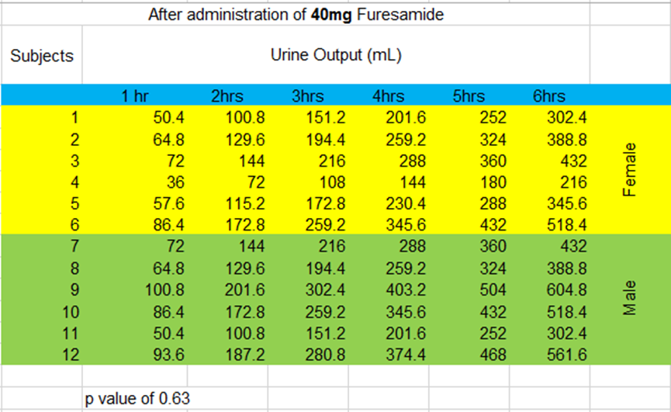
Figure-1: shows results of subjects urine output of both males and females after furosemide admiration.

The results overall show that the males urine output rate slightly higher than females.
And P-value more than 0.05 So there is no statistically significant difference between male and female subjects in terms of urine flow rate, sodium, and potassium excretion rates across treatments.

- Discussion
The Wistar rats study renal clearance performed in the two status, in the absence and in the presence of a of furosemide dose it is important to find out the identical urine excretion rates of furosemide in both males and females. In the absence of furosemide the fractional excretions of sodium, potassium, and water were similar in female and male rats. Female rats had considerably higher natriuretic, kaliuretic, and diuretic responses to Furosemide when expressed in fractional terms. Furosemide's diuretic, natriuretic, and kaliuretic efficacy were also stronger in female rats than in males. This might be related to the reduced quantity of sodium, potassium, and chloride cotransporters identified in homogenates from the medullae of female kidneys compared to male kidneys. ⁽³⁾ Drug inactivation is caused by two processes: metabolism and elimination. Without these mechanisms, drugs would circulate throughout our body, bind to numerous receptors, and disrupt critical physiological processes. Drugs are typically removed from the body via the renal, hepatic, or pulmonary pathways. As a result, drugs can exit the body through perspiration, tears, breast milk, expiration, and the most common pathways are feces and urine. Elimination is dependent on renal function. Chemicals can enter the urine by glomerular filtration, passive diffusion, or active secretion. Increases in renal blood flow and glomerular filtration will enhance the rate at which drugs are eliminated by the kidneys. Renal blood flow, glomerular filtration, tubular secretion, and tubular reabsorption are all greater in males than in non-pregnant women when normalized for body surface area. Alterations in renal blood flow, glomerular filtration rates (GFR), hepatic blood flow, bile flow, and pulmonary function during pregnancy can all affect maternal medication clearance. Maternal renal plasma flow rises from 500 to 700 ml/min/1.73 m2, representing a 1.44-fold increase over non-pregnant female values and a 1.1-fold increase over male values. During pregnancy, the GFR rises as well. GFR is around 100 ml/min/1.73 m2 at the start of pregnancy. By 20 weeks' gestation, the GFR is normally around 150 ml/min/1.73 m2 which is a 1.5-fold increase over the non-pregnant female value and a 1.2-fold rise over the male value. ⁽⁴⁾

- Conclusion
Specific drug pharmacokinetics may differ between men and women. Understanding sex variations in medication response is therefore critical, as they may alter drug safety and efficacy. Prior to treating women, doctors must define specific therapeutic goals for the medications of choice in order to reduce therapeutic side effects. It must be established if the therapy should be examined based on clinical signs and symptoms or laboratory test findings; whether drug toxicity should be evaluated clinically or via laboratory testing; and what defines the appropriate duration of treatment.

References

- Overview of Pharmacokinetics - Clinical Pharmacology - MSD Manual Professional Edition. MSD Manual Professional Edition. https://www.msdmanuals.com/en-gb/professional/clinical-pharmacology/pharmacokinetics/overview-of-pharmacokinetics. Published 2022. Accessed June 17, 2022.
- Ponto LL, Schoenwald RD. Furosemide (frusemide). A pharmacokinetic/pharmacodynamic review (Part I). Clin Pharmacokinet. 1990 May;18(5):381-408. doi: 10.2165/00003088-199018050-00004. PMID: 2185908.
- Brandoni A, Villar SR, Torres AM. Gender-related differences in the pharmacodynamics of furosemide in rats. Pharmacology. 2004 Feb;70(2):107-12. doi: 10.1159/000074675. PMID: 14685014.
- Soldin OP, Mattison DR. Sex differences in pharmacokinetics and pharmacodynamics. Clin Pharmacokinet. 2009;48(3):143-157. doi:10.2165/00003088-200948030-00001

